 **Introduction to DevOps**

**BCS/BS 6A**

Terraform-LAb02

# GROUP MEMBERS:

MUHAMMAD SHAYAN SHAHID (2212325)

MUHAMMAD ASHAD BAIG (2212115)

Part 2: Codify the Following in a Single Terraform Script

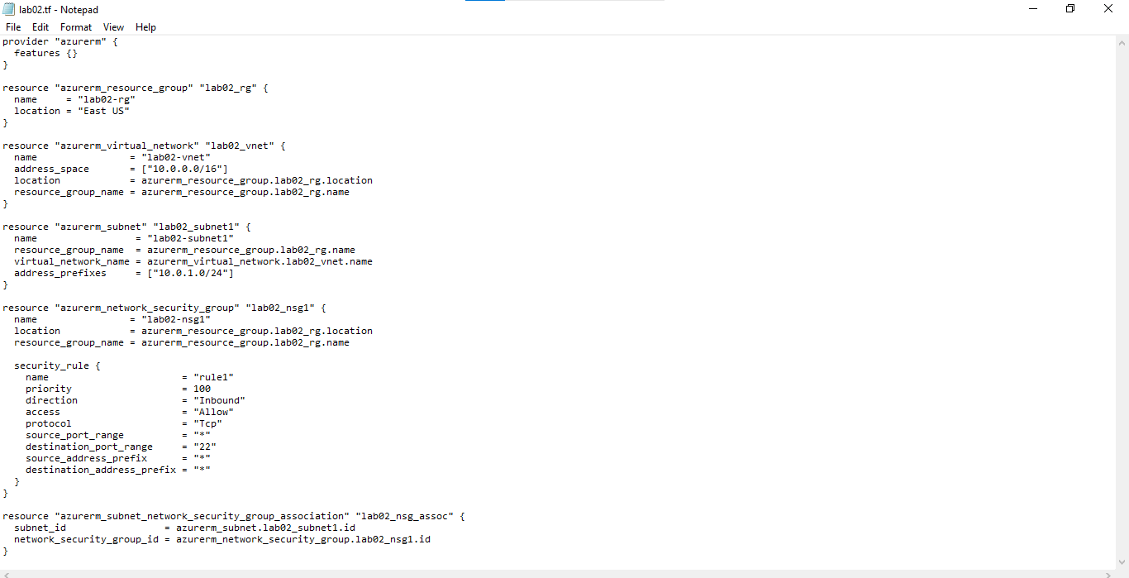

Initialize Terraform

Initialize Terraform and download plug-ins

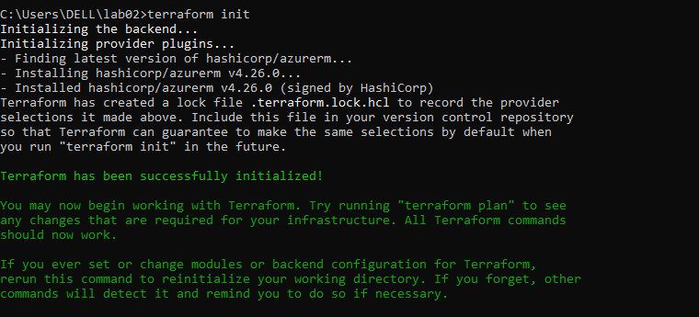

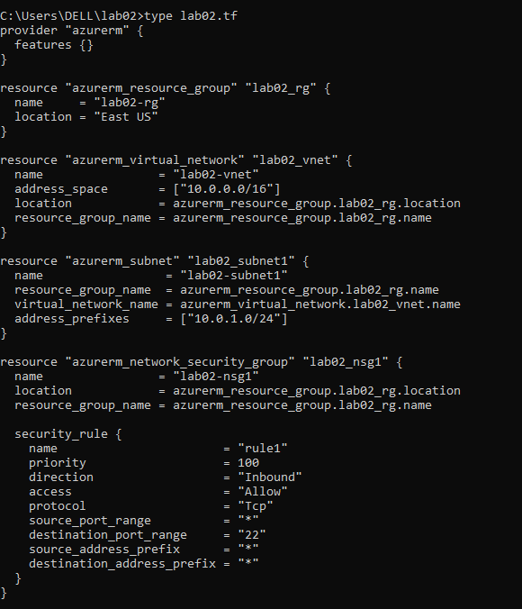

Validate Configuration

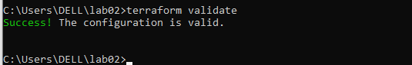

Run Simulation

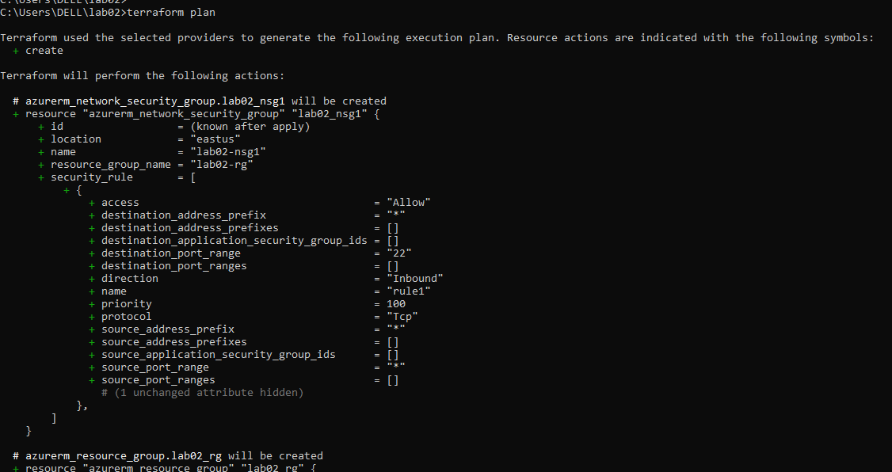

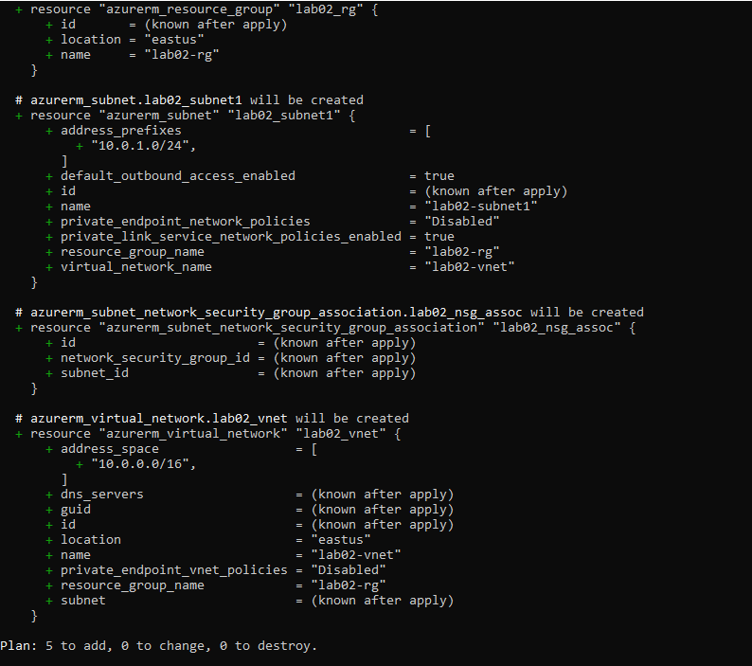

Deploy Infrastructure

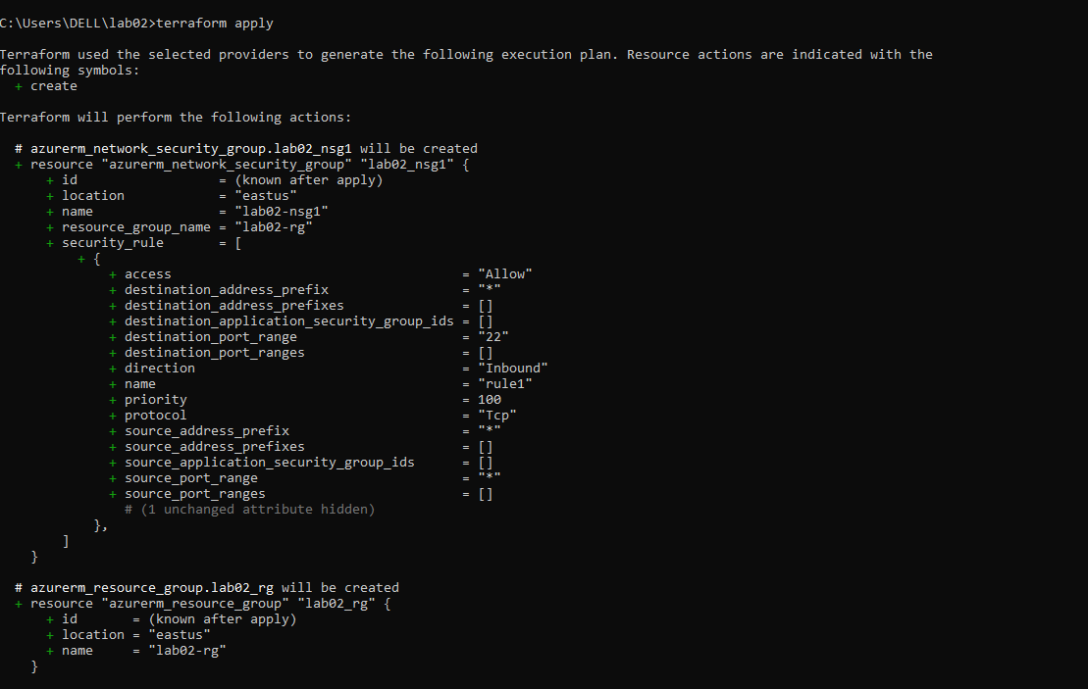

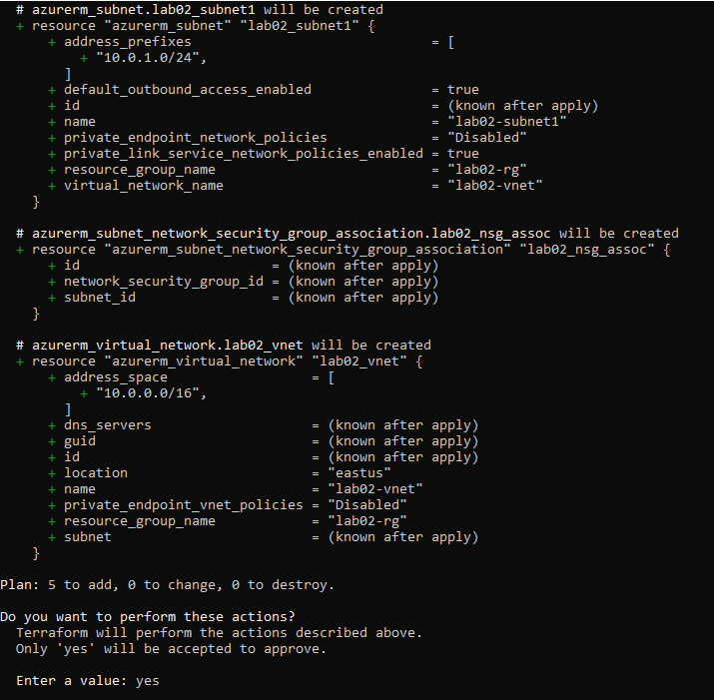

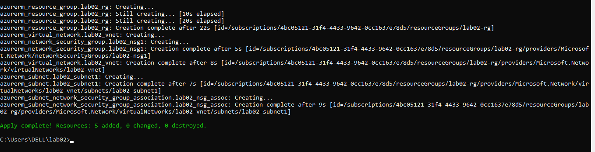

Get Information from Terraform State

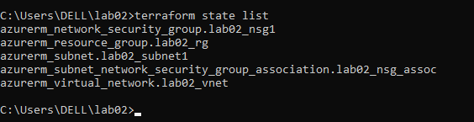

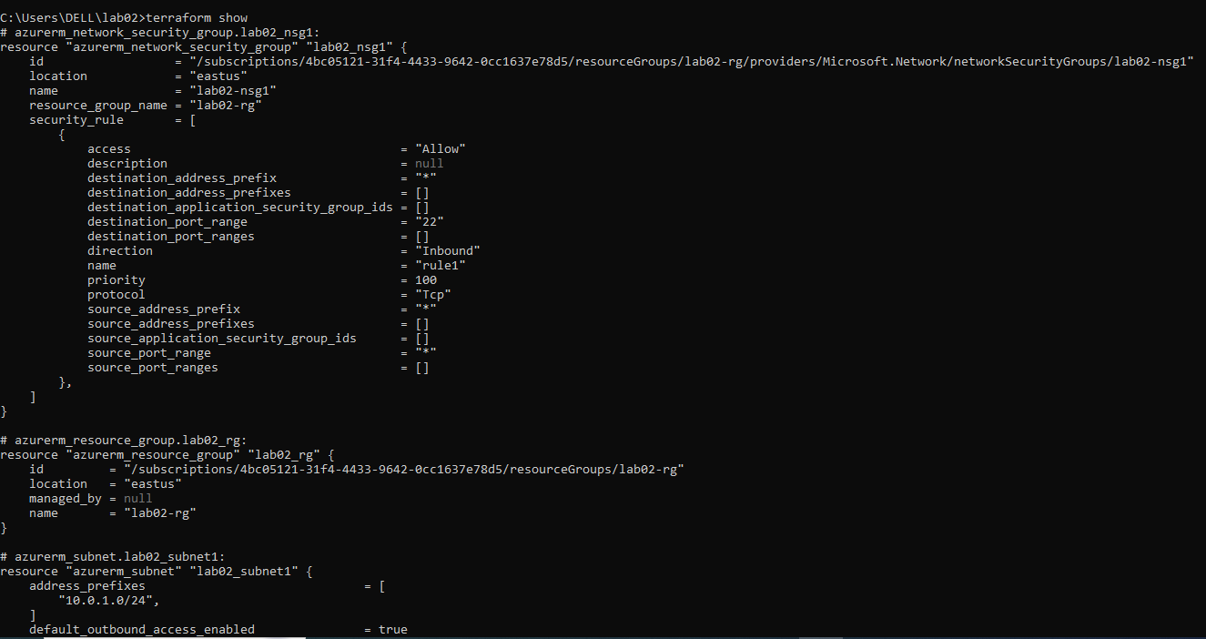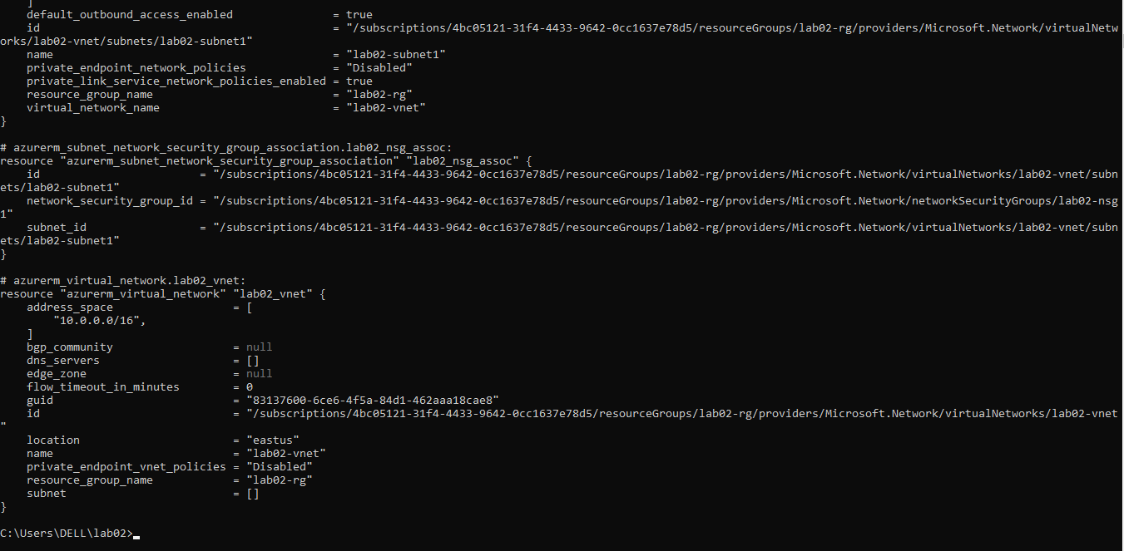

Confirm Resource Creation in Azure

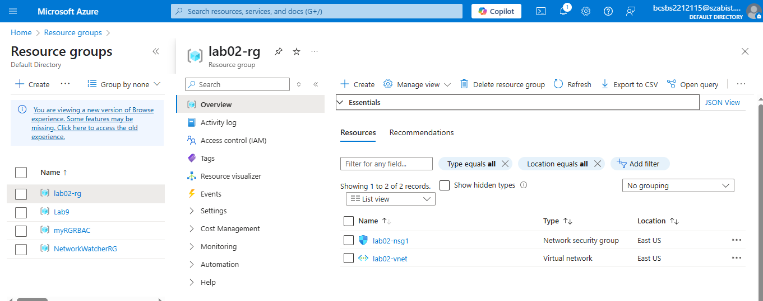

Expand the lab02.tf Script

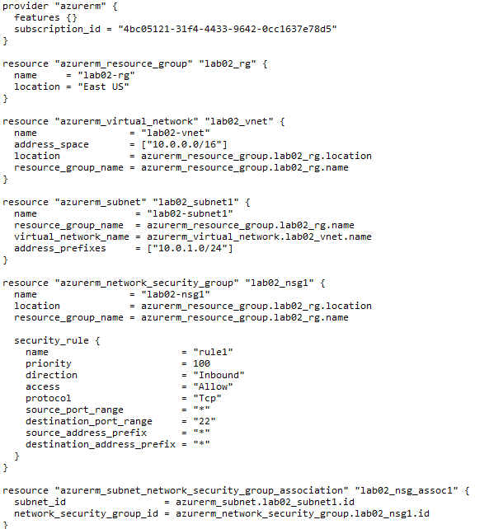

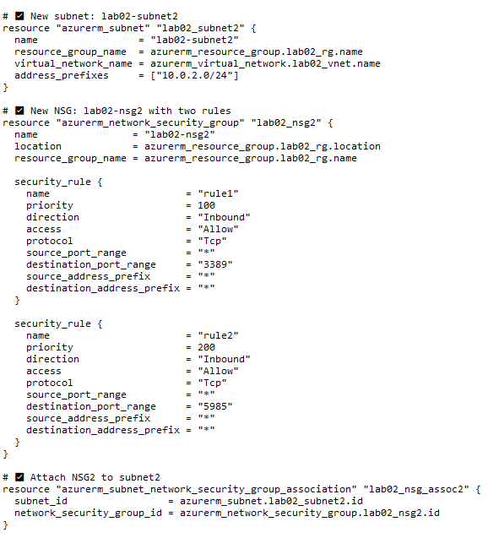

Validate Configuration

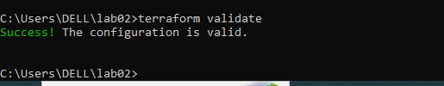

Run Simulation

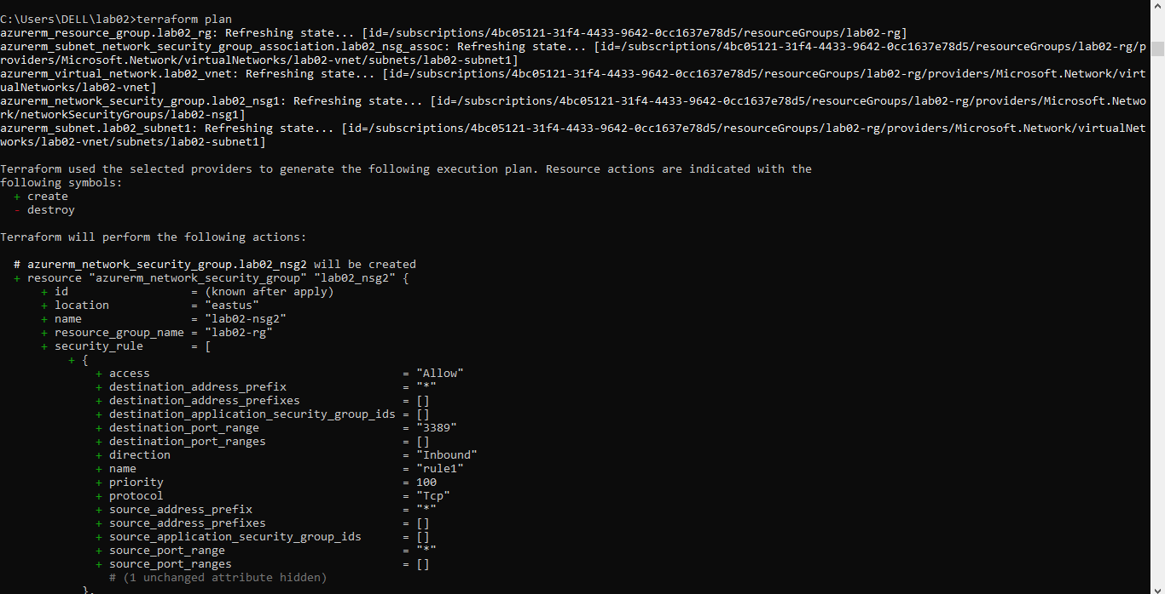

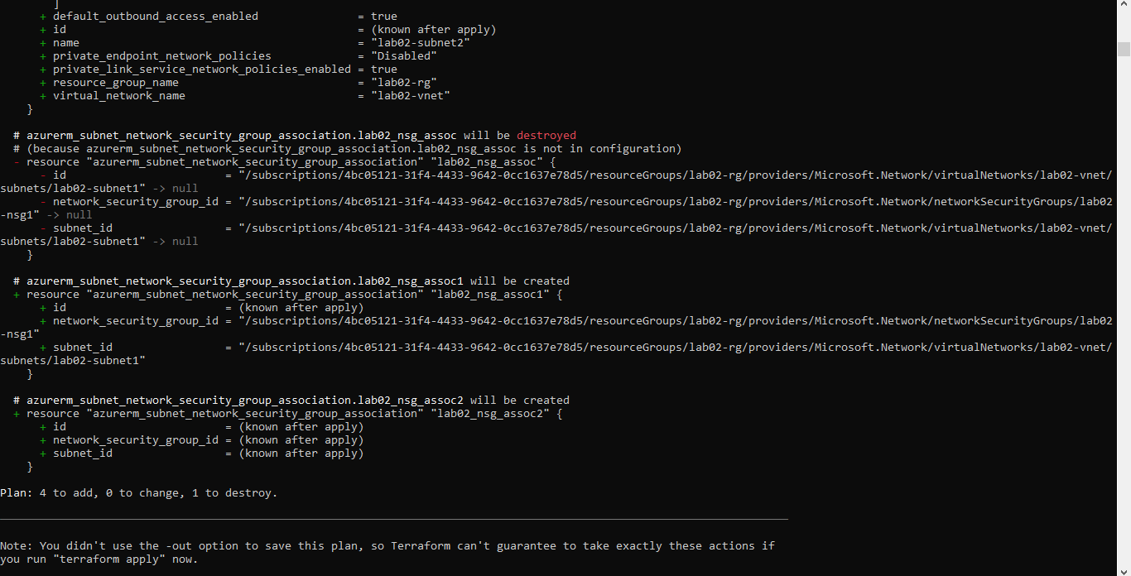

Deploy Infrastructure

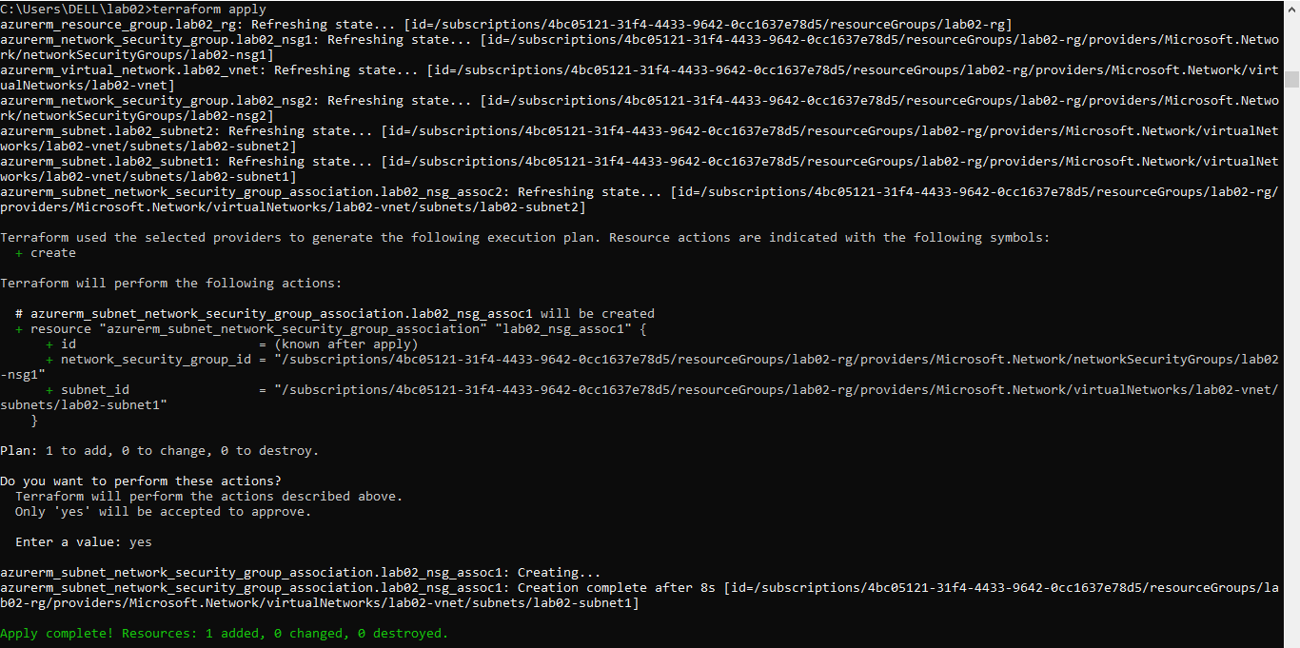

Get Information from Terraform State

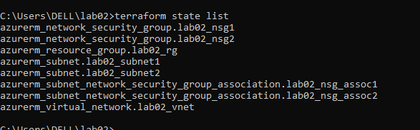

Confirm Resource Creation in Azure

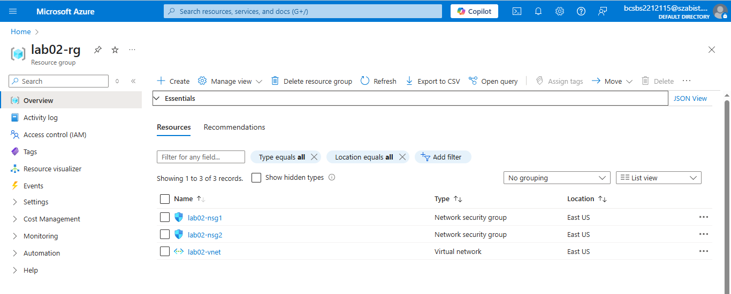

Destroy All Resources and Verify

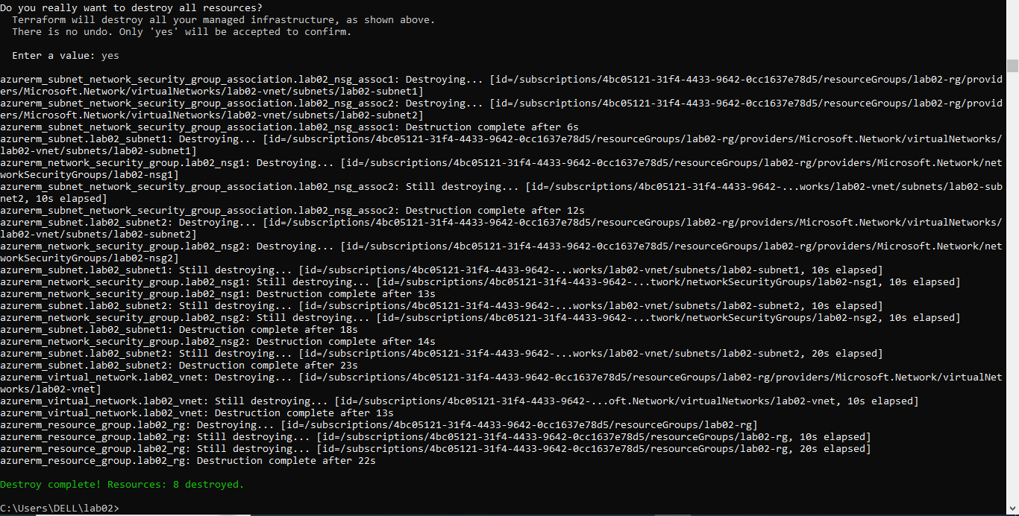

Verify deletion:

