 **Introduction to DevOps**

**BCS/BS 6A**

Terraform-LAb03

# GROUP MEMBERS:

MUHAMMAD SHAYAN SHAHID (2212325)

MUHAMMAD ASHAD BAIG (2212115)

Update vars03s1.tf File

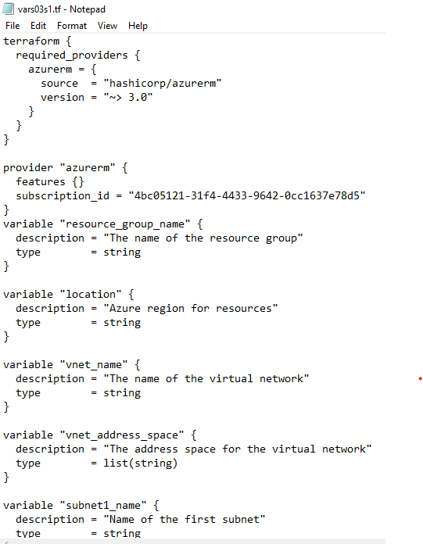

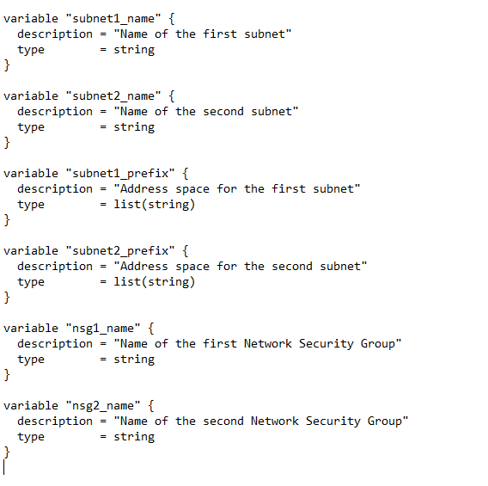

Update lab03s1.tf File

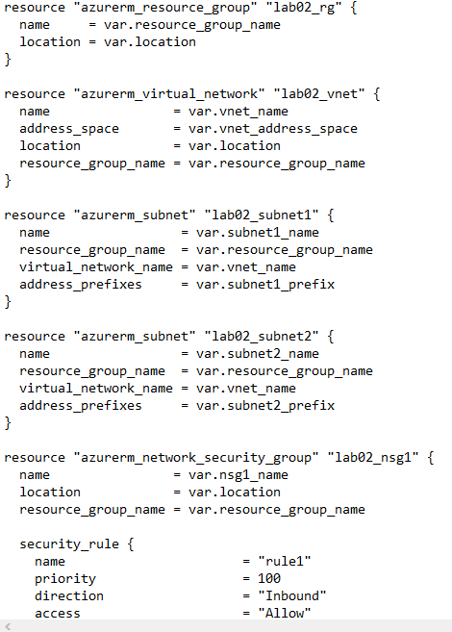

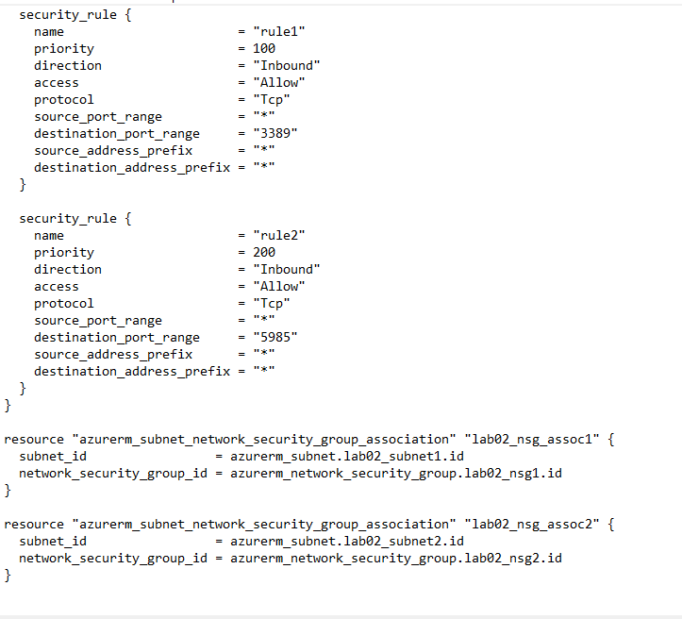

Initialize Terraform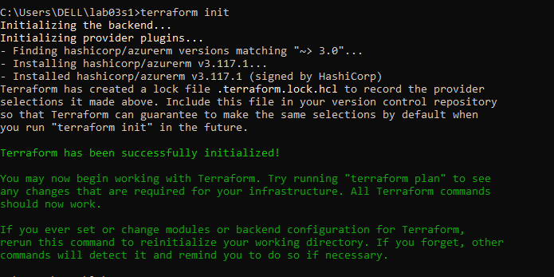

Validate Configuration

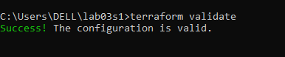

Run Simulation

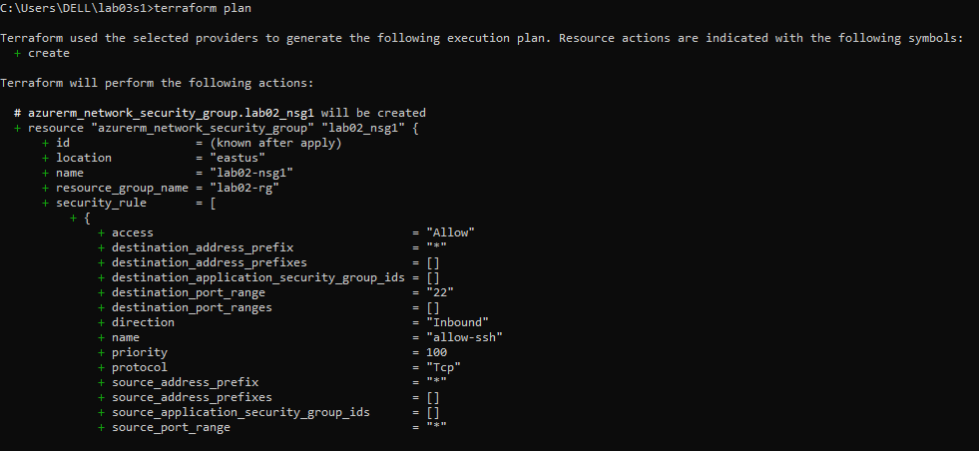

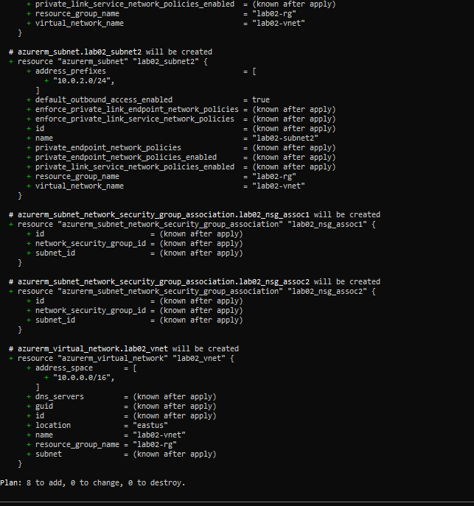

Deploy Infrastructure

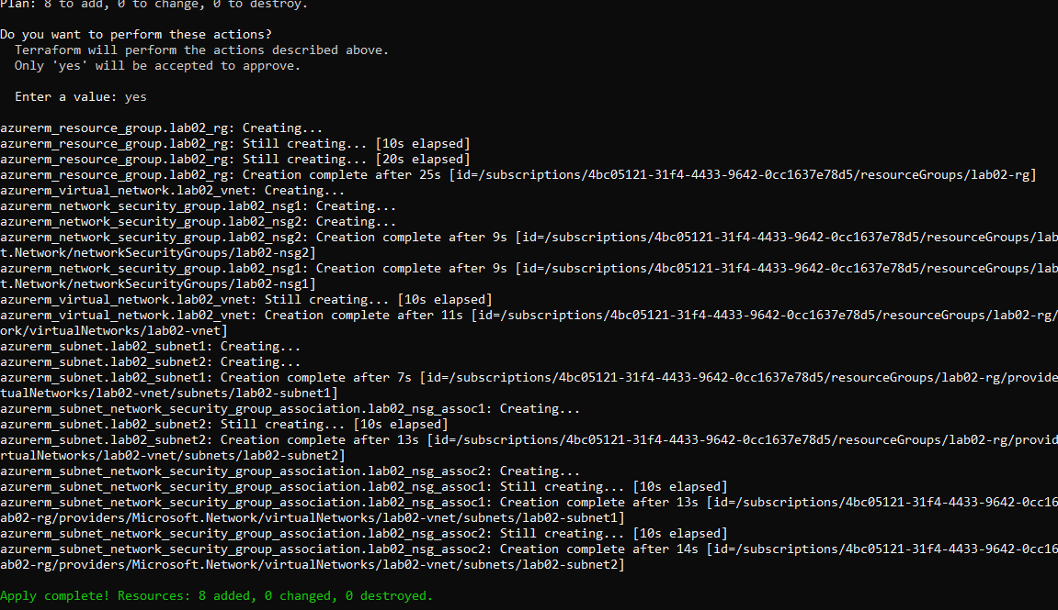

Get Information from Terraform State

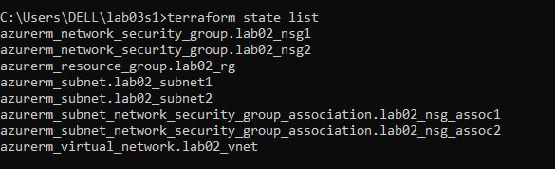

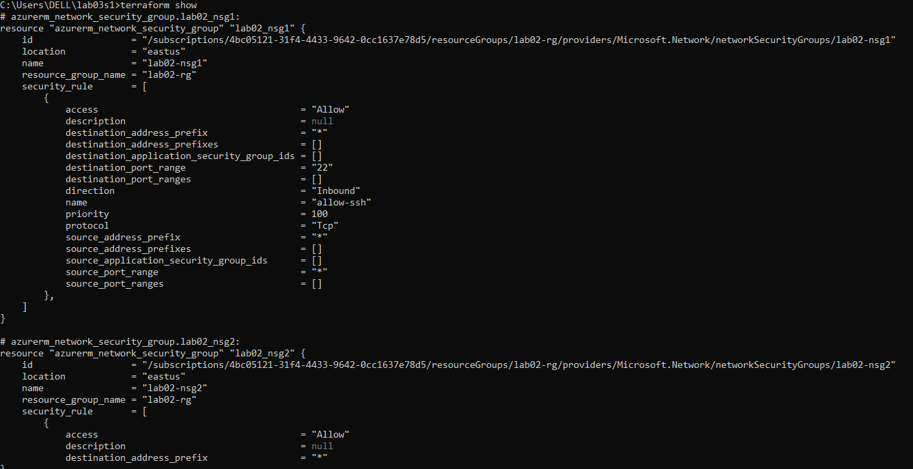

Confirm Resource Creation in Azure

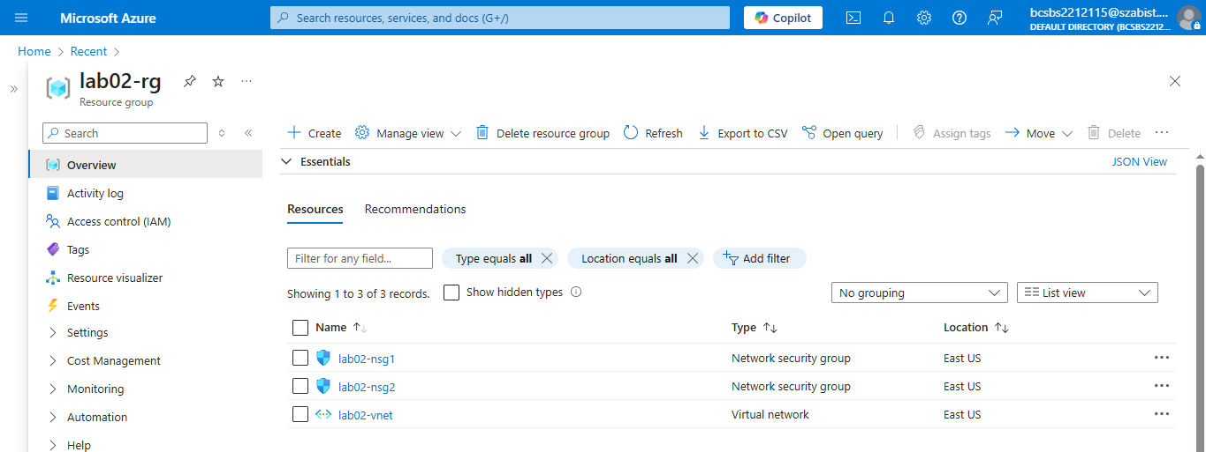

Destroy All Resources and Verify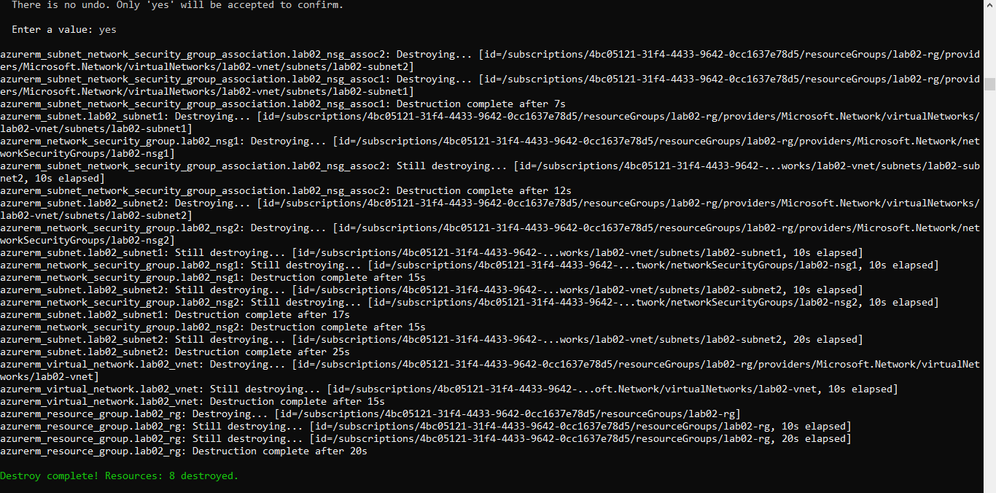

Verify deletion:

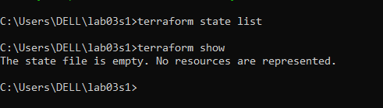

Section 2

Update vars03s2.tf File

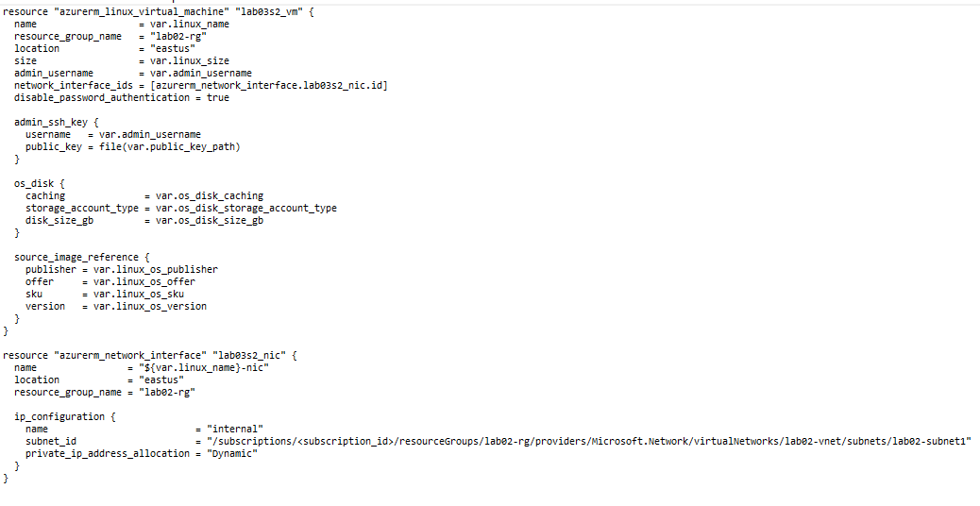

Update lab03s2.tf File

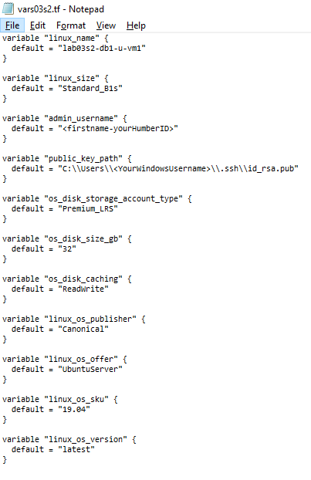

Initialize Terraform

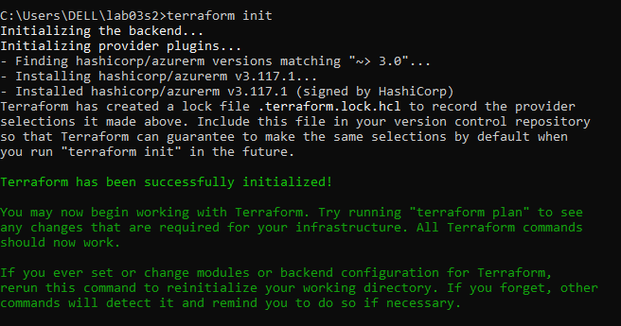

Validate Configuration

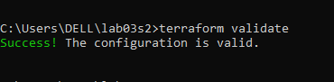

Run Simulation

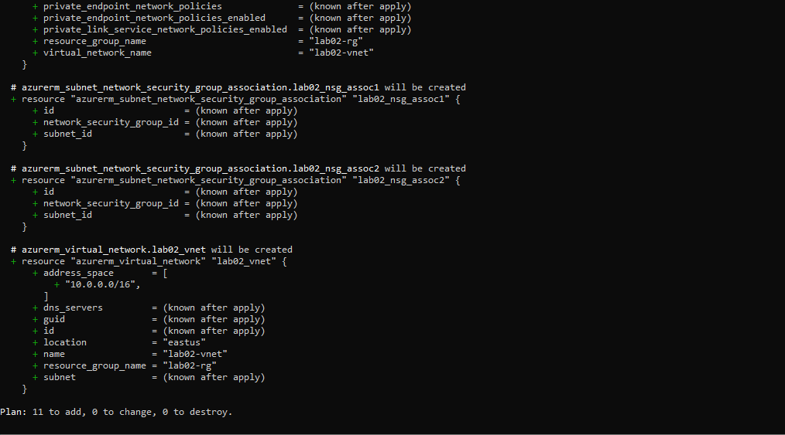

Section 3

Update vars03s3.tf File

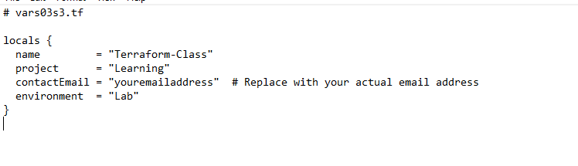

Update lab03s3.tf File

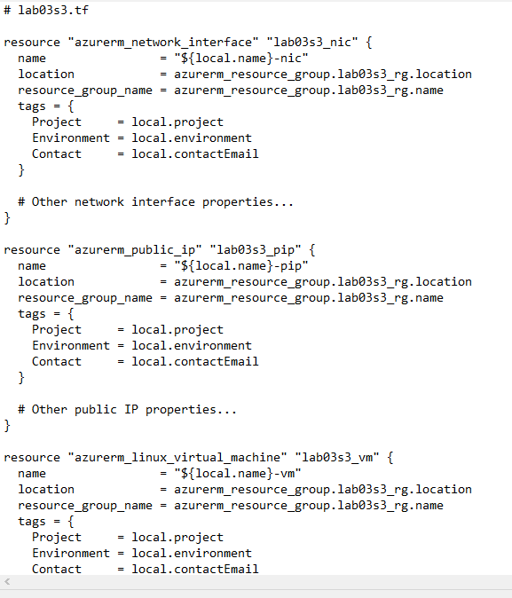

Initialize Terraform

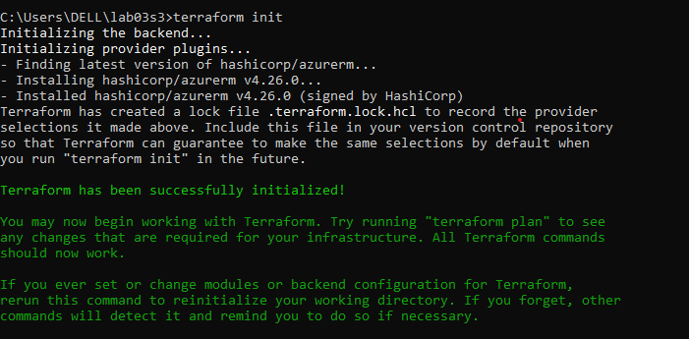

Validate Configuration

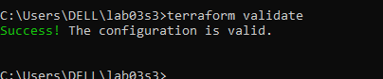

Run Simulation

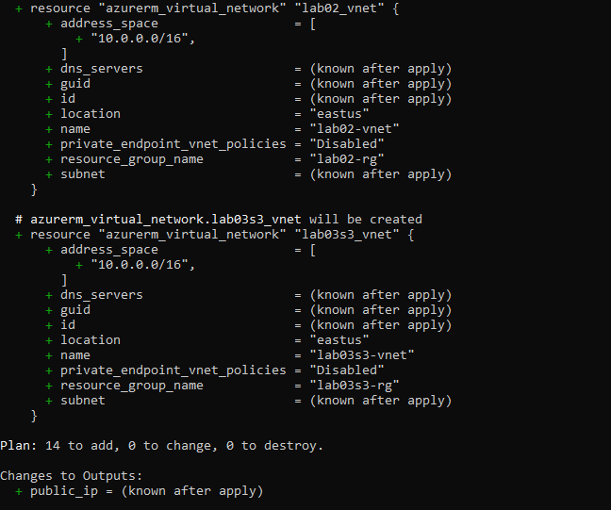

Deploy Infrastructure

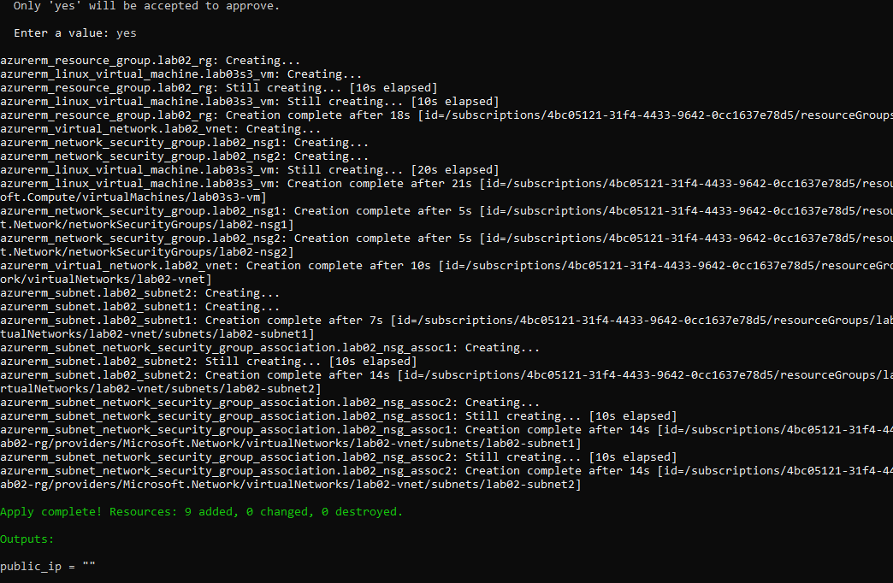

Get Information from Terraform State

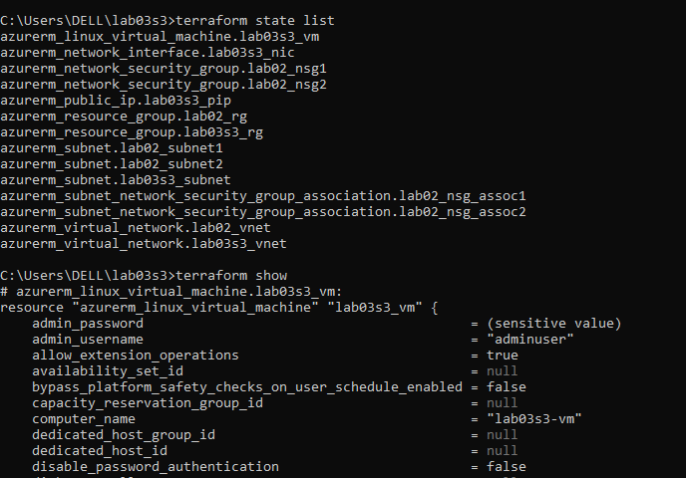

Destroy All Resources and Verify

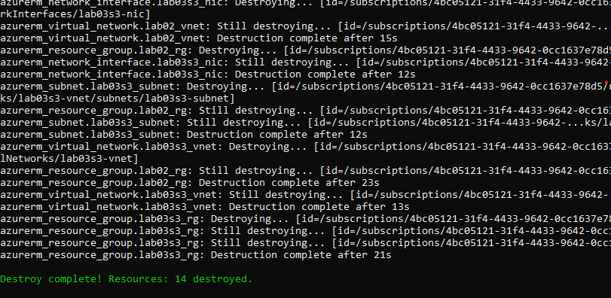

Verify deletion: 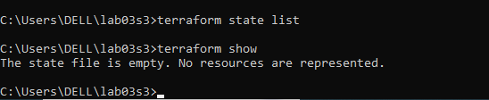

Section 4

Update outputs03s4.tf File

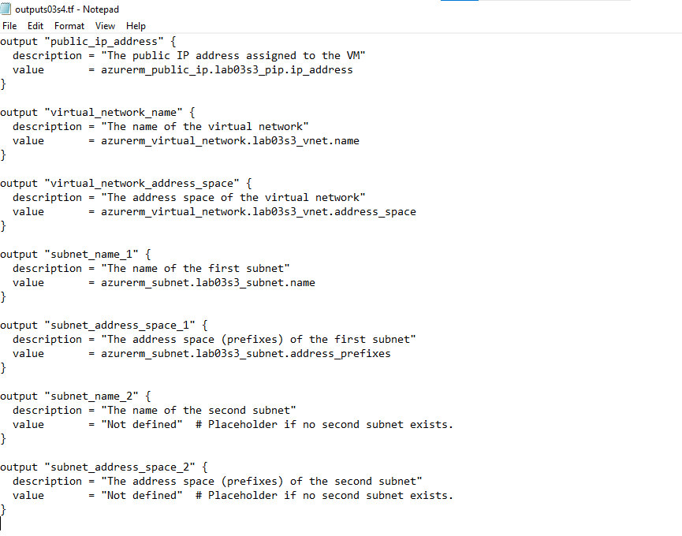

Validate Configuration

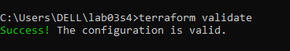

Run Simulation

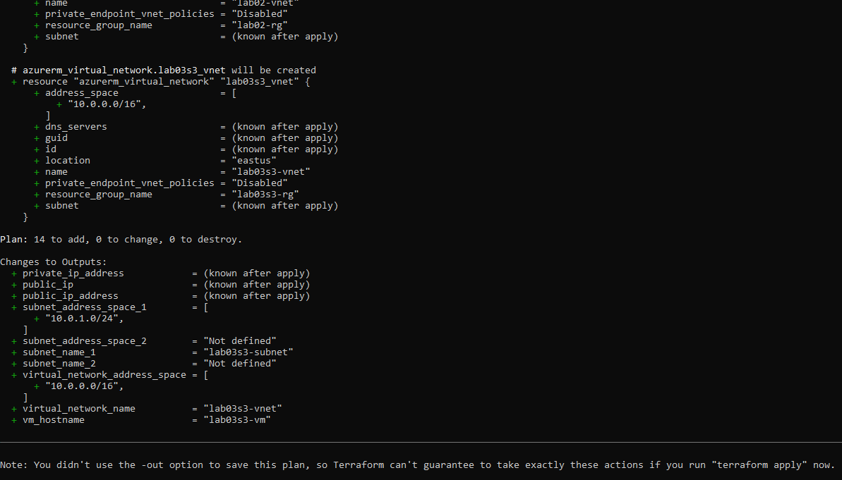

Deploy Infrastructure

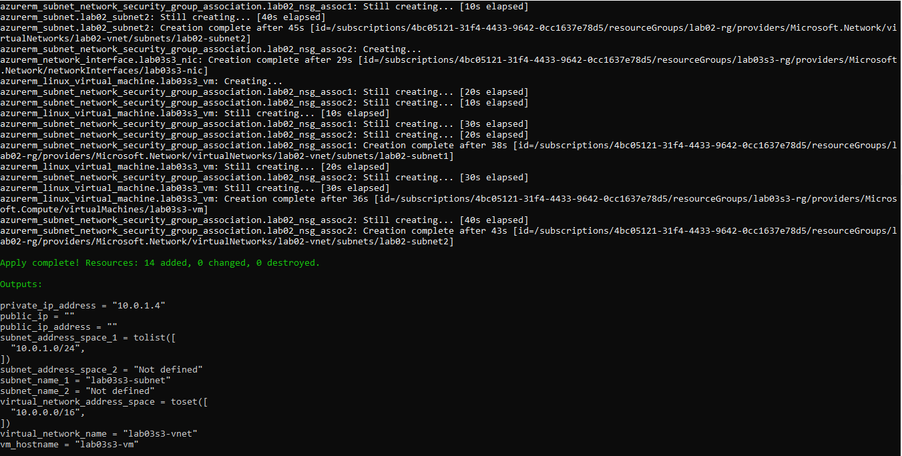

Get Information from Terraform State

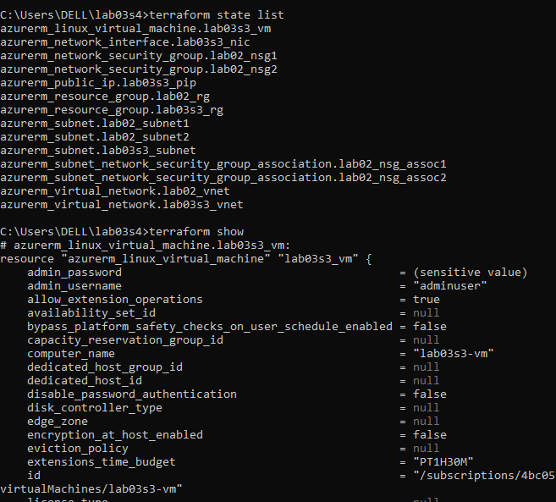

Display Output Information

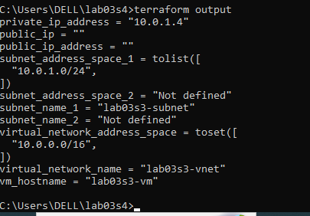

Destroy All Resources and Verify

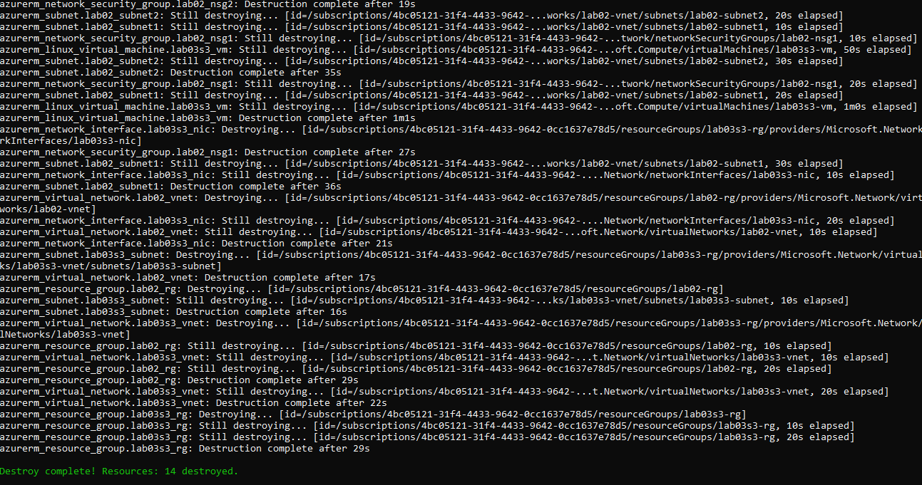

Verify deletion:

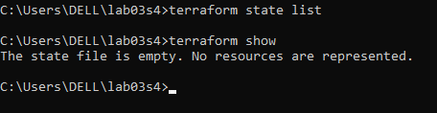

Section 5

Update lab03s5.tf File

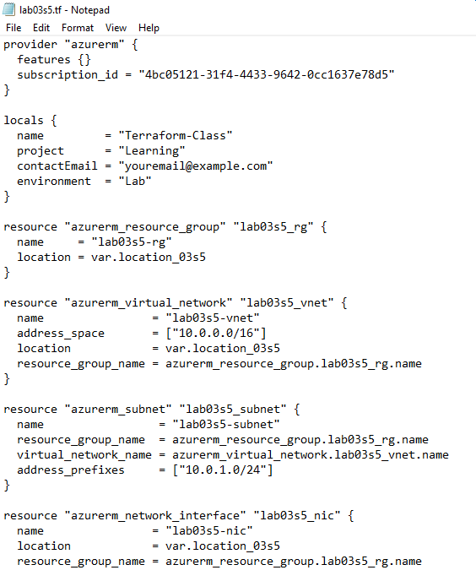

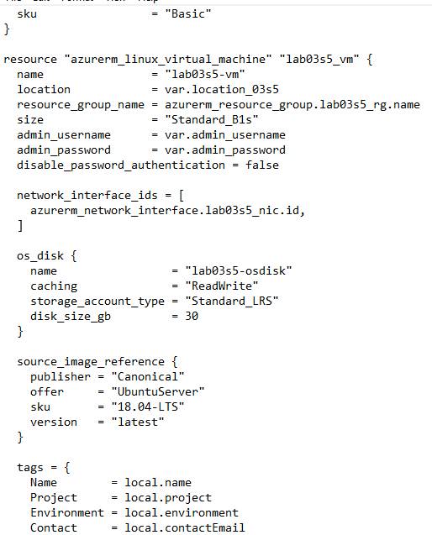

Validate Configuration

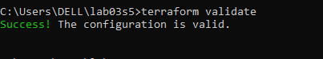

Run Simulation

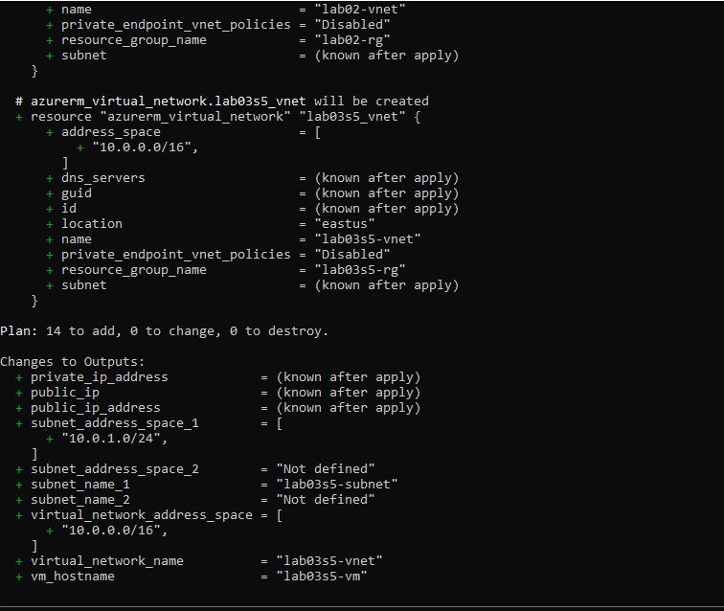

Deploy Infrastructure

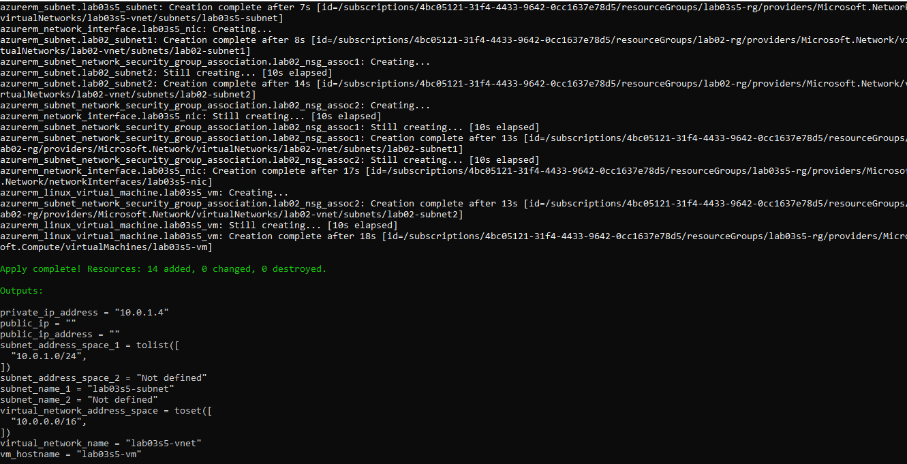

Add and Test a Lifecycle Deletion Rule

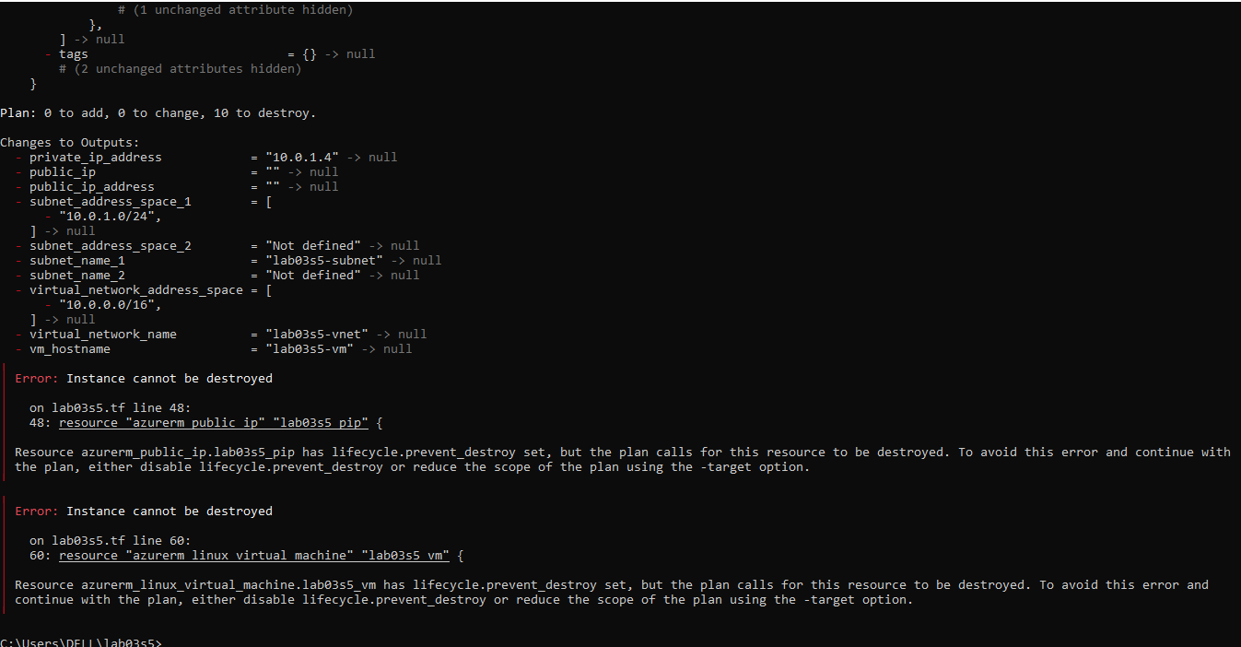

Add and Test a Lifecycle Update Rule

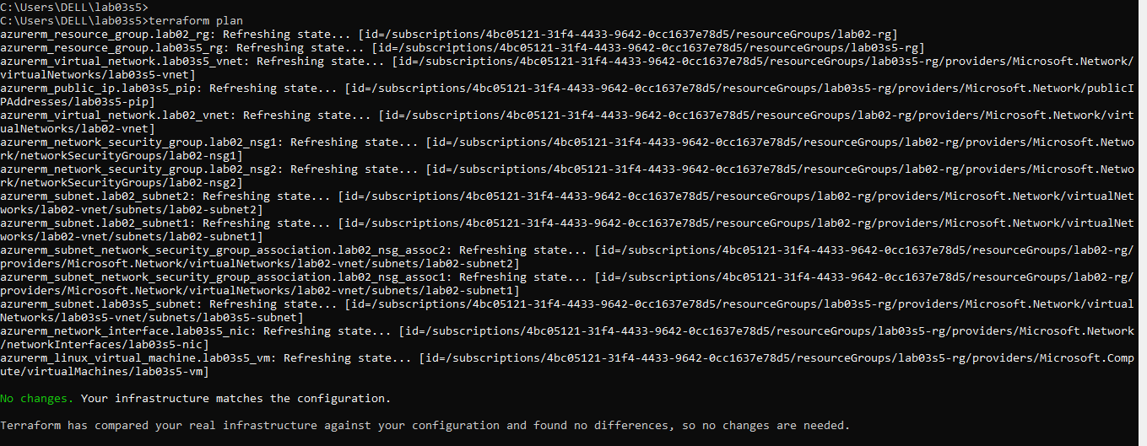

Display Dependency Graph

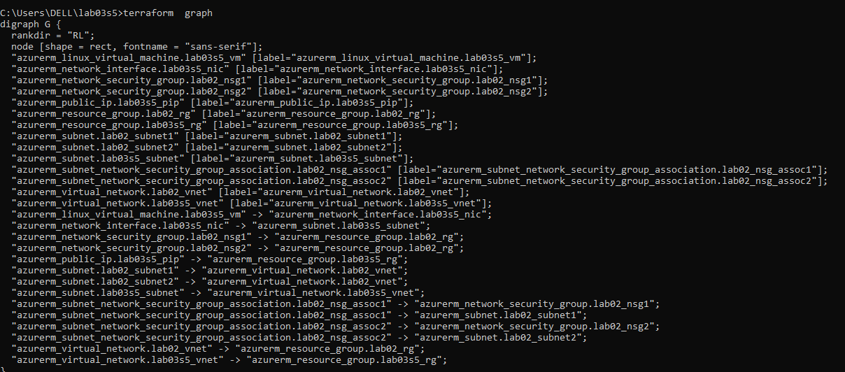

Destroy All Resources and Verify

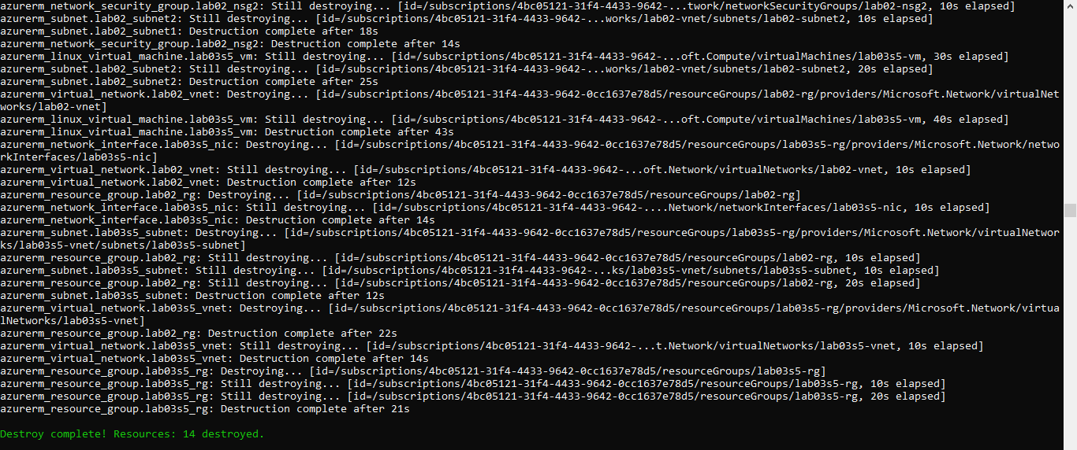

Verify deletion:

