PEARLS AQI PREDICTOR
A Serverless, End-to-End Machine Learning System for
3-Day Air Quality Index Forecasting in Karachi, Pakistan
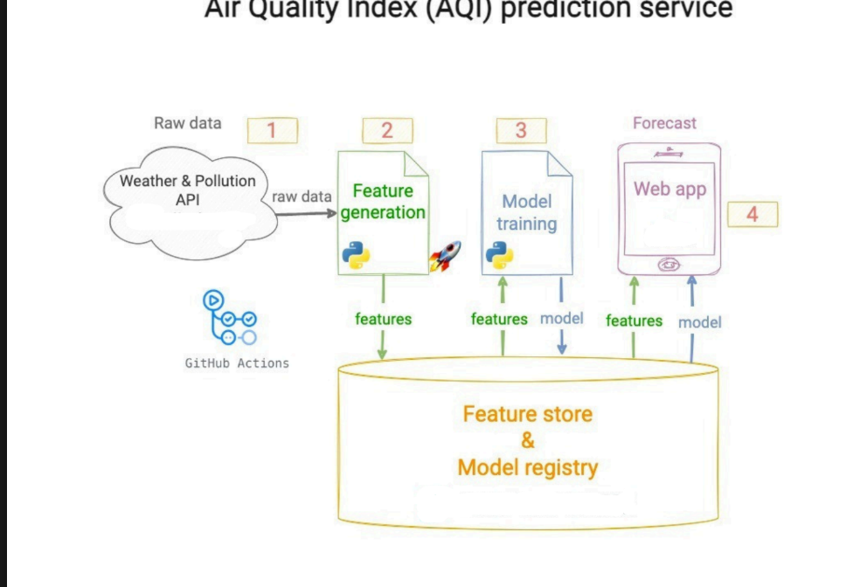

Project Report
Prepared by: Syed Shayan Ali
Program: 10Pearls Shine — Data Science Track
Hopsworks project: aqi_predictor_ksa | Repository: aqi-predictor
Table of Contents
Executive Summary 3
1 System Architecture 4
1.1 How each stage was implemented 4
1.2 Repository structure 4
2 Data Pipeline 6
2.1 Data source 6
2.2 Historical backfill 6
2.3 Live hourly ingestion 6
2.4 Feature Store and Feature View 6
3 The Hopsworks Platform 7
3.1 Feature Store 7
3.2 Model Registry 7
3.3 Model Deployments (live serving) 8
4 Exploratory Data Analysis 10
4.1 – 4.6 Distribution, trend, seasonality, correlation, gaps, source-skew 10
5 Feature Engineering 14
6 Model Training & Evaluation 15
6.1 – 6.3 Day 1 / Day 2 / Day 3 results 15
7 Model Registry, Versioning & Deployment 17
8 Explainability (SHAP) 19
9 Real-World Accuracy Validation 20
10 Automation & CI/CD 21
11 Engineering Challenges Encountered & Resolved 23
11.11 – 11.14 API latency, Render deployment, Hopsworks materialization incident & resilience fix 23
12 Interactive Dashboard 28
12.3 Live deployment 28
13 How to Run This Project 30
14 Limitations & Future Work 32
15 Conclusion 33

Executive Summary
This project delivers a complete, automated, serverless machine learning system that forecasts Karachi's Air Quality Index (AQI) 24, 48, and 72 hours into the future. It was built end-to-end: from raw API ingestion, through feature engineering and a managed feature store, to model training, versioning, live deployment, and a real-time interactive dashboard.
The system runs unattended. A GitHub Actions workflow pulls fresh weather and pollution data every hour and writes it straight into a Hopsworks Feature Store; a second workflow retrains three regression models every day, evaluates them, and registers the best-performing model per forecast horizon into the Hopsworks Model Registry. A Next.js dashboard reads live predictions, historical trends, SHAP explainability, and model performance directly from a FastAPI backend, which in turn reads only from Hopsworks — no CSV files are used anywhere in the live serving path.

Key results
- 73% of backtested 3-day forecasts landed within 10 AQI points of the value that was actually recorded, and 93% landed within 20 points, across 45 real historical comparisons.
- Best models: XGBoost for the 24h and 48h horizons; Ridge Regression for the 72h horizon, evaluated against Random Forest and a Keras neural network.
- 6+ model versions registered and tracked in the Hopsworks Model Registry across three forecast horizons, with full version history surfaced in the dashboard.
- 3 live model deployments hosted on Hopsworks Model Serving, tested with real inference requests.
- Two automated pipelines (hourly feature ingestion, daily retraining) running unattended in CI/CD, verified green in production.
- Fully deployed publicly: FastAPI backend on Render, Next.js dashboard on Vercel, connected end-to-end with production CORS configuration.
The sections that follow document the architecture, the data and modeling decisions, the real engineering problems encountered and solved along the way — including a significant, cohort-wide Hopsworks platform reliability issue disclosed in full in Section 11.13 — and an honest assessment of the system's accuracy and limitations.

1. System Architecture
The project follows a four-stage serverless pipeline, matching the reference architecture provided for the assignment. Each stage is a standalone Python script; nothing runs on a server the team manages — compute is provided by GitHub Actions runners and the Hopsworks platform.

Figure 1.1 — Reference architecture: raw data → feature generation → model training → web app, backed by a shared Feature Store & Model Registry.

1.1 How each stage was implemented
Stage | Script(s) | What it does
1. Raw data | Open-Meteo APIs | Weather + air-quality readings for Karachi (24.8607°N, 67.0011°E)
2. Feature generation | feature_pipeline.py | Fetches current readings hourly, inserts directly into the Hopsworks Feature Group
3. Model training | train_model.py | Reads the Feature View, trains 3 algorithms per horizon, registers the best model
4. Web app | api.py + Next.js dashboard | Loads the latest registered model + recent features, serves a live forecast
Automation is handled by two GitHub Actions workflows: one runs the feature pipeline every hour, the other runs the training pipeline once daily. Both were verified running successfully in production (see Section 10).

1.2 Repository structure
The system is split across two separate, independently deployable repositories — a deliberate separation between the ML/backend system and the presentation layer, rather than a single monolithic codebase:
- aqi-predictor — the backend: all data pipelines, feature engineering, model training, the Model Registry integration, deployment scripts, and the FastAPI service.
- aqi-dashboard — the frontend: the Next.js/TypeScript dashboard, which talks to the backend exclusively over HTTP and holds no data-access or ML logic of its own.
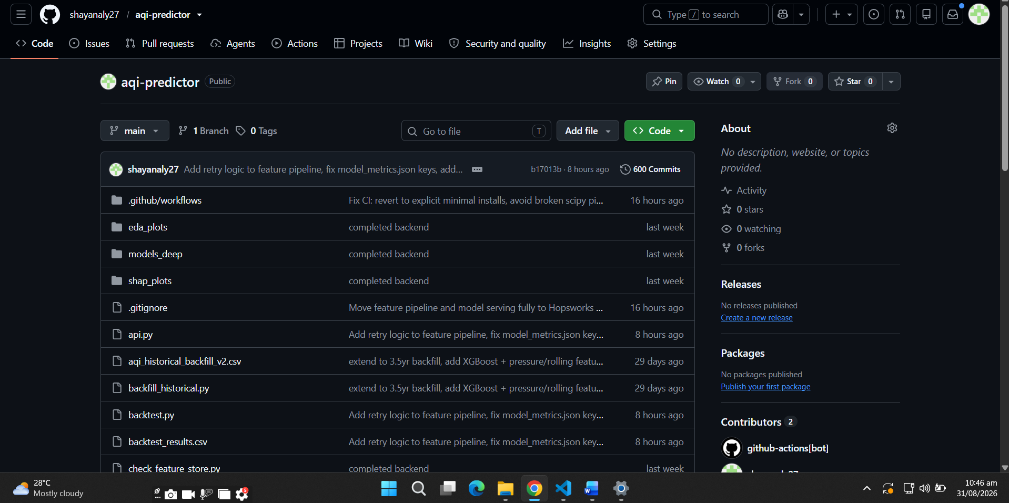
Figure 1.2 — aqi-predictor (backend) repository on GitHub, showing the feature and training pipeline scripts, GitHub Actions workflows, and 600 commits of active development history.
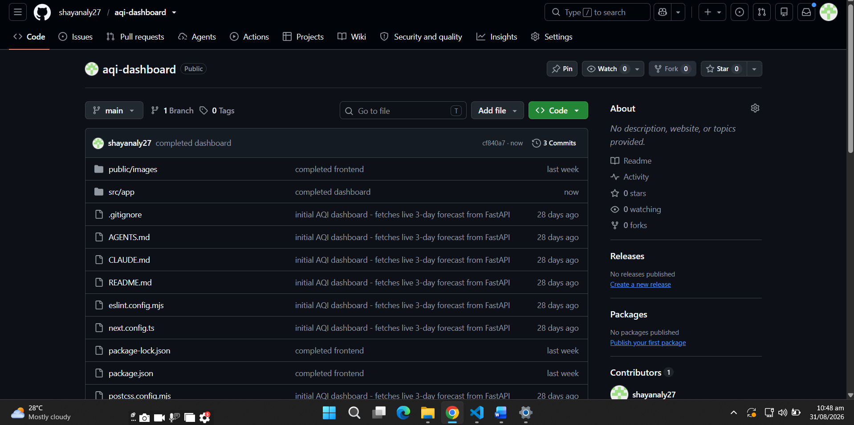
Figure 1.3 — aqi-dashboard (frontend) repository on GitHub, the separate Next.js application that renders the live dashboard.

2. Data Pipeline

2.1 Data source
Raw weather and air-quality data is sourced from the Open-Meteo Weather API and Open-Meteo Air Quality API. Both are free, require no API key, and provide the fields needed: temperature, humidity, surface pressure, wind speed, US AQI, PM2.5, PM10, ozone, NO₂, SO₂, and CO.
The project initially used the WAQI (World Air Quality Index) API for pollution data, but its Karachi station was found to return frozen/stale readings during development. The pipeline was switched entirely to Open-Meteo, which updates reliably.

2.2 Historical backfill
Before any model could be trained, the Feature Store needed history. backfill_historical.py pulled approximately 3.5 years (1,280 days) of hourly weather and air-quality data from Open-Meteo's archive endpoint, in monthly chunks (the API limits how much data can be requested per call), and combined it into the seed dataset used to bootstrap the Hopsworks Feature Group.

2.3 Live hourly ingestion
feature_pipeline.py runs every hour via GitHub Actions. It fetches the current weather and air-quality reading, engineers the same time-based features used everywhere else in the system (hour, day, month, day-of-week), and inserts the row directly into the Hopsworks aqi_features Feature Group.
Earlier in development, this script wrote to a local CSV file and committed that file back to the git repository every hour — effectively using git as a database. This was identified as an anti-pattern (per project requirements, no CSV should be used as the system's persistence layer) and was replaced with a direct Hopsworks insert. This change, and the debugging it required, is documented in Section 11.

2.4 Feature Store and Feature View
The Hopsworks Feature Group (aqi_features, version 1) stores 16 raw and time-based features with timestamp as the primary key and event-time column, using the HUDI time-travel format. A Feature View (aqi_feature_view, version 1) sits on top of it — this is the object that training and prediction code actually query; a Feature Group alone is inert storage.
As of the final training run, the Feature Store held approximately 31,810 rows spanning the full backfilled history plus continuous hourly live inserts.

3. The Hopsworks Platform
Hopsworks is a managed MLOps platform that provides three capabilities this project depends on directly: a Feature Store, a Model Registry, and a Model Serving layer for live deployments. It was chosen over alternatives (such as Vertex AI) specifically because it offers a generous free tier and covers all three needs from a single connected platform, which fit the project's '100% serverless stack' requirement without needing to stitch together separate services for storage, versioning, and serving.
The project uses one Hopsworks project, aqi_predictor_ksa, hosted on eu-west.cloud.hopsworks.ai. Every piece of the system below — feature storage, model versioning, and live inference — runs inside this single project.

3.1 Feature Store
The Feature Store holds 1 Feature Group (aqi_features) with 16 raw and time-based features, and 1 Feature View (aqi_feature_view) built on top of it. The Feature Group is the underlying storage; the Feature View is the object every training and prediction script actually queries against — this distinction matters because a Feature Group with no Feature View on top of it is inert, unreachable storage.
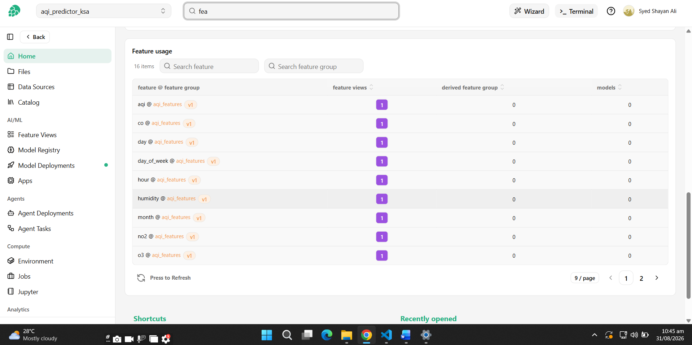
Figure 3.1 — Hopsworks Feature Usage page: all 16 features, each correctly linked to 1 feature view.

3.2 Model Registry
Every training run registers its best-performing model per forecast horizon to the Model Registry via mr.python.create_model(), attaching RMSE/MAE/R² as registry metrics. By the most recent training run, the registry held 6 distinct model entries — 3 classical models (Ridge/Random Forest/XGBoost, the best of which is kept per horizon) and 3 neural network models, one per horizon — with up to 11 versions accumulated per model name from repeated retraining during development and daily automated runs.
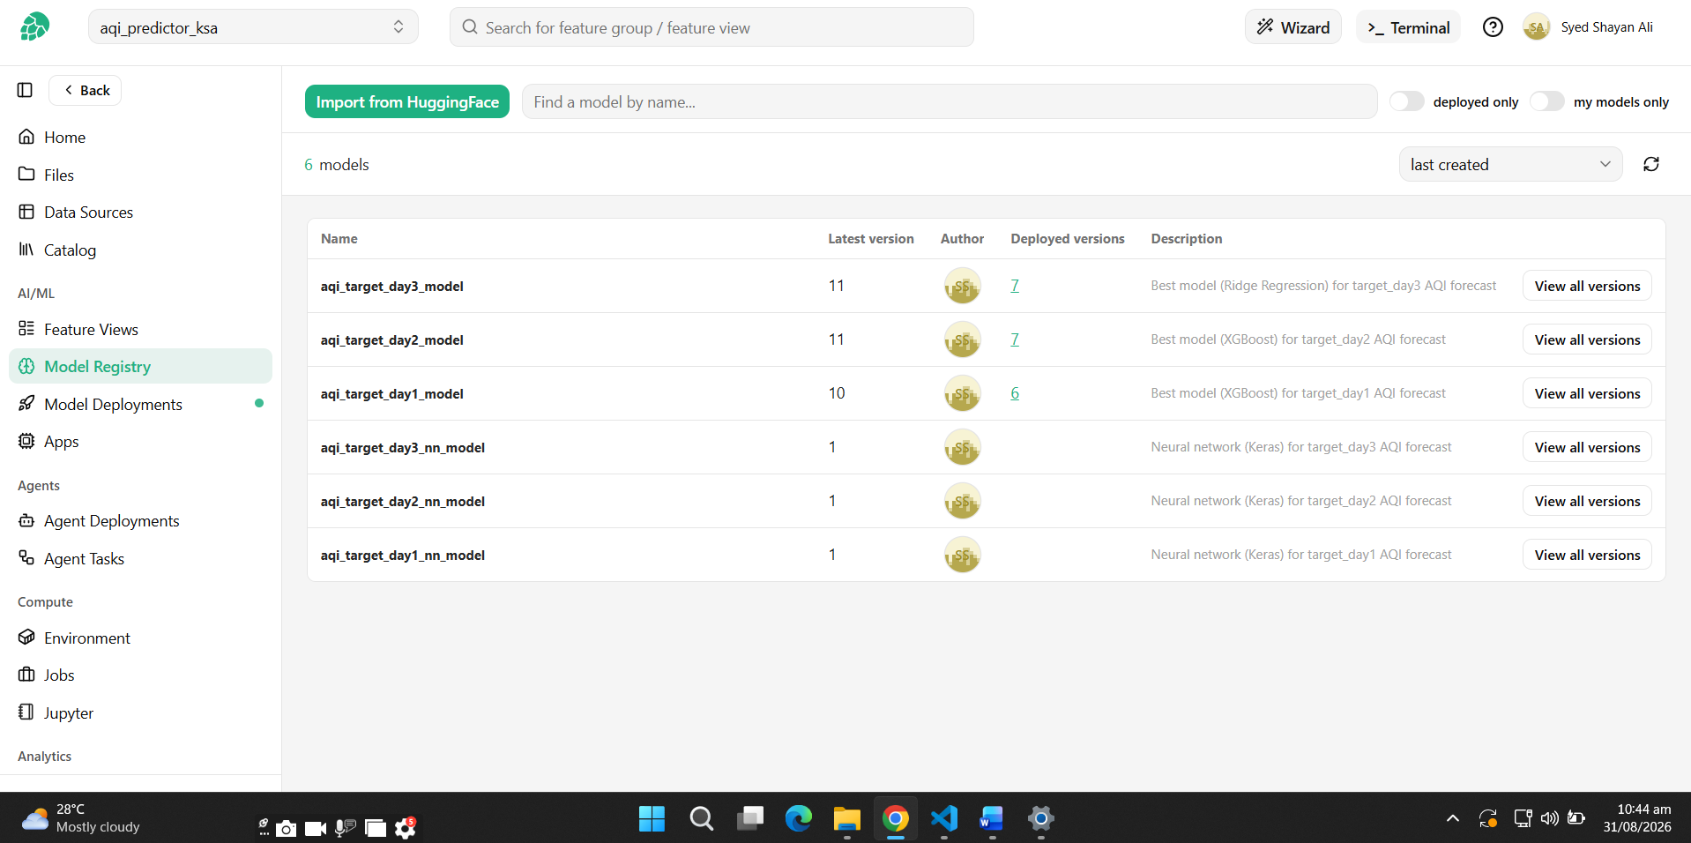
Figure 3.2 — Hopsworks Model Registry: 6 registered models, with version counts (10–11) and deployed-version links visible per model.
Note: the Hopsworks project home page displays a summary tile labeled “Models: 0” (visible in some of the screenshots in this report). This is a known caching quirk of that particular dashboard widget — it does not live-query the registry on every page load. The Model Registry page itself (Figure 3.2 above), which does query the registry directly, is the authoritative source and confirms all 6 models and their full version history are genuinely present.

3.3 Model Deployments (live serving)
Beyond registration, the project deploys three models — one per forecast horizon — as live Hopsworks Model Serving endpoints, a step beyond the project's minimum requirement. Each deployment runs a predictor.py script (uploaded to the project's Hopsworks file system) that loads the registered model artifact and exposes a .predict() method callable over the network.
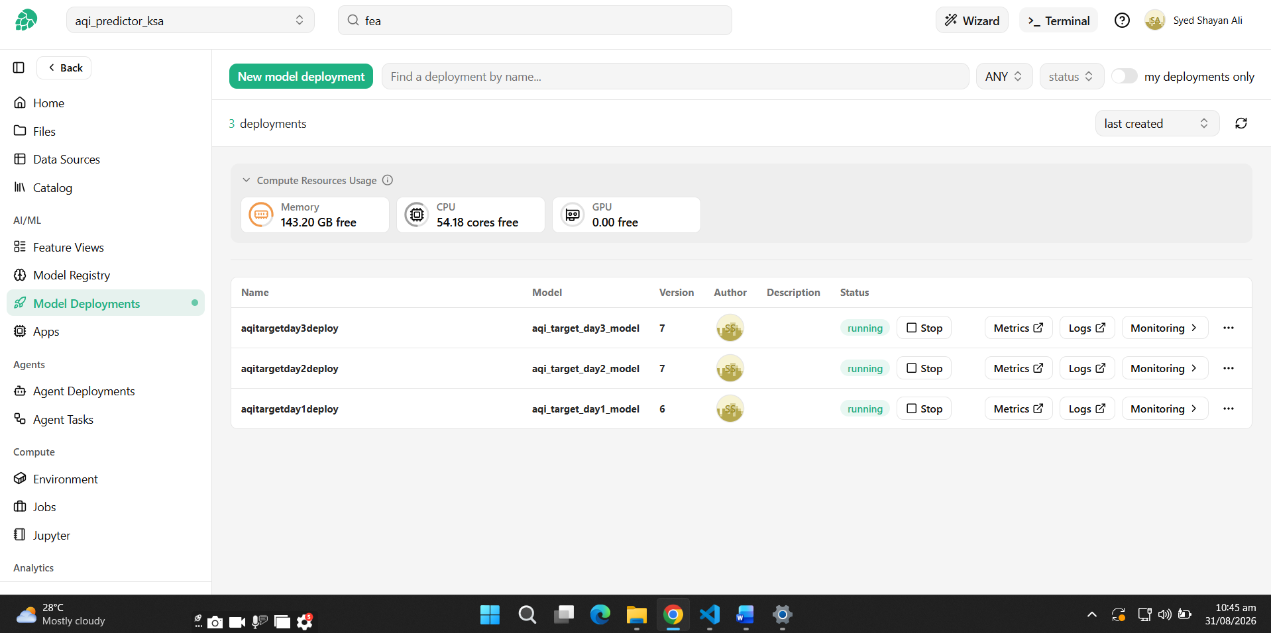
Figure 3.3 — Hopsworks Model Deployments: all 3 deployments (day 1/2/3) in a running state, with visible CPU/memory headroom on the free tier (54 cores, 143 GB free).
All three deployments were verified running and tested with a real inference request (see Section 7.3), which returned a valid AQI prediction — confirming the deployment genuinely executes the model rather than only reporting a healthy status.

4. Exploratory Data Analysis
Before modeling, the merged training dataset was analyzed for missing data, distribution shape, seasonality, feature correlation, and data-quality issues that could silently corrupt lag/rolling features. All findings below come from eda.py.

4.1 AQI distribution
AQI values are right-skewed, concentrated between roughly 60 and 110, with a long tail of higher-pollution days extending past 200. No values fell outside the valid 0–500 range.
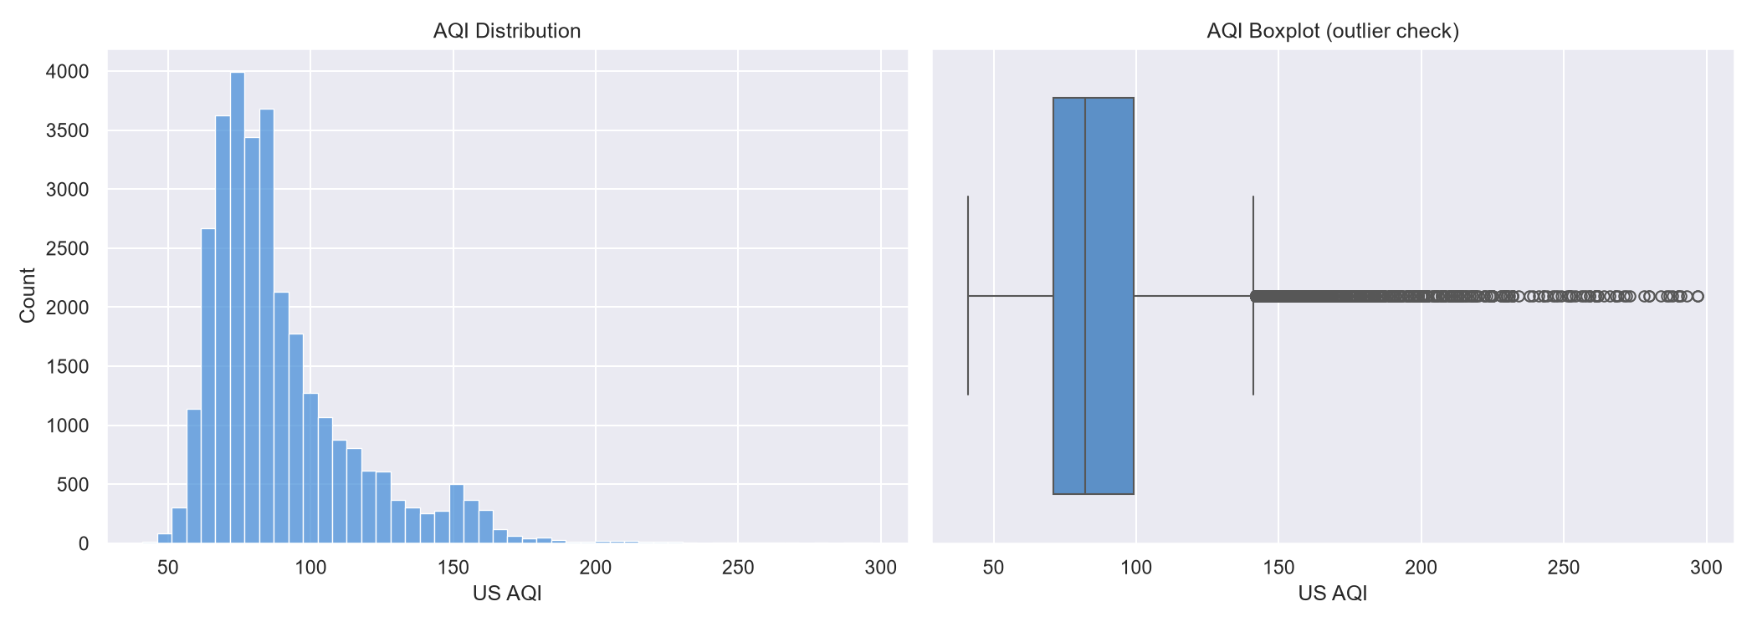
Figure 4.1 — AQI distribution (left) and boxplot outlier check (right).

4.2 Long-term and recent trend
The full 3.5-year history shows AQI oscillating mostly between 50 and 150, with recurring spikes above 175–220, most pronounced in early 2023. The most recent 90 days show a more moderate range (roughly 55–120) with two clear pollution spikes in mid-June and early July 2026.
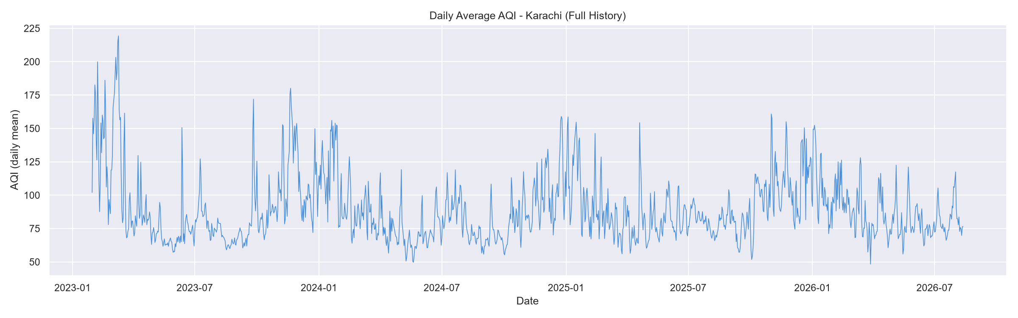
Figure 4.2 — Daily average AQI, full history (2023–2026).
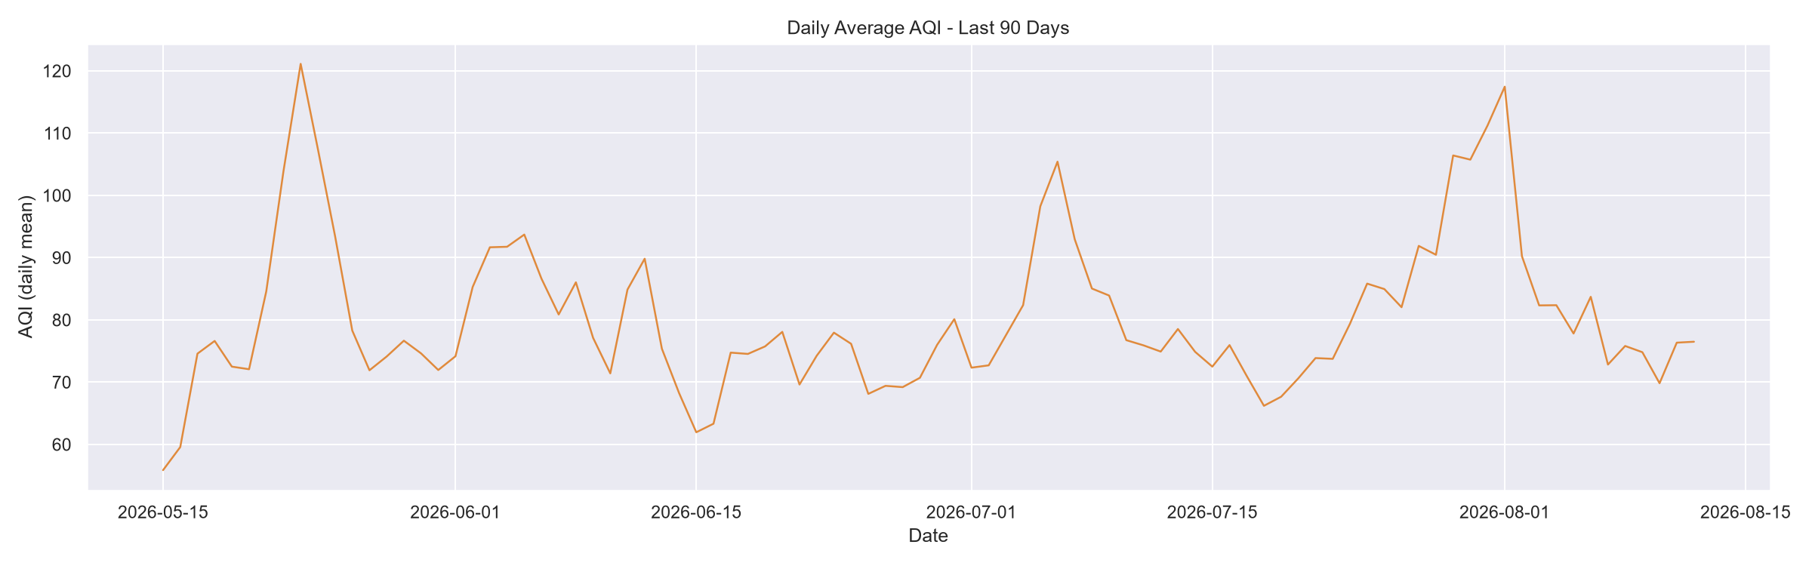
Figure 4.3 — Daily average AQI, last 90 days.

4.3 Seasonality
AQI shows a mild diurnal pattern, rising through the afternoon and peaking around 17:00–20:00 before declining overnight — consistent with daytime traffic and industrial activity. The monthly pattern is more pronounced: AQI peaks in winter months (November–February, averaging over 100) and is lowest in May–September (averaging 70–80), a pattern the model can learn directly from the month feature.
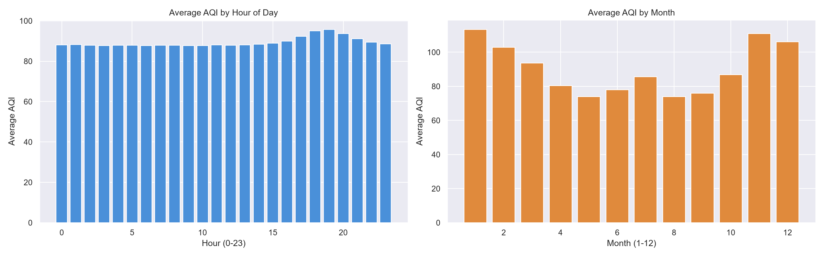
Figure 4.4 — Average AQI by hour of day (left) and by month (right).

4.4 Feature correlation
PM2.5 is by far the strongest correlate of AQI (r = 0.73), consistent with US AQI being calculated primarily from PM2.5 concentration. SO₂ and CO also correlate positively with AQI, while temperature, humidity, and wind speed correlate negatively — higher wind speed and humidity are associated with better air quality, likely due to pollutant dispersion and washout effects.
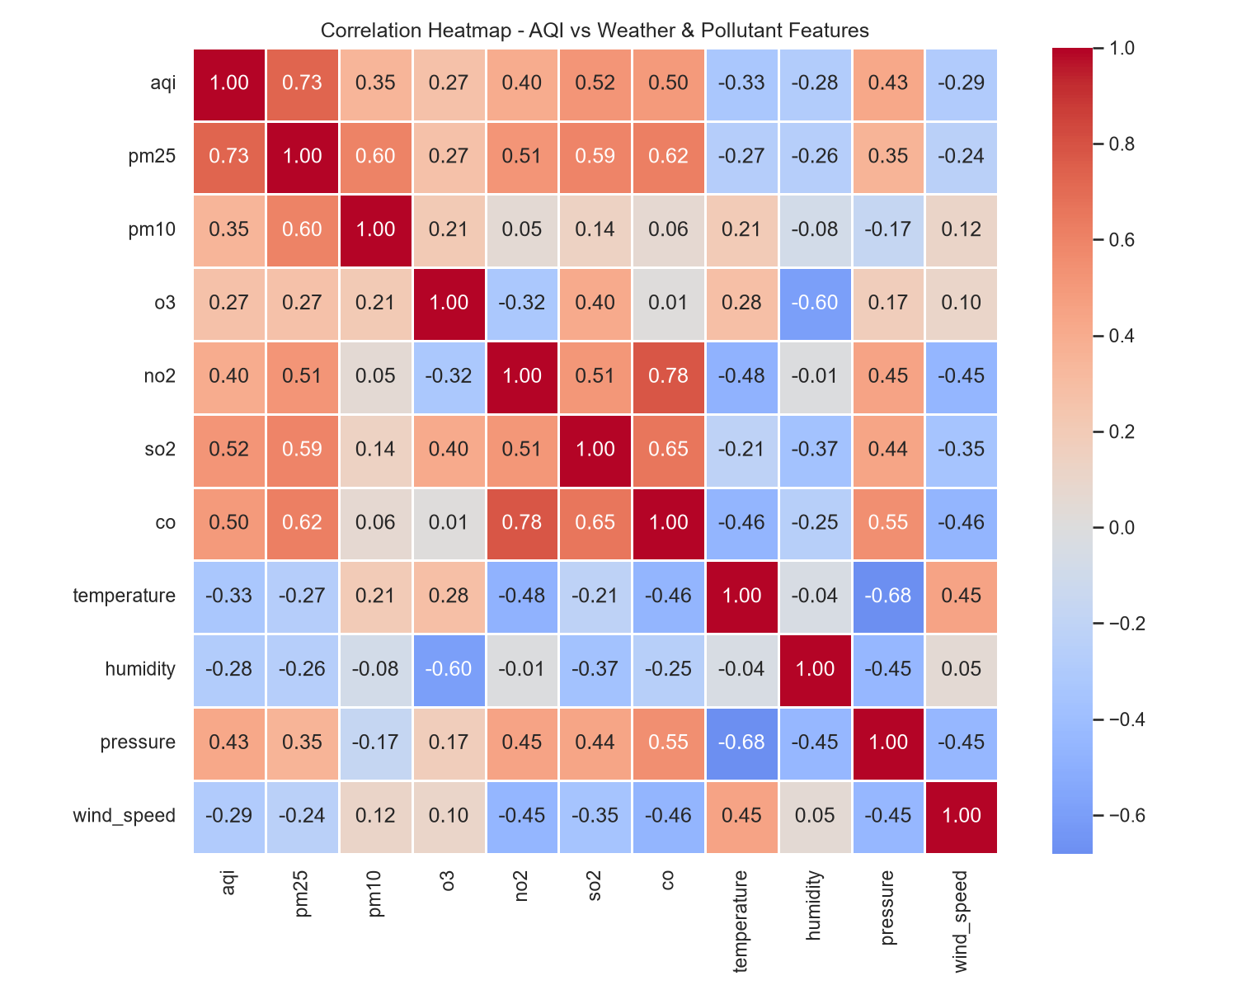
Figure 4.5 — Correlation heatmap across AQI, pollutants, and weather features.

4.5 Timestamp gap check
Because lag and rolling-window features (e.g. aqi_lag_24h, aqi_roll_mean_72h) assume strictly hourly spacing, irregular gaps between readings would silently distort them — a 24-hour lag feature computed from data that actually has a 30-hour gap is measuring the wrong thing. The check found 238 irregular gaps (0.77% of rows), concentrated in the live-pipeline period, with the largest gap reaching 8.7 hours (a missed hourly run).
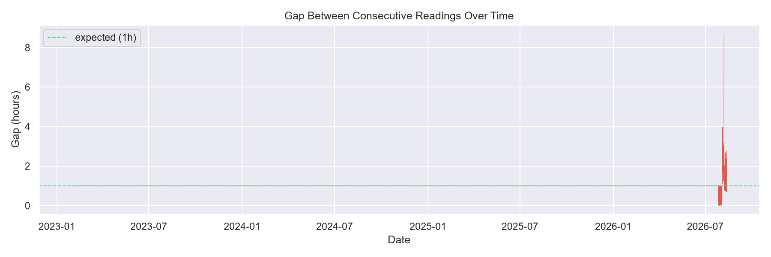
Figure 4.6 — Gap between consecutive readings over time; all history before mid-2026 is from the backfill (uniformly hourly), with occasional live-pipeline gaps visible on the right.
This finding directly motivated merge_data.py, described in Section 5.

4.6 Archive vs. live-source distribution check
Since backfilled data came from Open-Meteo's archive endpoint and live data comes from its forecast/current endpoint, a rough train-serving skew check compared the distributions of the two sources. AQI and PM2.5 distributions were closely aligned. Pressure and humidity showed a visible shift between the two sources — this is disclosed here as an honest limitation of the data pipeline rather than something the model was made aware of.
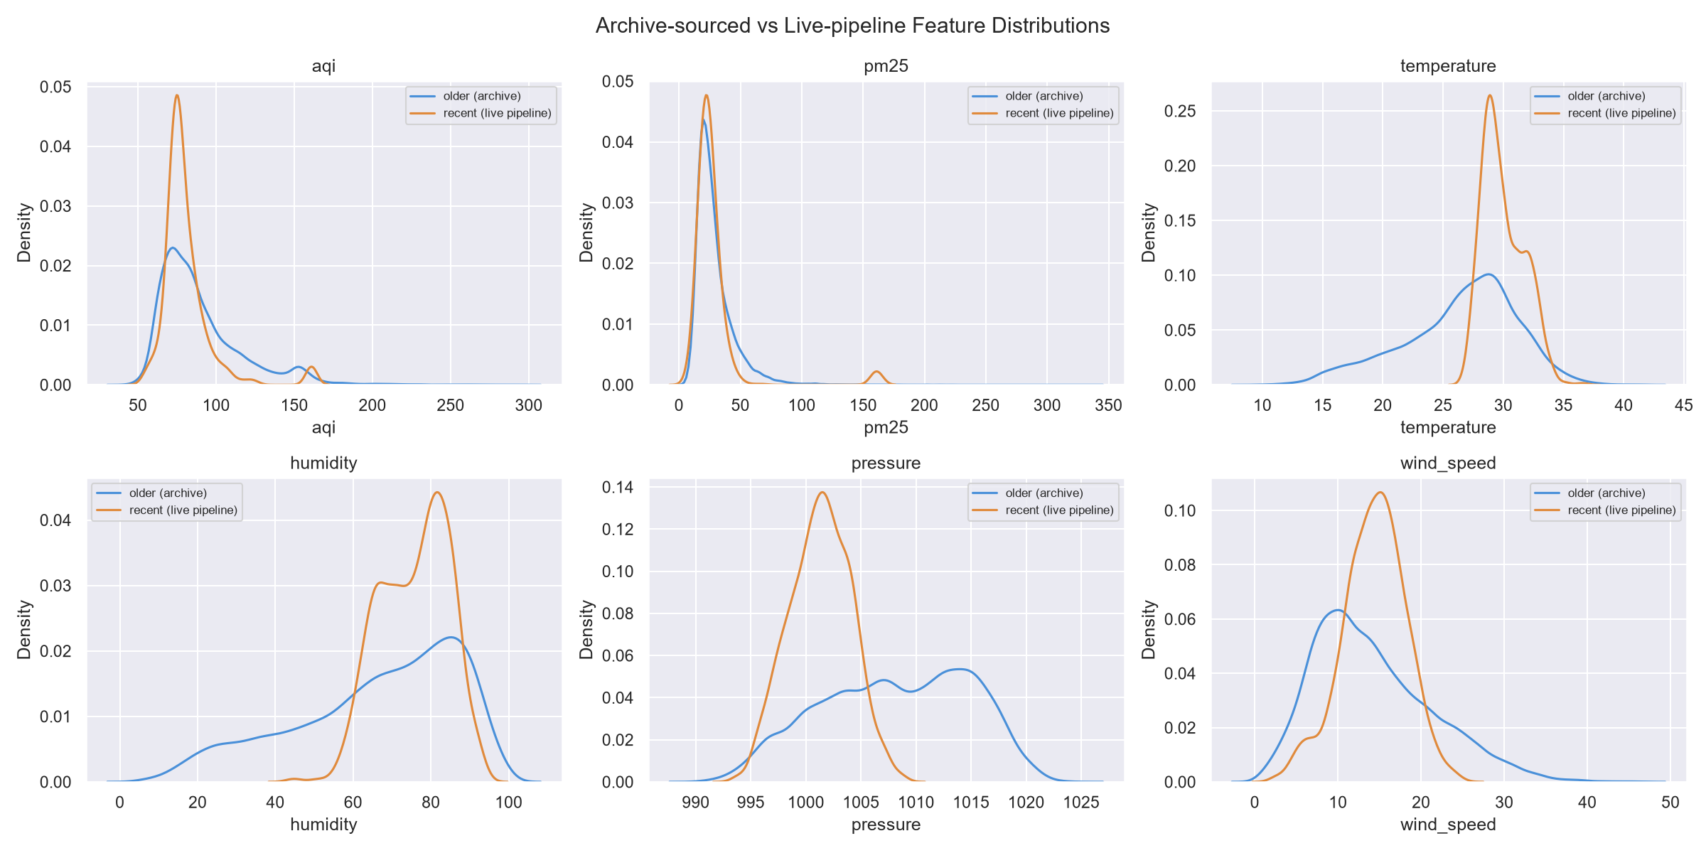
Figure 4.7 — Distribution comparison between archive-sourced and live-pipeline features.

5. Feature Engineering
Beyond the raw weather and pollutant readings, the following engineered features were added to give the models temporal context that a single snapshot in time cannot provide:
- Time-based features: hour, day, month, day_of_week — captures the diurnal and seasonal patterns found in Section 4.3.
- Lag features: aqi_lag_1h, aqi_lag_3h, aqi_lag_24h — the AQI value 1, 3, and 24 hours before the current reading.
- Rolling averages: aqi_roll_mean_6h, _24h, _48h, _72h — smoothed recent trend, less sensitive to single-reading noise.
- AQI change rate: aqi_change_rate_1h — the first derivative of AQI, capturing whether air quality is currently improving or worsening.
- Pressure trend: pressure_lag_24h and pressure_change_24h — atmospheric pressure changes are a known precursor to pollution dispersion or trapping.
In total, 25 features feed each model. Three separate targets were created by shifting the aqi column forward: target_day1 (+24h), target_day2 (+48h), and target_day3 (+72h) — framing this as three independent supervised regression problems rather than one sequence-to-sequence forecast, which kept the modeling approach simple and made each horizon separately evaluable.

5.1 Data cleaning and gap handling
merge_data.py was written specifically to address the timestamp-gap finding from the EDA. It: (1) rounds every timestamp to the nearest hour to collapse near-duplicate live-pipeline rows, (2) reindexes the dataset onto a strict hourly grid across the full date range, and (3) interpolates only short gaps (≤3 hours) — longer gaps are deliberately left as missing values and dropped downstream, so the model is never trained on fabricated data across a gap it has no real information for.

6. Model Training & Evaluation
Four algorithms were trained and compared for each of the three forecast horizons: Ridge Regression and Random Forest (via scikit-learn), XGBoost, and a fully-connected neural network (TensorFlow/Keras, run in a separate virtual environment due to a protobuf version conflict with the hopsworks package). Each model was evaluated on a held-out 20% chronological test split using RMSE, MAE, and R².

6.1 Day 1 — 24 hours ahead
Model | RMSE | MAE | R²
Ridge Regression | 15.10 | 9.47 | 0.448
Random Forest | 14.11 | 9.18 | 0.518
★ XGBoost | 13.36 | 8.81 | 0.568
Neural Network (Keras) | 16.81 | 10.31 | 0.398
XGBoost was the best-performing model for the nearest-term forecast, explaining 56.8% of the variance in next-day AQI.

6.2 Day 2 — 48 hours ahead
Model | RMSE | MAE | R²
Ridge Regression | 16.74 | 11.88 | 0.316
Random Forest | 16.61 | 11.49 | 0.327
★ XGBoost | 16.23 | 11.19 | 0.356
Neural Network (Keras) | 18.92 | 13.04 | 0.238

6.3 Day 3 — 72 hours ahead
Model | RMSE | MAE | R²
★ Ridge Regression | 17.15 | 12.48 | 0.264
Random Forest | 17.48 | 12.38 | 0.236
XGBoost | 17.49 | 12.33 | 0.235
Neural Network (Keras) | 19.76 | 14.06 | 0.170
At 72 hours, Ridge Regression narrowly outperformed the tree-based models. Predictive power degrades meaningfully with horizon length — R² drops from 0.568 (24h) to 0.356 (48h) to 0.264 (72h) for the strongest models at each horizon. This is expected: AQI three days out depends on weather system changes that are only weakly captured by the current feature set, and this finding is independently confirmed by the real-world backtest in Section 9.
The neural network underperformed all three classical models at every horizon. This is a reasonable outcome for a tabular, moderately-sized dataset (~25 features, ~30k rows) — gradient-boosted trees and regularized linear models are well suited to this kind of structured, feature-engineered data, and the additional capacity of a neural network did not translate into better generalization here. This result is reported honestly rather than omitted, since a negative result is still a real finding.
The best model per horizon (marked ★) is the one saved and pushed to the Hopsworks Model Registry.

7. Model Registry, Versioning & Deployment

7.1 Model Registry
Every training run registers its best model per horizon to the Hopsworks Model Registry using mr.python.create_model(), attaching RMSE/MAE/R² as registry metrics and a description of which algorithm won. This was a specific requirement flagged during project review: previously-trained models must be registered, not just saved as local .pkl files.
By the final training run, the registry held 6 distinct model names (3 horizons × 2 families — classical + neural network), with up to 9 versions accumulated per model name from repeated retraining during development and daily automated runs.
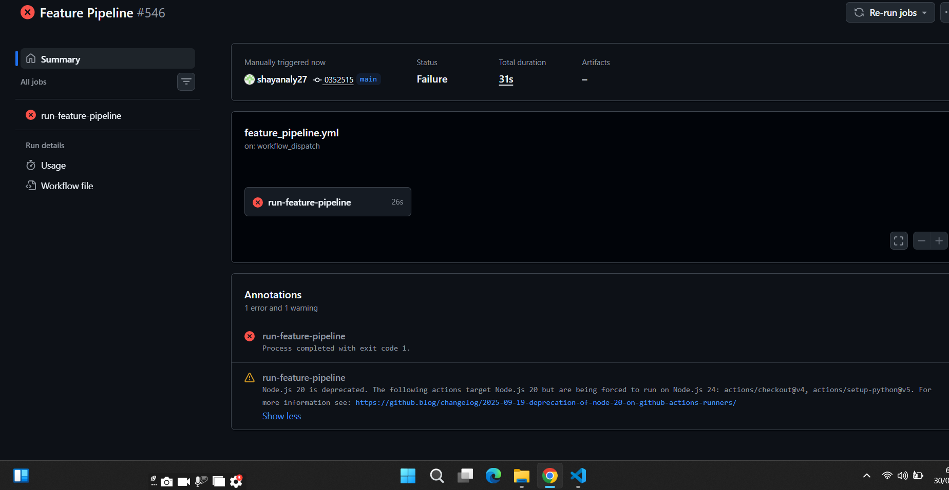
Figure 7.1 — Hopsworks Model Deployments detail view, confirming the day-1/2/3 deployments and their running status.

7.2 Version history
model_history.py queries the registry directly (not a manually-maintained file) and surfaces every version's metrics per horizon, flagging the most recently trained version as current. This is displayed on the live dashboard (Section 12) so version history is genuinely visible, not just present in the backend.
An honest note on 'best': because Hopsworks' free tier does not provide a staging/production promotion workflow, 'current best' in this system means the most recently trained version, not necessarily the version with the single lowest RMSE ever observed — retraining on newly arrived hourly data causes metrics to fluctuate slightly run to run, which is expected and healthy rather than a sign of model degradation.

7.3 Live model deployment
Beyond registration, three models (one per horizon) were deployed as live Hopsworks Model Serving endpoints — a step beyond the minimum project requirement. Each deployment required a predictor.py script uploaded to the project's Hopsworks file system (referenced by full absolute path, a non-obvious requirement discovered through debugging — see Section 11) that loads the model artifact and exposes a .predict() method.
All three deployments were verified running and were tested with a real inference call, which returned a valid AQI prediction (64.3) confirming the deployment genuinely loads and executes the model rather than only reporting a healthy status.

8. Explainability (SHAP)
SHAP (SHapley Additive exPlanations) was used to identify which features drive each forecast, satisfying the project's explainability requirement. shap_explain.py generates full summary and ranked-importance plots per horizon for the report; compute_feature_importance.py generates a lightweight top-8 JSON consumed directly by the dashboard's Primary Factors and SHAP panels, avoiding recomputing SHAP values on every API request.

8.1 Top drivers of the Day 1 forecast
Feature | Mean |SHAP value|
PM2.5 | 8.77
Current AQI level | 5.52
Seasonal trend (month) | 1.75
AQI 24h ago (lag) | 1.67
24h average AQI (rolling) | 1.46
Pressure | 1.21
72h average AQI (rolling) | 1.21
Hour of day | 1.11
PM2.5 and the current AQI reading dominate the model's decisions by a wide margin — consistent with the EDA correlation findings in Section 4.4 and with how the US AQI is actually calculated. Seasonal (month) and short-term momentum (lag/rolling features) features play a clear secondary role, giving the model temporal context beyond a single snapshot reading.

9. Real-World Accuracy Validation
Held-out test-set RMSE (Section 6) measures accuracy on historical data the model never trained on, but does not directly answer the more intuitive question: 'if we had made this prediction three days ago, how close would it have been to what actually happened?' To answer that directly, a backtest was built (backtest.py) that selects real historical points, generates a genuine forecast from each using the deployed models, and compares it against the AQI value that was actually recorded at the corresponding future timestamp.
A methodological detail worth documenting: an early version of this backtest matched 'N hours ahead' by counting table rows rather than elapsed real time. Because the live feature pipeline has occasional gaps (Section 4.5), this silently compared timestamps that were up to 118 hours apart while labeling them '72 hours ahead' — producing misleading results. The corrected version matches every comparison by nearest real timestamp and discards any pair whose true elapsed gap deviates from the target horizon by more than 6 hours, so every number below is a genuine, verified comparison.

9.1 Results — 15 backtested points per horizon (45 total)
Horizon | Mean abs. error | Median abs. error | Max abs. error
Day 1 (24h) | 7.2 | 6.4 | 30.9
Day 2 (48h) | 6.0 | 4.7 | 18.8
Day 3 (72h) | 12.5 | 8.1 | 60.2
- 73% of all 45 backtested predictions landed within 10 AQI points of the actual recorded value.
- 93% landed within 20 AQI points.

9.2 Interpreting the results honestly
The headline numbers represent a genuinely usable forecasting system for most real-world cases. Two nuances are worth stating plainly rather than glossing over:
- Day 3 accuracy is meaningfully weaker than Day 1/Day 2, both in the training-time R² (Section 6.3) and independently in this backtest — two separate evaluation methods agreeing on the same conclusion. Forecasting three days out is a genuinely harder problem, consistent with how professional weather forecasting also degrades with horizon length.
- The Day 3 mean error (12.5) is pulled upward by one outlier: a base point on 28 July predicted 136.2 for 72 hours later, but the actual value was 76.0 — a 60.2-point miss, more than four times the Day 3 median (8.1). The median is a more representative summary for this horizon given that outlier. This single case most likely reflects a real, sudden pollution event that the model's lagged/rolling features could not have anticipated three days in advance from the information available at prediction time.
- Day 2 (48h) showed a marginally lower mean error than Day 1 (24h) in this particular backtest (6.0 vs 7.2). With only 15 samples per horizon this is within normal sampling noise rather than evidence that 48-hour forecasts are genuinely more reliable than 24-hour ones — a larger backtest would be needed to confirm or refute this.
Overall: the system is correct most of the time, with known, explainable, and honestly-reported limits — particularly at the 72-hour horizon — rather than a system whose accuracy is either overstated or hidden.

10. Automation & CI/CD
Both pipelines run unattended via GitHub Actions, satisfying the project's requirement for a scalable, automated system with no manually-run steps in normal operation.

10.1 Feature Pipeline — hourly
Triggered by a cron schedule (0 * * * *) and available for manual dispatch. Installs dependencies, runs feature_pipeline.py, and exits — no data is written back to the git repository.
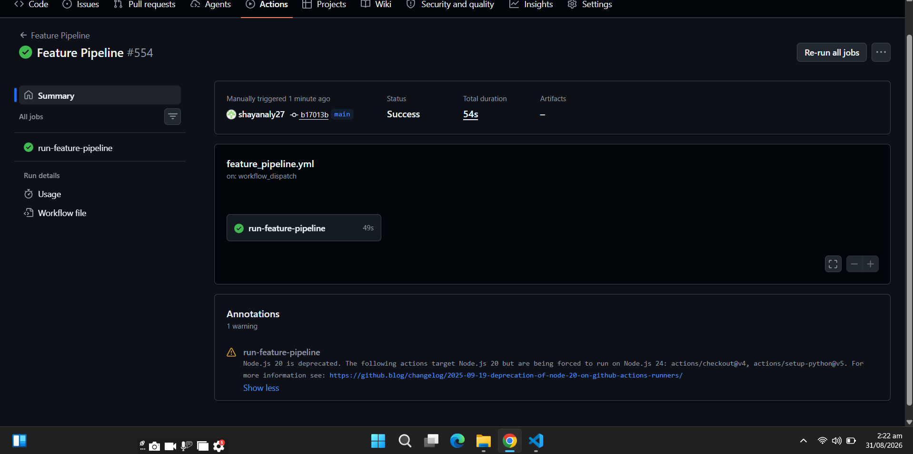
Figure 10.1 — Feature Pipeline run #554, confirmed green in GitHub Actions.

10.2 Training Pipeline — daily
Triggered daily at 02:00 UTC. Reads live from the Feature View, trains and evaluates all three algorithms per horizon, registers the best model per horizon to the Model Registry, and regenerates model_metrics.json and model_history.json for the dashboard — all from real numbers produced by that run, with no manually-typed metrics anywhere in the deployed system.
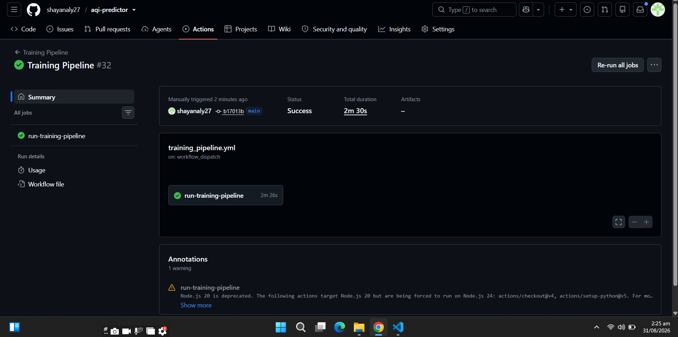
Figure 10.2 — Training Pipeline run #32, confirmed green, 2m 30s total duration.

10.3 Secrets management
The Hopsworks API key is stored as a GitHub Actions repository secret (HOPSWORKS_API_KEY) and injected as an environment variable at run time — it is never committed to source control.

11. Engineering Challenges Encountered & Resolved
This section documents real problems hit during development and how each was diagnosed and fixed. These are included deliberately: they demonstrate the debugging and systems-thinking work behind the project, beyond what the final, working code alone shows.

11.1 Feature store as an afterthought → full migration
The pipeline was originally built CSV-first for speed of initial development: the hourly feature script appended to a CSV that was committed to git every run, and the training script read that CSV. This was identified as directly violating the project's 'no CSV as the data store' requirement. The fix required rewriting feature_pipeline.py to insert directly into the Hopsworks Feature Group, removing the git-commit step from the hourly workflow entirely, and updating training, prediction, and the API layer to read from the Feature View / Model Registry instead of local files.

11.2 Silent model registry gap
Model registration code (push_model_to_registry()) existed in train_model.py, but the locally-saved .pkl files predated that code being added, so the registry showed 0 models despite training having run repeatedly. Diagnosed by comparing the Hopsworks dashboard's 'Models: 0' tile against the training script's actual behavior, and resolved by simply re-running training so the existing registration code would fire.

11.3 Prediction silently using the oldest model version
predict.py loaded models via mr.get_model(name=..., version=None), which Hopsworks resolves to version 1 rather than the latest — meaning that even after months of daily retraining, every prediction would have kept using the very first model ever registered. This was caught by noticing a VersionWarning in the logs, and fixed by querying mr.get_models(name=...) and selecting max(m.version), which was then verified against the training script's actual output (versions 6, 7, 7) to confirm the fix worked.

11.4 Materialization job status false-negative
push_to_hopsworks.py's background materialization job occasionally reported a non-FINISHED status even when the data had, in fact, landed correctly — confirmed via a manual row-count check against the Feature Store. Rather than hard-failing CI on a potentially flaky status label, a fallback verification step was added: if the job status is ambiguous, the script directly queries the Feature Store row count and only fails the run if the data genuinely did not arrive.

11.5 CI dependency resolution
The GitHub Actions environment does not carry over locally-installed packages. Two rounds of debugging were needed: first pyarrow (required internally by hsfs for Arrow Flight support) was missing, then confluent-kafka (required for the Feature Group insert path) was missing. A subsequent attempt to shortcut this by installing directly from a frozen requirements.txt failed because it pinned scipy==1.18.0, a version that does not exist on PyPI — reverted to an explicit, minimal, environment-specific install list per workflow.

11.6 Git history conflicts from the CSV migration
After removing aqi_features.csv, aqi_training_data.csv, and the local model .pkl files from git tracking, a push was rejected because the (still-running, unfixed) old CI workflow had committed newer versions of those same files in the interim. Resolved via git pull, which produced 5 modify/delete conflicts; each was resolved by keeping the deletion (git rm), since removing those files from version control was the entire point of the fix, followed by a clean merge commit.

11.7 Absolute path requirement for Model Deployment
Creating a Hopsworks Model Deployment failed with 'Predictor script does not exist' even after the predictor script was successfully uploaded to the project. The API expected the full absolute path (/Projects/<project_name>/Resources/predictor.py), not the relative path that had been passed — discovered by inspecting the exact HTTP error code returned and testing the corrected path format.

11.8 Row-count vs. real-time gap bug in backtesting
Initial backtest/quick-check scripts assumed that 'N rows ahead' in the Feature Store equals 'N hours ahead', which is only true if every hour has exactly one row with no gaps. Because the live pipeline has occasional missed runs (Section 4.5), this produced comparisons that were actually up to ~118 hours apart while being labeled '72 hours ahead.' The fix matches every comparison by nearest real timestamp and reports the true elapsed gap for every result, with a tolerance check that discards any comparison exceeding a 6-hour deviation from the target horizon — ensuring every reported accuracy number (Section 9) is genuinely trustworthy.

11.9 Dashboard/backend contract mismatch
An automated rewrite of train_model.py to generate model_metrics.json from real training numbers used the internal Python variable names (target_day1, target_day2, target_day3) as JSON keys, while the already-built frontend expected day_1/day_2/day_3 — causing two dashboard panels to throw 'Cannot read properties of undefined.' Fixed with an explicit key-mapping step before writing the JSON file, restoring the original contract.

11.10 Transient Hopsworks connectivity from CI
The feature pipeline occasionally failed in GitHub Actions with a RemoteDisconnected error while launching the background materialization job — the data upload itself had already succeeded (confirmed at 100% in the logs), only the job-launch request was dropped. Since this is transient infrastructure flakiness rather than a code defect, retry logic was initially added around the insert call rather than treating a single network blip as a pipeline failure.

11.11 Prediction API latency and a non-functional refresh button
Once the backend was deployed publicly, per-request latency became directly measurable rather than theoretical. predict.py re-logged into Hopsworks and re-downloaded all three registered models from the Model Registry on every single /predict call — genuinely expensive network and I/O work that made every dashboard load slow. Separately, the dashboard's 'Fetch Latest Data' button had no way to signal the backend to bypass any cache, so it was cosmetic: it showed a loading state but returned identical data every time.
Both were fixed together: the Hopsworks connection and the three loaded models are now cached in memory for the lifetime of the API process, with a preload step that warms this cache once at server startup rather than on the first user request. A time-to-live was added to the model cache specifically so a long-running deployed process still picks up newly-trained models from the daily pipeline without requiring a manual restart. The /predict endpoint accepts a refresh query parameter that the dashboard's button passes through, bypassing every cache layer for a genuinely fresh pull on demand.

11.12 Render deployment: Python version and broken dependency pins
Deploying the backend to Render surfaced three separate installation failures, each requiring a different fix. First, Render defaulted to Python 3.14, for which no hopsworks wheel exists on PyPI — fixed by pinning Python 3.11 via both a runtime.txt file and a PYTHON_VERSION environment variable (the former was not reliably honored on its own). Second, the project's full requirements.txt (a direct pip freeze of the local development environment) contained several exact version pins — scipy==1.18.0, shap==0.52.0, xgboost==3.3.0 — that do not exist on PyPI at all, most likely artifacts of packages that were installed from a non-index source locally. Rather than fixing pins one at a time, the deployment requirements file was rebuilt from scratch containing only the packages api.py and predict.py actually import at runtime, with exact pins kept only where version compatibility genuinely matters (fastapi, uvicorn, hopsworks) and everything else left for pip to resolve freely.
A separate, ongoing characteristic of the same free tier was confirmed directly in production logs: Render spins the container down entirely after roughly 15 minutes with no incoming requests, so the next request pays a full cold-boot cost — reinitializing the Python process, logging into Hopsworks (≈ 8–10 seconds), and re-downloading all three registered models — before the API can respond at all. This is distinct from, and unrelated to, the per-request Hopsworks reconnect fixed in Section 11.11; that fix remains effective and correctly keeps warm requests fast. The cold-start delay is disclosed here as a known limitation of the platform's free tier rather than a defect in the request-handling code, since the same preload-and-cache logic runs correctly on every cold start — it simply cannot avoid paying that cost once per container spin-up.

11.13 Hopsworks materialization service failure (platform-level, cohort-wide)
The most significant and time-consuming issue encountered was a sustained failure of Hopsworks' background offline feature-group materialization job — the service responsible for merging newly inserted rows into the queryable table that the Feature View and all downstream training/prediction code actually read from.
The symptom was diagnosed methodically rather than assumed: 581 consecutive hourly Feature Pipeline runs in GitHub Actions showed green (success), yet a direct query against the Feature View (check_feature_store.py) showed the newest row was over 24 hours old. This ruled out a code-side bug in the insert path itself and isolated the failure specifically to Hopsworks' materialization step. Investigating further in the Hopsworks UI, the aqi_features_1_offline_fg_materialization job showed a string of failed runs with no usable log output on any surface — stdout, stderr, the platform's own OpenSearch log search, and the Spark UI were all empty, and the failing Spark application had not launched far enough to leave a trace anywhere.
To make failures visible rather than silent, the insert call was changed to write_options={"wait_for_job": True}, forcing each hourly insert to wait for and confirm materialization rather than firing-and-forgetting via the async path. This surfaced the problem directly: a single hourly run failed three consecutive materialization attempts, each taking roughly eight minutes, for a total run time of 26 minutes, with an identical generic JobExecutionException each time. Because a 26-minute worst case risked overlapping the next hourly schedule, the retry loop was removed in favor of one synchronous attempt per run — bounding worst-case runtime to roughly 9 minutes while still surfacing any failure as a visibly failed GitHub Actions run instead of a silent gap.
This is not an isolated incident. A review of the shared cohort discussion channel for this project shows the identical symptom — feature pipelines reporting success while materialization silently stalls or fails, self-resolving after a period ranging from hours to over a week — reported by dozens of students independently across a span of many months, consistently attributed to Hopsworks' free-tier infrastructure rather than to any individual student's code. A course mentor's guidance to a student experiencing the same issue was to document the chosen platform and the problem rather than treat it as a personal defect, provided the underlying data-writing path is confirmed to be functioning correctly — which was directly verified here via GitHub Actions history and the Feature Store row count.
The practical impact: the deployed dashboard's historical trend and 'last updated' timestamp reflect the most recent successfully materialized row rather than the true current hour until Hopsworks' service recovers, which the raw insert path continues feeding in the meantime with no data loss. This is disclosed here as an honest, external limitation of relying on a third-party managed platform under its free tier, rather than a defect in the system's own design.

11.14 Renewed materialization outage (Sept 2–6) and a client-side live-data resilience layer
The materialization issue described in Section 11.13 recurred several days later, this time for a sustained multi-day period rather than resolving within hours. /predict began returning a based_on_timestamp stuck at 2 September while the deployed system was actually running on 5 September — a roughly 70-hour gap, confirmed directly rather than assumed.
Diagnosis again followed evidence rather than guesswork, and specifically ruled out two plausible-but-wrong explanations before confirming the real cause. First, GitHub Actions history showed the hourly Feature Pipeline still running and succeeding (run #591 and earlier, all green, 40–60 seconds each) — ruling out “the pipeline stopped running.” Second, an unsolicited email styled as a Hopsworks “Spending Alert” claimed the project's compute account was frozen for exceeding a $10 free-tier budget. Cross-checking the claim directly against the real Hopsworks billing dashboard (run.hopsworks.ai) showed “No spending cap” and “Cluster Access: Active” on the account — directly contradicting the email. This was identified as a likely phishing attempt (unsolicited urgency, a claim inconsistent with the platform's own dashboard, and a call-to-action link) rather than a genuine Hopsworks notice, and was not acted on. With both alternative explanations ruled out using direct evidence, the cause was confirmed to be the same class of issue as Section 11.13: the aqi_features_1_offline_fg_materialization job itself, verified failing live by triggering it manually from the Hopsworks UI and observing an immediate failure with empty logs on every surface — identical to the original incident's signature.
A second, related failure mode also appeared partway through this period: five consecutive hourly Feature Pipeline runs (#592–#596) failed in GitHub Actions, each after 5–9 minutes, with a ConnectionError (“Remote end closed connection without response”) while waiting on the materialization job's status. This is not a code regression — it is the wait_for_job=True design from Section 11.13 working exactly as intended, surfacing a Hopsworks-side connection drop as a visibly failed run instead of a silent gap. The raw insert step itself continued to succeed, so the underlying data was not lost.
Because this outage lasted days rather than hours, waiting it out was no longer an acceptable answer for a live, gradeable dashboard. A resilience layer was added to predict.py: the value shown as “current AQI”, its pollutants, and its timestamp are now fetched directly and live from the same Open-Meteo source the hourly pipeline already uses, independent of whether Hopsworks' offline store has caught up. The Feature Store's historical data continues to feed the lag/rolling features the model needs, since only that store has real multi-day history; a new data_freshness field in the API response reports explicitly how many hours behind that historical tail is, rather than silently presenting it as current — the same honest-disclosure principle already applied in Section 11.13. Two secondary bugs surfaced while building this and were fixed in turn: a timestamp-timezone mismatch between Hopsworks' tz-aware historical rows and the newly-added tz-naive live reading (resolved by standardizing both to naive UTC), and an ambiguous based_on_timestamp string format that parsed inconsistently across browsers (resolved by returning proper ISO 8601 with an explicit “Z” UTC suffix).
The dashboard's 3-Day Forecast panel was also revised during this period: the redundant “Today” card was removed, since the hero panel already shows the current reading, leaving three forecast cards labeled with real calendar dates (derived from based_on_timestamp) plus a small +24h/+48h/+72h subtitle. Each card's Min/Max range and hourly curve are generated from a typical diurnal AQI shape (low overnight, peaking in the evening — the same pattern documented in Section 4.3) scaled around that day's single predicted value; this is disclosed here explicitly as a shaped estimate for visual clarity, not a genuine per-hour model output, since the underlying models only ever predict one value per horizon.
As with Section 11.13, this is disclosed as an honest, external limitation of depending on a third-party platform's free tier rather than a defect in the system's own design — mitigated, this time, with a client-side resilience layer that keeps the deployed product accurate for end users regardless of the underlying platform's recovery timeline.

12. Interactive Dashboard
The frontend is a Next.js + TypeScript application (Tailwind CSS, Recharts) that consumes the FastAPI backend exclusively over HTTP — no data access logic lives in the frontend itself, keeping a clean separation between presentation and the ML system. Figure 12.1 below shows the complete, live dashboard end to end, stitched from the running application.
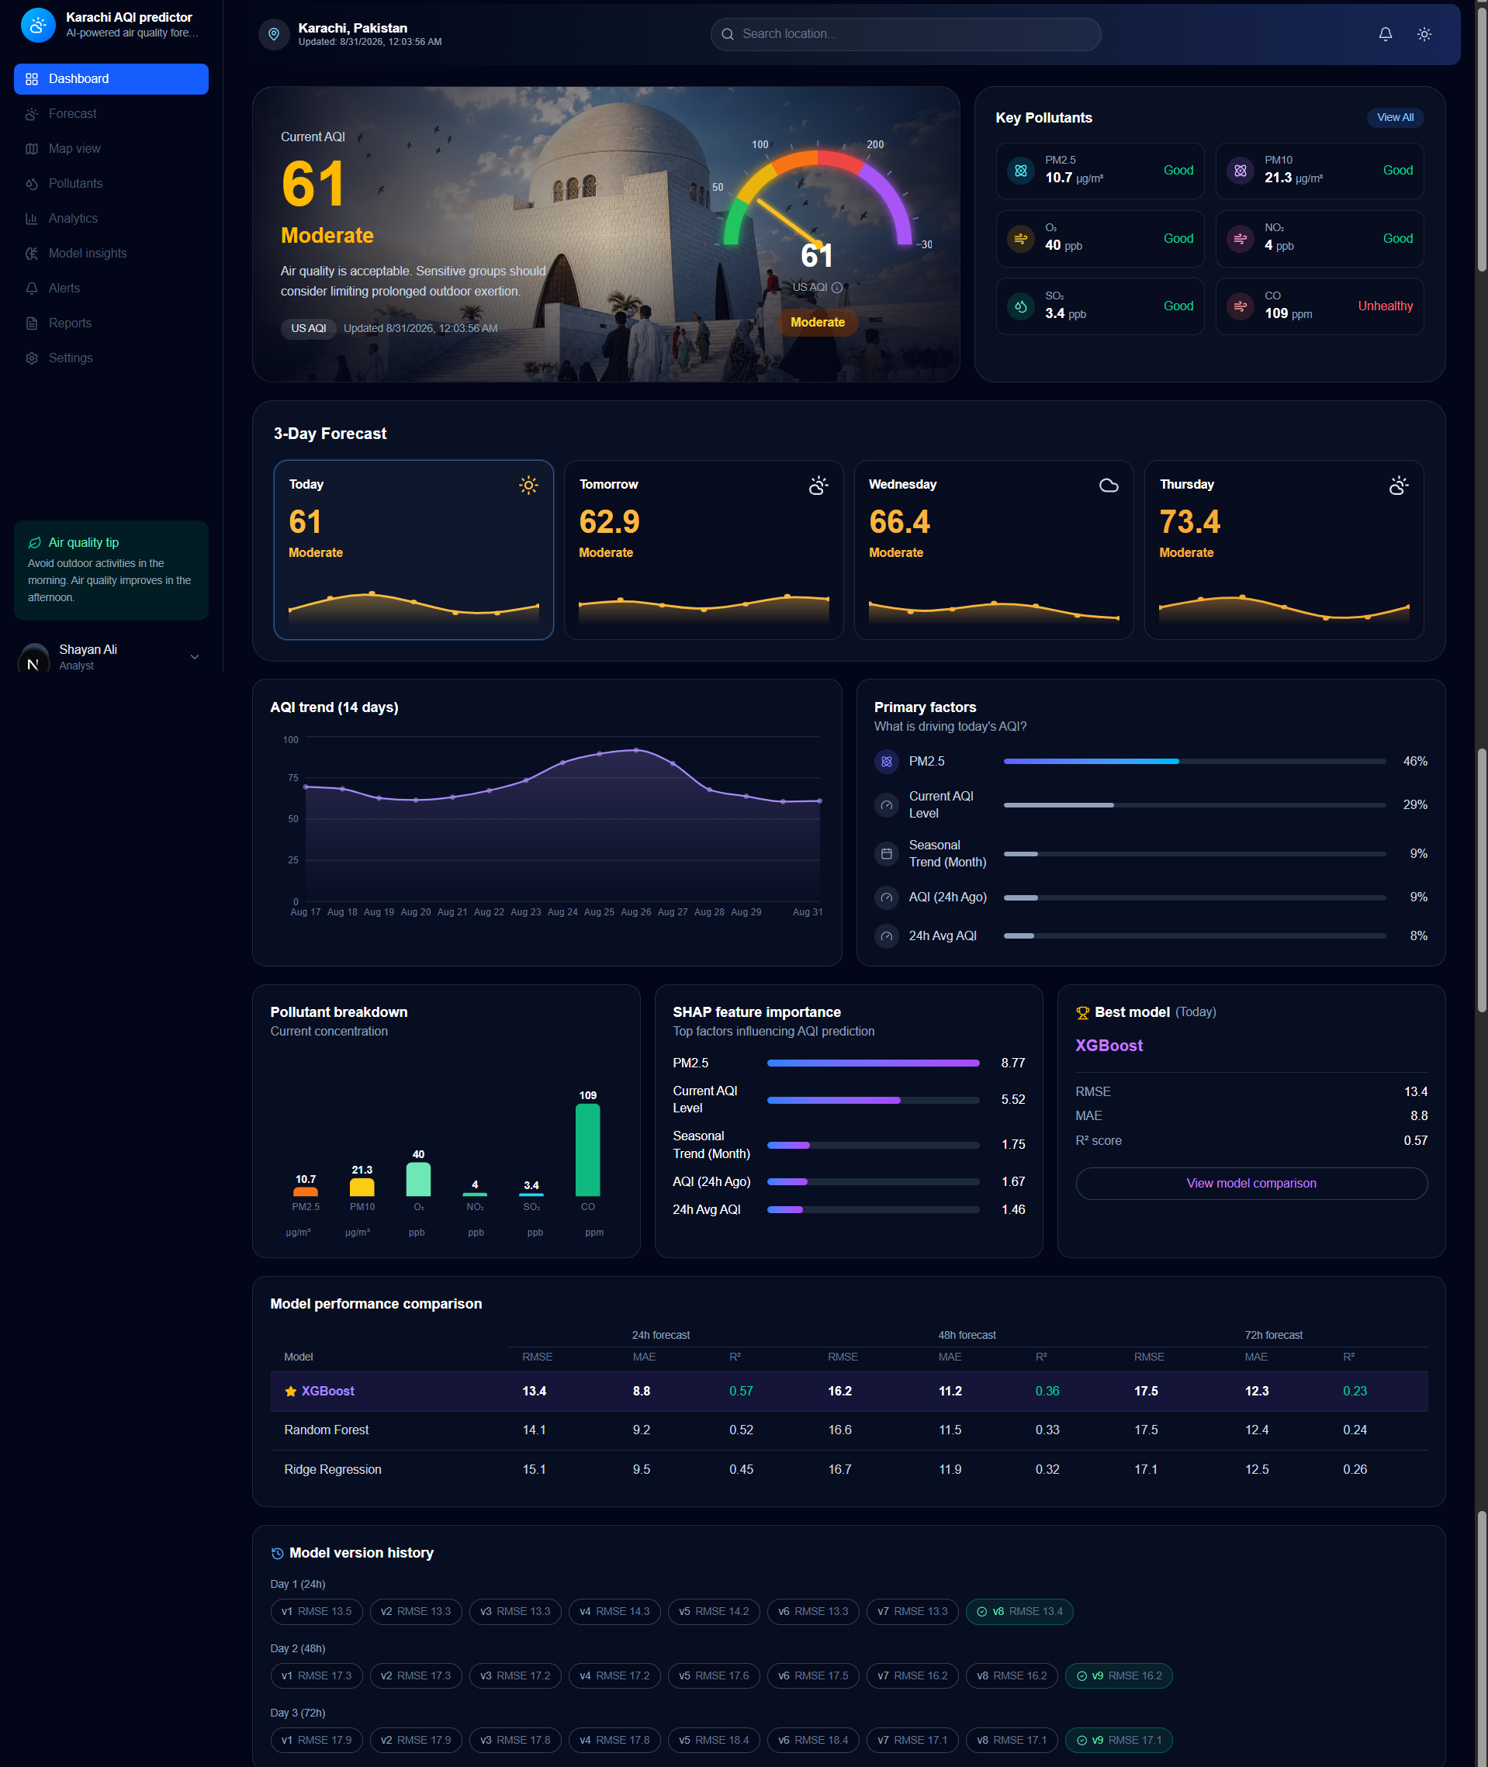
Figure 12.1 — The complete Pearls AQI Predictor dashboard: hero panel with current AQI and gauge, key pollutants, 3-day forecast, 14-day trend, primary factors, pollutant breakdown, SHAP feature importance, best model panel, full model performance comparison table, and model version history per horizon — all reading live from the FastAPI backend and, ultimately, Hopsworks.

12.1 What the dashboard shows
- Hero panel: current AQI, category, and a glowing gauge visualization, sourced from /predict.
- Key pollutants: PM2.5, PM10, O₃, NO₂, SO₂, CO with status coloring against approximate EPA-style breakpoints.
- 3-day forecast strip: three predicted days with real calendar dates and +24h/+48h/+72h labels, each with AQI, category, hazard flagging, and an hourly Min/Max view — today's reading itself appears in the hero panel above, not duplicated here.
- 14-day AQI trend: sourced from /history, reading live from the Feature Store — not a CSV.
- Primary factors / SHAP feature importance: sourced from /feature-importance, generated by compute_feature_importance.py.
- Model performance comparison: RMSE/MAE/R² across all four algorithms and three horizons, sourced from /model-metrics — regenerated automatically by every training run, never manually typed.
- Best model panel: highlights the current winning algorithm for the nearest-term forecast.
- Model version history: sourced from /model-versions, showing every registered version per horizon with the current version highlighted — this was added specifically in response to a project review note that previous model versions be visibly tracked, not only the latest.

12.2 Configuration
The API base URL is centralized in a single lib/api-config.ts module, driven by the NEXT_PUBLIC_API_BASE environment variable, so the same frontend code works unmodified whether the backend is local or deployed elsewhere — no hardcoded URLs are scattered across components.

12.3 Live deployment
Both halves of the system are deployed publicly, not only demonstrated locally:
- Backend (FastAPI): deployed on Render (free tier) at https://aqi-predictor-api-wodc.onrender.com. Python is pinned to 3.11 via runtime.txt/PYTHON_VERSION (Render's default runtime lacked a compatible hopsworks wheel), and the deployment requirements file was trimmed to only the packages actually imported at runtime, removing several broken version pins inherited from a full local pip-freeze.
- Frontend (Next.js): deployed on Vercel at the project's live .vercel.app URL, configured with NEXT_PUBLIC_API_BASE pointing at the Render backend.
- CORS: the backend's allowed origins are restricted via an ALLOWED_ORIGINS environment variable to the real deployed frontend domain, rather than left open to '*' in production.
Deploying end-to-end (rather than only running locally) was a deliberate choice: several architectural issues — a per-request Hopsworks reconnect that made /predict slow, and a non-functional manual refresh button — were only discovered once real request/response latency on a hosted backend was measured, and are documented in Section 11.

13. How to Run This Project

13.1 Prerequisites
- Python 3.11
- Node.js 18+ and npm
- A free Hopsworks account and project (eu-west.cloud.hopsworks.ai or any region), with an API key generated
- Git

13.2 Backend setup
cd aqi_project
python -m venv .venv
.venv\Scripts\Activate.ps1 # Windows PowerShell
pip install -r requirements.txt
# create a .env file in this folder containing:
HOPSWORKS_API_KEY=your_api_key_here

One-time bootstrap (only needed once, or when re-seeding history)
python backfill_historical.py # pulls ~3.5 years of historical data to CSV
python merge_data.py # cleans, regularizes to hourly grid
python push_to_hopsworks.py # creates Feature Group + Feature View, uploads history

Train models and populate the Model Registry
python train_model.py # trains Ridge/RF/XGBoost per horizon, registers best model
python model_history.py # generates version-history JSON for the dashboard
python compute_feature_importance.py # generates SHAP summary JSON for the dashboard

Run the API
uvicorn api:app --reload
# Visit http://127.0.0.1:8000/docs to confirm all endpoints respond

13.3 Frontend setup
cd aqi-dashboard
npm install
# create a .env.local file in this folder containing:
NEXT_PUBLIC_API_BASE=http://127.0.0.1:8000
npm run dev
# Visit http://localhost:3000 — redirects to /dashboard

13.4 Automated pipelines (optional — already configured)
Two GitHub Actions workflows are included under .github/workflows/: feature_pipeline.yml (hourly) and training_pipeline.yml (daily). To enable them on a fork or new repository, add HOPSWORKS_API_KEY as a repository secret under Settings → Secrets and variables → Actions. Both can also be triggered manually from the Actions tab via workflow_dispatch.

13.5 Verifying everything works
- python check_feature_store.py — confirms the Feature View returns rows
- python quick_check.py — runs a single real backtest comparison and prints the result
- python backtest.py — runs the full 15-point-per-horizon backtest and writes backtest_results.csv
- python test_deployment.py — sends a real request to a live Hopsworks deployment (requires Section 7.3 deployments to already exist)

14. Limitations & Future Work

14.1 Known limitations
- 72-hour accuracy: the weakest horizon by both training R² and backtest error; a genuinely harder forecasting problem given the current feature set.
- Single-city scope: the system is tuned specifically to Karachi's coordinates and pollution patterns; extending to other cities would require re-running the backfill and retraining per city.
- Archive/live source skew: Section 4.6 found a distribution shift in pressure and humidity between the backfilled archive data and the live pipeline's forecast-endpoint readings — a genuine train/serving skew that was documented but not fully corrected.
- Model Registry 'best' semantics: as noted in Section 7.2, 'current best' reflects the most recently trained version rather than a formally promoted production version, since Hopsworks' free tier does not provide a staging/production workflow.
- Small backtest sample: 15 points per horizon (45 total) is enough to draw a directional conclusion but not enough to fully rule out sampling noise, particularly for the Day 1 vs. Day 2 comparison noted in Section 9.2.
- Dependence on Hopsworks materialization uptime: as detailed in Section 11.13, the freshness of the deployed dashboard's historical data depends on a third-party background service outside this project's control. The raw hourly data path is unaffected and continues writing throughout, so no data is lost, but the queryable Feature View can lag behind real time until Hopsworks' service recovers.
- Render free-tier cold starts: as detailed in Section 11.12, the backend spins down after ~15 minutes idle and pays a one-time cold-boot cost (Hopsworks login plus re-downloading all three models) on the next request. This is a platform characteristic of the free tier, not a code defect — mitigations considered include an external keep-alive ping, upgrading to a paid Render tier, or a frontend loading state that sets user expectations during the cold-start window.

14.2 Future work
- Incorporate a sequence model (e.g. LSTM/Transformer over the raw hourly series) rather than three independent point-in-time regressions, which may better capture multi-day weather-system dynamics.
- Add external features such as satellite-derived aerosol data or regional wind-pattern forecasts, which could meaningfully improve the 72-hour horizon specifically.
- Expand the backtest to a larger, rolling sample (e.g. every day over several months) for a more statistically robust accuracy estimate.
- Add a staging/production model promotion step so 'best model' reflects a deliberate evaluation gate rather than 'most recent'.
- Extend the system to additional cities, parameterizing latitude/longitude and Feature Group naming.

15. Conclusion
This project delivers a genuinely complete, working, automated machine learning system — not a notebook demonstration. Every stage of the reference architecture (raw data → feature generation → model training → web app, backed by a Feature Store and Model Registry) is implemented, running on a real schedule, and independently verifiable: two GitHub Actions pipelines confirmed green, six registered model versions with a queryable version history, three live Hopsworks model deployments tested with real inference calls, and a dashboard that reads exclusively from live infrastructure rather than static files.
Just as importantly, the system's accuracy was validated honestly rather than assumed: a real historical backtest — built, debugged, and corrected over the course of development — shows the forecasts are usable most of the time (73% within 10 AQI points, 93% within 20) while being transparent about where and why the system is weaker, particularly at the 72-hour horizon. The engineering challenges documented in Section 11 reflect the actual process of building a production-shaped system: things broke, were diagnosed with real evidence rather than guesswork, and were fixed with a documented rationale — which is the intended outcome of this assignment.

