**Real-world Deployability and**  
**Usability of Bitcoin**

Shayan Eskandari

A Thesis

in

The Department

of

Computer and Electrical Engineering

Presented in Partial Fulfilment of the Requirements for

the Degree of Master of Computer and Electircal at

Concordia University

Montréal, Québec, Canada

August 2015

CONCORDIA UNIVERSITY

Division of Graduate Studies

This is to certify that the thesis prepared  
By :

Entitled :

and submitted in partial fulfilment of the requirements for the degree of

complies with the regulations of this University and meets the accepted standards with respect to originality and quality.  
Signed by the final examining committee :

Chair

Examiner

Examiner

Supervisor  
Approved by

# Introductory Remarks

We’re living in an era that internet is one of the daily needs of human life and modern countries, instead of going to banks people use internet banking and instead of sending a physical letter they use digital ways of communication. This leads to a more digital robust way of living, but it should be considered that this means people are trusting the middle companies and third parties for their online services. The most important one are banks and financial middle mans (*e.g.,*credit card companies) and there has been many downsides to these trust, such as banks failing[1], government collapses that leads to the countries currency exchange rate fall to pennies (*e.g.,*Zimbabwean dollar  Hanke and Kwok (2009) ) and many more examples in smaller scales. The need of having a digital form of money that is not being controlled by one entity is obvious.

Bitcoin is the first decentralized virtual currency and by far has adopted the most number of users  Nakamoto (2008). It is based on cryptographic functions to remove the need of a central bank and regulates the generation of new units. Bitcoin is still on its early stages and there has not been that many practical usage of this digital currency that could offer an ultimate solution for financial problems.

In this thesis, we would like to look at available tools for end user to hold and use bitcoin with a usability and security perspective, and then evaluate the possibilities for a small business to be able to accept Bitcoin payments. This could summaries the usage of any kind of a currency as there only should be two entities involved in a monetary transaction, the payee and the payer.  
**Thesis Statement:** End-to-end usable payment system using Bitcoin, and its components, can be designed for real-world deployability while maintaining a strong notion of usability and security.

## Background

The concept of digital cash was introduced by David Chaum in 1983  Chaum (1983), he continued the idea and founded a company named DigiCash[2] as a digital cash company but filed for bankruptcy in 1998. In the same year, Paypal[3] emerged and other systems such as E-gold[4] followed but due to criminal usage of E-gold they got shut down in 2005 by United States Federal. In 2008, Bitcoin was introduced and solved most of the problems of all the digital cashes before it which marked the start of digital currencies.

Even though the idea of having a decentralize money is interesting, there has not been any work on the usability of this new form of money. Thus a framework to be able to evaluate applications in this field in usability perspective is needed.

For Bitcoin to flourish, adoption must expand beyond developers and tech-savvy enthusiasts to novice users. Expansion solidifies the need for a usable, comprehensible approach to Bitcoin. If users cannot safely manage Bitcoin keys, it may result in the users’ loss of funds and/or a poor reputation for Bitcoin, both of which could dissuade further user adoption.

## Contributions

While this research is one of the first usability researches on the subject of Bitcoin, our work provides a number of new contributions toward the evaluation of Bitcoin wallet clients and payment systems, we summarize them here:

**Bitcoin Wallet comparison framework:** we come up with a framework for comparing Bitcoin wallet clients and evaluate the existing tools.

**Bitcoin Point of Sale comparison framework:** with the focus on the available tools for businesses to accept bitcoin as a method of payment, we analyses a small business’s requirements using SCRAM a requirement engineering method and evaluate all the available options for bitcoin payments.

**Fully customizable open-source Bitcoin Point of Sale**[5] : later we develop a customized Bitcoin point of sale specific to a small business needs as none of the available approaches could satisfy the needs. This software is available under GNU General Public Licience v2 and has already been used in other small businesses to accept bitcoin.

Our focus in this thesis, is mostly on usability of these tools and having a framework for comparing and evaluating future tools.

## Organization

In the next chapter (Chapter 2), we present some background on Bitcoin, the underlying protocol as long as it fits the scale of this thesis, and also some details about the methods used in the next chapters such as Cognitive walkthrough and requirement engineering.

On Chapter 3, we use cognitive walkthrough to evaluate the usability of bitcoin wallet clients and then develop a framework for comparing existing and future wallet clients. This published work was the first ever usability paper on the Bitcoin subject, mostly focused on how these clients handle key management that is the fundamental requirement in any Bitcoin wallet client.

In chapter 4, we survey all the available tools for small businesses to accept bitcoins and evaluate them based on the framework introduced in the same chapter. Then using a requrement engineering method we list all the advantages and disadvates of using each method for a small business and later we develop a fully customized open-srouce Bitcoin point of sale and implement it in real-world cafe to accept bitcoins. This cafe[6]. is the first cafe in eastern Canada that accepts Bitcoin.

And in the end we evaluate our contributions and discuss the future work needed in this field to have a more usable and robust system.

# Backgroud

## Introductory Remarks

Bitcoin or any other digital form of money by nature is an interesting idea for 21st century, but how practical and useful they would be to the people living in this era is what would make a difference. In this research we tried to have a real world view of the implications that the Bitcoin usage could have and also evaluated the existing approaches to hold, use and accept Bitcoin as a digital form of money.

## Bitcoin

Bitcoin is a cryptographic currency deployed in 2009 Nakamoto (2008) which has reached a level of adoption unrealized by decades of previously proposed digital currencies (from 1982 Chaum (1982) onward). Unlike many previous proposals, Bitcoin does not distribute digital monetary units to users. Instead, a public ledger maintains a list of every transaction[7] made by all Bitcoin users since the creation of the currency. A *transaction* in its simplest form describes the movement of some balance of the Bitcoin currency (XBT or BTC) from one or more accounts (called input addresses) into one or more accounts (called output addresses). Bitcoin addresses are indexed by the fingerprint of a public key from a digital signature scheme.[8] They are not centrally allocated or registered in any way—the addresses become active when the first transaction moving money into them is added to the ledger.

In Bitcoin, every transaction must be digitally signed using the private signing key associated with each input address in the transaction. In order to spend Bitcoin, users require access to the signing key of the account holding their Bitcoin. Thus users do not maintain any kind of units of currency; they maintain a set of keys that provide them signing authority over certain accounts recorded in the ledger.

The ledger (known as the *blockchain*) is maintained and updated by a decentralized network using a novel method to reach consensus that involves incentivizing nodes in the network with the ability to generate (known as mining) new Bitcoin and collect transaction fees. The details of the Bitcoin consensus model are not relevant to this paper, but we note that clients in the network participate in the consensus model by downloading and cryptographically verifying the integrity of the blockchain. As of writing, the Bitcoin blockchain is roughly 30 GB in size.[9] This introduction is not an introduction to Bitcoin, but the details of Bitcoin that is needed in this research. Some details has been simplified to prevent going outside the scope of this thesis. Every aspect of Bitcoin that is missing from this introduction has explained through this thesis when the preliminary information of the usage is known to the reader.

### Bitcoin Address

Bitcoin address is a random string of 26-35 alphanumeric characters that starts with “1” or “3”, that contains digits, uppercase and lowercase letters with the exception of “O”, “I” (Uppercase i) , “l” (Lower case L) and the number 0 to prevent visual ambiguity. Bitcoin addresses are commonly shared via QR-Code as it’s easier to read with QR-code mobile scanners and it is also implemented in almost all Bitcoin wallets (see figure  [fig:bitcoinqr]). Bitcoin addresses are derived from the equivalent ECDSA public key that is explained later.



QR-Code representing the bitcoin address “1shaYanre36PBhspFL9zG7nt6tfDhxQ4u”

#### Public Key

In other words, Bitcoin address is 160-bit hash of the public portion of the public and private ECDSA keypair. Public key is derived from the Private key by some cryptographic functions (see Figure  [fig:pubkeytoaddr]).

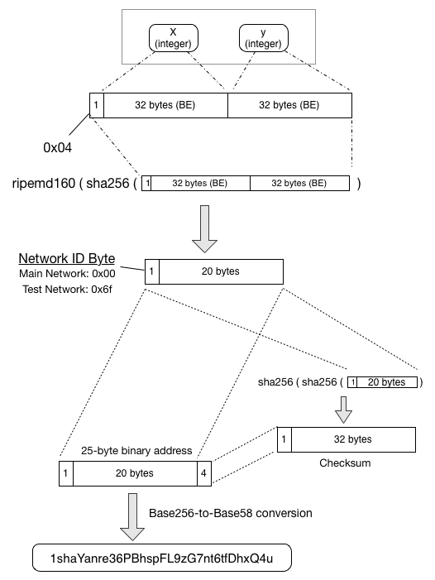

ECDSA Public key to Bitcoin Address  Wiki (n.d.)

#### Private Key

Private key can be any 256 bit number from 0x1 to 0xFFFF FFFF FFFF FFFF FFFF FFFF FFFF FFFE BAAE DCE6 AF48 A03B BFD2 5E8C D036 4140. Basically any number in this range would be valid as the input for secp256k1[10] ECDSA standard. This is the secret part of the bitcoin address that should be kept secure and there are already different methods of securing the private key as discussed in Chapter 3. Anyone with the private key has the ability to sign a transaction and spend the bitcoins that are signed with the relevant public key (or bitcoin address). Same as Bitcoin addresses and Public keys, Private keys have a shorter format called wallet import format (wif) that is used commonly by most Bitcoin wallet clients, it contains error checking bits and also some information about the public key associated to the private key. An example of a private key in wif format would be “5Kb8kLf9zgWQnogidDA76MzPL6TsZZY36hWXMssSzNydYXYB9KF” that would result in “1CC3X2gu58d6wXUWMffpuzN9JAfTUWu4Kj” as the associated bitcoin address.

To better understand how Bitcoin address is derived from the private key see Figure  [fig:pubkeytoaddr]

#### BIP32

As Satoshi Nakamoto  Nakamoto (2008) also points out, it’s better to generate a new address for each transaction and receive the changes in a new change address (The concept of change addresses would be explained more in chapter 3) to use the pseudonymity of bitcoin. This brought a challenge to Bitcoin wallet client designs as keeping track of all the addresses in the wallet file and also the ability to back up the private keys could get complicated when there are hundreds of keys in the wallet (More on Chapter 3).  
Bitcoin is an open source project, and to make improvements to the protocol there are Bitcoin Improvement Proposals (BIP) introduced by developers to be implemented in the core code. One important one is BIP32 also known as Hierarchical Deterministic Wallets or HD wallets  Pieter Wuille (n.d.). BIP32 introduces the ability to generate a tree of addresses from a single seed known as “Master Seed”. A Master node would be generated from the master seed and it’s possible to branch it to multiple nodes shown as m/0, m/1, ... . m/i , and then from each multiple addresses could be derived such as m/0/1, m/0/2, *etc.*. Commonly the first branch would be used on different accounts and the second depth of nodes on the tree would be used as the addresses of each account. BIP32 simplifies the backing up process as there is just a seed to be backed up and it’s easier to keep track of the addresses, a visualization of how BIP32 is design can be seen in figure  [fig:bip32].

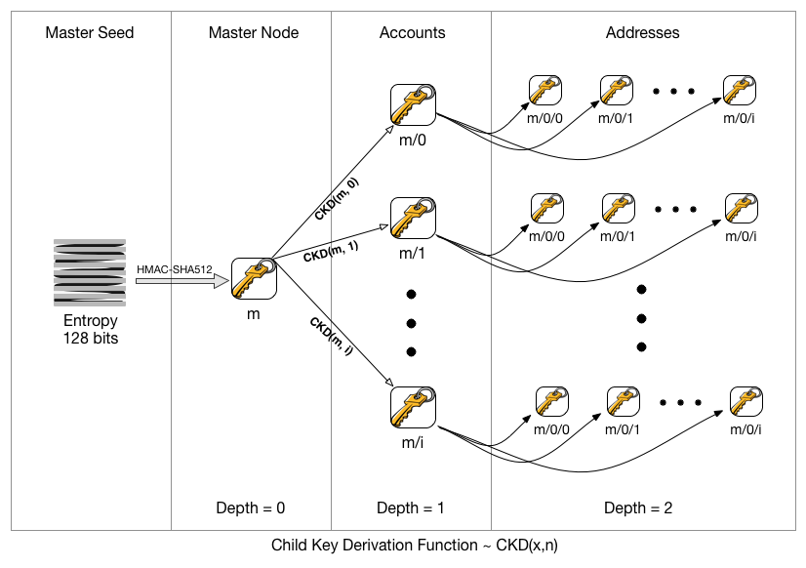

BIP32 - Hierarchical Deterministic Wallets  Pieter Wuille (n.d.)

### Bitcoin Wallet

This term has been misused in bitcoin sphere as both the file that contains the private keys and also the software client used to do mange bitcoin transactions, this concept has been more discussed in Chapter 3. For the sake of simplicity, we use the term Bitcoin wallet client as in the software used to sign bitcoin transactions with the private key held in Bitcoin wallet file and manage the bitcoin transactions. The first and official Bitcoin wallet client is Bitcoin QT (Bitcoind as the daemon) that will be explained more on Chapter 3.

### Confirmation

When a bitcoin transaction is broadcasted to the network, it should get included in a block by Bitcoin miners. Bitcoin miners are the computers that are using their hashing power to verify each and every transaction within the bitcoin network and include them in a block. Each block would be added to the blockchain with a hash referencing its previous block and everyone in the network should have the consensus that the hash value for the block and the previous one is correct. As soon as the transaction is broadcasted it has 0-confirmation, that means it has not been added to any block, right after it gets included in a block it has 1 confirmation and this increases by each block that gets added to the blockchain.

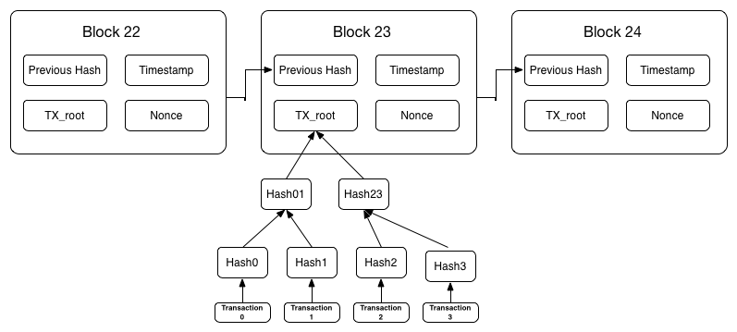

Bitcoin Blocks in the blockchain  Nakamoto (2008)

This is really important to understand that it is possible for a 0-confirmation transaction to stay unconfirmed for a while, depending on how much miner’s fee is included in the transaction, miner’s tend to chose the transactions with a higher miner’s fee to be included in the new block first.

# First Look at the Bitcoin Key Management

## Introductory Remarks

In all of the excitement surrounding Bitcoin, it is easy to forget that the decentralized currency assumes a solution to the longstanding problem of usable public key cryptography for user authentication. Studies of the usability of key management Garfinkel and Miller (2005; Garfinkel et al. 2005; Sheng et al. 2006; Gaw, Felten, and Fernandez-Kelly 2006) have shown that there are numerous usability issues that prevent public key cryptography from being effectively leveraged by end users. Managing, controlling, and using cryptographic keys are complex tasks, and no clear solution has been proposed.

Despite the known complexity in creating and managing cryptographic keys, the Bitcoin network and software clients use such keys extensively for many operations. For example, digital signatures, which require the Bitcoin software to read private keys into memory, are used to assert ownership over a specific set of Bitcoins. Thus, managing the same coins on multiple devices (*e.g.,*a desktop and a phone) requires the corresponding private keys to be copied to and made accessible on these devices.

The consequences of losing exclusive control over an account containing monetary value connects the threat of losing a Bitcoin private key to that of losing an online banking password. However, consumers in many countries are legally protected from any liability of banking credential loss. Furthermore, most bank transactions are traceable and reversible, making it difficult to extract value from stolen banking credentials (most techniques involve a mule Florencio and Herley (2012)). Bitcoin transactions are also traceable, however they are not reversible. Stolen Bitcoins can thus not be centrally or automatically recovered. Bitcoin users typically have no legal protection against loss or theft, and while stolen Bitcoins could be traced as they change ownership,[11] several mechanisms exist for laundering Bitcoins and similar digital currencies Miers et al. (2013; Bonneau et al. 2014).

In an effort to address some of the complexities of key management, developers of Bitcoin software have created a variety of innovative technologies ranging from password-derived keys to air-gapped computers to physical printouts of private keys in the form of 2D barcodes. However, since none of these proposals have been evaluated in the Bitcoin context, it remains unclear which techniques have usability advantages.

For Bitcoin to flourish, adoption must expand beyond developers and tech-savvy enthusiasts to novice users. Expansion solidifies the need for a usable, comprehensible approach to Bitcoin. If users cannot safely manage Bitcoin keys, it may result in the users’ loss of funds and/or a poor reputation for Bitcoin, both of which could dissuade further user adoption.

In this paper, we aim to investigate the usability challenges surrounding key management in Bitcoin. To do this, we survey and categorize the most prominent Bitcoin key management proposals. Next we conduct an expert usability inspection technique known as a cognitive walkthrough Wharton et al. (1994) on popular examples of each proposal. Our goal is to identify overarching usability issues as well as advantages of specific proposals, allowing us to propose design recommendations for future Bitcoin clients.

Specifically, the contributions of the paper are as follows:

We perform a broad survey of six Bitcoin key management techniques which cover the vast majority of deployed Bitcoin software.

Using the results from our survey, we propose an evaluation and comparison framework for Bitcoin key management techniques. The framework is based on 10 security, usability and deployability criteria, and enables direct comparison of current and future key management proposals. Using our framework we find that certain properties, such as trust in a central party enable additional beneficial properties. We also find that the disadvantages of certain properties, such as malware protection, outweigh the relative benefits.

We perform a cognitive walkthrough of six distinct Bitcoin clients and tools to identify usability issues while performing basic Bitcoin tasks (*e.g.,*viewing account balance, sending funds, *etc.*). We find that the metaphors and abstractions used in the surveyed clients are subject to misinterpretations, and that the clients do not do enough to support their users.

## Background

### Bitcoin

One subtlety of Bitcoin’s transaction architecture is that in order to spend Bitcoins, the entire value of unspent outputs (*i.e.,*from previous transactions) must be spent. To accommodate this, Bitcoin clients automatically spend the full amount of unspent outputs and create multiple components in the transaction: one component will send part of the unspent coins to the intended recipient, and the other component will send the remaining inputs back to the sender as *change*. It is technically possible (and some clients behave this way) to send change back to the sending address. However, to enhance anonymity, the reference client generates fresh addresses (and corresponding private keys) to receive the remaining transaction amount.

As more transactions are made, Bitcoin clients must keep track of multiple private keys for use in future transactions. Many clients prominently display a Bitcoin balance on the main screen, which represents the sum of all unspent outputs for which private keys are available.

One subtlety of Bitcoin transactions is that each XBT amount in the set of inputs must reference past transactions where the address received adequate XBT to cover the input amount. The complexity here is that a transaction must completely spend the amount received in these past transactions even if it is larger than the amount in the current transaction. To enable this, transactions will output the surplus XBT back to the sender as ‘change.’ Change can be sent back to the same input address, or to enhance privacy, it can be sent to a brand new address created by the sender’s client (called ‘change addresses’).

### Usability of Key Management

Passwords remain the most common form of user authentication Herley and Oorschot (2012). Private key-based authentication is rarely used by non-experts, and is typically never used as the default configuration in applications which support this authentication method. Transport Layer Security (TLS) client-side certificates have failed to reached wide-spread deployment. Secure shell (SSH) uses passwords by default, and recent efforts to reintegrate them in a different form (*e.g.,*origin-bound certificates Dietz et al. (2012)) still rely on passwords as the primary authentication mechanism.

Password managers, when configured to generate or store system-chosen random passwords, share at least one property of cryptographic keys: such passwords become something you *have* instead of *know*. However, if access to such a password is lost, online services generally offer account recovery mechanisms (*e.g.,*based on email). No such recovery mechanism exists for self-managed cryptographic keys.

The use of public key systems by non-experts that is closest to Bitcoin is arguably encrypted/authenticated email, in particular Pretty Good Privacy (PGP) and its open-source alternatives (*i.e.,*GPG and OpenPGP). Beginning with *Why Johnny Can’t Encrypt* Whitten and Tygar (1999), the usability of public key technology has been well-studied from a usability perspective Garfinkel and Miller (2005; Garfinkel et al. 2005; Sheng et al. 2006; Gaw, Felten, and Fernandez-Kelly 2006). The findings of this literature are diverse but relevant observations include the following: (1) the metaphor and terminology behind public and private keys is confusing; (2) it is difficult to correctly obtain other users’ public keys; (3) key migration between devices is difficult. This literature tends to focus primarily on encryption and not signatures, but we find some overlap to the work presented here.[12]

## Bitcoin Key Management Approaches

Before turning to a detailed usability evaluation, we evaluate from a systems perspective each category of tool for managing Bitcoin private keys. We highlight security and deployability issues, and note relevant details of the Bitcoin protocol that create complexities and potential discrepancies with users’ mental models.

### Keys in Local Storage

One way in which Bitcoin software manages several private keys is by storing these keys on the device’s local storage, typically in a file or database in a pre-configured file system path. When a new transaction is created, the Bitcoin client can read the keys and immediately (possibly without any further user input) broadcast the transaction over the network. The reference Bitcoin client (Bitcoin Core), as well as certain mobile wallets (*e.g.,*Android Bitcoin Wallet) use this approach, storing private keys in a file (referred to as a *wallet*) inside the user’s home or application directory.

Storing keys in a locally accessible file has several advantages. First, there is no additional cognitive load on users, since only the software must access the file. Second, a practically unlimited number of keys can be stored on disk due to the small size of keys. Third, the Bitcoin software can automatically generate keys and create transactions without additional input or actions from the user.

Storing keys locally also creates several threats, which the user must consider. For example, the file storing private keys can be read by any application with access to the user’s application folder. Malware authors may be particularly interested in exploiting this key management approach, since access to the local file results in the adversary gaining immediate access to the victim’s funds. One of the first examples of private key-stealing malware was discovered by Symantec in 2011 Symantec (n.d.), with many other similar malware examples following suit.

Users must be cautious to not inadvertently share their Bitcoin application folder (*e.g.,*through peer-to-peer file sharing networks, off-site backups or on a shared network drive). Physical theft, especially in the case of portable computers or smartphones must also be considered. Similar to the storage of other sensitive files, threats to digital preservation Baker, Keeton, and Martin (2005) should be taken into account. Examples include general equipment failure due to natural disasters and electrical failures; acts of war; mistaken erasure (*e.g.,*formatting the wrong drive or deleting the wrong folder); bit rot (*i.e.,*undetected storage failure); and possibly others. If storing private keys for a long period of time (*e.g.,*a trust fund or long-term savings), users must also preserve a specification of the file format to ensure the keys can continue to be read.

The reference Bitcoin client pre-generates keys in a batch of 100 (these keys are known as the keypool). When a transaction is made, the next available key is selected from the keypool for receiving change. The keypool is then periodically refilled with a new batch of keys as necessary. This *key churn* requires users to periodically create new backups of their key storage file to ensure that new keypool keys are stored.

The user must also be wary of *key churn* as the Bitcoin Coreclient sends change to new addresses. By default, it creates private keys in batches of 100 (called a keypool). This has the unfortunate side-effect that backups become obsolete after the user churns through their current keypool. The user interface of Bitcoin Coredoes not display change addresses or give any indication that they are being used, and so it is quite natural that a novice users’ mental model will not account for this behaviour, and they will not act accordingly to ensure they re-backup wallet.dateach time they deplete the keypool (another event that is not communicated to the user in any way). To address key churn, alternative Bitcoin clients return all change to the same address or derive all change addresses, called a *deterministic wallet*, from a single key.

Another disadvantage of using Bitcoin Coreis that it requires a copy of the entire blockchain to validate the balance associated with each of the keys it will create. At the time of writing, the blockchain is 35 GB.[13] For a new installation, it is not uncommon for it to take days to obtain a local copy of blockchain from the Bitcoin peer-to-peer network.

### Password-protected (Encrypted) Wallets

Certain Bitcoin clients allow a locally stored wallet file to be encrypted with a key derived from a user-chosen password or passphrase. Password-protected wallets appear to address only *physical* theft of the underlying storage device, requiring brute-force of the password if the file containing private keys is stolen. Password protection seems less useful in the case of *digital* theft; if malware can be installed on to the device storing the wallet, it is reasonable to assume a keystroke-logging module would be present, limiting or nullifying the benefits of the password protection.

Password-protected wallets share the advantages and disadvantages of non-encrypted wallets (see Section [sec:localstorage]), with a few subtle differences. Password-protected wallets trade recoverability and usability for the mitigation of physical theft. If the password is forgotten, users lose the balance of their password-protected wallet since no mechanism exists for recovery[14]. For day-to-day use, users must unlock the wallet by entering their password when new transactions are made.

The trade-off of a password-protected wallet is that users can lose their XBT by forgetting the password protecting their wallet. No recovery mechanism exists (as this mechanism could itself be exploited in the case of theft) short of exhaustive search, which is an available service.[15]

Password-protected wallets may mislead the user to believe that the password itself provides access to their funds regardless of the location of the device storing the wallet, as would be congruent with a traditional mental model for web-based online banking. Users may be surprised to discover that they cannot access their funds at a new device by simply entering their encryption password; the wallet file must also be transferred to the new device.

### Offline Storage of Keys

To further protect Bitcoin private keys from malware-based threats, wallets can be stored offline on some form of portable media, such as a USB thumbdrive. Keeping keys offline enables the use of traditional physical security techniques (*e.g.,*storing the drive in a fire-proof safe) to protect the wallet. However, offline storage has the drawback of making the wallet inaccessible for immediate use by software, preventing users from spending funds unless the offline storage media is nearby. As expected, offline storage can be used for backup, but all copies of the wallet must be kept offline for the full benefits of theft-protection to be realized. Prior to offline storage (wallet creation) and after storage (future transactions), the wallet will be exposed on a computational device, potentially to malware.

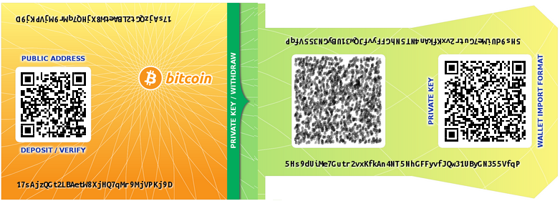 [fig:paperwallet]

An interesting case of offline key storage is paper wallets (see  ) where private keys are printed onto paper typically in the form of a 2D barcode (*e.g.,*a QR code) or as a long sequence of characters. Barcodes facilitate reading the key back into a Bitcoin client by, for example, scanning the code with a smartphone camera. Securing a paper wallet is similar to securing cash, which most users should be comfortable with. However, funds can be stolen from a paper wallet by simply observing the QR code (*e.g.,*on live television[16]), which is not possible with physical money. Thus transporting a paper wallet securely requires that the printed contents remain unobservable at all times. Users must remember that a paper wallet does not contain the funds itself, but rather enables signing authority over a set of Bitcoins. For example, if a paper wallet is discarded after funds are spent, the paper wallet still provides access to any future funds that may be sent to that address.[17]

Finally, users still need to be cautious of key churn and that spending XBT from a paper wallet does not result in XBT being sent to a change address not included in the paper wallet.

As with any long-term storage, users must preserve software capable of decoding the QR code in the event that the paper wallet generation service is unavailable when attempting to reload keys onto a device. As of writing, many Bitcoin clients as well as offline storage solution use a common “wallet import format”, which involves manipulating an ECDSA private key by performing cryptographic hashes, adding a checksum for integrity, and encoding the resulting string into Base58.[18]

### Air-gapped Key Storage

In offline storage, we assume the device or media holding private keys cannot perform computations such as creating digital signatures. We distinguish this type of storage from air-gapped storage, where wallets are stored on a secondary device that generates, signs, and exports transactions, but this secondary device is never connected to a network. When spending Bitcoins using an air-gapped device, a transaction is created from the air-gapped device and the resulting signed output transported (usually through portable media) to an Internet-enabled device for transmission onto the Bitcoin network. An air gap improves theft-resistance by never directly using a private key on an Internet-connected device. However, air gapped devices are capable of actually executing malware if infected. Malware may jump the air gap by infecting the portable media used to export signed transactions.

While not literally an air gap, hardware security modules (HSMs) emulate the properties of an air gap by isolating the key material from the host device, and only exposing the ability to sign transactions. Bitcoin-specific HSMs are under active development at the time of writing and a few have been recently released (*e.g.,*Trezor[19]).

Note that the consequences of obtaining access to the private keys are not much different from accessing a transaction-signing oracle for the wallet—both allow the current balance of Bitcoin to be stolen. However, future funds may be protected if access to the signing oracle is non-persistent.

### Password-derived Keys

Thus far, all key management solutions have required users to maintain cryptographic keys. The remaining two solutions enable users to access their Bitcoin with a password instead.

The first approach is to derive cryptographic keys from a user-chosen password (*e.g.,*using PBKDF2 RSA Laboratories (n.d.), manipulating the output to produce a valid Bitcoin private key). The disadvantage of using this approach directly is that only one resulting keypair is created, requiring the user to select a new (different) password for a new keypair.

A more robust approach is described in the Bitcoin Improvement Proposal 32 Pieter Wuille (n.d.), and is known as a Hierarchical Deterministic (HD) Wallet. HD wallets deterministically derive a set of private keys from a master secret (a randomly chosen passphrase). These keys can derive new private keys. The deterministic nature allows the password holder to view the balance, as well as spend the funds, of any sub-account derived from the password. However, if the private key on one of the sub-accounts is compromised, only the funds sent to that sub-key (or sub-keys derived from it) may be stolen.

Password-derived wallets are targeted at loss-prevention and simpler cross-device access. The challenges of preserving access to a digital file are no longer necessary as long as the wallet can be re-generated from a memorized password. The primary drawback of a password-derived wallet is that weak user-chosen passwords can be found through unthrottled exhaustive search since a fingerprint of the associated public key will be in the global public ledger if the account holds any amount of Bitcoin. Rainbow tables Oechslin (2003) for password-derived keys have been developed.[20] Finally, it remains unclear whether memorization poses an advantage over maintaining a digital file when preventing loss—a forgotten password will orphan all funds in the account.

### Hosted Wallets

A final approach to key management is to host user accounts on a third-party web service. In this case, the service maintains possession of the private keys. Hosted wallet web services provide the user with access to transactional functionalities through standard web authentication mechanisms, such as a password or two-factor authentication, and may also offer password recovery mechanisms. Bitcoin smartphone applications that act as clients to hosted wallets benefit from reduced application complexity (*i.e.,*no need to perform cryptographic operations on the device) and brick and mortar bank-like user interfaces. Currency exchange services that allow Bitcoin to be exchanged with fiat currency effectively provide this service, as do web services deployed specifically to host wallets.

The popularity of hosted wallets appears to be justified, since these services provide the closest experience to traditional online banking. However, their use has also been hampered by high profile breaches and fraud. Users’ funds have been unrecovered from services such as Mt.Gox and Bitcoinica, while popular exchanges such as BTC-E have suffered losses but fully reimbursed users. Thefts and losses from/by third party services are catalogued online[21] and include over 40 events involving losses greater than 1000 XBT.[22]

It is natural to expect hosted wallet services will become primary targets of attack since these services typically hold large amounts of Bitcoin. Offloading the task of key management to a third-party requires users to assume the risk that the service could be breached and funds lost, in exchange for a traditional online banking-style user experience.

As a counter-measure to theft, hosted wallet providers often keep only a small float of their holdings online (called *hot storage*) and store the majority of their holdings offline in *cold storage*. This has the drawback of causing delays in transactions for users if the hot storage amount is exhausted. Hosted wallet services may also allow audits, where they cryptographically prove possession of sufficient Bitcoin to match their liabilities. Another approach that falls under the hosted wallet category is a hybrid hosted wallet. Hybrid wallets use client side encryption (typically in Javascript) to encrypt all private keys and sensitive data. The web service is then only used for broadcasting transactions to the network and for displaying the user’s balance (which requires inspecting the entire blockchain).

Other than server side encryption and security measures, It uses client side encryption (javascript) to encrypt all the private keys and sensitive data with user’s password and sends the encrypted data as a random base64 string to the server. With this implementation, there is no access to the private keys and the final balance from anyone whom have access to the server’s data.[23] Blockchain.info uses this implementation for its hosted wallet.

0.9@ llccccccccccccc

*Category* & *Example* & & & & & & & & & & & &

Keys in Local Storage & Bitcoin Core& & && &&&&& & &&  
Password-protected Wallets &MultiBit& &&&&& &&& & &&  
Offline Storage &Bitaddress&&&& & && & & &&&  
Air-gapped Storage & Armory&&&& &&&& & & &&  
Password-derived Keys & Brainwallet& &&&& & &&&&&&  
Hosted Wallet (Hot) & Coinbase.com& & & & & &&&&&&&  
Hosted Wallet (Cold) & &&& & & &&& &&&&  
Hosted Wallet (Hybrid) & Blockchain.info& &&& & &&&&&&&  
Cash & &&&& &&&&&&&&  
Online Banking & & & & & & &&&&&&&

## Evaluation Framework

In this section, we systematize the major category-wide issues we have uncovered in describing the various key management approaches used by Bitcoin clients. We present an evaluation framework based on 10 criteria as shown in Table [tab:prims] and discussed in the following subsections. This framework both summarizes the advantages and disadvantages of the various approaches we have evaluated, while also providing a benchmark for evaluating future key management proposals. The framework is adapted from a similar framework for evaluating password replacement schemes Bonneau et al. (2012).

### Evaluation Criteria

We briefly enumerate the criteria used to evaluate each proposal in the framework below.

##### Malware Resistant

Malware designed to steal Bitcoin wallets and related passwords has been observed in the wild. Wallets that are not stored on an Internet-connected device, or devices capable of performing computations are considered malware resistant (), unless creating a transaction involves transferring to a computational device ().

##### Key Stored Offline

For archival storage of infrequently used keys, keys not directly accessible from an Internet-connected device—either due to being offline () or online but password-protected ()—are preferable.

##### No Trusted Third Party

All Bitcoin key management tools are trusted to a certain extent. This criteria considers the absence of a persistent trusted third party () that maintains direct signing authority over a user’s Bitcoin.

##### Resistant to Physical Theft

If the cryptographic keys are stored on some media or device that can be physically stolen, we do not consider the tool to be resistant to physical theft. Within our framework, the only tools meeting this requirement rely on a human memorized password being necessary for key recovery. These are awarded () since passwords tend to be weak and may not adequately resist unthrottled guessing.

##### Resistant to Physical Observation

Physical observation, such as observing key strokes or capturing QR codes with a camera, may result in access to a user’s Bitcoin account.

##### Resilient to Password Loss

If passwords are used (), the loss of a password could result in some Bitcoin becoming unrecoverable if it is a necessary authentication factor in obtaining access to the signing key. For solutions where funds are held by third parties, these entities could provide a password recovery/reset mechanism ().

##### Resilient to Key Churn

Assuming the client sends change from transactions to a newly created change addresses, a tool is resilient to key churn if it can maintain access to the funds even after exhausting the initial keypool (). Tools not awarded this benefit are not guaranteed to maintain persistent access to new change addresses, and any balance sent to these addresses may be lost.

##### Immediate Access

Key management mechanisms that maintain direct access to the wallet enable Bitcoin to be transacted immediately (). We award this benefit to techniques that require a user to enter a password. We omit the benefit for techniques that require data to be obtained from external storage medium or secondary device.

##### No New User Software

Some approaches require users to install new software on their system, for which the user may not have suitable permission, or software may not be developed for their specific platform (*e.g.,*some mobile platforms). By contrast, some tools can be executed from widely available software such as any standards-compliant web browser ().

##### Cross-Device Portability

A key management technique is cross-device portable () if it allows easy sharing of the a Bitcoin address across multiple devices with minimal configuration or usability issues due to complexities like key churn.

### Discussion

demonstrates that key management approaches provide varying levels of security and convenience, with no single approach being obviously superior to others. One possible takeaway from our evaluation and comparison is that users can benefit heavily by offloading key management to a trusted party (*e.g.,*hosted wallets). The lower right side of the chart focuses on usability properties that are already present in traditional financial services (*i.e.,*resilient to password loss, no new software, cross-device portability). These properties are difficult to obtain if users independently manage their keys through one of the local storage techniques. Of course, the disadvantage of trusting a third party is that Bitcoin funds are now bound by a contractual agreement between users and the hosted wallet provider, negating one of the primary features of Bitcoin: a fully decentralized currency. Users in countries lacking regulatory maturity for digital currencies should exercise caution when trusting a third party with large amounts of Bitcoin.

Based on our analysis, users can be given the concrete advice of treating digital currency much like they would treat fiat currency: keeping small amounts in ready-to-spend form (*e.g.,*local storage or online hosted walled) mimicking cash, and keeping larger sums in more difficult to access but more secure storage (*e.g.,*air-gapped or offline storage) mimicking a savings account or trust fund. Barber *et al.* Barber et al. (2012) suggest the use of “super wallets” where users essentially run their own personal bank. A super-wallet keeps keys across multiple devices and requires all (or a subset using a threshold scheme) to be present to transfer funds to sub-wallets. Pre-configured transfers of small amounts can be authorized to move funds to sub-wallets that can be used for day-to-day spending. While the idea of super-wallets is intuitive, the implementation of such a scheme could introduce high levels of complexity.

## Usability Evaluation of Bitcoin Clients

### Methodology

We used a series of cognitive walkthroughs Wharton et al. (1994) to evaluate the usability of six Bitcoin clients. Cognitive walkthrough is a form of expert evaluation where an expert (or group of experts) steps through the design to evaluate aspects of its usability. The focus of the walkthrough is on the novice user and emphasizes *learnability*. At each step, the evaluators ask three questions: Will the user see what to do? Will the user see how to do it? And once it is done, will the user know if they have performed the correct action?

We chose to use cognitive walkthroughs for several reasons. First, it allowed us to choose and compare standard tasks on disparate tools, and gave us easily compared insight into the common problems and successes of different Bitcoin clients. The cognitive walkthrough also allowed us to keep the focus on the novice user. The goal of our evaluation was to uncover problems specific to key management within Bitcoin software rather than to evaluate the usability of the clients themselves. A number of usability evaluation methodologies employ expert review. We use a cognitive walkthrough Wharton et al. (1994), which has been used previously to study closely-related subjects: public key technology Whitten and Tygar (1999) and software configuration Clark, Oorschot, and Adams (2007). A cognitive walkthrough is premised on the idea that users learn through exploration of the software, instead of reading manuals. They attempt to perform the task they want completed and rely on the interface to intuitively guide them through proper design, interface cues, and feedback.

For our cognitive walkthrough, we defined a set of core tasks involving key management that a typical user needs to perform. We compared the results of each walkthrough against a standard set of evaluation guidelines, combining aspects of an heuristic evaluation Nielsen (1992) with the walkthrough in order to interpret our results.

Each of the following four tasks was independently performed by 2 experts to evaluate each tool:

[**T1] Configure a new Bitcoin address and obtain its balance. This task involves launching the Bitcoin client (or logging into one if hosted online) for the first time. After a new address has been generated (either explicitly or transparently in the background), the user should be confident that the address’ balance is XBT 0.00000000. The user should also be able to find their receiving Bitcoin address.[sec:ct-1]**

[**T2] Spend Bitcoin. Send some amount of Bitcoin to an arbitrary (but valid) Bitcoin address. This task requires the user to create a new transaction, entering relevant information such as recipient, amount, *etc.*[sec:ct-2]**

[**T3] Spend Bitcoin from the same address as above, but on a secondary device. This task may require copying private keys to the secondary device, entering passwords on multiple devices, or logging in to a hosted wallet provider on a different browser.[sec:ct-3]**

[**T4] Recover from the loss of the main credential. In the case of locally stored keys, this task involves restoring a file from backup. Otherwise this task involves recovering from password loss.[sec:ct-4]**

Since the focus of our walkthrough was on configuration and learnability, we used a set of heuristics first developed for a usability evaluation of Tor Clark, Oorschot, and Adams (2007). We chose to use these guidelines because like the anonymity software, successfully managing Bitcoin involves the application of complex cryptographic knowledge in an everyday activity. The set of guidelines, from Clark, Oorschot, and Adams (2007), are:

[**G1] Users should be aware of the steps they have to perform to complete a core task.**

[**G2] Users should be able to determine how to perform these steps.**

[**G3] Users should know when they have successfully completed a core task.**

[**G4] Users should be able to recognize, diagnose, and recover from non-critical errors.**

[**G5] Users should not make dangerous errors from which they cannot recover.**

[**G6] Users should be comfortable with the terminology used in any interface dialogues or documentation.**

[**G7] Users should be sufficiently comfortable with the interface to continue using it.**

[**G8] Users should be aware of the application’s status at all times.**

Cognitive walkthroughs are primarily relied on when the breadth of the evaluation makes a user or field study prohibitive to run due to time and cost. We examine six Bitcoin key managers, from configuration through transaction authorization through key recovery. If the results of the cognitive walkthrough narrows the field significantly, user studies are an appropriate follow-up for detailed examination of the most challenging set of tasks within one or two solutions. Thus while our result can be considered a first-pass at the problem, we felt the richness of the result merits sole presentation.

### Evaluated Clients

Real-world evaluation of the general approaches detailed in is difficult. Thus, we select six distinct Bitcoin clients or utilities that implement the key management approaches described. For the purposes of our usability evaluation, each client was evaluated in its default configuration on OS X unless otherwise stated.

##### Keys in Local Storage

The reference Bitcoin client, Bitcoin Core Bitcoin Core Developers (n.d.), is a cross-platform client that stores keys locally (optionally encrypted with a password). Bitcoin Core is the first recommended client on the <bitcoin.org> website.

##### Password-protected (Encrypted) Wallet

We use the MultiBit MultiBit Team (n.d.) client (also recommended on <bitcoin.org>) since it provides a more convenient way to encrypt with a user-chosen password.

##### Offline Storage

We use paper wallets as offline storage. While paper wallets can be as simple as printing private keys on to paper, we select the paper wallet creation website <Bitaddress.org> Pointbiz (n.d.). Bitaddress allows users to generate new randomized keys in their web browsers, and then print QR encoded keys.

##### Air-gapped Storage

We select the Bitcoin Armory Armory (n.d.) client which includes functionality for creating an offline wallet that can be used to sign and export transactions.

##### Password-derived Keys

One of the simplest ways to create a password-derived key is on the Brainwallet brainwallet (n.d.) website. The site allows users to enter a passphrase which is converted into a private key.

##### Hosted Wallets

We use <Blockchain.info> Blockchain Team (n.d.) as our hosted wallet provider. As of writing, Blockchain.info advertises the management of over 2.5 million user wallets.

## Results

The following is the full details of our walkthroughs, which expands on the shorter version presented in the conference version of this paper.

### Keys in Local Storage (Bitcoin Core)

We begin with an evaluation of Bitcoin Core, the original Bitcoin wallet client, which uses locally-stored keys. We assume the user has downloaded and installed the Bitcoin Coreclient (it has a straight forward wizard installation procedure).

##### T1: Configure

Bitcoin Coretransparently generates a new set of addresses on first run, but shows no notification to the user that this has occurred (fails G3). The receiving address can be found under the *Receive coins* tab, but this could be easily confused with the *Addresses* tab which contains a contact list of other user addresses (fails G2).

To retrieve the account balance, Bitcoin Coremust be online and the user must wait until a full copy of the blockchain has been downloaded. Except for a small status indicator on the bottom-right side of the window that shows a small red cross in-between two black windows, there are no other messages to show the user that the application should be online. Due to the size of the blockchain, this may take hours to days to complete. A status bar displaying “Synchronizing with network” shows the progress of the blockchain download (achieves G8), but the terminology may be too technical for novice users, With a mouse over the icon, it says ‘0 active connections to bitcoin network’ which is likely unfamiliar language that does not help resolve the error (fails G4 and G6). Once the blockchain has been downloaded, the balance is displayed on the *Overview* tab (achieves G3).

##### T2: Spend

Spending Bitcoin is straightforward since the keys are readily available to the Bitcoin Coreclient. Users spend Bitcoin by navigating to the *Spend* tab (achieves G1 and G2). Since our focus is on key management, we do not evaluate the actual completion of transactions (which may have additional usability issues). We focus on ensuring the key is available to the software tool (which is not so straightforward with *e.g.,*offline storage).

##### T3: Spend from Secondary Device

Installing Bitcoin Coreon a secondary device creates a new set of keys. Users may not understand that the keys must be copied to the secondary device (fails G1), and if so, what file must be copied (fails G2). The correct procedure is to back up the wallet.datwith the ‘backup wallet...’ option in the ‘File’ tab of the first installation and chose a directory to save the wallet.dat. Next the user must securely transfer this file to the secondary device, and no guidance is provided on how to do this (fails G2) or the dangers of transferring it through an insecure mechanism (fails G5).

Assuming the user has transferred wallet.datto the secondary device, she could try looking for import options in the newly installed wallet client, or drag and drop the wallet.datinto the client, but she would fail to do so as no import option exists. The documentation is inadequate here as well—there is actually nothing in the help menu except a debug window that is for advance user to tweak the application (fails G2 and G6)!

The only mechanism to activate the wallet on a secondary file is to actually overwrite wallet.daton the secondary device with wallet.datfrom the first. It is unlikely any novice user would be able to complete this step. It is actually even difficult to find the path to copy wallet.datto on the new device—this could be possible by searching the local file system for wallet.dat, which might not succeed due to non-searchable system reserved folders or not knowing the exact file name (spotlight does not return any result for wallet.dat). More likely, the user will search online.[24] On OS X, the path is /Users/User/Library/Application Support/Bitcoin/wallet.dat.

The next step is to replace the new wallet.datwith the one from the primary device. It should be noted that the name of the file should be exactly wallet.datfor the Bitcoin Coreto be able to read the file. Some of errors that the user might encounter during this procedure are:

* The user might copy wallet.datfrom the primary device wallet client path instead of the one exported through the back up option. This could cause a corrupted wallet.datthat is not readable by the secondary device’s Bitcoin Core. This is due to Bitcoin Core’s procedure to lock wallet.datwhile it is in use. The error is recoverable by repeating the process correctly (fails G4).
* User should wait for the Bitcoin Coreon the secondary device, to download and sync the Blockchain from the P2P network to be able to authorize a transaction.
* On the secondary device, the final balance might be wrong and there would be the need to resynchronize and rescan the blockchain to have the correct final balance (fails G3).

Finally, this process must be repeated if either client exhausts their keypool. If both do, there is no way to merge the new keys in the keypool, and replacing one wallet.datwith the other will lead to unrecoverable funds (fails G5).

We note that replacing the key file may require a re-scan of the blockchain to display the correct balance (fails G3).

##### T4: Recovery

If only one device is used, there is no way to recover from loss of the key file (*e.g.,*due to a disk failure, file corruption, or loss of the device itself; fails G5). If the user backed-up the key file, the process for recovering from loss is equivalent to that of T3 above.

### Password-protected Wallets (MultiBit)

Although it is possible to encrypt the wallet.datwith a password in Bitcoin Core, it is not the default option nor is there any cue to do so. Instead we evaluate the MultiBitclient, where one of the recommended first steps is to password protect the wallet file. MultiBitis a popular client in particular for its use of SPV[25] for lightweight blockchain validation that can complete within minutes instead of, relative to Bitcoin Core, days.

##### T1: Configure

On first run, a welcome page contains an explanation of common tasks that can be performed with MultiBit—where the send, request and transaction tabs are and how to password protect the wallet file (achieves G1 and G2). The client provides help options for other functionalities with direct and non-technical guides (achieves G6).

MultiBitautomatically generates a new receiving address on first run, but does not notify the user (fails G3). Reading the newly generated address requires navigation to the *Request* tab, which displays “Your address” as well as a copy of the QR code of address.(partially achieves G2).

The interface shows the status of the program (online, offline, or out of sync) on the bottom left status bar, the balance of the user’s wallet on the upper left, and the latest price of bitcoin on the upper right of the window (achieves G8). The interface seems to minimize jargon and technical vocabulary (achieves G6). As it is mentioned on the *welcome page* of the application, every option in MultiBithas the ability to show help tips by hovering the mouse over that option (achieves G6 and G7).

The displayed balance is not necessarily current until synchronization is completed, however there is no direct cue in the balance area indicating this (achieves G8).

##### T2: Spend

The user must navigate to the tab labeled *Send*, as instructed on the welcome screen (achieves G1 and G2). If the client is not synced, the send button is disabled (achieves G4). If it is synced, the user fills out the transaction details, destination address and amount and clicks send. The client prompts the user for the decryption password (achieves G2). An incorrect password displays the error ‘The wallet password is incorrect’ but otherwise allows immediate and unlimited additional attempts. Entering the correct password authorizes the transaction (achieves G3).

##### T3: Spend from Secondary Device

On the primary device, the user must navigate to the *Options* menu, and select *Export private keys* under tools (fails G1 and G2). The interface displays a wizard requesting an export password as well as a file system path for the exported file to be saved. If the user attempts to save the exported file without password, a warning is displayed in red: ‘Anyone who can read your export file can spend your bitcoin’ (achieves G5). By having a password-protected file exported, the user can securely copy the file to the secondary device with some protection against interception. After clicking to export, wallet file is saved in the given path and the client checks that the file is readable (achieves G4 and G5).

On the secondary device, the user must select *Import private keys* from the *Options* menu. After selecting the previously exported file, the wizard confirms the completion of the import (achieves G4) and the balance is updated to reflect the newly imported keys. The user can proceed to create a new transaction as in T2. MultiBitsends change to the originating address, so keypool churn is not an issue.

##### T4: Recovery

. As with Bitcoin Core, recovery is not possible if no backup of the wallet file was made. Creating a backup and importing it follows the same procedure as T3. As expected, both the password and the backed up wallet are necessary for recovery.

### Air-gapped Key Storage (Armory)

Bitcoin Armoryis an advanced bitcoin wallet that allows the wallet to be stored and managed on an offline device, while supporting the execution of a transaction through an online device. Armoryis also used on the online device to obtain the blockchain and broadcast the transaction created on the offline device. It is possible to use some other online application to implement the airgap, however this is the recommend method and the one we will consider.

##### T1: Configure

The user begins by installing Bitcoin Armory on the offline computer. On the start, the welcome page offers the option to ‘Import Existing Wallet’ and ‘Create Your First Wallet!’ (achieves G2). The user creates her wallet, with passphrase-protection being a mandatory option. Armory asks to verify the passphrase and warns the user not to forget her passphrase (achieves G5). After this step, a backup window pops up with the options to print a paper wallet or save a digital backup of the wallet, and also warns the user if he decides not to backup his wallet (achieves G5). After proceeding, the user must click on ‘Receive Bitcoins’ to prompt the client to generate the bitcoin address in the wallet file (fails G3,G4). By contrast, most clients do this step automatically on launch.

In order to see the balance of the account, the device must be online and synced (fails G2). Thus the user must use the online device, not the offline device, to check her balance. Users can click on the ‘Offline Transaction’ button, which offers a short documentation of the steps to be taken to sign a transaction and in doing so, explains the offline/online distinction relevant to checking a balance. Within the ‘Wallet’ window, there is an option to ‘Create Watching-Only Copy.’ The language is difficult (fails G6): this option allows a copy of only the bitcoin addresses to be exported, not the private keys, for use on the online computer to display an updated balance for each address. The exported file can be copied to the online computer.

We assume the user has installed Armoryon the online computer. It should be noted that Armory only works side-by-side with Bitcoin Coreand uses Bitcoin Coreto synchronize and read the downloaded blockchain (fails G1). A pop-up window will alert the user when ‘the blockchain’ has been downloaded (partially achieves G3). Armorydisplays a ‘Connected’ cue in green in the bottom-right when it connects to Bitcoin Core. Upon launching Armory, the user should click on ‘Import Existing Wallet’ and she is prompted to import either a digital backup or watch-only wallet. She should chose the watch-only back up file that has been copied from the offline computer. After the application is done syncing, the balance is displayed on the main window under ‘available wallets’ (achieves G8).

**T2 & T3: Spend**. With an air gap, the distinction between primary and secondary devices is less clear given that the basic setup itself includes two devices: one online and one offline, but authorization of transactions uses the offline device. To authorize a transaction, the user may begin from Armoryon the online or offline device (may not fully achieve G2). On the either device, the user should click on ‘Offline Transactions’ in the main window which displays a very detailed description of the steps involved (achieves G1, G2, and G6). On the online computer, the user clicks the option: *Create New Offline Transaction*. The user will be asked to enter the transaction details to generate an unsigned transaction as a file. The user must transfer this file to the offline computer. As mentioned in this step’s documentation, the unsigned transaction data has no private data (the exact data will ultimately be added to the public blockchain) and no harm can be done by an attacker who captures this file (achieves G5) other than learning the transaction is being prepared.

On the offline computer, the user clicks on *Offline Transactions* and then *Sign Offline Transaction* which prompts the user for the unsigned transaction data file. Armoryasks the user to review all the transaction information, such as the amount and the receiving addresses (achieves G5). By clicking on the *sign* button signed transaction data can be saved to a file. Text at the top of the window describes the current state of the file (signed) and what must be done (move to online device) to complete the transaction (achieves G1 and G2).

The signed file should be transferred to the online computer and be loaded through the same offline transaction window. When a signed transaction is detected, the *Broadcast* button becomes clickable. By clicking on broadcast, the user can once more review transaction details, and receive confirmation that the Bitcoins have been sent (achieves G3 and G8).

##### T4: Recovery

Like Bitcoin Coreand MultiBit, Armoryrequires a backup of the wallet to have been made. Without this backup, recovery is impossible. Armoryencourages backups at many stages (achieves G1 and G2). Armoryprovides many prompts for the user to back up her wallet keys. At the time of creating the wallet, there are multiple windows and alerts conveying the importance of a back up, with options for digital and paper copies. Even if user decides not to back up her wallet at this stage, she is provided a persistent ‘Backup This Wallet’ option (achieves G4). In the backup window, there are a number of options to back up: a digital copy, paper copy, and others. By clicking on the ‘Make Paper Backup’ for example, the paper backup is shown to the user containing a root key that consist of 18 sets of 4-characters words and a QR code. To restore the paper wallet backup, on the main page, the user can click on ‘Import or Restore Wallet’ and select ‘Single-sheet Backup’ option. She will be prompted to input the Root Key from the paper wallet. The ‘Digital Backup’ option provides an unencrypted version of the wallet file that can be securely stored on portable media. Recovering from a lost wallet with a digital backup involves selecting ‘Import Digital Backup or watch-only wallet’ from the ‘Import or Restore Wallet’ window as explained in core task 1. Armoryalso enables the user to test the backups to ensure there is no error in the backup file (achieves G5) through the same import procedure.

### Offline Storage (Bitaddress)

There are different methods to use for offline storage of a bitcoin wallet. For our evaluation, we consider the use of a paper wallet. Specifically we use the Bitaddressweb-service, a popular Bitcoin paper wallet generator. Many paper wallet generators exist, however Bitaddress, at the time of writing, is the first search result for ‘bitcoin paper wallet’ on Google.

##### T1: Configure

Upon visiting the <bitaddress.org>, the user is asked to move the mouse or enter random characters in a text box to generate a high-entropy random seed to be used to generate a private key associated with the Bitcoin address (achieves G1 and G2). Once enough entropy has been collected, the site redirects the user to a page that shows the receiving Bitcoin address and it’s associated private key (achieves G3). The public key (Bitcoin address) is labeled *Share* in green text and the private key *Secret* in red (helping achieve G5). In general Bitaddressuses non-expert terminology and simple instructions (achieves G6). To ensure the web service does not retain a copy of the users’ key (the generation is done client-side in Javascript), the user should complete the process offline.

After printing, the user has a bitcoin receiving address and, as mentioned in the documentation, the balance can be checked through a Bitcoin Block Explorer[26], such as <blockchain.info>. The user uses this site to search for her bitcoin address and checks her balance. Although it is documented that the private key must remain secret, a user may inadvertently expose the private key by placing the paper wallet where it can be observed or by searching the website for the private key instead of the public key.

##### T2 & T3: Spend

Since the keys are printed on paper, there is no difference between authorizing from a primary or secondary device so we collapse the analysis of core tasks 2 and 3.

To send funds from a bitcoin address that has been stored on a paper wallet, as it is mentioned in the documentation, the user has to import her private key in one of the wallet clients available, such as Armoryor the Blockchain.infohosted wallet discussed below. If the user inputs the private key address into a client that returns change to newly generated addresses, she must export these new addresses to a new paper wallet or she will lose the surplus when she removes the wallet from the client (fails G5). If the user fails to remove the wallet from the client, a second copy is maintained increasing her exposure to theft (but reducing her exposure to key loss).

The process to import a key from a paper wallet depends on the client. For Blockchain.info, after making an online account, the user navigates to the ‘Import/Export’ tab and uses the option ‘Import Using Paper Wallet, Use your Webcam to scan a QR code from a paper wallet.’ It is also possible to type in the private key in the ‘Import Private Key’ text field. After this step, the address now is hosted on the online wallet and is the same as core task 2 in the Hosted Wallet section (Section [hosted transaction]) below.

##### T4: Recovery

Loss of a paper wallet makes the funds unrecoverable (fails G5). Bitaddressprompts the user to acknowledge this fact (also mentioned in its short documentation) when creating a paper wallet (achieves G1).

### Password-Derived Keys (Brainwallet)

The most popular and complete implementation of a deterministic wallet with password-derived keys, at the time of writing, is Brainwallet.

##### T1: Configure

The Brainwalletwebsite displays by default a pre-generated address corresponding to an empty passphrase. The passphrase input field displays “Long original sentence that does not appear in any song or literature. Never use empty passphrase. (SHA256)”, but there is no corresponding documentation explaining the purpose of the passphrase or how it relates to the generated key (fails G1, G2, G6). As characters are typed, a new key is generated. User may not notice that generation of keys is happening dynamically, possibly preventing the user from noticing that the task is complete (fails G3). The user should replace the default passphrase with her own, hopefully ensuring her passphrase is not a commonly used phrase or anything that could be brute forced by an offline dictionary attack[27] as this passphrase is sufficient to access the funds stored in the resulting bitcoin address. On entering the desired passphrase, the public and private keys are displayed on the same page.

Once the address has been generated, retrieving the balance of that address requires the use of an external service, but no suggestions are provided on the site (fails G1 and G2). The interface does display a number of other fields (*e.g.,*additional encodings of the public key) which may not be meaningful to novice users (fails G6 and G7).

##### T2 & T3: Spend

Spending Bitcoins from a password-derived wallet requires the user to import the private key into another client. The user should experience similar usability challenges as those detailed in the Offline Storage client above.

##### T4: Recovery

Forgetting the password of a password-derived key leads to funds becoming unrecoverable (fails G5). Users will typically return to the same website (*i.e.,*the Brainwalletwebsite) to extract private keys, but this may not be possible if the site is inaccessible (fails G5).

### Hosted Wallets (Blockchain.info)

A variety of online services offer online hosted wallet clients to users. We use the popular Blockchain.infowebservice for our evaluation.

##### T1: Configure

The user navigates to the Blockchain.infosite and creates a new wallet by providing an email address and a (min) 10 character password (achieves G1 and G2). A message warning the user about the importance of not forgetting the password is displayed during registration (achieves G5). Next, a *Wallet Recovery Mnemonic* is shown to the user as a backup in case the password is forgotten. The balance and address are immediately displayed (achieves G3).

##### T2 & T3: Spend

Hosted wallets are accessible from any web browser, so creating transactions from many devices is straightforward. The user logs in to the site, clicks *Send money* (achieves G1 and G2). After filling in the required fields, the user is informed that the Bitcoins have been sent (achieves G3). Some of Blockchain.info’s error messages may be too technical for novice users. For example, *No free outputs to spend* is displayed when transactions are created without sufficient funds (fails G6).

##### T4: Recovery

To recover from a forgotten password, a wallet recovery mnemonic may be provided on the login page. By clicking the *Recover Wallet* button, the site will ask for the mnemonic phrase and the email address send the new credentials (achieves G1 and G2). Another recovery option is to proactively make backups and import them in case recovery is needed. To do so, in the main wallet page, user has to click *Import/Export* and exporting either an encrypted or unencrypted backup. Unencrypted backups should be kept in a secure storage. There are different options for the unencrypted backup procedure that could confuse the user and might result in an unrecoverable backup (fails G5 and G6)—the back up is shown on a text field that the user has to copy and paste into a text file to be able to save it on her computer (fails G2, G3 and G7). To restore the backups, there is an ‘Import Wallet’ option.

## Discussion

### Metaphors

Bitcoin naturally invites a metaphor to traditional currency. This metaphor is often used in the clients (*e.g.,*send coins, receive coins, wallet), but does not always support their usability. The coin metaphor fails in both of the ways that user interface metaphors traditionally fail Carroll, Kellogg, and Mack (1987): aspects of Bitcoin transactions do not easily fit the coin metaphor, and conversely, encourages users to overextend the metaphor. Both of these lead to confusion on the part of users.

One way in which the metaphor of physical coins fails is in the sending and receiving of Bitcoin. In the physical world, the same physical token is almost always used to represent the same unit of currency (*i.e.,*giving money to a friend involves handing them the coin). However, when Bitcoins are exchanged, the private key is not transferred along with the balance. Private keys remain in possession of the sender, and can be reused and associated with new coins at a later time.

Many of the evaluated clients use the word “Send” to describe authorizing (digitally signing) a transaction, and private keys are not mentioned in any of the evaluated clients at the moment of transaction. It may appear counter-intuitive that this is a bad thing, but never mentioning the existence of keys may cause further confusion. The password-protected wallets, (*e.g.,*Multibit) require the user to input their password, but do not clarify the reason for the password.

Addresses are another metaphor that relate to the issue of transacting. The evaluated clients use the word “Address” to refer to the public key associated with a private key held by some user. This seems to be a relatively successful metaphor: it emphasizes the public nature of the public key, and also divorces the user’s perception of a relationship between the public and private keys. To momentarily extend the metaphor, a user is accustomed to the idea that they will need to share their address in order to receive an item. However, the private key is more akin to the key to their mailbox, and a user would never think that they should share their mailbox key in order to receive mail to an address.

Another pervasive metaphor in the evaluated clients is the Bitcoin “wallet”, where the user’s Bitcoins are stored. The wallet metaphor is deeply entrenched in the foundations of Bitcoin. The reference client, *Bitcoin Core*, stores private keys in a file named wallet.dat and the *MultiBit* client invites users to “create your first wallet!” on first launch. The hosted clients also use the metaphor; Blockchain.info prominently shows a Wallet tab, under which users are invited to ``Create My Free Wallet". The wallet metaphor is descriptive for users, but fails to encompass the complexity of a user’s collection of keys. In reality, the Bitcoin wallet contains private keys, but the term wallet is used to describe both the file storing the private keys, and the main interface of Bitcoin clients (as in Blockchain.info). This main interface sometimes includes a variety of other information, such as transaction history, address book, currency exchange rates, *etc.*

### Abstractions

Abstraction and automation are complex issues for security software. Often, security is too complex to be completely automated, and the problem cases are often punted to the user (*e.g.,*in the case of TLS certificates Biddle et al. (2009)).

On first run, all of the evaluated clients transparently generate keypairs without informing the user. This behaviour continues as new transactions are made, where clients generate new addresses with no user notification (*e.g.,*for receiving change). It is unclear how well this abstraction works: while users do not need to be burdened with the knowledge of each private key, there are still situations in which a user might need to manage those keys, and the abstraction prevents users from doing so. Recovery from key loss depends on the existence of an up-to-date backup. While backup sounds like a simple task, in many of the evaluated clients, it involves finding the right menu (MultiBit), or the right file (Bitcoin Core). Some clients do prompt the user to back up their wallets (*e.g.,*Bitcoin Armory), but with the private keys so completely abstracted away, users may not even understand what they are backing up, or why. Key churn, and the consequent need for semi-regular backups complicate the issue even farther. The abstractions made in Bitcoin clients are sometimes beneficial for users, such as in the case of displaying a user’s balance. A user’s Bitcoin balance is typically made up of many small amounts corresponding to many private keys. However, most of the evaluated clients abstract these balances into a single figure. This highlights a usability disadvantage of paper wallets – the user must manage these multiple balances manually, and there is no method of seeing an aggregate balance when multiple paper wallets are in use.

### Technical Language and Content

When performing our evaluation, we identified multiple occurrences of highly specialized or technical language used in the Bitcoin clients. These instances of technical language are confusing, particularly to novice users who are unlikely to be aware of either the jargon, and for whom the language will not help clarify the issues. The language itself highlights the complexity of the tasks associated with Bitcoin, and the difficulty of explaining them simply.

Examples of such language included messages in MultiBitand Bitcoin Corethat referenced the client being “out of sync” or “synchronizing with network” (see Figure [fig:btcore-sync]) referring the process of downloading a full copy of the blockchain or retrieving relevant blocks from a trusted peer. A related message in MultiBit(Figure [fig:multibit-sync]) and Armorydisplayed the number of blocks that had been downloaded, as well as the number of connections to the Bitcoin network. These messages are intended to communicate that clients may benefit from faster transaction notifications when connected to more peers, but since peer connectivity is difficult for users to control, there is little benefit in communicating these ideas with the user. Similarly, the number of blocks independently has little significance to most tasks performed by an end user. We suggest that not only could this language be clarified, but that the interfaces could also streamline the amount of information that is presented to the user on every screen.

We also noticed that some clients used highly technical language when they could have used the metaphor to provide a simpler explanation to users. When attempting to authorize a new transaction on Blockchain.infowith insufficient funds, the web interface displayed “no free outputs to spend”. This error message is confusing, and would be more easily understood if it referred to the lack of coins instead of the lack of outputs. Similarly, essential actions such as importing or exporting keys were often buried behind advanced or debug menus.

In the evaluated clients, there were often few resources to which users could turn for help. In the cognitive walkthroughs, the answer to the question ``will the user know what to do?" was almost always unclear. Interface cues and features such as tool tips, wizards, or other contextual help were almost entirely lacking. Some actions were guided (*e.g.,*Multibit’s prompted backups or create your first wallet), but many actions such as obtaining the balance of a paper or password-derived address were unsupported by help or documentation.

## Conclusion

Bitcoin’s usability limitations, particularly those related to key management, pose challenges to its rising popularity. In our evaluation, we found that developers in the Bitcoin ecosystem are making innovative attempts at solving the decades-old problem of usable key management. While some of these techniques seem promising, we find that tasks involving key management can be mired in complex metaphors and confusing abstractions.

Further investigation is needed to better understand and address these issues. A user study would give insight into exactly how these problems are affecting users and it would be interesting to investigate how expert users are (apparently successfully) handling these challenges. Bitcoin presents a new opportunity for public key cryptography to become mainstream, and our evaluation is a first step towards achieving usable key management in decentralized cryptocurrencies.

We covered All the available Bitcoin Wallet clients in this chapter, in the next chapter, we would try to evaluate all the available point of sale methods for a small business to accept bitcoin payments.

# Emperical Study of Bitcoin Point of Sale

## Introductory Remarks

On previous chapter we evaluated all the existing Bitcoin wallet clients for the user, in this chapter we would survey and evaluate the existing Bitcoin payments for the business to accept bitcoin and use SCRAM requirement engineering method to develop the best suitable Point of Sale (PoS) for a small business.

One interesting aspect of bitcoin is that there is no identity backing up the currency but everyone who uses it. As a Bitcoin enthusiast one of the goals is to have more places to accept Bitcoin, however so far this has been an issue for the business owners to implement a simple, yet fully functional Point of Sale (PoS) to be able to accept Bitcoin as a method of payment. In this chapter I discuss my approach to come up with a solution and implement the Bitcoin PoS in a Cafe in Montreal[28].

In order to do so I started by going through the requirements of a payment system in a small business, and then browsed through the available options and if they meet our requirements. Then I came up with a framework to compare these PoS with different aspects in Security, Privacy, Usability and Deployability categories. In the end, we implemented a customized PoS for this small business that could be used in any other similar businesses as the payment method to accept Bitcoin.

## Requirments Engineering

Requirement engineering is the process of defining, documenting and maintaining requirements and is a subfield of software and system engineering, the term was first used in 1979  Alford (1979) and then became a general term in with the publication of an IEEE Computer Society tutorial  Dorfman (1990). Requirements Engineering is the first phase of waterfall software development process  Rocye (1970). Depending on the type of the system being developed, the methods differ.

Probably the base way to analyze the requirements of a small business is to model real world descriptions and stories in scenarios. Scenarios are basically examples of real world experiences that we could use to model what is needed in the system. That is why we chose a scenario-based requirements engineering method named SCRAM.

### SCRAM

We used SCRAM (Scenario-based Requirements Analysis Method) Sutcliffe (2003) as our framework to gather the requirements of this system. SCRAM defines four phases of requirement engineering and has been shown to be a great requirement engineering framework.

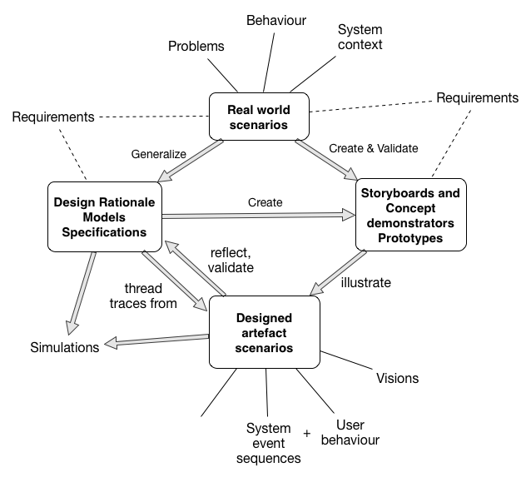

Role of scenarios and their relationship to requirements specifications and prototypes  Sutcliffe (2003)

This method consists of four phases:

* **Initial requirements capture and domain familiarisation:** This is done by interviewing and fact-finding techniques to have a full understanding of how the business works.
* **Storyboarding and design visioning:** This is done by making storyboards and walkthroughs to show to the client and get feedbacks on feasibility.
* **Requirement exploration:** This uses the early prototypes and designs to get critiques from the client and validate the requirements.
* **Prototyping and requirement validation:** This is done by developing fully functional prototypes and continues refining the requirements until the product is acceptable by the client

*Phase 1: Initial requirements capture and domain familiarisation.* We asked the cafe owner, two employees and two customers for a scenario involving Bitcoin payment in the cafe to create the common “normal use case”. The differences between the scenarios were insignificant thus the exceptions to this normal use case are not valid. One exception was power failure, and because even the current accepted payment methods such as Visa would fail we would not consider such a scenarios, that being said, there are methods to mitigate this that will be discussed, such as browser based PoS)

As the cafe already have other payment systems in place, there is no need to go through the cafe’s business plan or any other specification to check for conflicts. The only difference is implementation of another payment system at cashier [fig:phase1]. However, there are requirements in the PoS system that needs to be met, such as realtime bitcoin to fiat money exchange rate and obvious alert of successful or failed payments.

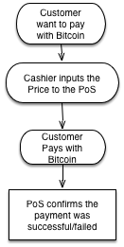

Phase 1 - Normal Use Case

*Phase 2: Storyboarding and design visioning.* Based on the information gathered from Phase 1 and further analysis such as user survey on the design, we can develop the storyboard, see figure [fig:storyboard]. More technical requirements will be explained later [section XX].

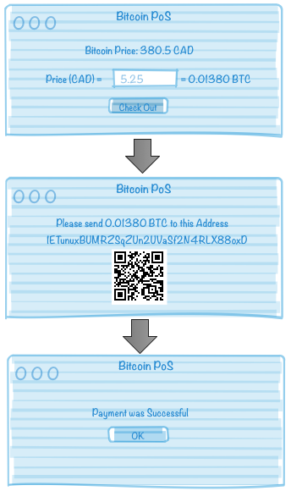

Storyboard - User Interface first sketch

*Phase 3: Requirements exploration.* We developed a concept demonstrator, capable of doing a simple bitcoin payment. The bitcoin exchange rate and amount of transaction were hard coded and the transaction would be executed manually. We asked the employees to run a mock purchase with the demonstrator to see how they would interact with the system and got the feedback. As the bitcoin concepts might be ambiguous for the new user, there should not be any interactions for them with bitcoin concepts and terminology. After the transaction was done, the owner pointed that there is the need for a central logging system that could be checked from time to time for the daily transactions.  
*Phase 4: Prototyping and requirements validation.* We used the feedbacks gathered from phase 3 to make the first prototype. This had the bitcoin exchange rate retrieval automatically and the employee only had to input the dollar amount in the PoS, this made it possible to keep the bitcoin terminology out of the scope of the training for the employees. However on the first prototype, to show the success payments, the system was showing the transaction a blockchain explorer[29], using web-based APIs. This was not clear for a novice user about the state of the system. On the second round of prototyping we designed an interface to show that the transaction has been broadcasted to the bitcoin network and would use that knowledge to inform the employee of the state of the payment.

## Decision Framework

We propose a framework specialized for Bitcoin point of sale systems to score the system with a set of requirements based on usability, deployability, privacy and security. These are not a final set of requirements for a general purpose system, however in the case of Bitcoin payments for a small business these will suffice.  
We start by using our scenario based requirement engineering approach and adding the required non-functional requirements (*e.g.,*payee’s privacy, data encryption). Then we will use these requirements to score each systems described in this section and gather the result in Table  [tab:method-comp]. For simplifying the figure we use three score indicators, () for a complete score on the requirement, () if the requirements has not met completely and empty space if it is not satisfying the need. For some of the requirements the scoring system might be confusing (*e.g.,*cost to run) that will be explained later.

### Usability

There are different aspects of usability that should be considered. One is how the PoS is accessible for the employees and the other is technical matters of the implementation.

* **User Friendly:** The payment process should not be technical or complex for a cafe employee, or just a simple training for the employee would be enough for them to be able to accept Bitcoin. Also, There should be a clear, mutual understanding when the payment is finalized.
* **Time-Efficient:** the process of payment should not take significant amount of time more than the common payment systems such as Visa payments.
* **Fair Exchange Rate:** there should be a easy and fair approach for the payer and payee to have a deal on fiat currency to bitcoin exchange rate.
* **Availability:** all employees should be able to do the bitcoin payment process without the need to know any credentials

### Deployability

We use this category to state the requirements regarding the implementation of the system and branching. In the case of small businesses, the ability to manage multiple branch systems might not be a really important aspect. That being said, we will score the systems for future work and hence to have a more complete framework.

* **Cost to Run:** PoS should be implemented in a way that is accessible with one of the currently owned devices of the cafe such as the cashier computer, the PoS terminal[30] or mobile devices. There should not be the need of buying new hardware or an expensive software. For this requirement, we would score a () score to a free of monetary cost system, and a () score to a moderate amount of spendings.
* **Branching** The ability to install the point of sale on multiple branches or modify the existing systems.

### Privacy

Privacy is important in the payment system in the sense that no information should be leaked from any of the payers nor payee to the other party, This should be one of the fundamental requirements for any payment system.

* **No Information leakage:** There should not be any sensitive information available to the customer when she wants to pay with Bitcoin.
* **Payee’s Privacy:** The payer should not be able to see how much the payee has received prior or after her payment but just her own amount of payment.
* **Payer’s Privacy:** The payee should not be able to see how much the payer owns. This is one of the challenges that has not been fully solved  Androulaki et al. (2013), it is the payer’s responsibility to manage her funds and addresses in a sense that there is no privacy leak.
* **Authenticiation:** The ability to see the payments list only available for the manager via a password protected panel.

### Security

Security might not be the cafe owners priority as he might not have a deep understanding of this concept in payment systems nor Bitcoin sphere. Anyhow it is one of the most important aspects in any financial payment systems and also usable bitcoin applications. Security of the system represents more than just the PoS code, it includes the environment that PoS is being used, the people using the software and the operating environment of the software Haley et al. (n.d.).

* **No 3rd-Party Trust:** There should be as less 3rd party trust as possible to accept and hold the bitcoins.
* **Data Ecnryption:** In the case of any attacks on the service there should be security measures that makes sure the attacker will not be able to have access to the private keys and transfer of the bitcoins.
* **No Software dependency:** The system should use as less dependencies as possible to minimize the attack vector on the server. This also falls under deployability category as more dependencies could lead to the need of having a more complex system for implementation.

## Evolution of PoS proposals

I will first go through the available options and why we chose to develop a custom PoS for this purpose.

There exist multiple payment systems that most of the suit the online markets (*e.g.,*e-commerece) and not a physical point of sale.[31] We list all the available approaches to accept Bitcoin payments for a physical business, and not as an e-commerce business.

### One Bitcoin address - QR Code

One of the introduced ways for small businesses to accept bitcoin is to hold one bitcoin address and print out the QR code of that address near the cash register. In this way, the customer could scan the QR code and input the dollar value on his bitcoin wallet and pay the business with the equivalent bitcoins.  
**Usability** It is not user friendly as it puts the employee in a position that she needs to know how bitcoin transactions work and she needs to prepare,receive and checks the payment manually. This makes the time spent on the payment longer than normal payment systems, same goes for the fair exchange rate, She should come to an agreed exchange price with the customer and this needs a deeper understanding of bitcoin and finance. Thus a technical training is required for each employee responsible for handling bitcoin payments.

**Deployability** The cost to implement this method is almost zero, in monetary and time value. However, as mentioned in usability section, the time spent on each transaction fails for regular use. In case there are multiple branches, more print outs suffice to have multiple point of sales.

**Privacy** This method provides no privacy for the seller. As all the bitcoin transactions are publicly available in the Blockchain, anyone with the knowledge of the receiving bitcoin address could see all the received payments, thus anyone could have access to the reporting page that is the payments received by the printed address.

**Security** Other than the system holding the private key, not much of security concern is applicable to this approach. The private key should be kept in a secure place, preferably a cold storage unless the funds should be transferred to another address (*e.g.,*to exchange for cash).

### Hardware Terminals

There are multiple hardware terminals available for accepting bitcoin, however due to the high cost to run (*e.g.,*coinkite[32] PoS are for sale at starting price of 970USD), they have not been used in most of the small businesses and have not been reviewed a lot. Also the fast changing technology made most of the terminal provider companies to move to mobile or web-based solutions.

**Usability** The interfaces of each of the provided terminals are different, the most popular ones mimic the look and behaviour of a normal point of sale terminal used by credit card companies. However adding a new device to the payment routine, would make it less user friendly and rises the need for a training for the employees. The time and availability of the payment through a hardware terminal should be the same as the credit card payments if not any lower. The customer, nor the payee have any control over the exchange rate and it is provided by the PoS terminal operator.

**Deployability** Due to the high costs these devices have, they would score low on our framework. Also in case there are multiple branches of the business, there should be one devices bought for each branch, this makes the costs even higher.

**Privacy** Accepting bitcoin with a hardware terminal should persevere the privacy the same as the regular credit card terminals, however the payees privacy depends on the implementation of the Bitcoin payment system.

**Security** The payee has no control over the private keys nor holds the funds, thus he needs to trust a third-party company that provided the terminals to keep the funds safe, and will receive the payments upon the agreed time frame with the probably small transaction fees. As for other aspects of the security, we assume the back-end implementation keeps the private keys encrypted and secure. There are security risks involved in adding a new hardware or software to the cashier’s computer that will fall out of the scope of this chapter.

### Online Merchant Services

Most of these services are focused for online businesses and don’t have implicit implementation for a physical payment system. One of the most famous ones, by the time of writing, is Bitpay[33] that takes 0% fees unlike some others competing companies, but they all have their own advantages. One other similar company is Coinbase[34] that charges 1% on exchanging bitcoins to fiat currency.

**Usability** Implementing a Bitpay payment is straightforward and easy to implement. There are not many jargons or technical options for the employee. They have their own exchange rate that the business owner could set to exchange to cash as soon as he receives payments, this will remove the possible effects that Bitcoin price volatility could have on the payments.

**Deployability** The only thing required by this approach, is a smart phone or a small computer that users could interact with and browse to bitpay payment page, preferably with a touchscreen for easier price input and user interaction, as the interface is designed for touchscreen devices (Mobile interface)

**Privacy** Bitpay has taken the privacy too serious. As they generate a new address for each transaction, the payees privacy is safe, however there has been reports on account suspensions because the payments were coming from a flagged bitcoin addresses (*e.g.,*blackmarkets[35] or localbitcoins[36]), in the sense that there was malicious activities on that bitcoin address such as money laundry or buying drugs from online site. In this case the privacy, as the sense that we are evaluating, is being held but maybe not in he aspects needed in a payment system.

**Security** Every aspect of the payment system is implemented by Bitpay, they offered one of the most secure payment systems so far and there has been no big hacks reported. However, user has no control over his private keys and all the keys are being stored on Bitpay servers, this means complete trust to a third party.

### self hosting wallet

Another option is to run a customized wallet as the point of sale service. There are multiple options for this case and it depends on the features needed for managing the bitcoin addresses. it’s still possible to use a 3rd party for some of the functionalities like address generation or PoS interface. For the sake of simplicity I cover two popular methods, one using Mycelium Gear and the other a full custom self-hosting wallet using available open source softwares.

### Mycelium Gear

Mycelium Gear[37] is a service offered by Mycelium group that offers a widget as an interface to the user and a service that would use the BIP32 public key provided on the Admin panel to generate new addresses securely. This means that they don’t hold any private keys, but still uses the same path for address generation as their Mycelium Mobile wallet uses .

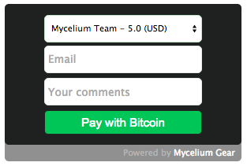

Mycelium Gear Widget

**Usability** Mycelium Gear is designed in a way to suit e-commerce businesses needs and needs to be customized to suit a physical business PoS. There are no fees related to using this service, the only usability issue is that the BIP32 path that is generated by the PoS widget sometimes is different that the ones being checked by the mobile wallet client, so there might be some payments missing from the available credits in the application that is actually hard to retrieve if the path is unknown.

**Deployability** This method would be simple to implement but somehow more complicated to customize as there’s not that much access to the code to be able to customize for business needs. Although the cost-to-run depending on the implementation could be almost zero. The only deployability downside is that the payee is forced to use Mycelium Mobile wallet to manage his payments.

**Privacy** As Mycelium Gear uses BIP32 to generate a new address for each transaction request the payees privacy is held. However, there is no user management for the report page, If the customer closes the successful payment page, the employee would not be able to check if the payment was received or not unless he has the administrator password to check the transaction list.

**Security** Nothing related to the PoS holds any private information or keys that might be in danger of getting hacked, so there’s no trust in any 3rd party in this sense. Although all the private keys would be in the Mycelium Mobile wallet that is not prone to mobile malwares or hardware failure. Also this would be the weak point that if the hacker steals the phone, he has full access to all the available funds and also the future payments if stays unnoticed.

### Custom PoS

Depending on the requirements, it’s possible to use integration of some open source softwares to build a fully custom self-managed Bitcoin PoS. The details of this custom wallet would be discussed in section .

**Usability** As this is a fully customized PoS we could use the scenario based requirement engineering method to implement a system that meets the business needs.

**Deployability** cost-to-run this system depends on the requirements and how it is implemented. There might be some time needed to implement the prototype and change the bugs on the next round of requirement engineering when we get the feedback of the business owner and employees.

**Privacy** We could implement the system with all the privacy measurements that needs to be satisfy for the business owner. New address generation for each transaction would be basic need to have a good private PoS.

**Security** Same as Privacy, It’s possible to keep in mind all the security features when implementing this system. One of the basic needs is that the private keys should not be easily accessible, either to be kept offline or encrypted if they are stored on the online server and also there should not be any trust in any 3rd party as it’s not needed on such a system.

### Desicion result

As you can see on table [tab:method-comp] there is no perfect solution out of the box for a small business to start accepting bitcoins. After discussing the advantages and disadvantages of each method with the business owner, we decided to implement our own custom PoS using available open source softwares. This way it would be easy to incrementally change the PoS system with the customer and employees feedback to meet the needs of the business.

[ht!]

0.9@ llccccccccccccc

*Category* & & & & & & & & & & & & & &

QRCode & & &&&&& && && &&&  
Hardware Terminal &&&&& & &&&& && &&  
Online Merchant Services &&&&&&&&&& &&&&  
Mycelium Gear &&&&&&&&&&& &&&  
Custom PoS &&&&&&&&&&&&&&

## Design and Implementation

There were multiple approaches for implementing this PoS. We first have to see what programming language we want to use and under which environment. One of the lower cost methods would be to use a computer on the cafe’s network as the webserver but the maintenance and support would be really hard as the network might go down or overwhelmed with customer’s devices and would not function properly, up time is one of the most important aspects for a payment system. Next low cost solution is to use a shared hosting to host the wallet server and design a web based payment interface for the employees and also a reporting page for the business owner to track the bitcoin payments. This made our decision easier to chose a programming language, the most common programming languages supported by most hosted shared is PHP[38].  
**PHP** is a server-side scripting language designed for web development and can be mixed with HTML to have more tools for interface design, also can be used with MySQL[39] as database backend.

### Implementation measurements

After multiple rounds of surveying employees and customers to understand their needs and also researching around the subject, here is the break down of the results.

#### Usability

* **User Friendly:** The interface should be minimal and simple, with the ability to show the exchange price of Bitcoin to fiat currency, input box for the price in dollars, estimation of bitcoin amount equivalent to the price and a note section to jot down the details of the transaction. As for the user facing interface, it should be simple, showing all the required information such as bitcoin amount and the exchange rate, the QRCode for the deposit bitcoin address. Both interfaces should indicate when the transaction is complete.
* **Time-Efficient:** It should not take more than normal payment systems to initiate the payment, a web based interface would have this advantage that it can be loaded from any device in a quite good speed, depending on the internet speed. Also to verify the payment it should not take long time and need to use fast verification methods to indicate that the payment is propagated (broadcasted to the bitcoin network).
* **Fair Exchange Rate:** After doing our research on this we found the website called bitcoinaverage[40] that offers a good combination of all the exchange prices to come up with an average daily price to be used as the fair exchange rate.
* **Availability:** The payment interface should be open to public in the sense that it could be loaded on any device.

#### Deployability

* **Cost to Run:** The only costs associated with this implementation would be the annual cost of the shared hosting that nowadays is less than 100 dollars for an unlimited web host. For the sake of this research, there would be no other implementation and development costs.
* **Branching** For now there’s no plan to have more branches for this business, but depending on the implementation, to have another branch it would be as easy as running another instance of the application on the server.

#### Privacy

* **No Information leakage:** The payment interface should not reveal any information about the backend nor the business’ internal detail.
* **Payee’s Privacy:** There should be a new address generated for each transaction request so no one could see how much the business had received in Bitcoin prior or after each transaction.
* **Payer’s Privacy:** This would be the payers Bitcoin wallet client responsibility and it would be out of the scope of this PoS system.
* **Authenticiation:** There should be a reporting and administration interface designed that is protected by password and only accessible to the business owner.

#### Security

* **No 3rd-Party Trust:** There should not be any sensitive usage of 3rd parties in the system so that the trust is needed, it should work as a stand alone system.
* **Data Ecnryption:** All the private keys should be encrypted and then stored on the server.
* **No Software dependency:** There should not be any software dependency on the payment page for the business. The software dependencies on the server side should all be included in the package as open source software.

### Opensource libraries and softwares

There are multiple approaches to implementing the PoS, after the requirement engineering phase we chose PHP as our main programming language to code this project, this brings down the options to a few opensource projects. As we experienced with different PHP Bitcoin projects, we chose the following as the base of our PoS software:

#### Bitcoin libraries

* **Bitcoin SCI:** Bitcoin Shopping Card Interface
* **PHP Elliptic Curve library**[41]**:** Used as a dependency to Bitcoin SCI to generate bitcoin addresses.
* **bitcoin-prices**[42]**:** Display bitcoin prices in human-friendly manner in fiat currency using bitcoinaverage.com market data

After searching the internet, we decided to use “Bitcoin SCI: process bitcoin transactions with PHP” as the software to use as our bitcoin core. It is originally designed to be integrated in e-commerce websites but it could be easily modified to meet our needs.

**Bitcoin SCI** (Bitcoin Shopping Cart Interface:[43] is a set of libraries and tools that enables the user to process bitcoin transactions with only PHP.

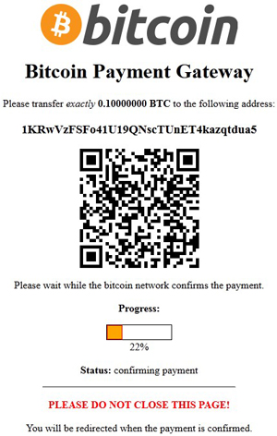

Bitcoin SCI (Bitcoin Shopping Cart Interface)

This is not a complete project to process payments, the first decision was to use this package for building the prototype and then if we failed to modify the package to meet out needs, use another approach, however we could make it suit the needs and Bitcoin SCI was used in the end product.

A break down of the tools Bitcoin SCI gives us are as follow:

* **Bitcoin Address generation**: Bitcoin SCI uses PHP Elliptic Curve library to generate new secure bitcoin addresses (set of public and private keys)
* **Private key encryption:** using phpseclib library, all the private information (Bitcoin private keys, transaction details) are stored encrypted
* **Payment Confirmation:** It uses APIs from a blockchain explorer site[44] to confirm receiving payments.
* **Input Interface** even though this package was meant to be used as an e-commerce payment system, it has the basic tools and methods to build the price input page

However it lacks some other features that should be added:

* **Database:** In order to have management and report page, saving the transaction details into a database is a must.
* **Fair Bitcoin Exchange rate:** It uses a predefined source to get the exchange rate of bitcoin and it’s not possible to set different currencies as the input
* **User-Friendly interface:** All the interfaces are poorly designed and needs to be modified to suit the PoS system.
* **Report Page:** We need a report page with authentication in place.
* **Input Validation:** Other than security perspective of input validation, this is needed because of the way we want the PoS to work, it should alert the employee if she has done something wrong before going to the next page and adding a failed transaction to the database.
* **Cash out option:** As all the private keys are stored encrypted in the server we need a way to cash out the available bitcoins and send them to another bitcoin address. It’s possible to retrieve the private keys of each bitcoin address separately from the tool, but it’s not scalable to multiple weekly transactions.

**bitcoin-prices** This library allows us to use bitcoinaverage.com prices as our main source of price conversion, and it gives nice tools for interface design, such as the ability to switch between different currencies by just clicking on the price. This allows us to reach a fair exchange rate that is also shown in different currencies in case it was needed.

#### Encryption libraries

* **phpseclib**[45]**:** used for private key encryptions.

We used this library mainly because it was already included in the Bitcoin SCI package as a dependency, but later on when we added the database functionality, we needed a library for encryption purposes that they were all included in phpseclib.

#### Interface libraries

* **Sweet Alert:**[46] A Beautiful replacement for javascript’s “Alert”,

This is a nice Javascript library that we used to make the interface more user-friendly. Also in the case of data validation, we needed a simple and nice way to inform the employee that she did a mistake on the form and the mistake should be fixed, for this case Javascript is the best option in the sense that it could validate the inputs on the browser before sending it to the server.

### Prototyping

With the full knowledge of the requirements and a few sketches of the interface, I started developing the PoS. Although the first prototype was ready to launch within a week, we did 3 prototypes in the month after that, each had bugs fixed and features added as we surveyed and got feedback from the employees on each round of prototyping.  
Here is a short description of the implemented functionalities:

#### PoS main functionalities

The PoS was hosted on a shared hosting service named Host Monster,[47] They offer low cost annual plans that offer PHP and MySQL, that are the requirements that we need. Then I started working with Bitcoin SCI to add the database functionality and defined tables for transaction requests and payments on MySQL.

I designed three tables (first prototype had two) for the purpose of this PoS. One table is for the Bitcoin key pairs to be stored and will be used to decrypt and export the private keys when required (see Figure  [fig:wifkeys]. The other table holds the information regarding each transaction (Figure  [fig:txhistory], later on to prevent spam requests and test cases from making the table unnecessary big, I designed a temporary transaction table to hold the information of the transactions before the payment is validated, as soon as the payment is flagged as valid the relevant information would be moved to the main table and will be removed from the temporary table.

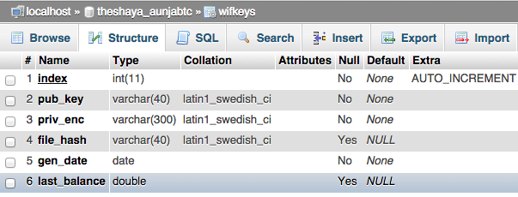

Structure for wifkeys table that holds the bitcoin key pairs

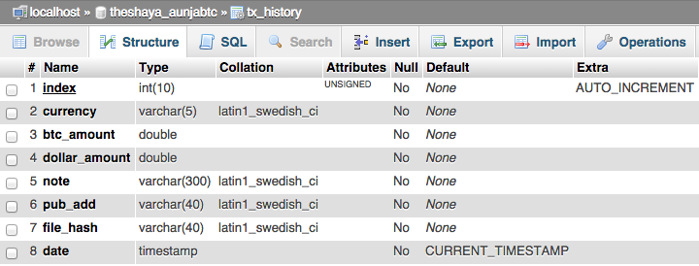

Structure for transaction history table

Bitcoin SCI uses a file-based method to store the keys and transaction details, as a backup method I kept that in place and stored the file_hash detail of each entity for future references.

Other tasks were involved in integrating the above mentioned open source projects into each other to have a complete solution package.

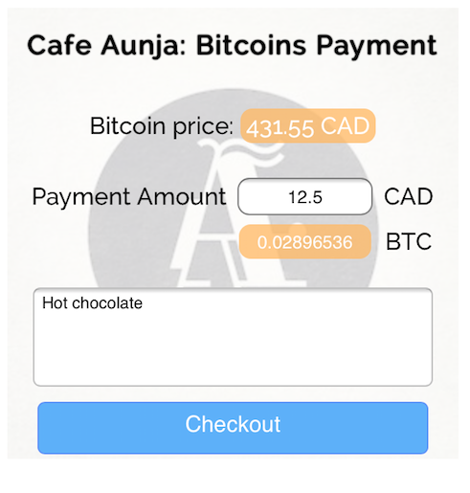

PoS - First View

One of the features that were added on the second round of prototyping was the ability to show the Bitcoin price in USD other than the default CAD, this was added with the usage of bitcoin-prices library. The other was to add the “Notes” field to be able to add invoice ID or the items that the customer bought. It was possible to implement a drop down menu with all the cafe’s menu options to be added to the list but as we discussed this solution with the cafe owner, he mentioned that the items in the menu might not stay the same during the year and also there might be price changes, so that approach was not suitable for this business, although it might be a good option for an e-commerce site.

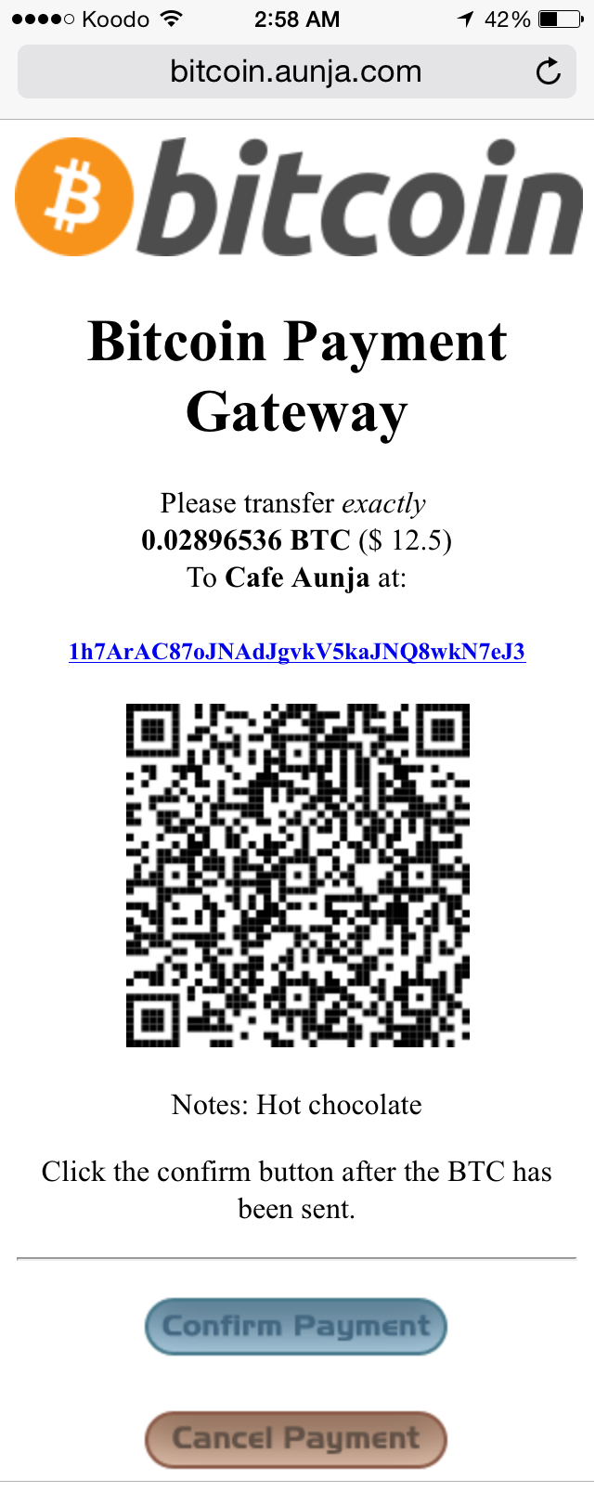

PoS - Payment

#### Private reporting page

One other aspect of the requirements was a reporting page, this was based on the feedbacks from the cafe’s owner and his preferences.

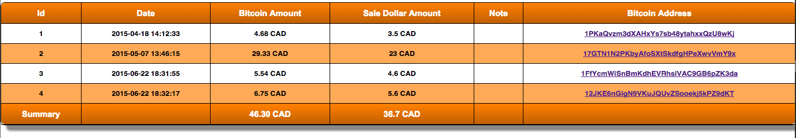

Report Page

One of the important fields later on added to the report page was the “Sale Dollar Amount”. The reason was that Bitcoin price is really volatile comparing to other currencies and the cafe owner did not want to risk loosing money by accepting bitcoin. As you can see in (Figure [fig:report_page]) the Sale Dollar amount is less than the Bitcoin amount, in this time period the owner could have had more profit on the sales because of the increase in bitcoin prices, but this would be risk that he did not want to take. So as an agreement, we decided to lock the price of each sale on the sale time and he would get paid the same amount as if he was selling his products with cash[48], Thus on the second prototype of the report page I added this field for accounting purposes.

Other added feature was the ability to check on the blockchain for each transaction, If the cafe owner clicks on any of the bitcoin addresses related to each sale, he would be redirected to a blockchain explorer site and he can see if the transaction went through or not.

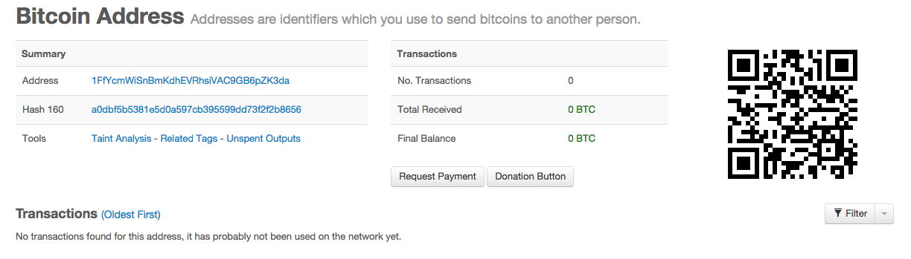

A canceled sale - this means that the request was made on the PoS interface to generate an address, but the customer never sent the bitcoins. Probably a test or customer changed his mind and paid via another payment method

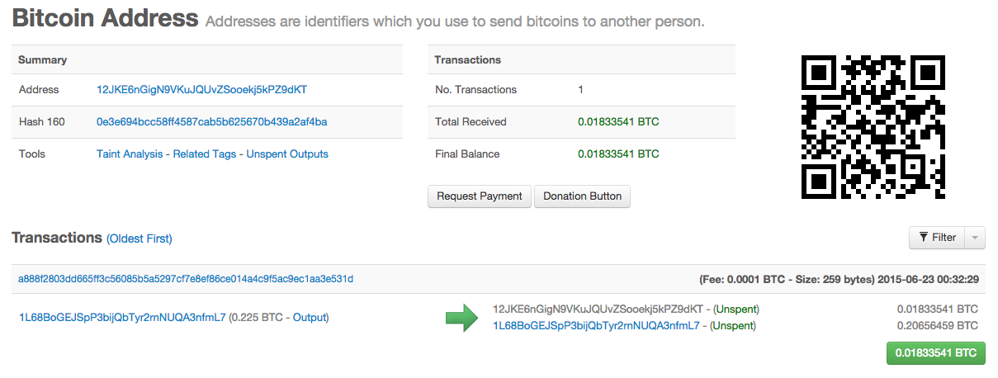

A Complete Sale - This shows that 0.01833541 BTC (approximately 5.5 CAD on the time of sale) was deposited in the address generated by the PoS

Another feature request was the ability to decrypt and export the private keys of those addresses that has some balance. This has been done for the admin page that is out of the scope of this chapter.

This PoS has been made open source and available to public[49] under GNU General Public License v2 and has already been used in other small businesses to accept bitcoin.

### Training

I tried to make the interface as simple as possible for the employees. There are no jargons or technical requirements to use the PoS, but anyhow some details specific to Bitcoin transactions has to be taught to the employees to be able to recover from human errors while a transaction is processing. Other than in person training that I did with every employee, I made a manual (Figure [fig:payment_manual]) and attached it to the cashier’s counter for future reference by all cafe employees.

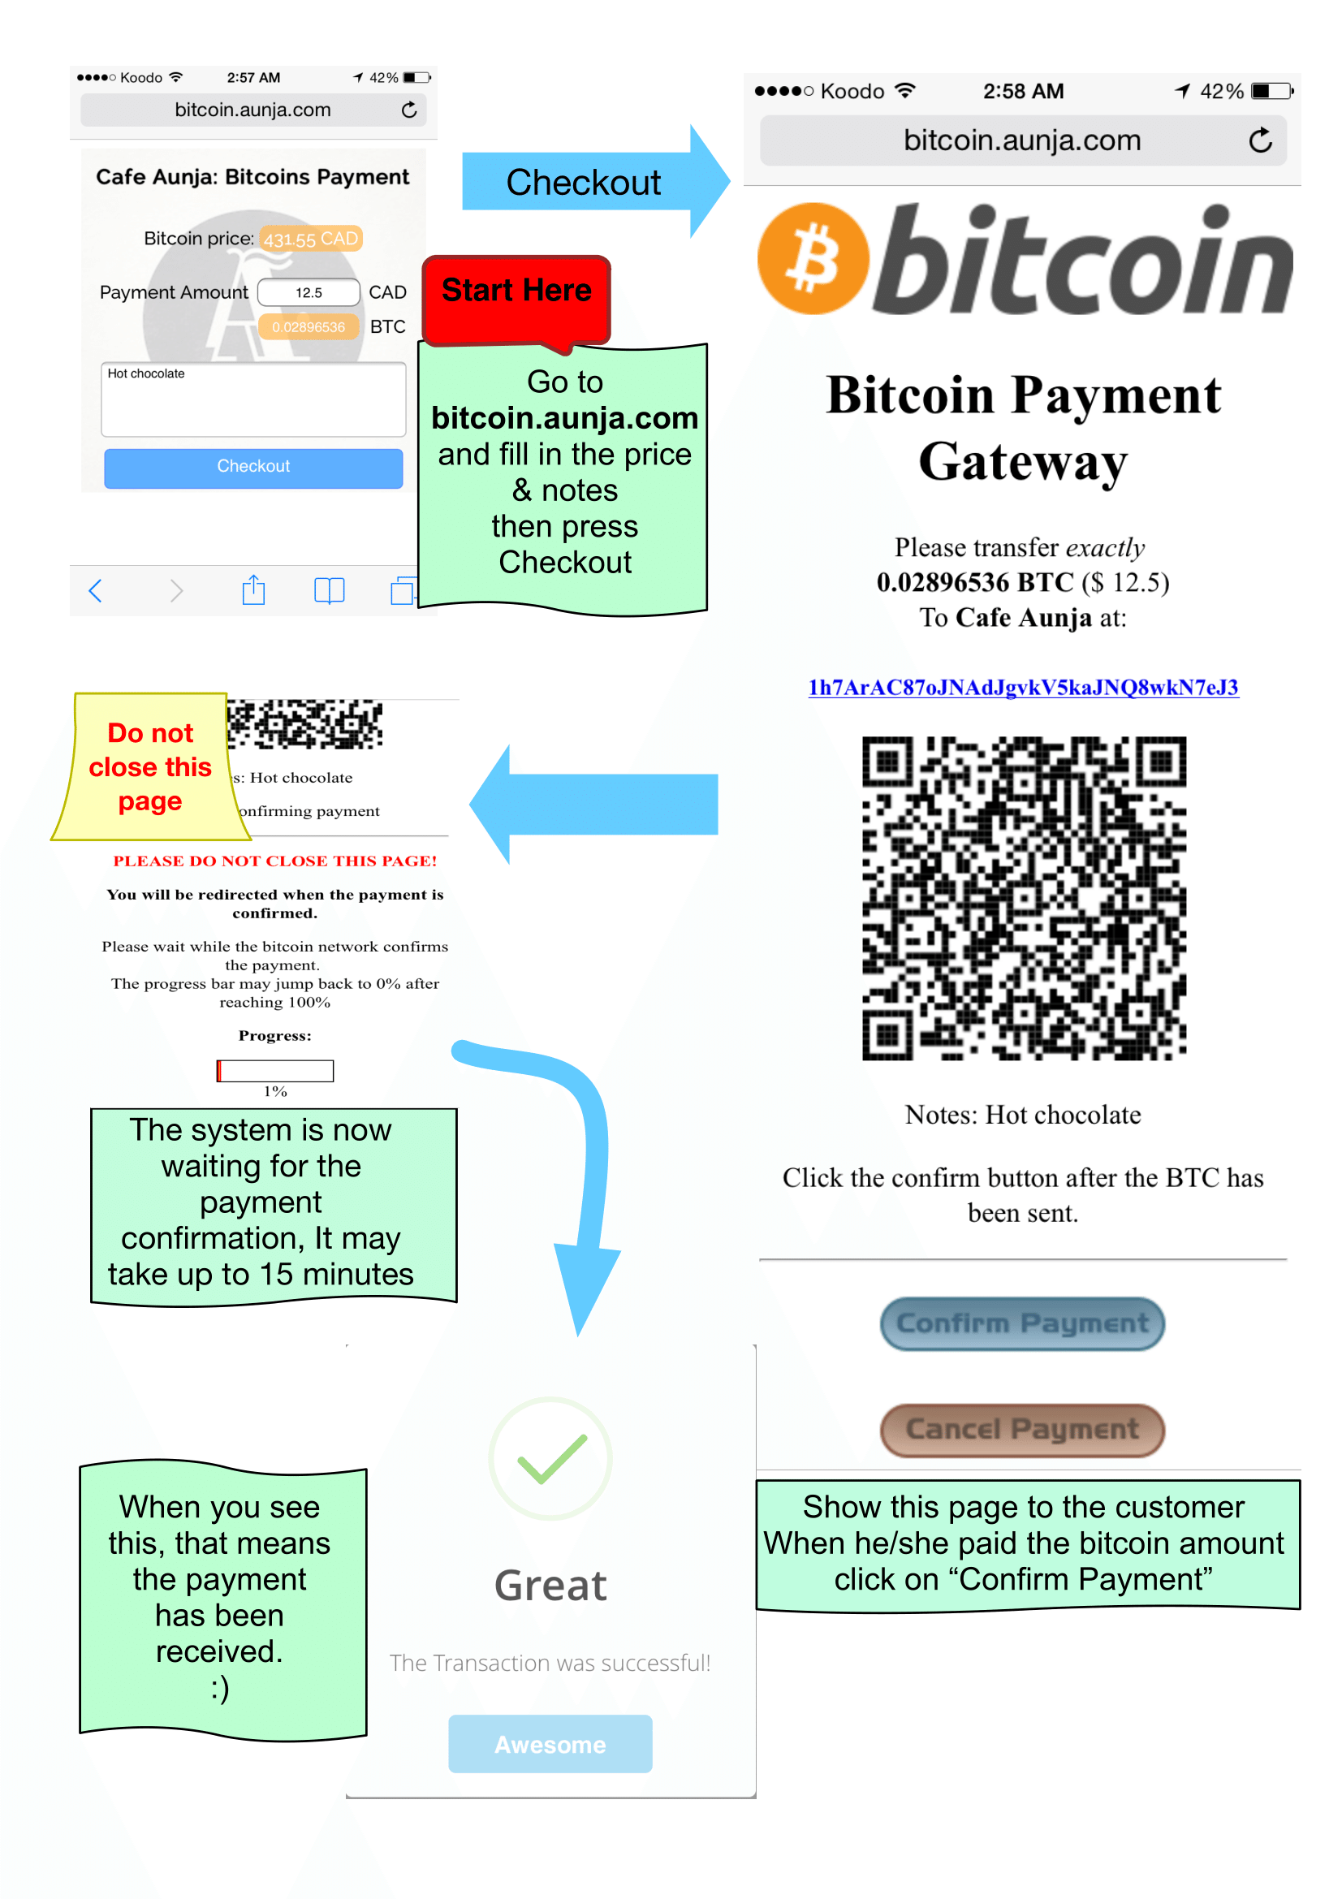

PoS - Step by step manual for Bitcoin payments

## Real-world Deployement

Cafe Aunja started accepting Bitcoin with this customized PoS on Oct 23, 2014, and was the first cafe in eastern Canada that accepts Bitcoin. During the first month, there was more than 10 bitcoin payments and it has been working ever since.

### lessons learned

One of the missing features that should be implemented in such a system is a fast verification method, in the sense that for each payment customer need to wait for average of 10 minutes for the transaction to get confirmed. To remedy this, I solved this issue that the payment would be flagged as successful as soon as the transaction is broadcasted to Bitcoin network also known as 0-confirmation transaction. This could work for a PoS in a cafe as the volume of each transaction is small and it’s not risky to take 0-confirmation transactions, However this is still a open problem to remedy the risk for higher value transactions and prevent double spend attacks  Karame, Androulaki, and Capkun (2012)  Bamert et al. (2013).

Bitcoin and Bitcoin transactions are still a unfamiliar concept for most people, we encountered countless number of questions from customers to explain what Bitcoin is and how it works and fascinating enough they got more interested to know more about Bitcoin when they observed a payment done with the Bitcoin PoS, mostly because they would not reveal any personal information with each payment.

Another interesting lesson, is the concept of locked price, that is the price of bitcoin for each sale is locked to the exact exchange rate on the time of the transaction. This means if the customer paid 0.01 bitcoin for a coffee that was 3 dollars in the time of the purchase, the business owner will be paid the exact same amount of 3 dollars and it should not make him any difference if the bitcoin price has been increasing or decreasing from the time of the purchase to the time he choses to cash out the receiving bitcoins. This makes the acceptance of bitcoin payments for the business risk free.

Now to test the system on production, it was time for the first ever coffee in eastern Canada to be bought with Bitcoin (Figure  [fig:firsttransaction]).



Database details of the first Coffee bought with Bitcoin in the cafe

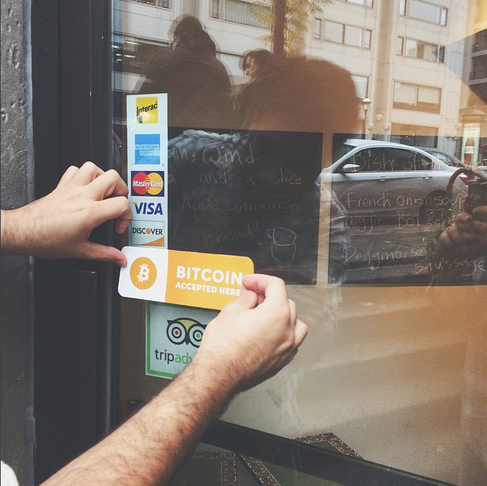

Cafe Aunja Started to accept bitcoin on Oct 23, 2014

# Conclusion

In this thesis, we evaluate all the existing Bitcoin wallet clients and came up with a framework to evaluate the upcoming softwares. We concluded that there’s no perfect wallet client yet and we have a long way to go to have a perfect solution. We also evaluate the Bitcoin point of sales that accepted bitcoin and again there was no perfect solution for a small business to easily accept Bitcoins. We developed and deployed a custom point of sale for small businesses and published it as an open source application that has already been used by a few more small businesses all over the world.

These are small steps toward having a universal framework for Bitcoin softwares, but they are the first steps.

Alford, Mack. 1979. *Software Requirements Engineering Methodology*. Wiley Online Library.

Androulaki, Elli, Ghassan O Karame, Marc Roeschlin, Tobias Scherer, and Srdjan Capkun. 2013. “Evaluating User Privacy in Bitcoin.” In *Financial Cryptography and Data Security*, 34–51. Springer.

Armory. n.d. “Armory Secure Wallet.” <https://bitcoinarmory.com>.

Baker, Mary, Kimberly Keeton, and Sean Martin. 2005. “Why Traditional Storage Systems Don’t Help Us Save Stuff Forever.” In *HotDep*.

Bamert, Tobias, Christian Decker, Lennart Elsen, Roger Wattenhofer, and Samuel Welten. 2013. “Have a Snack, Pay with Bitcoins.” In *Peer-to-Peer Computing (P2P), 2013 IEEE Thirteenth International Conference on*, 1–5. IEEE.

Barber, Simon, Xavier Boyen, Elaine Shi, and Ersin Uzun. 2012. “Bitter to Better — How to Make Bitcoin a Better Currency.” In *Financial Cryptography*.

Biddle, Robert, P. C. van Oorschot, Andrew S. Patrick, Jennifer Sobey, and Tara Whalen. 2009. “Browser Interfaces and Extended Validation SSL Certificates: An Empirical Study.” In *CCSW*.

Bitcoin Core Developers. n.d. “Bitcoin Core.” <https://bitcoin.org>.

Blockchain Team. n.d. “My Wallet Be Your Own Bank.” <https://blockchain.info>.

Bonneau, J, C Herley, P C van Oorschot, and F Stajano. 2012. “The Quest to Replace Passwords: A Framework for Comparative Evaluation of Web Authentication Schemes.” In *IEEE Symposium on Security and Privacy*.

Bonneau, Joseph, Arvind Narayanan, Andrew Miller, Jeremy Clark, Joshua A. Kroll, and Edward W. Felten. 2014. “Mixcoin: Anonymity for Bitcoin with Accountable Mixes.” In *Financial Cryptography*.

brainwallet. n.d. “Brainwallet.” <https://brainwallet.github.io/>.

Carroll, J, W Kellogg, and R Mack. 1987. *Interface Metaphors and User Interface Design*.

Chaum, David. 1982. “Blind signatures for untraceable payments.” In *CRYPTO*.

———. 1983. “Blind Signatures for Untraceable Payments.” In *Advances in Cryptology*, 199–203. Springer.

Clark, Jeremy, Paul C. van Oorschot, and Carlisle Adams. 2007. “Usability of Anonymous Web Browsing: An Examination of Tor Interfaces and Deployability.” In *SOUPS*.

Dietz, M., A. Czeskis, D. Balfanz, and D. S. Wallach. 2012. “Origin-Bound Certificates: A Fresh Approach to Strong Client Authentication for the Web.” In *USENIX Security*.

Dorfman, Merlin. 1990. “System and Software Requirements Engineering.” In *IEEE Computer Society Press Tutorial*. Citeseer.

Florencio, D., and C. Herley. 2012. “Is Everything We Know About Password Stealing Wrong?” *IEEE Security & Privacy* 10 (6).

Garfinkel, Simson L., and Robert C. Miller. 2005. “Johnny 2: A User Test of Key Continuity Management with S/MIME and Outlook Express.” In *SOUPS*.

Garfinkel, Simson L., David Margrave, Jeffrey I. Schiller, Erik Nordlander, and Robert C. Miller. 2005. “How to Make Secure Email Easier to Use.” In *CHI*.

Gaw, Shirley, Edward W. Felten, and Patricia Fernandez-Kelly. 2006. “Secrecy, Flagging, and Paranoia: Adoption Criteria in Encrypted Email.” In *CHI*.

Gervais, Arthur, Ghassan Karame, Damian Gruber, and Srdjan Capkun. 2014. “On the Privacy Provisions of Bloom Filters in Lightweight Bitcoin Clients.” In *ACSAC*. ACM.

Haley, C B, R Laney, J D Moffett, and B Nuseibeh. n.d. “Security Requirements Engineering: A Framework for Representation and Analysis.” *IEEE Transactions on Software Engineering* 34 (1): 133–53. <http://ieeexplore.ieee.org/lpdocs/epic03/wrapper.htm?arnumber=4359475>.

Hanke, Steve H, and Alex KF Kwok. 2009. “On the Measurement of Zimbabwe’s Hyperinflation.” *Cato J.* 29. HeinOnline: 353.

Herley, Cormac, and Paul C van Oorschot. 2012. “A Research Agenda Acknowledging the Persistence of Passwords.” *IEEE Security & Privacy* 10 (1): 28–36.

Karame, Ghassan, Elli Androulaki, and Srdjan Capkun. 2012. “Two Bitcoins at the Price of One? Double-Spending Attacks on Fast Payments in Bitcoin.” *IACR Cryptology EPrint Archive* 2012: 248.

Miers, Ian, Christina Garman, Matthew Green, and Aviel D Rubin. 2013. “Zerocoin: Anonymous Distributed E-Cash from Bitcoin.” In *IEEE Symposium on Security and Privacy*.

MultiBit Team. n.d. “MultiBit.” <https://multibit.org>.

Nakamoto, S. 2008. “Bitcoin: A Peer-to-Peer Electionic Cash System.” Unpublished.

Nielsen, Jakob. 1992. “Finding Usability Problems Through Heuristic Evaluation.” In *CHI*.

Oechslin, Philippe. 2003. “Making a Faster Cryptanalytic Time-Memory Trade-Off.” In *CRYPTO*.

Pieter Wuille. n.d. “BIP32 Hierarchical Deterministic Wallets.” <https://github.com/bitcoin/bips/blob/master/bip-0032.mediawiki>.

———. n.d. “BIP32: Hierarchical Deterministic Wallets.” <https://github.com/genjix/bips/blob/master/bip-0032.md>.

Pointbiz. n.d. “JavaScript Client-Side Bitcoin Wallet Generator.” <https://bitaddress.org>.

Rocye, WW. 1970. “Managing the Development of Large Software Systems: Concepts and Techniques.” In *IEEE WESTCON*.

RSA Laboratories. n.d. “PBKDF2 (Password-Based Key Derivation Function 2).” <http://tools.ietf.org/html/rfc2898>.

Sheng, Steve, Levi Broderick, Colleen Alison Koranda, and Jeremy J. Hyland. 2006. “Why Johnny Still Can’t Encrypt: Evaluating the Usability of Email Encryption Software.” In *SOUPS (Poster)*.

Sutcliffe, A. 2003. “Scenario-Based Requirements Engineering.” In *Requirements Engineering Conference, 2003. Proceedings. 11th IEEE International*, 320–29. [doi:10.1109/ICRE.2003.1232776](http://doi.org/10.1109/ICRE.2003.1232776).

Symantec. n.d. “Infostealer.Coinbit.” <http://www.symantec.com/security_response/writeup.jsp?docid=2011-061615-3651-99>.

Vanstone, S. 1992. “Responses to NIST’s Proposal.” *Communications of the ACM* 35: 50–52.

Wharton, C., J. Rieman, C. Lewis, and P. Polson. 1994. “The Cognitive Walkthrough Method: A Practitioner’s Guide.” In *Usability Inspection*. Wiley & Sons.

Whitten, A., and J. D. Tygar. 1999. “Why Johnny Can’t Encrypt: A Usability Evaluation of PGP 5.0.” In *USENIX Security*.

Wiki. n.d. “Technical background of version 1 Bitcoin addresses.” <https://en.bitcoin.it/wiki/Technical_background_of_version_1_Bitcoin_addresses>.

1. List of bank failures in the United States (2008–present) <https://en.wikipedia.org/wiki/List_of_bank_failures_in_the_United_States_(2008–present)>
2. <https://en.wikipedia.org/wiki/DigiCash>
3. <http://paypal.com>
4. <https://en.wikipedia.org/wiki/E-gold>
5. <https://github.com/shayanb/Bitcoin-PoS-PHP>
6. Cafe Aunja <http://aunja.com>
7. Technically, a transaction specifies a short script that encodes how the balance can be claimed as the input to some future transaction.
8. Elliptic Curve Digital Signature Algorithm (ECDSA) Vanstone (1992).
9. Due to the large size of the blockchain, full download is infeasible for thin clients running on mobile devices, as well as some desktop clients. These clients connect to a semi-trusted node and only request transactions relevant to keys in their wallet. This technique, known as Simplified Payment Verification (SPV), eliminates the need to download and verify the entire blockchain but, when implemented incorrectly, can create privacy risks Gervais et al. (2014).
10. Standards for Efficient Cryptography (SEC) <https://en.bitcoin.it/wiki/Secp256k1>
11. Public keys associated with specific Bitcoins are publicly available in the Bitcoin blockchain, but the identities of users who control those keys are not.
12. “Why King George III can encrypt,” *Freedom to Tinker* (blog), 6/6/2014.
13. <https://blockchain.info/charts/blocks-size>
14. Of course, exhaustive search of the password space is theoretically possible, and is available as a service: <http://www.walletrecoveryservices.com>
15. <http://www.walletrecoveryservices.com>
16. “A Bloomberg TV Host Gifted Bitcoin On Air And It Immediately Got Stolen,” *Business Insider*, 10/23/2013.
17. “Five Ways to Lose Money with Bitcoin Change Addresses,” *Bitzuma* (Blog), 17/03/2014.
18. Base58 avoids the use of characters such as “0, O, I, and l” which may look visually similar, and also avoids punctuation characters which may trigger software (*e.g.,*e-mail clients) to perform line breaks.
19. <http://www.bitcointrezor.com>
20. D. Martyn. “Bitcoin ‘Brainwallets’ and why they are a bad idea,” *Insecurety Research (sic)* (Blog), 26 Mar 2013.
21. https://bitcointalk.org/index.php?topic=576337.0
22. At the time of writing, 1000 XBT > 650000 USD.
23. <http://bitcoin.stackexchange.com/questions/5249/how-secure-is-blockchain-info>
24. <https://en.bitcoin.it/wiki/Data_directory>
25. Simplified Payment Verification[Nak08]
26. webservice that provides access to the blockchain
27. “Bitcoin Brainwallets and why they are a bad idea”, *Insecurety Research* (blog), 3/26/2013.
28. Cafe Aunja <http://aunja.com>
29. <http://blockchain.info>
30. The common PoS that accepts Visa/Debit Cards
31. <https://en.bitcoin.it/wiki/How_to_accept_Bitcoin,_for_small_businesses>
32. <https://coinkite.com/store/products/all>
33. <https://bitpay.com>
34. <http://coinbase.com>
35. Darknet Blackmarkets<https://en.wikipedia.org/wiki/Darknet_market>
36. Peer to peer bitcoin trading site <http://localbitcoins.com>
37. <https://gear.mycelium.com/>
38. PHP originally stood for Personal Home Page, it now stands for PHP: Hypertext Preprocessor<https://secure.php.net/manual/en/history.php.php>
39. Structured Query Language
40. “BitcoinAverage.com is the first aggregated bitcon price index that was initially launched in August 2013 with a goal to aggregate rates from all available Bitcoin exchanges around the world and provide a weighted average bitcoin price.” <https://bitcoinaverage.com>
41. <http://matejdanter.com>
42. <https://github.com/miohtama/bitcoin-prices>
43. <http://bitfreak.info/?page=tools&t=bitsci>
44. blockexplorer.com
45. <http://phpseclib.sourceforge.net>
46. <http://t4t5.github.io/sweetalert>
47. <http://hostmonster.com>
48. this method is actually one of the common methods recently used by bitcoin payment processors.
49. <https://github.com/shayanb/Bitcoin-PoS-PHP>