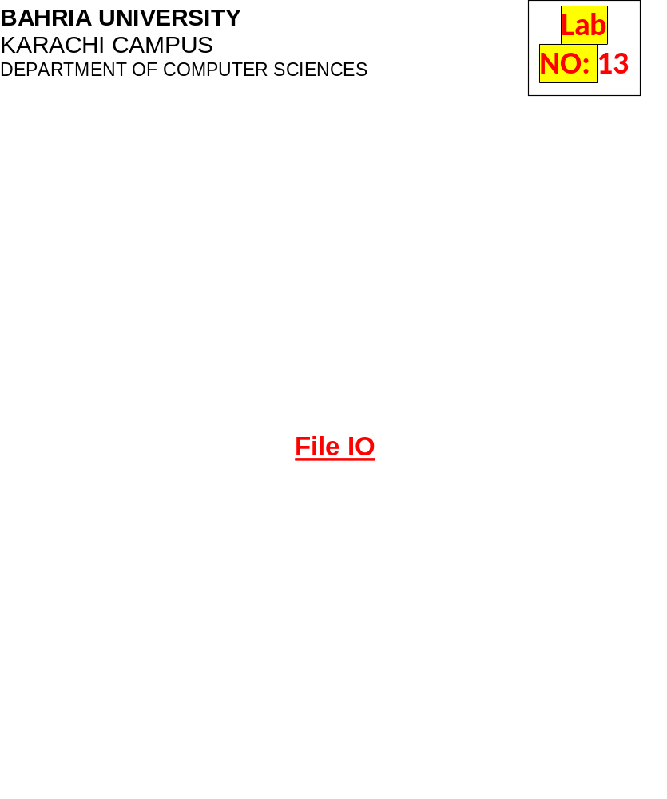
Lab13: File IO
Designing and implementing Java programs that deal with:
- Reading Input From Text Files
- Writing Output To Text Files
Exercises
Exercise 1
Create a system that gets following information of the employees
Employee name, Empoyee department, Employee contact, Employee designation, Employee Salary, Employee status.
And store it in the file names as EmplyeeData.txt. Once the data is inserted properly then fetch the data from the file display the data properly. Update record for sec and third employee and reenter the data in new file named as UpdatedEmployeeInfo. Ad display the upoadted data again.

Code (Employee Class)
package filehandling;

public class Employee {

private String empName, empDep, empContact, empDesignation, empSalary, empStatus;

public Employee(String empName, String empDep, String empContact, String empDesignation, String empSalary, String empStatus) {
this.empName = empName;
this.empDep = empDep;
this.empContact = empContact;
this.empDesignation = empDesignation;
this.empSalary = empSalary;
this.empStatus = empStatus;
}

public String getEmpName() {
return empName;
}

public void setEmpName(String empName) {
this.empName = empName;
}

public String getEmpDep() {
return empDep;
}

public void setEmpDep(String empDep) {
this.empDep = empDep;
}

public String getEmpContact() {
return empContact;
}

public void setEmpContact(String empContact) {
this.empContact = empContact;
}

public String getEmpDesignation() {
return empDesignation;
}

public void setEmpDesignation(String empDesignation) {
this.empDesignation = empDesignation;
}

public String getEmpSalary() {
return empSalary;
}

public void setEmpSalary(String empSalary) {
this.empSalary = empSalary;
}

public String getEmpStatus() {
return empStatus;
}

public void setEmpStatus(String empStatus) {
this.empStatus = empStatus;
}

}

Main Class
package filehandling;

import java.io.FileReader;
import java.util.Scanner;
import java.io.IOException;
import java.io.FileWriter;
import java.io.BufferedWriter;
import java.io.FileReader;
import java.io.BufferedReader;

public class FileHandling {

public static void main(String[] args) {

Scanner input = new Scanner(System.in);
System.out.println("Enter Employee Name");
String name = input.nextLine();
System.out.println("Enter Employee Department");
String depart = input.nextLine();
System.out.println("Enter Employee Contact");
String cont = input.nextLine();
System.out.println("Enter Employee Designation");
String desig = input.nextLine();
System.out.println("Enter Employee Salary");
String sal = input.nextLine();
System.out.println("Enter Employee Status");
String status = input.nextLine();

System.out.println("Enter Second Employee Name");
String name2 = input.nextLine();
System.out.println("Enter Employee Department");
String depart2 = input.nextLine();
System.out.println("Enter Employee Contact");
String cont2 = input.nextLine();
System.out.println("Enter Employee Designation");
String desig2 = input.nextLine();
System.out.println("Enter Employee Salary");
String sal2 = input.nextLine();
System.out.println("Enter Employee Status");
String status2 = input.nextLine();

System.out.println("Enter Third Employee Name");
String name3 = input.nextLine();
System.out.println("Enter Employee Department");
String depart3 = input.nextLine();
System.out.println("Enter Employee Contact");
String cont3 = input.nextLine();
System.out.println("Enter Employee Designation");
String desig3 = input.nextLine();
System.out.println("Enter Employee Salary");
String sal3 = input.nextLine();
System.out.println("Enter Employee Status");
String status3 = input.nextLine();

Employee Irtaza = new Employee(name, depart, cont, desig, sal, status);
Employee Shayan = new Employee(name2, depart2, cont2, desig2, sal2, status2);
Employee Huzaifa = new Employee(name3, depart3, cont3, desig3, sal3, status3);

try {
//Sample 01: Open the FileWriter, Buffered Writer
FileWriter fw = new FileWriter("C:\\Users\\Cyberland Computers\\Documents\\Irtaza Bahria\\Semester 2 Spring 2022\\OOP Lab\\Lab 13\\EmployeeData.txt");
BufferedWriter WriteFileBuffer = new BufferedWriter(fw);
//Sample 02: Write Some Text to File
// Using Buffered Writer)
WriteFileBuffer.write("Employee Name: " + Irtaza.getEmpName());
WriteFileBuffer.newLine();
WriteFileBuffer.write("Employee Department: " + Irtaza.getEmpDep());
WriteFileBuffer.newLine();
WriteFileBuffer.write("Employee Contact: " + Irtaza.getEmpContact());
WriteFileBuffer.newLine();
WriteFileBuffer.write("Employee Designation: " + Irtaza.getEmpDesignation());
WriteFileBuffer.newLine();
WriteFileBuffer.write("Employee Salary: " + Irtaza.getEmpSalary());
WriteFileBuffer.newLine();
WriteFileBuffer.write("Employee Status: " + Irtaza.getEmpStatus());
WriteFileBuffer.newLine();
//Second Employee
WriteFileBuffer.write("Employee Name: " + Shayan.getEmpName());
WriteFileBuffer.newLine();
WriteFileBuffer.write("Employee Department: " + Shayan.getEmpDep());
WriteFileBuffer.newLine();
WriteFileBuffer.write("Employee Contact: " + Shayan.getEmpContact());
WriteFileBuffer.newLine();
WriteFileBuffer.write("Employee Designation: " + Shayan.getEmpDesignation());
WriteFileBuffer.newLine();
WriteFileBuffer.write("Employee Salary: " + Shayan.getEmpSalary());
WriteFileBuffer.newLine();
WriteFileBuffer.write("Employee Status: " + Shayan.getEmpStatus());
WriteFileBuffer.newLine();
//Third Employee
WriteFileBuffer.write("Employee Name: " + Huzaifa.getEmpName());
WriteFileBuffer.newLine();
WriteFileBuffer.write("Employee Department: " + Huzaifa.getEmpDep());
WriteFileBuffer.newLine();
WriteFileBuffer.write("Employee Contact: " + Huzaifa.getEmpContact());
WriteFileBuffer.newLine();
WriteFileBuffer.write("Employee Designation: " + Huzaifa.getEmpDesignation());
WriteFileBuffer.newLine();
WriteFileBuffer.write("Employee Salary: " + Huzaifa.getEmpSalary());
WriteFileBuffer.newLine();
WriteFileBuffer.write("Employee Status: " + Huzaifa.getEmpStatus());
WriteFileBuffer.newLine();
//Sample 03: Close both the Writers
WriteFileBuffer.close();
//Sample 04: Open the Readers Now
FileReader fr = new FileReader("C:\\Users\\Cyberland Computers\\Documents\\Irtaza Bahria\\Semester 2 Spring 2022\\OOP Lab\\Lab 13\\EmployeeData.txt");
BufferedReader ReadFileBuffer = new BufferedReader(fr);
//Sample 05: Read the text Written
// using BufferedWriter

while (ReadFileBuffer.read() != -1) {
System.out.println(ReadFileBuffer.readLine());
}
// System.out.println(ReadFileBuffer.readLine());
// System.out.println(ReadFileBuffer.readLine());
// System.out.println(ReadFileBuffer.readLine());
//Sample 06: Close the Readers
ReadFileBuffer.close();
} catch (IOException Ex) {
System.out.println(Ex.getMessage());
}
FileHandling.editRecord();
}

public static void editRecord() {
try {
FileReader fr = new FileReader("C:\\Users\\Cyberland Computers\\Documents\\Irtaza Bahria\\Semester 2 Spring 2022\\OOP Lab\\Lab 13\\UpdatedEmployeeData.txt");
BufferedReader ReadFileBuffer = new BufferedReader(fr);

Scanner input = new Scanner(System.in);

System.out.println("Enter Updated Employee Name");
String name2 = input.nextLine();
System.out.println("Enter Employee Department");
String depart2 = input.nextLine();
System.out.println("Enter Employee Contact");
String cont2 = input.nextLine();
System.out.println("Enter Employee Designation");
String desig2 = input.nextLine();
System.out.println("Enter Employee Salary");
String sal2 = input.nextLine();
System.out.println("Enter Employee Status");
String status2 = input.nextLine();
Employee updatedEmp = new Employee(name2, depart2, cont2, desig2, sal2, status2);

//Sample 01: Open the FileWriter, Buffered Writer
FileWriter fw2 = new FileWriter("C:\\Users\\Cyberland Computers\\Documents\\Irtaza Bahria\\Semester 2 Spring 2022\\OOP Lab\\Lab 13\\UpdatedEmployeeData.txt");
BufferedWriter WriteFileBuffer = new BufferedWriter(fw2);
//Sample 02: Write Some Text to File
// Using Buffered Writer)
WriteFileBuffer.write("Employee Name: " + updatedEmp.getEmpName());
WriteFileBuffer.newLine();
WriteFileBuffer.write("Employee Department: " + updatedEmp.getEmpDep());
WriteFileBuffer.newLine();
WriteFileBuffer.write("Employee Contact: " + updatedEmp.getEmpContact());
WriteFileBuffer.newLine();
WriteFileBuffer.write("Employee Designation: " + updatedEmp.getEmpDesignation());
WriteFileBuffer.newLine();
WriteFileBuffer.write("Employee Salary: " + updatedEmp.getEmpSalary());
WriteFileBuffer.newLine();
WriteFileBuffer.write("Employee Status: " + updatedEmp.getEmpStatus());
WriteFileBuffer.newLine();
//Sample 03: Close both the Writers
WriteFileBuffer.close();
//Sample 04: Open the Readers Now
FileReader fr2 = new FileReader("C:\\Users\\Cyberland Computers\\Documents\\Irtaza Bahria\\Semester 2 Spring 2022\\OOP Lab\\Lab 13\\UpdatedEmployeeData.txt");
BufferedReader ReadFileBuffer2 = new BufferedReader(fr2);
//Sample 05: Read the text Written
// using BufferedWriter

while (ReadFileBuffer2.read() != -1) {
System.out.println(ReadFileBuffer2.readLine());
}
ReadFileBuffer2.close();

} catch (IOException Ex) {
System.out.println(Ex.getMessage());
} finally {

}

}
}

Output
File Writing
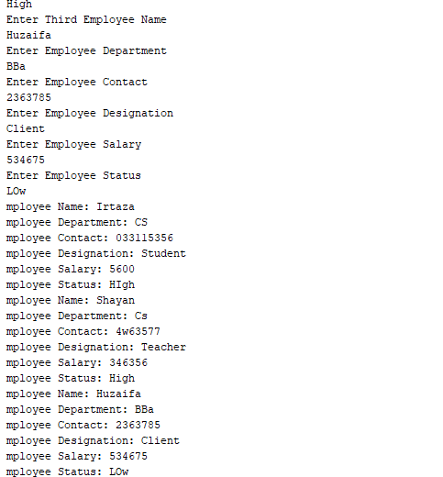
Updated Employee
