Worked Example: One Joint, One Intermediate Waypoint

1. Setup
A single joint must rotate from $0^{∘}$ to ${90}^{∘}$, starting and ending at rest.
Waypoint | Time | Angle | Velocity | Status
Waypoint 0 (start) | $$t=0$$ | $$q^{\left(0\right)}=0^{∘}$$ | $0$ (at rest) | Fixed by the task
Waypoint 1 (intermediate) | $$t=Δt_{1}$$ | $$q^{\left(1\right)}$$ | Computed | Angle chosen by the optimizer
Waypoint 2 (goal) | $$t=Δt_{1}+Δt_{2}=T$$ | $$q^{\left(2\right)}={90}^{∘}$$ | $0$ (at rest) | Fixed by the task
The decision variables are the intermediate waypoint angle and the two segment durations:
$$x=\left[ q^{\left(1\right)}, Δt_{1}, Δt_{2} \right]∈R^{3}$$
Other fixed values: speed limit ${90}^{∘}/\text{s}$ and smoothness weight $w={10}^{-4}$.
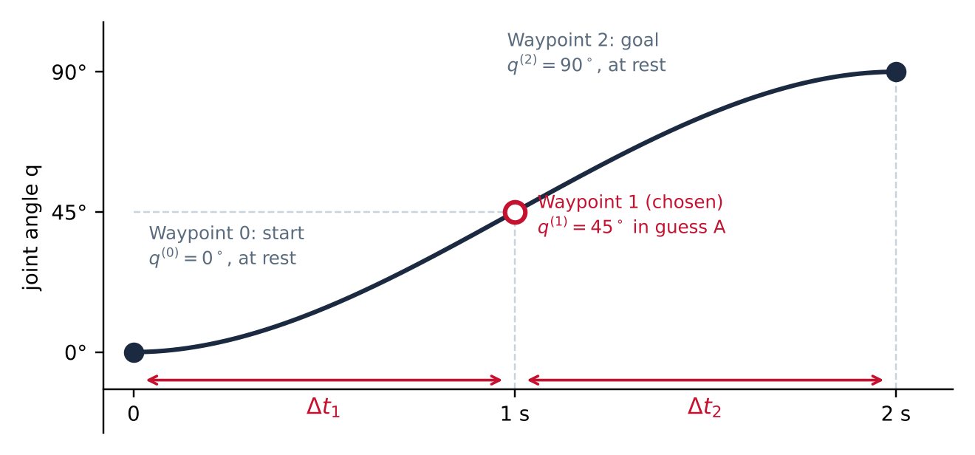
Figure 1. The trajectory for guess A, $x=\left[{45}^{∘}, 1\text{ s}, 1\text{ s}\right]$. The start and goal are fixed; the optimizer chooses the waypoint angle and the two durations.

2. Assumptions and what they allow
Assumption | What it allows
One rotating joint | The motion is a single curve $q\left(t\right)$. The full arm repeats this for each joint, with shared segment durations.
Fixed start and goal angles, at rest | Gives the four boundary conditions, so the task is fully specified.
One intermediate waypoint | The smallest case with a real choice: 3 decision variables.
Each segment is a cubic in time | The simplest curve that can match angle and velocity at both ends. Jerk is constant on each segment, so the jerk integral is exact.
Angle, velocity, and acceleration continuous at the waypoint | No sudden jumps in motion. Supplies the condition that fixes the waypoint velocity.
$w$ fixed during each solve | One speed-versus-smoothness trade-off per solve; $w$ is varied afterward.
Only a speed limit, no dynamics | Keeps the example solvable by hand. Torque limits return in the full model.

3. Step 1: one cubic per segment
The motion has two segments: segment 1 from the start to the waypoint, and segment 2 from the waypoint to the goal. On each segment the angle is a cubic in $τ$, the time since that segment began:
$$q_{1}\left(τ\right)=a_{1}+b_{1}τ+c_{1}τ^{2}+d_{1}τ^{3}, 0≤τ≤Δt_{1}$$
$$q_{2}\left(τ\right)=a_{2}+b_{2}τ+c_{2}τ^{2}+d_{2}τ^{3}, 0≤τ≤Δt_{2}$$
Differentiating gives the velocity, acceleration, and jerk on each segment:
$$\dot{q}\left(τ\right)=b+2c τ+3d τ^{2}, \ddot{q}\left(τ\right)=2c+6d τ, j=6d$$
Jerk is constant on each segment. That gives 8 unknown coefficients in total: $a,b,c,d$ for each of the two segments.

4. Step 2: eight conditions fix the eight coefficients
# | Condition | Meaning
1 | $$q_{1}\left(0\right)=q^{\left(0\right)}$$ | Start at the start angle
2 | $${\dot{q}}_{1}\left(0\right)=0$$ | Start at rest
3 | $$q_{1}\left(Δt_{1}\right)=q^{\left(1\right)}$$ | Segment 1 ends at the waypoint
4 | $$q_{2}\left(0\right)=q^{\left(1\right)}$$ | Segment 2 starts at the waypoint
5 | $$q_{2}\left(Δt_{2}\right)=q^{\left(2\right)}$$ | End at the goal angle
6 | $${\dot{q}}_{2}\left(Δt_{2}\right)=0$$ | End at rest
7 | $${\dot{q}}_{1}\left(Δt_{1}\right)={\dot{q}}_{2}\left(0\right)$$ | Same velocity on both sides of the waypoint
8 | $${\ddot{q}}_{1}\left(Δt_{1}\right)={\ddot{q}}_{2}\left(0\right)$$ | Same acceleration on both sides of the waypoint
These are 8 linear equations in 8 unknowns. For any choice of $x$ they have exactly one solution, so each $x$ produces exactly one smooth trajectory.

5. Step 3: solve for the coefficients
Call the velocity at the waypoint $v_{1}$ (so $v_{1}={\dot{q}}_{1}\left(Δt_{1}\right)={\dot{q}}_{2}\left(0\right)$), and define the average slope of each segment:
$$s_{1}=\frac{q^{\left(1\right)}-q^{\left(0\right)}}{Δt_{1}}, s_{2}=\frac{q^{\left(2\right)}-q^{\left(1\right)}}{Δt_{2}}$$
Conditions 1, 2, and 4, together with the definition of $v_{1}$, give the first two coefficients of each segment directly:
$$a_{1}=q^{\left(0\right)}, b_{1}=0, a_{2}=q^{\left(1\right)}, b_{2}=v_{1}$$
Conditions 3, 5, 6, and 7 (segment 1 reaching the waypoint with velocity $v_{1}$, segment 2 reaching the goal at rest) then give the remaining coefficients in terms of $v_{1}$:
$$c_{1}=\frac{3s_{1}-v_{1}}{Δt_{1}}, d_{1}=\frac{v_{1}-2s_{1}}{Δt_{1}^{2}}$$
$$c_{2}=\frac{3s_{2}-2v_{1}}{Δt_{2}}, d_{2}=\frac{v_{1}-2s_{2}}{Δt_{2}^{2}}$$
Condition 8 (equal acceleration at the waypoint) fixes $v_{1}$. Setting $2c_{1}+6d_{1}Δt_{1}=2c_{2}$ and solving gives
$$v_{1}=\frac{3 \left(Δt_{2} s_{1}+Δt_{1} s_{2}\right)}{2 \left(Δt_{1}+Δt_{2}\right)}$$
Written only in the decision variables:
$$v_{1}\left(x\right)=\frac{3}{2\left(Δt_{1}+Δt_{2}\right)}\left[\frac{Δt_{2}}{Δt_{1}}(q^{\left(1\right)}-q^{\left(0\right)})+\frac{Δt_{1}}{Δt_{2}}(q^{\left(2\right)}-q^{\left(1\right)})\right]$$
So the waypoint velocity is an output of $x$, not an extra choice, and with it every coefficient is known.

6. Why the waypoint velocity is not a decision variable
Count the unknowns: 8 coefficients and 8 conditions. The only free inputs are $q^{\left(1\right)}$, $Δt_{1}$, and $Δt_{2}$, so the motion has 3 degrees of freedom, and $v_{1}=b_{2}$ is one of the 8 coefficients that the conditions determine. Adding $v_{1}$ as a fourth decision variable leads to one of two outcomes:
- Keep condition 8. Now there are 4 variables and 1 extra equality constraint, which still leaves 3 degrees of freedom. The solver returns the same $v_{1}$, with more work.
- Drop condition 8. Now acceleration can jump at the waypoint. A jump in acceleration means infinite jerk at that instant, which the segment-by-segment jerk integral never sees, so the objective would be wrong.
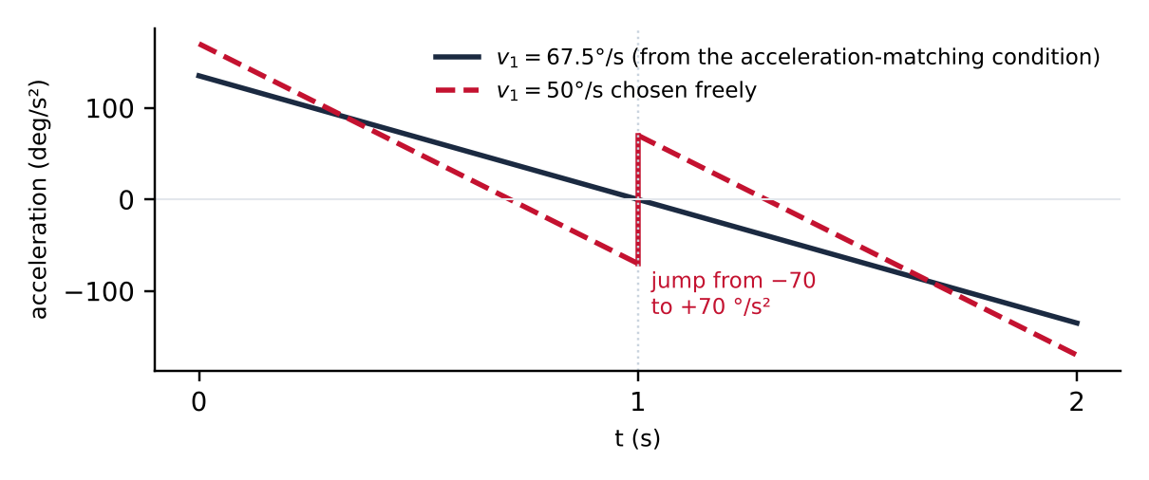
Figure 2. Acceleration for $x=\left[{45}^{∘}, 1\text{ s}, 1\text{ s}\right]$. With $v_{1}={67.5}^{∘}$/s from condition 8, acceleration is continuous. Choosing $v_{1}={50}^{∘}$/s freely makes it jump from $-70$ to $+{70}^{∘}/{\text{s}}^{2}$ at the waypoint.

7. Step 4: write the objective in the decision variables
Definition. Total time plus the weighted squared jerk over the whole motion:
$$J=T+w\int_{0}^{T}{j}{\left(t\right)}^{2} dt$$
Split at the waypoint. The motion has two segments, and the jerk on segment $k$ is $6d_{k}$:
$$J=\left(Δt_{1}+Δt_{2}\right)+w\left[\int_{0}^{Δt_{1}}{{\left(6d_{1}\right)}^{2}} dτ+\int_{0}^{Δt_{2}}{{\left(6d_{2}\right)}^{2}} dτ\right]$$
Integrate exactly. The jerk is constant on each segment, so each integral is the constant times the segment duration:
$$J\left(x\right)=Δt_{1}+Δt_{2}+36 w\left(d_{1}^{2} Δt_{1}+d_{2}^{2} Δt_{2}\right)$$
where $d_{1}$ and $d_{2}$ come from Step 3. Every term is now an explicit function of $q^{\left(1\right)}$, $Δt_{1}$, and $Δt_{2}$.

8. Step 5: evaluate one guess by hand
Guess A: $x=\left[ {45}^{∘}, 1\text{ s}, 1\text{ s} \right]$.
Quantity | Formula | Value
Average slopes $s_{1},s_{2}$ | $\left(45-0\right)/1$, $\left(90-45\right)/1$ | $45, 45$ °/s
Waypoint velocity $v_{1}$ | $$3\left(1⋅45+1⋅45\right)/\left(2⋅2\right)$$ | $67.5$ °/s
Segment 1: $c_{1},d_{1}$ | $\left(3⋅45-67.5\right)/1$, $\left(67.5-90\right)/1$ | $$67.5, -22.5$$
Segment 2: $c_{2},d_{2}$ | $\left(3⋅45-135\right)/1$, $\left(67.5-90\right)/1$ | $$0, -22.5$$
Jerk on each segment | $6d_{1}$, $6d_{2}$ | $-135$ °/s³ each
Total time $T$ | $$Δt_{1}+Δt_{2}$$ | $2$ s
Jerk integral | $$36 \left(d_{1}^{2}⋅1+d_{2}^{2}⋅1\right)$$ | $$36,450$$
Objective $J$ | $$2+{10}^{-4}⋅36,450$$ | $$5.65$$
The resulting trajectory is
$$q_{1}\left(τ\right)=67.5 τ^{2}-22.5 τ^{3} \left(0≤t≤1\text{ s}\right)$$
$$q_{2}\left(τ\right)=45+67.5 τ-22.5 τ^{3} \left(1≤t≤2\text{ s}\right)$$
Where the joint is at each moment:
Time $t$ | Segment | Angle $q$ | Velocity $\dot{q}$ | Acceleration $\ddot{q}$ | Jerk
0 s | 1 | $$0^{∘}$$ | $0$ °/s | $135$ °/s² | $-135$ °/s³
0.5 s | 1 | $${14.1}^{∘}$$ | $50.6$ °/s | $67.5$ °/s² | $-135$ °/s³
1.0 s (waypoint) | 1 → 2 | $${45}^{∘}$$ | $67.5$ °/s | $0$ °/s² | $-135$ °/s³
1.5 s | 2 | $${75.9}^{∘}$$ | $50.6$ °/s | $-67.5$ °/s² | $-135$ °/s³
2.0 s (goal) | 2 | $${90}^{∘}$$ | $0$ °/s | $-135$ °/s² | $-135$ °/s³
Checks: the joint passes through ${45}^{∘}$ at the waypoint and reaches ${90}^{∘}$ at the goal; velocity and acceleration match on both sides of the waypoint; velocity is zero at the start and goal; the peak speed of ${67.5}^{∘}$/s is within the ${90}^{∘}$/s limit.
Note that acceleration at the start is ${135}^{∘}/{\text{s}}^{2}$, not zero. With cubic segments, the start and goal are at rest but the acceleration there is not forced to zero.

9. Step 6: the optimizer adjusts x to lower J
Guess | $$q^{\left(1\right)}$$ | $$Δt_{1},Δt_{2}$$ | $$T$$ | Peak speed | Jerk integral | $$J$$ | Result
A: starting guess | $${45}^{∘}$$ | 1.0, 1.0 s | 2.0 s | 67.5 °/s | 36,450 | 5.65 | Feasible
B: waypoint off-center | $${60}^{∘}$$ | 1.0, 1.0 s | 2.0 s | 80.4 °/s | 101,250 | 12.13 | Jerkier
C: faster | $${45}^{∘}$$ | 0.6, 0.6 s | 1.2 s | 112.5 °/s | 468,750 | 48.08 | Breaks the speed limit
D: slower | $${45}^{∘}$$ | 1.4, 1.4 s | 2.8 s | 48.2 °/s | 6,777 | 3.48 | Better
E: best equal times | $${45}^{∘}$$ | 1.45, 1.45 s | 2.89 s | 46.7 °/s | 5,778 | 3.469 | Best with equal times
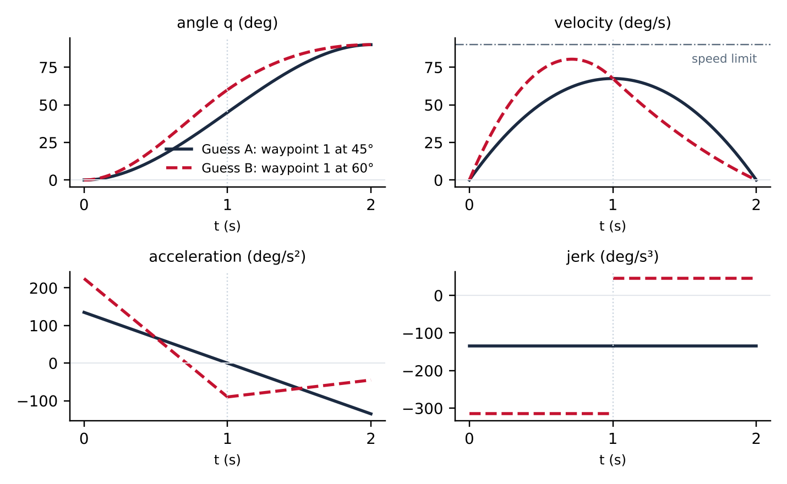
Figure 3. Angle, velocity, acceleration, and jerk for guesses A and B. Angle, velocity, and acceleration are continuous. Jerk is constant on each segment; in guess B it jumps from $-315$ to $+{45}^{∘}/{\text{s}}^{3}$ at the waypoint.
Finding the equal-time optimum by hand. Set $Δt_{1}=Δt_{2}=h$. Then $v_{1}=67.5/h$, $d_{1}=\left(67.5-2q^{\left(1\right)}\right)/h^{3}$, and $d_{2}=\left(2q^{\left(1\right)}-112.5\right)/h^{3}$, so
$$J\left(q^{\left(1\right)},h\right)=2h+\frac{36 w\left[(67.5-2q^{\left(1\right)})^{2}+(2q^{\left(1\right)}-112.5)^{2}\right]}{h^{5}}$$
Setting the derivative with respect to $q^{\left(1\right)}$ to zero:
$$\frac{∂J}{∂q^{\left(1\right)}}=\frac{36 w}{h^{5}}\left[-4(67.5-2q^{\left(1\right)})+4(2q^{\left(1\right)}-112.5)\right]=0 ⇒ q^{\left(1\right)}={45}^{∘}$$
With $q^{\left(1\right)}={45}^{∘}$ the bracket equals $1012.5$, so $J=2h+K/h^{5}$ with $K=36 w⋅1012.5=3.645$. Setting the derivative with respect to $h$ to zero:
$$\frac{∂J}{∂h}=2-\frac{5K}{h^{6}}=0 ⇒ h={\left(\frac{5K}{2}\right)}^{1/6}=1.45\text{ s}, J=3.469$$
Unequal durations show the problem is nonconvex. Searching over all three variables shows that this symmetric point is a saddle, not a minimum. The true minima are a mirror-image pair:
 | $$q^{\left(1\right)}$$ | $$Δt_{1},Δt_{2}$$ | $$T$$ | Peak jerk | Jerk integral | $$J$$
Minimum 1 | $${4.8}^{∘}$$ | 0.42, 2.44 s | 2.86 s | 47.9 °/s³ | 5,727 | 3.434
Minimum 2 (mirror) | $${85.2}^{∘}$$ | 2.44, 0.42 s | 2.86 s | 47.9 °/s³ | 5,727 | 3.434
Because there is more than one local minimum, the optimizer must be started from several initial guesses.

10. The same example with a jerk limit instead of a weight
In this formulation the objective is time alone, and smoothness becomes a constraint:
$$\min_{x} Δt_{1}+Δt_{2} \text{subject to} \left|6d_{1}\right|≤j_{max}, \left|6d_{2}\right|≤j_{max}, \text{peak speed}≤{90}^{∘}/\text{s}$$
Solving it for several jerk limits gives the trade-off curve:
Jerk limit $j_{max}$ (°/s³) | Minimum time $T^{*}$ (s) | Peak speed (°/s) | Active constraints
50 | 2.79 | 48.5 | Jerk on both segments
135 | 2.00 | 67.5 | Jerk on both segments
200 | 1.75 | 76.9 | Jerk on both segments
400 | 1.49 | 90.0 | Jerk on one segment and the speed limit
What this shows:
- The jerk limit is active: the optimizer pushes jerk right up to $j_{max}$.
- When only the jerk limit is active, the minimum time equals that of a single cubic from start to goal, $T^{*}={\left(12⋅90/j_{max}\right)}^{1/3}$. The waypoint can sit anywhere along that same curve, so the optimum is not unique. The waypoint only changes the answer once the speed limit also becomes active.
- The two formulations measure smoothness differently. At the same peak jerk (about ${48}^{∘}/{\text{s}}^{3}$), the weighted sum gives $T=2.86$ s with a jerk integral of 5,727, while the jerk-limited version gives $T=2.83$ s with a jerk integral of about 6,485. The jerk limit is faster for the same peak; the weighted sum has less total jerk.

11. How this scales to the full problem
 | This example | Our project
Joints | 1 | 3
Intermediate waypoints / segments | 1 / 2 | 3 / 4
Decision variables | 3: $q^{\left(1\right)}$, $Δt_{1}$, $Δt_{2}$ | 13: 9 waypoint angles and 4 durations
Coefficients per joint | 8 | 16
Waypoint velocities | 1, from one formula | 3 per joint, from one $3×3$ linear system
Constraints | Speed limit | Joint range, speed, acceleration, torque (and jerk in formulation B)
Problem class | Nonconvex NLP, 3 variables | Nonconvex NLP, 13 variables

