AI PROMPT DOCUMENT
Project Title: Spider-Man: No Way Home Fan Website
Student Name: Muhammad Shayan
Roll Number: i263068
Section: B
Course: Introduction to Information and Communication Technologies

Introduction
This document contains the prompts used during the development of my Spider-Man: No Way Home fan website. ChatGPT was used for guidance, generating HTML and CSS code, improving website design, and troubleshooting errors. I reviewed and tested the generated code.
Prompt 1 :
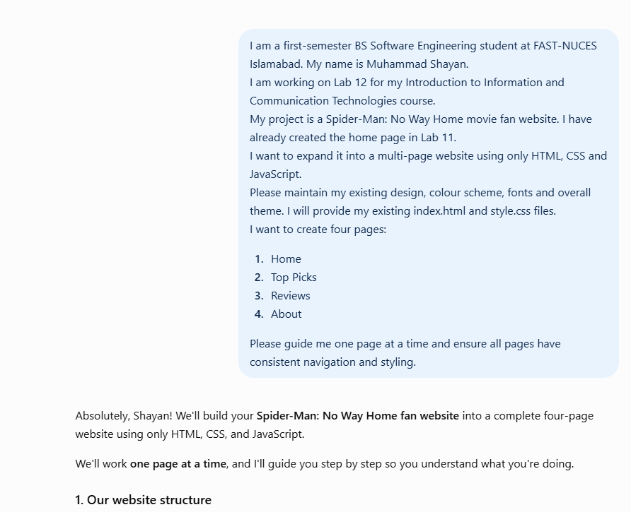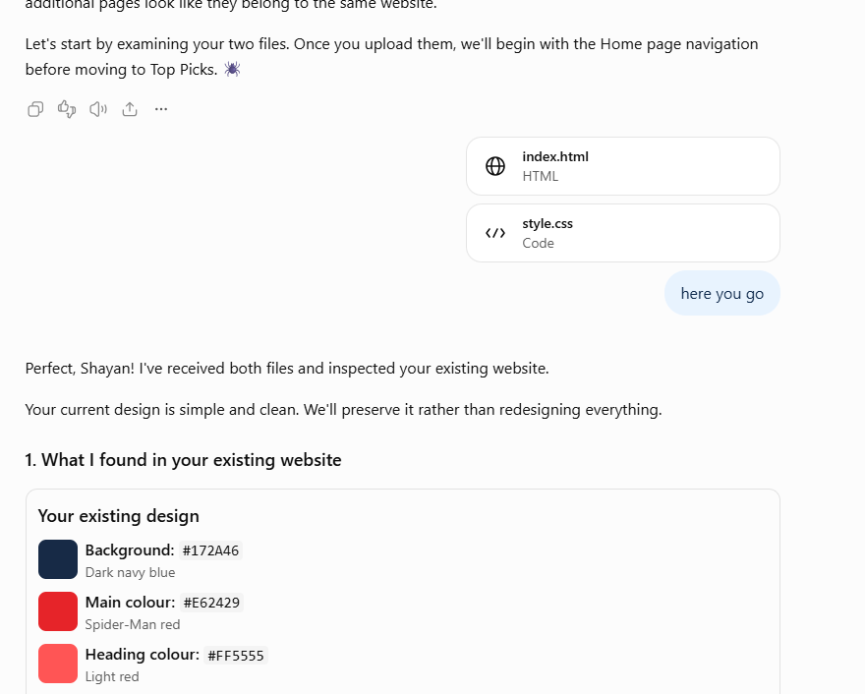

Prompt 2:
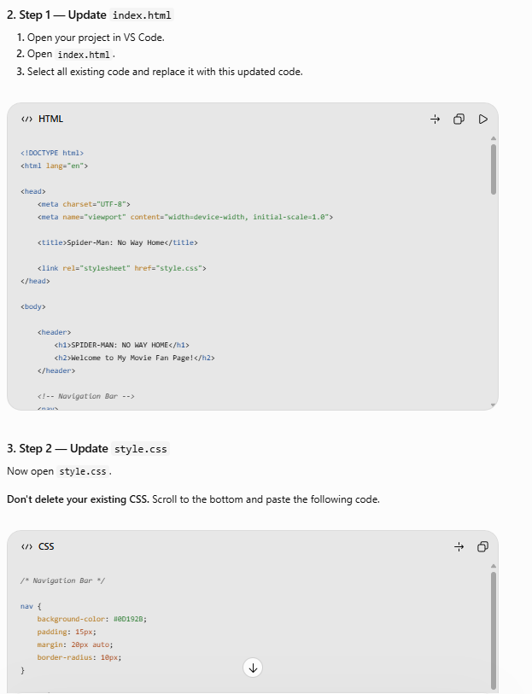
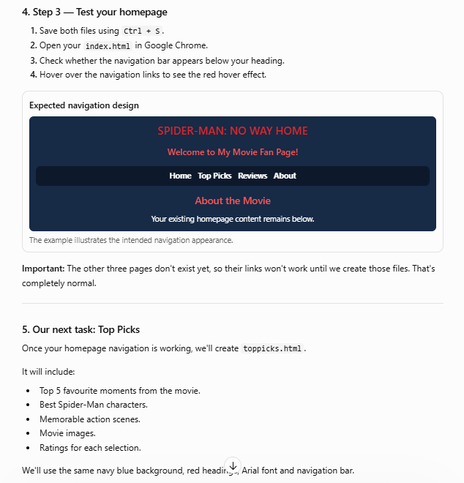
Prompt 3: Top picks
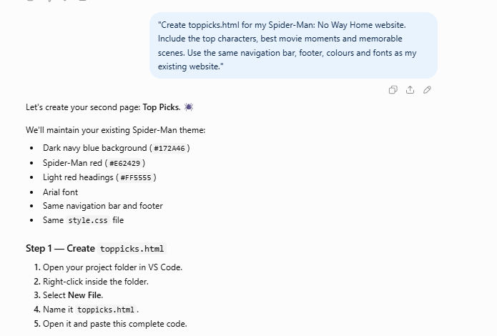
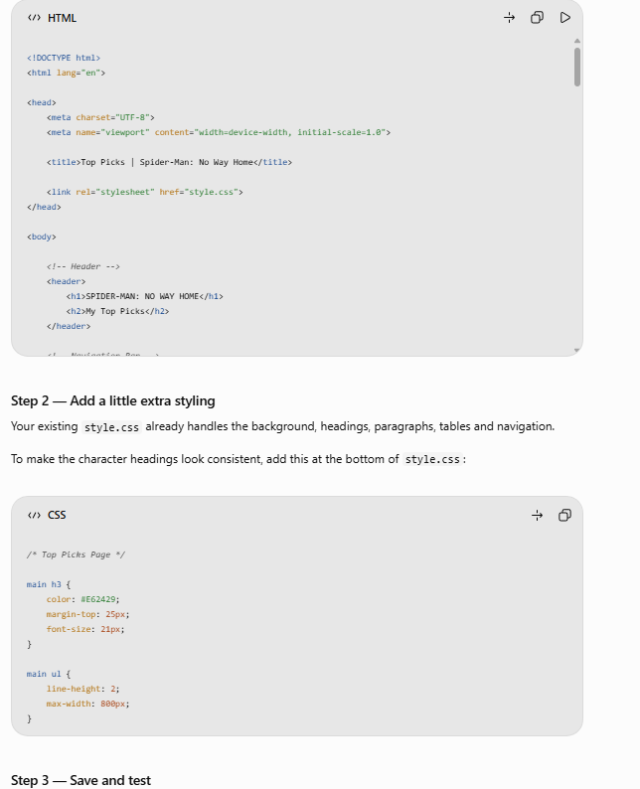

Prompt 4: reviews
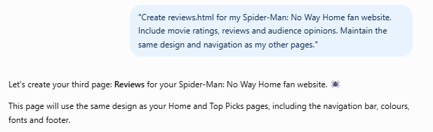
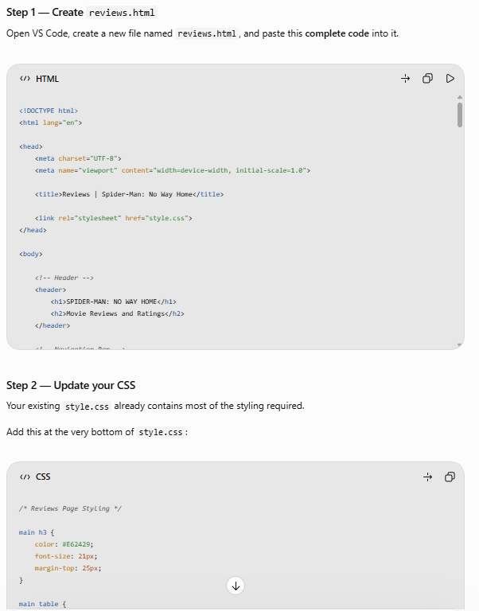

Prompt 5:about
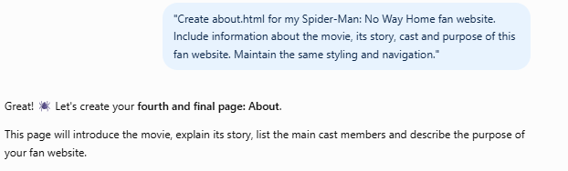
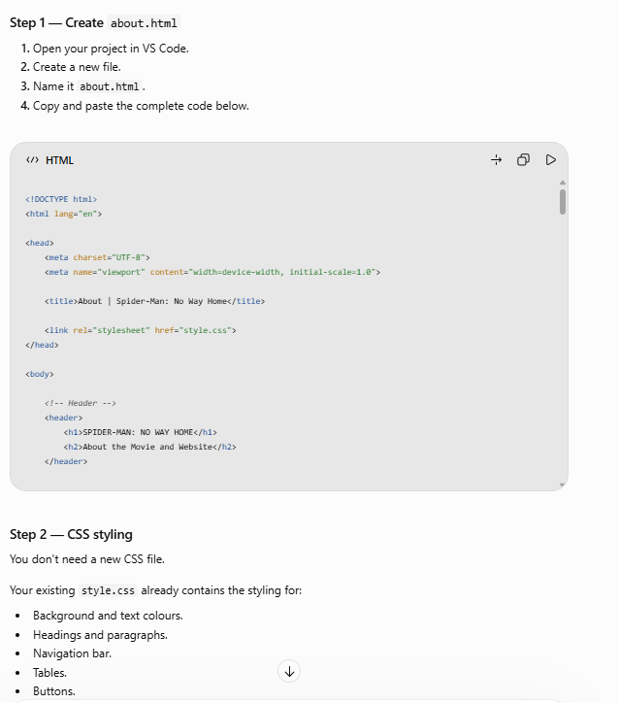
Prompt 6: checking navigation
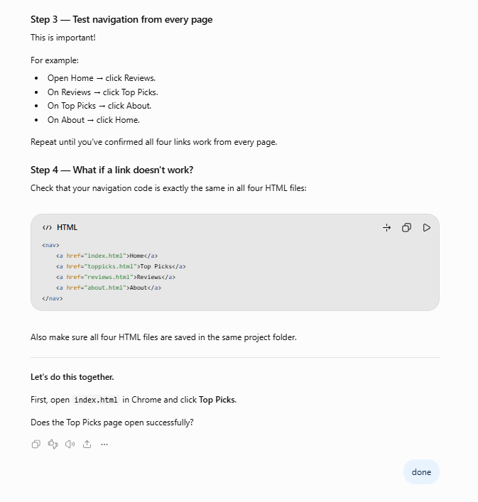

GITHUB

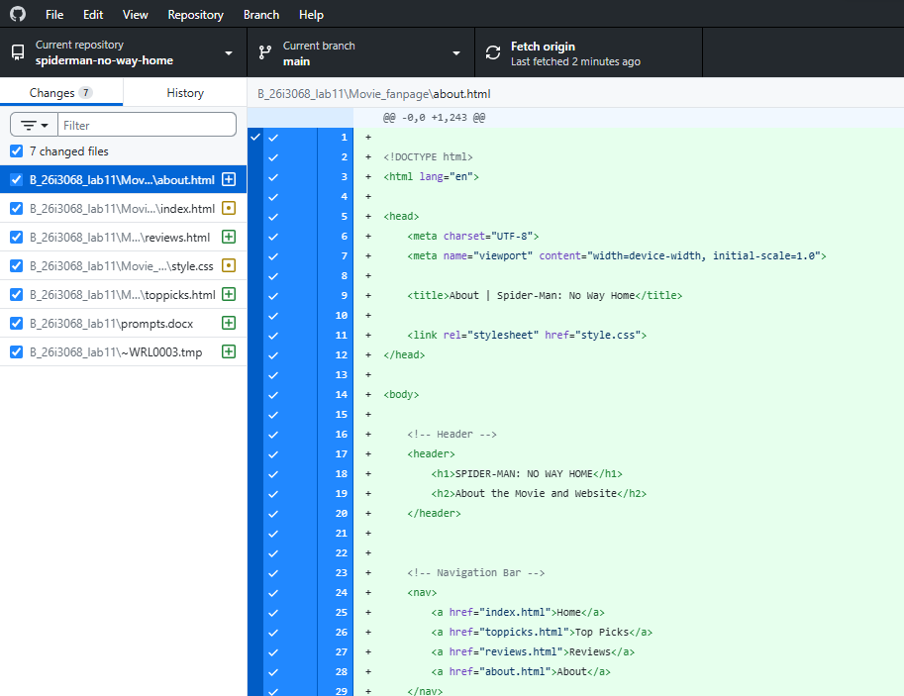

Conclusion
ChatGPT helped me generate website code, improve the design, create additional pages and troubleshoot problems. I tested the website in my browser and checked its navigation.

