OPERATING SYSTEMS
20K-1873

The pics contain all the codes of all parts.

Q.1
code:
#include<stdio.h>
#include <sys/types.h>
#include<unistd.h>
#include<wait.h>
#include <stdlib.h>

int main()
{
int fd[2];
if(pipe(fd) == -1)
{
printf("Error in opening the the pipe");
}
int id = fork();
if(id > 0)
{
close(fd[0]);
int x;
printf("Input any number:");
scanf("%d/n",&x);
if(write(fd[1],&x,sizeof(int))==-1)
{
printf("Error in writing the value.");
return 2;
}
else
{
close(fd[1]);
}
}
else{
close(fd[1]);
int y;
if(read(fd[0],&y,sizeof(int))==-1){
printf("Error in reading the value.");
return 2;
}
else{
close(fd[0]);
printf("Got the value from parent process: %d\n",y);
}
}
}

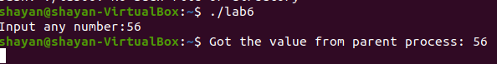

Q.2
Code:
(Read)
#include <stdio.h>
#include <sys/stat.h>
#include <unistd.h>
#include <fcntl.h>

int main(void)
{
int fd = open("/tmp/Task2_fifo", O_RDONLY);
if(fd == -1)
{
perror("open");
}

char buf[255] = {};
while(read(fd, buf, sizeof(buf)) <= 0);
close(fd);
printf("Message received: %s\n", buf);

return 0;
}

(Write)
#include <stdio.h>
#include <sys/stat.h>
#include <unistd.h>
#include <fcntl.h>

int main(void)
{
int ret = mkfifo("/tmp/Task2_fifo", 0666);
if(ret < 0)
{
perror("mkfifo");
}

int fd = open("/tmp/Task2_fifo", O_WRONLY);
if(fd == -1)
{
perror("open");
}
char buf[] = "Hello there";
write(fd, buf, sizeof(buf));
close(fd);
return 0;
}
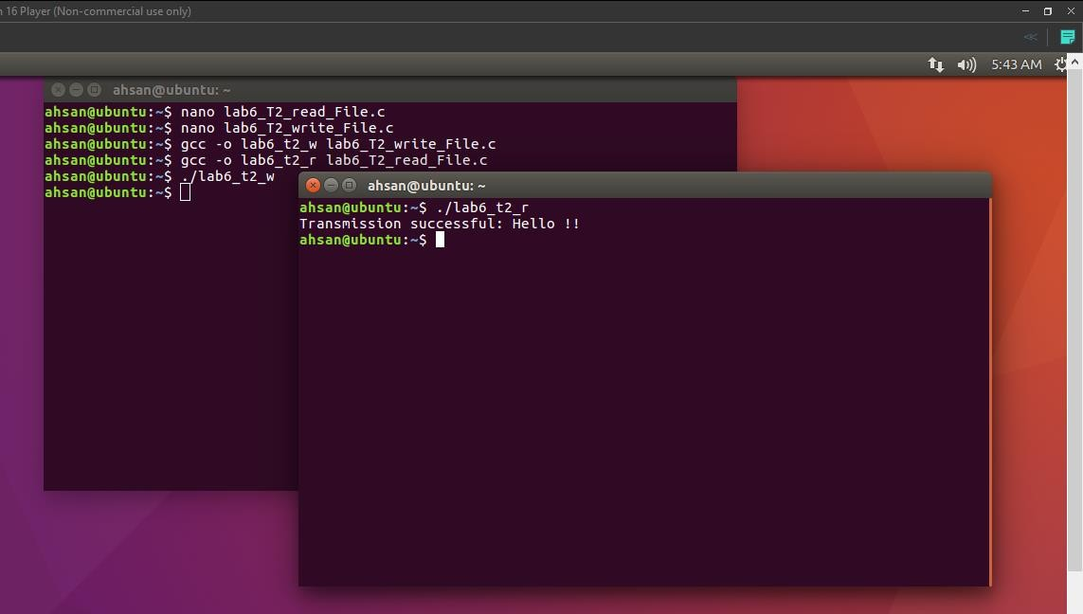

Q.3(a)
#include <sys/shm.h>
#include <stdio.h>
#include <stdlib.h>
#include <string.h>
#include <unistd.h>

#define SHM_SIZE 10

void Error(const char* msg)
{
perror(msg);
exit(EXIT_FAILURE);
}

int main(int argc, char* argv[])
{
if(argc != 2)
{
printf("Usage: ./Task3_P1 num\n");
exit(EXIT_FAILURE);
}
// create shm
int shmid = shmget(123, SHM_SIZE, IPC_CREAT | 0666);
if(shmid < 0)
{
Error("shmget");
}
// get ptr to shm
char* shm = shmat(shmid, NULL, 0);
if(shm == (char*)-1)
{
Error("shmat");
}
// write number and wait for P2 to read
strncpy(shm, argv[1], SHM_SIZE);
printf("Number sent to P1: %s\n", argv[1]);
while(strncmp(shm, "Ready", SHM_SIZE) != 0)
{
sleep(1);
}
// print ready
printf("Message from P2: %s\n", shm);

for(int i = 0; i < 10; i++)
{
// put * in memory
strncpy(shm, "*", SHM_SIZE);
// wait for other process to respond
while(strncmp(shm, "*", SHM_SIZE) == 0)
{
sleep(1);
}
printf("Result from P1: %d\n", atoi(shm));
}

return 0;
}

(B)
#include <sys/shm.h>
#include <stdio.h>
#include <stdlib.h>
#include <string.h>
#include <unistd.h>

#define SHM_SIZE 10

void Error(const char* msg)
{
perror(msg);
exit(EXIT_FAILURE);
}

int main(void)
{
// create shm
int shmid = shmget(123, SHM_SIZE, IPC_CREAT | 0666);
if(shmid < 0)
{
Error("shmget");
}
// get ptr to shm
char* shm = shmat(shmid, NULL, 0);
if(shm == (char*)-1)
{
Error("shmat");
}

char buf[SHM_SIZE + 1] = {}; // +1 in case shm has no null terminator
// read number
strncpy(buf, shm, SHM_SIZE);
int num = atoi(buf);
printf("Number received from P1: %d\n", num);
// put ready in shm
strncpy(shm, "Ready", SHM_SIZE);

for(int i = 1; i <= 10; i++)
{
// wait for * to be put in memory
while(strncmp(shm, "*", SHM_SIZE) != 0)
{
sleep(1);
}
printf("* received from P1\n");
// put result in memory
int calc_res = num * i;
sprintf(shm, "%d", calc_res);
}

return 0;
}

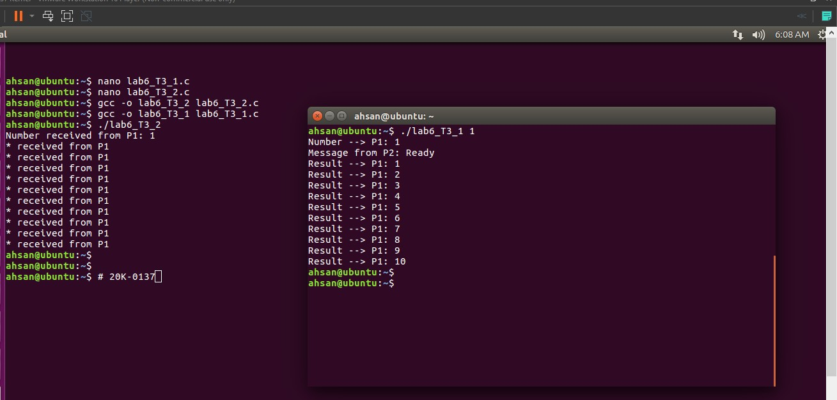

Q.4
(A)
#include <stdio.h>
#include <sys/shm.h>
#include <string.h>
#include <stdlib.h>
#include <unistd.h>

#define SHM_SIZE sizeof(num)

void Error(const char* msg)
{
perror(msg);
exit(EXIT_FAILURE);
}

int main(void)
{
long long num = 0;
int shmid = shmget('A', SHM_SIZE, IPC_CREAT | IPC_EXCL | 0666);
if(shmid < 0)
{
Error("shmget");
}
char* shm = shmat(shmid, NULL, 0);
if(shm == (char*)-1)
{
Error("shmat");
}

printf("Process started... will exit upon read -1 in shm\n");

memcpy(shm, &num, SHM_SIZE);
while(1)
{
memcpy(&num, shm, SHM_SIZE);
if(num == -1)
break;
sleep(1);
}

printf("Exiting process\n");
shmdt(shm);
shmctl(shmid, IPC_RMID, NULL);
return 0;
}

(B)
#include <stdio.h>
#include <sys/shm.h>
#include <string.h>
#include <stdlib.h>
#include <unistd.h>

#define SHM_SIZE sizeof(num)

void Error(const char* msg)
{
perror(msg);
exit(EXIT_FAILURE);
}

int main(void)
{
long long num = 1;
int shmid = shmget('B', SHM_SIZE, IPC_CREAT | IPC_EXCL | 0666);
if(shmid < 0)
{
Error("shmget");
}
char* shm = shmat(shmid, NULL, 0);
if(shm == (char*)-1)
{
Error("shmat");
}

printf("Process started... will exit upon read -1 in shm\n");

memcpy(shm, &num, SHM_SIZE);
while(1)
{
memcpy(&num, shm, SHM_SIZE);
if(num == -1)
break;
sleep(1);
}

printf("Exiting process\n");
shmdt(shm);
shmctl(shmid, IPC_RMID, NULL);
return 0;
}

(C)
#include <stdio.h>
#include <sys/shm.h>
#include <string.h>
#include <stdlib.h>
#include <unistd.h>

#define SHM_SIZE sizeof(long long)

void Error(const char* msg)
{
perror(msg);
exit(EXIT_FAILURE);
}

int main(int argc, char* argv[])
{
if(argc != 2)
{
printf("Usage: ./Task4_C n\n");
exit(EXIT_FAILURE);
}
// get shm of A
int shmid_a = shmget('A', SHM_SIZE, 0666);
if(shmid_a < 0)
{
Error("shmget a");
}
char* shm_a = shmat(shmid_a, NULL, 0);
if(shm_a == (char*)-1)
{
Error("shmat b");
}

// get shm of B
int shmid_b = shmget('B', SHM_SIZE, 0666);
if(shmid_a < 0)
{
Error("shmget b");
}
char* shm_b = shmat(shmid_b, NULL, 0);
if(shm_a == (char*)-1)
{
Error("shmat b");
}

long long n = atoi(argv[1]);
for(int i = 0; i < n; i++)
{
// get the numbers from A and B
long long num1, num2;
memcpy(&num1, shm_a, SHM_SIZE);
memcpy(&num2, shm_b, SHM_SIZE);
// add nums
long temp = num2;
num2 = num1 + num2;
num1 = temp;
// print res
printf("%lld ", num2);
// store back
memcpy(shm_a, &num1, SHM_SIZE);
memcpy(shm_b, &num2, SHM_SIZE);
}

printf("\nSending exit msg to A and B\n");
// send closing signal to A and B
n = -1;
memcpy(shm_a, &n, SHM_SIZE);
memcpy(shm_b, &n, SHM_SIZE);

shmdt(shm_a);
shmdt(shm_b);
return 0;
