Full Code Snapshot

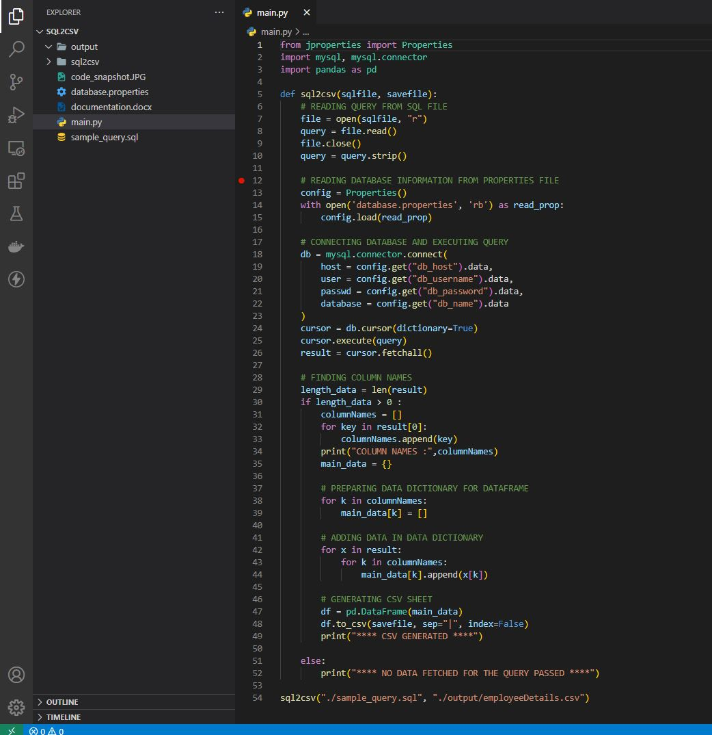

Database table columns in MySQL

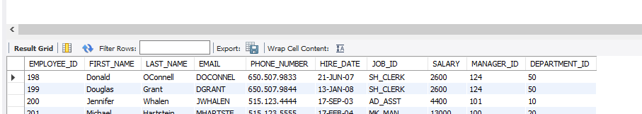

Code output with column names

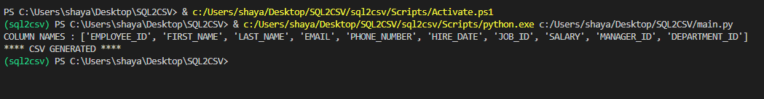

Generated CSV file (separated with “|”)

