Customer Shopping Behavior Analysis

1. Project Overview
This project analyzes customer shopping behavior using transactional data from 3,900 purchases across various product categories. The goal is to uncover insights into spending patterns, customer segments, product preferences, and subscription behavior to guide strategic business decisions.

2. Dataset Summary
- Rows: 3,900
- Columns: 18
- Customer demographics (Age, Gender, Location, Subscription Status)
- Purchase details (Item Purchased, Category, Purchase Amount, Season, Size, Color)
- Shopping behavior (Discount Applied, Promo Code Used, Previous Purchases, Frequency of Purchases, Review Rating, Shipping Type)
- Missing Data: 37 values in Review Rating column

3. Exploratory Data Analysis using Python
• Imported dataset using pandas.
• Used df.info() and describe() for initial exploration.
• Handled missing values using median imputation.
• Standardized columns into snake_case.
• Created engineered features such as age_group and purchase_frequency_days.
• Connected cleaned dataset to PostgreSQL for SQL analysis.

4. Data Analysis using SQL
1. Revenue by Gender
2. High-Spending Discount Users
3. Top 5 Products by Rating
4. Shipping Type Comparison
5. Subscribers vs. Non-Subscribers
6. Discount-Dependent Products
7. Customer Segmentation
8. Top 3 Products per Category
9. Repeat Buyers & Subscriptions
10. Revenue by Age Group

5. Dashboard in Power BI
Built an interactive Power BI dashboard to visualize customer behavior, revenue, product categories, subscription distribution, and age-group trends.

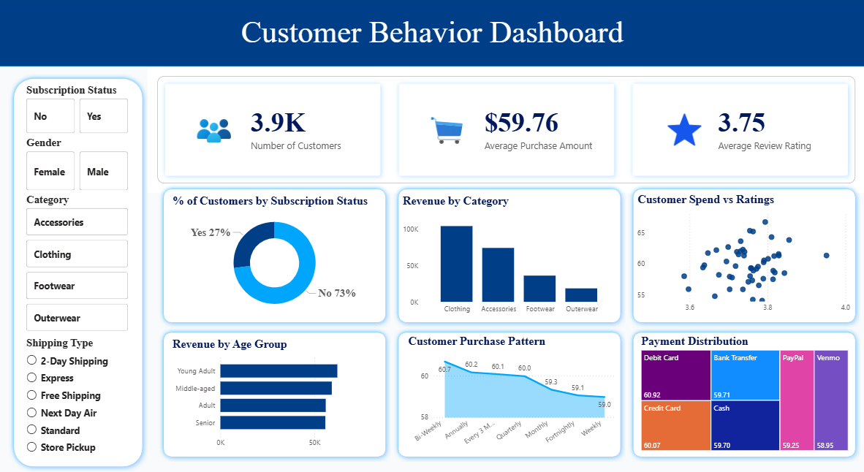

6. Key Insights
• Clothing category generated the highest revenue.
• Young adults contributed the highest total revenue.
• Loyal customers formed the majority customer segment.
• Express shipping users showed slightly higher average spending.
• Certain products had significantly higher discount dependency.

6. Business Recommendations
• Boost subscriptions with exclusive offers.
• Reward loyal customers.
• Balance discount policies with profitability.
• Promote top-rated and best-selling products.
• Use targeted marketing for high-revenue customer groups.

