Seattle Building Energy Dashboard

1. Project Overview
This project analyzes building energy consumption and greenhouse gas emissions using the Seattle Building Energy Benchmarking dataset. The objective of the project is to uncover insights into energy usage patterns, sustainability performance, emission intensity, and building efficiency across different neighborhoods and property types.
The dashboard was developed using Power BI to provide interactive visual analysis for understanding building performance and environmental impact.

2. Dataset Summary
• Rows: Approximately 3,000+ buildings
• Columns: Multiple energy and building-related attributes
Key Features:
• Building information (Property Type, Neighborhood, Year Built)
• Energy metrics (Site Energy Use, Electricity Use, Natural Gas Use)
• Sustainability metrics (Energy Star Score, GHG Emissions, Emission Intensity)
• Geographic details (Latitude, Longitude, Location)

3. Initial Data Cleaning using Excel
Before importing the dataset into Power BI, preliminary cleaning and inspection were performed in Microsoft Excel.
Cleaning Steps Performed in Excel:
• Checked for duplicate records and removed inconsistencies
• Verified column names and corrected formatting issues
• Identified missing or blank values in important fields
• Adjusted numerical formatting for energy and emission columns
• Inspected categorical columns such as Neighborhood and Property Type for spelling consistency
• Removed unnecessary spaces and invalid entries
• Performed initial sorting and filtering to validate dataset quality
Purpose of Excel Cleaning:
The Excel preprocessing stage helped improve data quality and ensured smoother transformation and visualization in Power BI.

4. Python-Based Exploratory Data Analysis
Python was used during the initial analysis stage to better understand the dataset before dashboard creation.
Libraries Used:
• Pandas
• NumPy
• Matplotlib
• Seaborn
Tasks Performed in Python:
• Loaded and inspected the dataset using Pandas DataFrames
• Performed descriptive statistical analysis
• Checked missing values and null distributions
• Explored correlations between energy usage and emissions
• Generated preliminary visualizations for trend analysis
• Analyzed distribution of building types and neighborhoods
• Studied energy consumption trends across construction years
• Validated relationships between Energy Star Score and GHG emissions
Benefits of Python Analysis:
Python-based exploratory analysis helped identify important trends and guided the selection of meaningful visualizations later implemented in Power BI.

5. SQL Analysis and Querying
SQL was used for querying and analyzing the energy dataset efficiently before visualization.
SQL Operations Performed:
• Data selection using SELECT statements
• Filtering records using WHERE clauses
• Grouping data using GROUP BY
• Sorting outputs using ORDER BY
• Aggregate analysis using SUM(), AVG(), COUNT(), MAX(), and MIN()
• Building-wise and neighborhood-wise energy analysis
• Property-type level emission comparisons
• Energy source contribution analysis
Sample Analytical Queries:
• Total energy consumption by property type
• Average Energy Star Score by neighborhood
• Highest emitting building categories
• Buildings with highest site energy usage
• Emission intensity comparisons across property types
Purpose of SQL Usage:
SQL helped in efficient data extraction, summarization, and validation of analytical insights before dashboard implementation.

6. Data Preparation and Cleaning in Power BI
The dataset was further cleaned and transformed inside Power BI using Power Query.
Data Cleaning Steps:
• Checked for null and missing values
• Removed unnecessary fields
• Corrected inconsistent column formats
• Renamed columns for readability
• Converted numerical columns into proper data types
• Verified data consistency across energy metrics
Feature Engineering:
• Created KPI measures using DAX
• Calculated average emission intensity
• Created total energy and total emissions measures
• Grouped building categories for better analysis

7. Dashboard Development in Power BI
The dashboard was developed in Microsoft Power BI using interactive charts, KPI cards, slicers, and filters.
Page 1 — Overview Dashboard
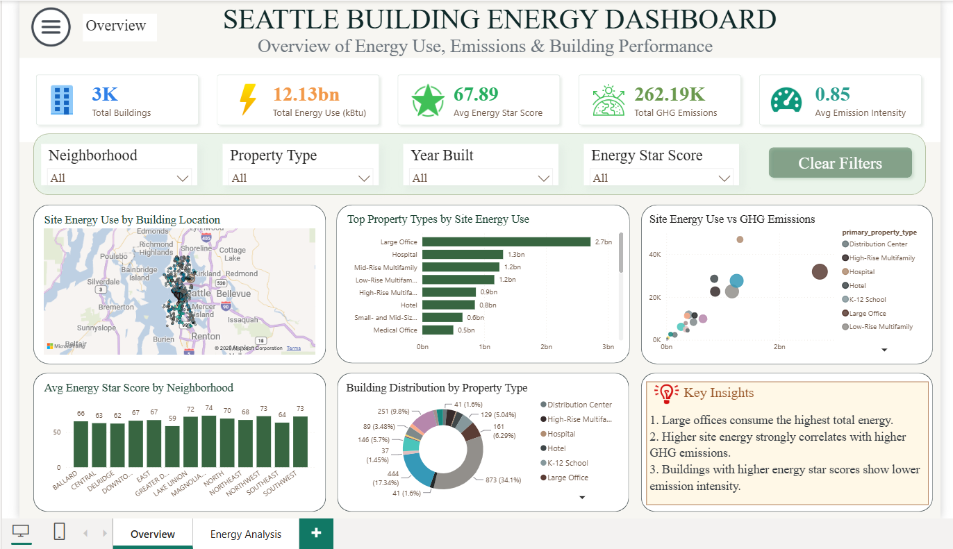

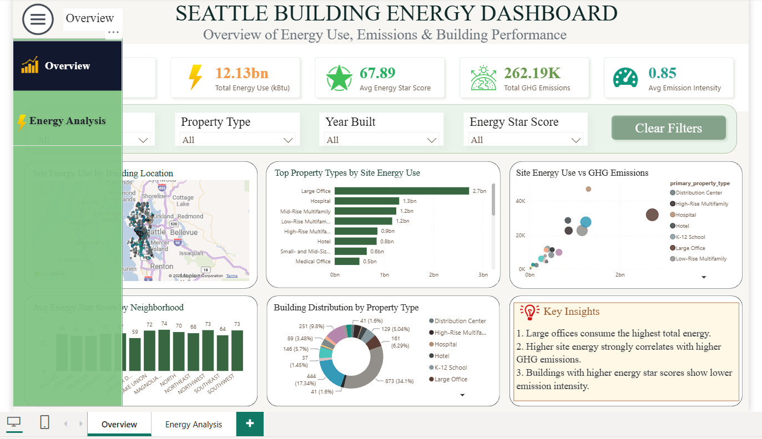

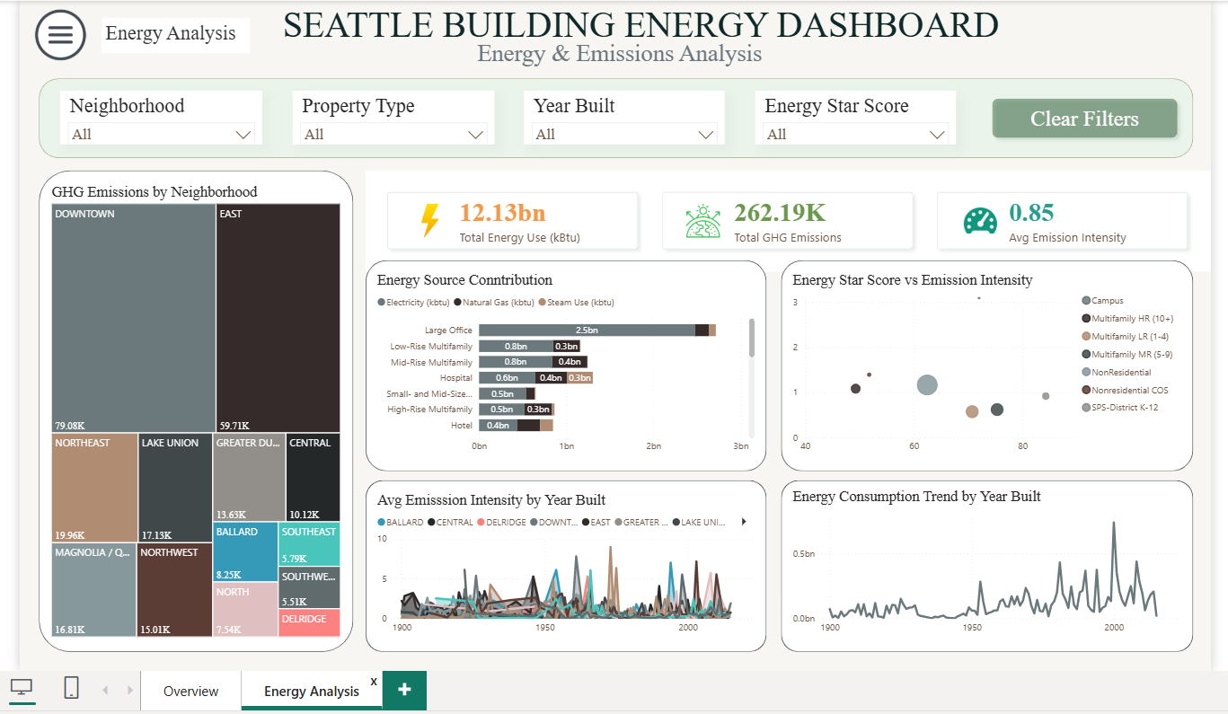
KPI Cards Included:
• Total Buildings
• Total Energy Use (kBtu)
• Average Energy Star Score
• Total GHG Emissions
• Average Emission Intensity
Visualizations Used:
• Map — Site Energy Use by Building Location
• Bar Chart — Top Property Types by Site Energy Use
• Scatter Plot — Site Energy Use vs GHG Emissions
• Column Chart — Average Energy Star Score by Neighborhood
• Donut Chart — Building Distribution by Property Type
• Key Insights Panel
Page 2 — Energy & Emissions Analysis

Visualizations Used:
• Treemap — GHG Emissions by Neighborhood
• Stacked Bar Chart — Energy Source Contribution
• Scatter Plot — Energy Star Score vs Emission Intensity
• Line Chart — Average Emission Intensity by Year Built
• Line Chart — Energy Consumption Trend by Year Built

8. DAX Measures Used
Total Buildings = COUNT(osebuildingid)
Total Energy Use = SUM(site_energy_use_kbtu)
Avg Energy Star Score = AVERAGE(energy_star_score)
Total GHG Emissions = SUM(ghg_emissions_mtco2e)
Avg Emission Intensity = AVERAGE(ghg_emissions_intensity_kgco2e_ft2)

9. Key Insights
• Large office buildings consume the highest amount of total energy.
• Downtown neighborhoods contribute significantly higher greenhouse gas emissions.
• Higher site energy consumption generally correlates with higher GHG emissions.
• Electricity contributes the largest share of overall building energy consumption.
• Older buildings tend to show higher emission intensity compared to newly constructed buildings.
• Energy-efficient buildings generally show lower environmental impact.

10. Dashboard Features
Interactive Features:
• Dynamic filtering using slicers
• Cross-filtering between visuals
• Hover tooltips for detailed information
• Drill-down capability
• Clear Filters button for resetting analysis
Design Features:
• Minimal and professional layout
• Sustainability-inspired green theme
• Rounded visual containers
• Soft shadow effects
• Consistent alignment and spacing

11. Challenges Faced
• Handling missing and inconsistent energy values
• Managing overcrowded scatter plots
• Selecting meaningful visualizations without duplication
• Maintaining clean dashboard alignment and responsiveness
• Optimizing dashboard readability and interactivity

12. Business Recommendations
• Focus sustainability initiatives on high-emission neighborhoods.
• Encourage modernization of older buildings.
• Improve efficiency in electricity-heavy properties.
• Promote greener building standards.
• Monitor high-energy-consuming building categories regularly.

13. Conclusion
The Seattle Building Energy Dashboard successfully converts complex energy benchmarking data into meaningful business intelligence insights. By integrating Excel preprocessing, Python exploratory analysis, SQL querying, and Power BI visualization, the project demonstrates a complete end-to-end data analytics workflow.
The dashboard enables interactive exploration of building performance, energy efficiency, and environmental impact, helping users make informed sustainability decisions.

14. Tools and Technologies Used
• Microsoft Excel — Initial cleaning and preprocessing
• Python — Exploratory Data Analysis
• SQL — Data querying and aggregation
• Power BI Desktop — Dashboard creation
• Power Query — Data transformation
• DAX — KPI calculations

