CSE 4241: Biomedical Engineering

Protein 2D Structure Prediction Using Deep Learning
By
Shayka Islam Shipra
Roll: 2007110


Submitted To:
Safin Ahmmed
Assistant Professor
Department of Computer Science and Engineering

Department of Computer Science and Engineering
Khulna University of Engineering & Technology
Khulna 9203, Bangladesh

1. Introduction
In this assignment I tried to build a small deep learning workflow for protein secondary structure prediction. The task was to predict whether each amino acid position belongs to helix, sheet, or coil. I understand that this is not the same as full 3D structure prediction, but it is still related because secondary structures are one of the first levels of protein folding.
I used this project mainly to practice the full pipeline. I collected protein sequences, cleaned them, encoded them, trained a neural network, and then checked the result using graphs and evaluation metrics. My model was not perfect, but the output helped me understand where it was learning and where it was failing.

2. Data Collection
For data collection I used the NCBI protein database through Biopython. I searched human proteins from different groups such as hemoglobin, insulin, collagen, kinase, myosin, and transporter proteins. I did this because using only one type of protein would make the dataset less varied.
One thing I noticed during collection was that some search terms gave very few records. For example, hemoglobin gave only one sequence and some terms returned zero usable IDs. After running all searches, I got 42 raw sequences. After cleaning and filtering, 21 sequences were usable for the model.
Raw sequences collected | 42
Usable sequences after preprocessing | 21
Shortest sequence | 43 residues
Longest sequence | 1160 residues
Average sequence length | 240.8 residues
FASTA output | protein_assignment_outputs/collected_sequences.fasta

3. Preprocessing
In preprocessing, I removed any character that was not one of the 20 standard amino acids. Then I kept sequences between 40 and 1200 residues. I first used a smaller length range, but that removed too many proteins. Later I changed it so that longer proteins could still be included. For the model input, long proteins were truncated and short proteins were padded.
I used one-hot encoding for the amino acids. So each residue became a vector of length 20. The fixed input length was 500, which made the final input shape (21, 500, 20). The dataset was split into 14 training sequences, 3 validation sequences, and 4 test sequences.
A limitation here is that NCBI FASTA sequences do not directly provide helix, sheet, and coil labels. To keep the assignment runnable, I created approximate labels using amino acid tendency rules. This means the labels are useful for learning the workflow, but they are not as strong as real DSSP labels from experimentally solved protein structures.
Encoding method | One-hot encoding
Number of amino acid features | 20
Fixed input length | 500 residues
Training set | 14 sequences
Validation set | 3 sequences
Test set | 4 sequences

4. Model Architecture
I used a Bidirectional LSTM model. I chose BiLSTM because protein sequences are ordered, and the class of one residue can depend on residues before and after it. The first LSTM layer used 96 hidden units in both directions. The second LSTM layer used 48 hidden units in both directions. Then I used dropout, one dense layer, ReLU activation, and a final output layer for three classes.
The model summary showed 189,955 trainable parameters.
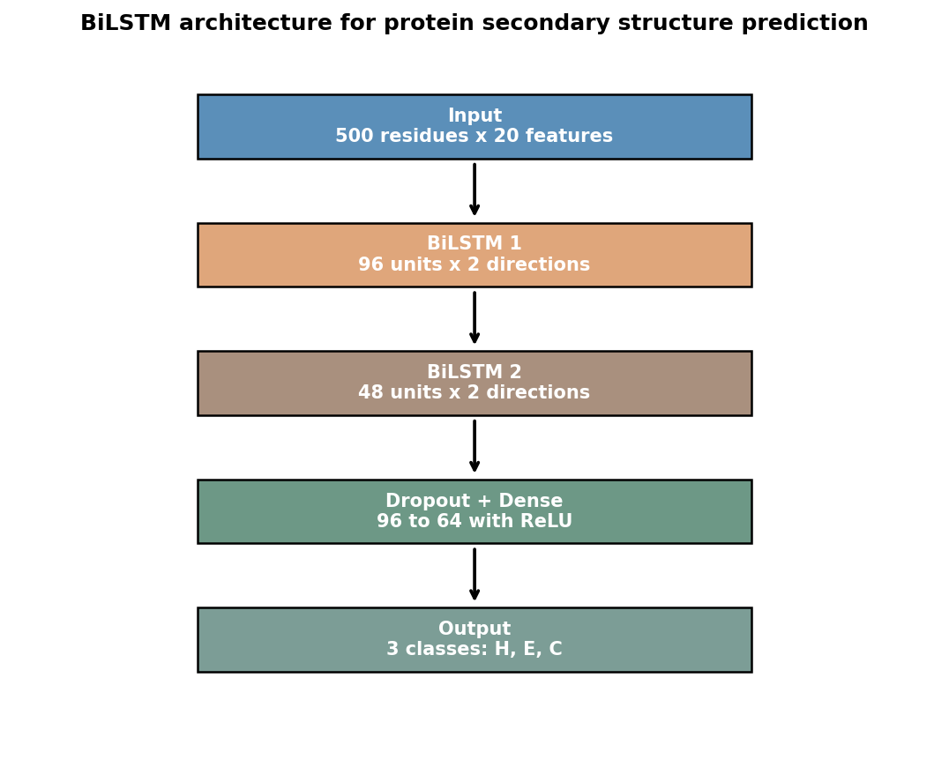
Figure 1: Model architecture diagram.

5. Training
The model was trained with Adam optimizer and cross-entropy loss. At first, the model mostly predicted Helix, so the result looked weak for Sheet and Coil. After that I used class-weighted cross-entropy. This helped because the model gave more attention to the classes that were not being predicted properly.
During training, the loss decreased from around 1.14 to around 0.99 in the earlier run. After balancing the classes, the final test result became better than the first result. I also tracked the mean absolute weights of the LSTM and fully connected layers so that weight update GIFs could be generated.
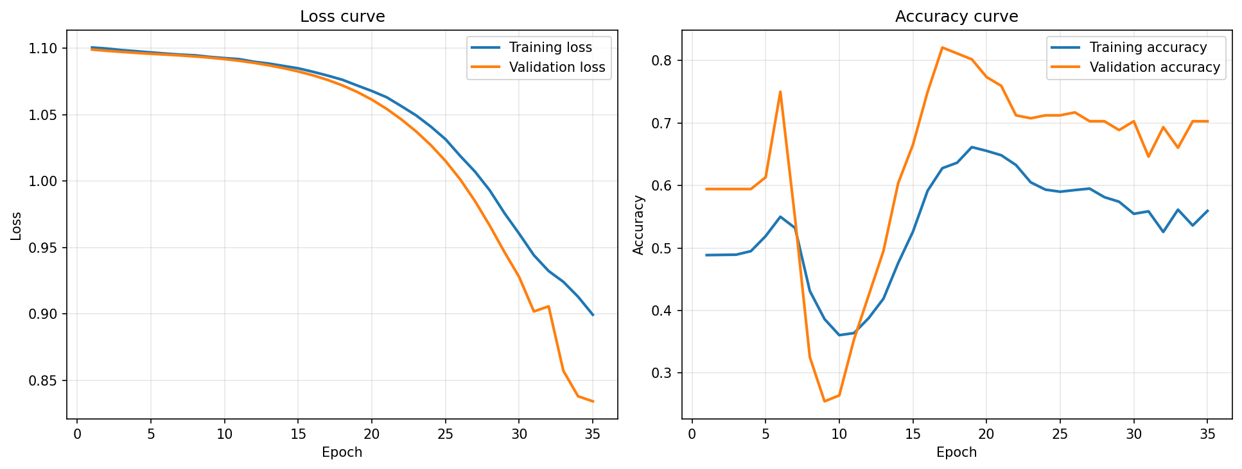
Figure 2: Loss and accuracy curves during training.

6. Result and Evaluation
The final test result was calculated only on real residue positions, not on padded positions. The test set had 373 residue labels. The model achieved 52.55% accuracy. The weighted precision was 54.10%, weighted recall was 52.55%, and weighted F1-score was 45.92%.
Accuracy | 0.5255
Weighted precision | 0.5410
Weighted recall | 0.5255
Weighted F1-score | 0.4592
Test residues | 373

Class | Precision | Recall | F1-score | Support
Helix (H) | 0.68 | 0.75 | 0.71 | 186
Sheet (E) | 0.33 | 0.78 | 0.46 | 67
Coil (C) | 0.44 | 0.03 | 0.06 | 120
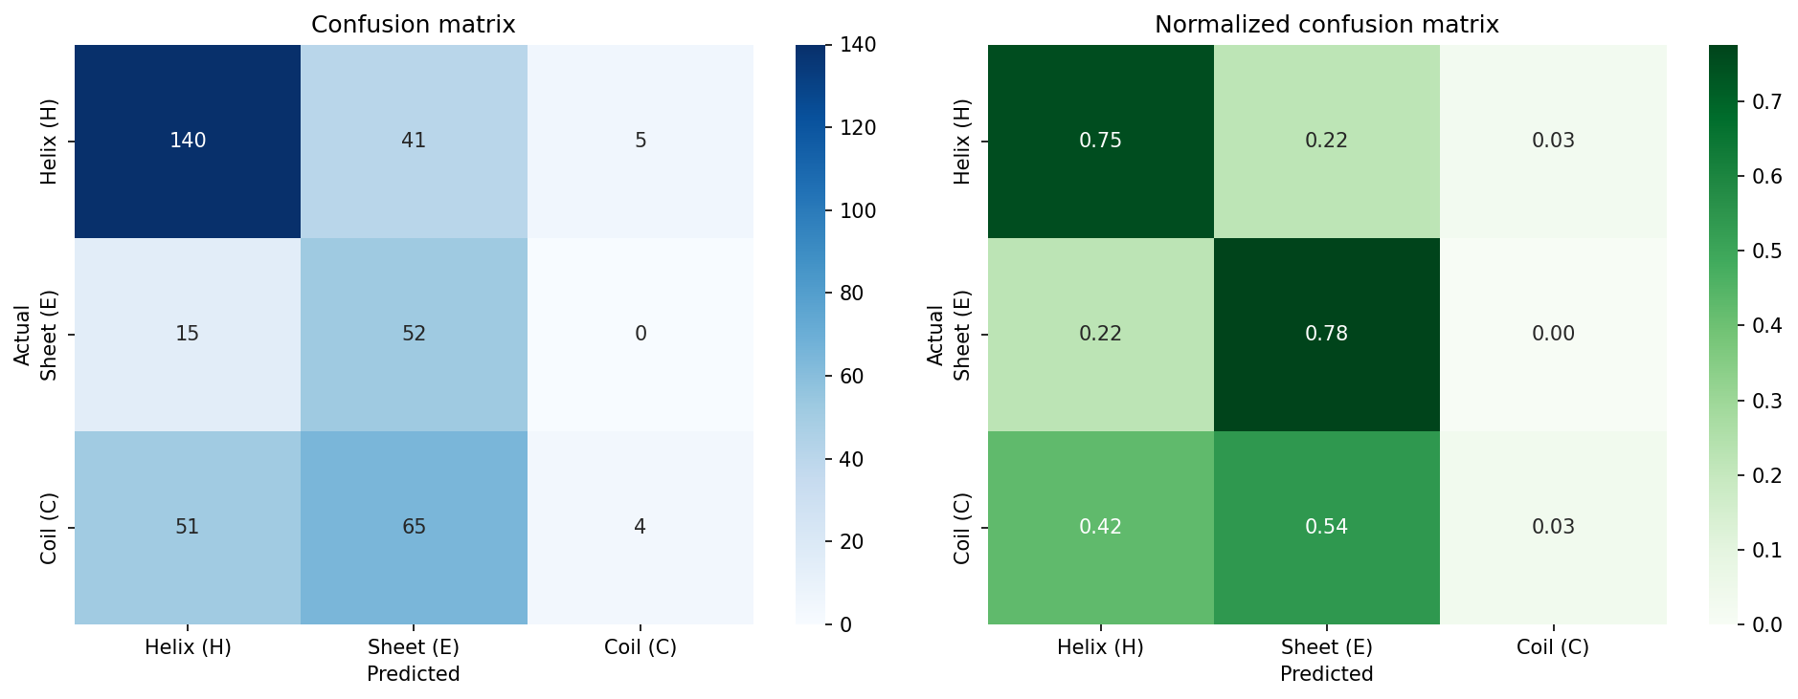
Figure 3: Confusion matrix for the test result.

7. My Observation
The model performed best on Helix. Its F1-score was 0.71, which is much better than the other two classes. Sheet also improved after using class weighting, especially recall, which became 0.78. That means many actual Sheet residues were found, although some wrong predictions were also made.
Coil was the weakest class. Its recall was only 0.03, so most Coil residues were classified as Helix or Sheet. I think this happened because Coil regions are less regular and harder to describe with a simple rule. Also, my dataset was small, and the labels were approximate. Because of these reasons, I do not think the moderate accuracy is surprising.
From this result I learned that accuracy alone is not enough. The accuracy was about 52.55%, but the class-wise report showed that Helix was much easier for the model than Coil. So the confusion matrix and F1-score gave a clearer picture than accuracy only.

8. Weight Update GIFs
The notebook generated GIF files for weight updates. I made one combined GIF and separate GIFs for each tracked layer. These files can be submitted with the notebook and report. Word does not always play GIF animation properly, so I am listing the file names here.
All tracked layers | weight_updates_all_layers.gif
LSTM layer 1 | weight_updates_lstm1.gif
LSTM layer 2 | weight_updates_lstm2.gif
Fully connected layer 1 | weight_updates_fc1.gif
Fully connected layer 2 | weight_updates_fc2.gif

9. Limitations and Future Work
The main limitation of this work is the dataset. Only 21 usable sequences were used, so the model did not have enough examples to learn all classes strongly. Another limitation is the label generation method. Real secondary structure labels from DSSP or PDB would be much better than approximate labels.
In future work, I would use a larger dataset with experimentally verified labels. I would also try protein embeddings or a transformer-based model, because they can learn richer sequence patterns than one-hot encoding.

10. Conclusion
In this project I completed the full workflow for protein secondary structure prediction. I collected sequences from NCBI, preprocessed them, converted them using one-hot encoding, trained a BiLSTM model, generated graphs and GIFs, and evaluated the result using multiple metrics. The final accuracy was 52.55%, which is not very high, but the project still shows the complete process and gives a clear idea of what needs to be improved.
References
- NCBI Protein Database.
- Biopython Entrez and SeqIO documentation.
- PyTorch documentation for LSTM and neural network training.
- Chou-Fasman secondary structure prediction concept.

