***Activity-2***

Shayla Tyagi,23bce0822

Aim:

Use appropriate list elements to represent the following data

* List of courses in Winter 2024-2025.
* List the programming languages and provide rating yourself out of 10.
* Add reviews or book summary of your 3 favourite movies/books/TV shows/ music concert.

|  |  |
| --- | --- |
| **HTML Tags need to be used:**    **Tags used** | **Attributes** |
|  |  |
| <table> | border, rowspan, colspan, align=center/left/right, cellpadding=, cellspacing= |
| <tr> | |
| <td> | bg-color |
| <th> | |
| <caption> | |
| <font> | color, face, size |

<h1> for heading

<p> for paragraphs

<img> to attach image

**Procedure:**

1. In notepad or any editor or IDE type the necessary code & save with the file name mentioned with .html extension display your time table.
2. To view your web page, simply double click your html file.

code

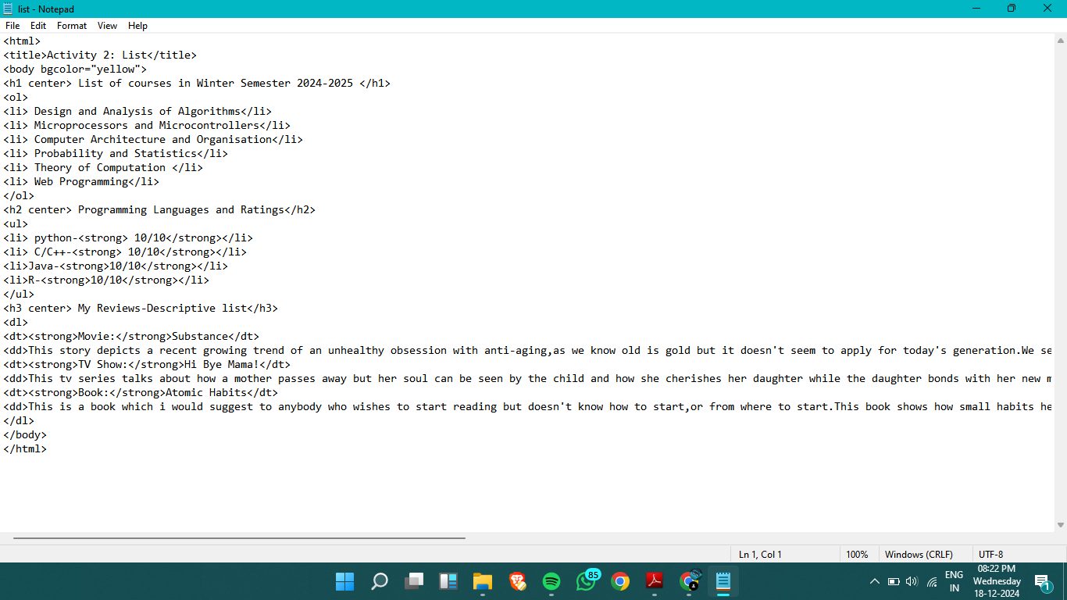

Output

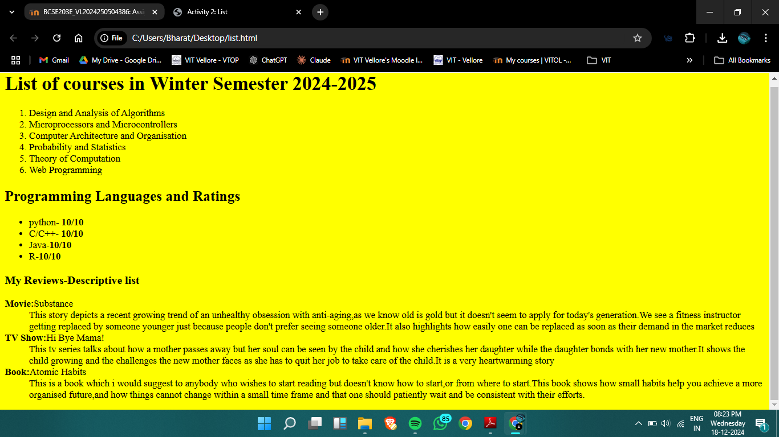

Result:

Lists