***Activity-3***

Aim

Use the tables as depicts in the following figure



* r1c1 – include any images of your choice
* r1c3, r5c1, r4c1, r4c2- shades with your favourite color
* r1c4, r5c3, r6c4, r5c5- include your positive affirmations (use font family, color, formatting as per choice)
* r3c1- provide links to “*home.html*”
* r2c3- Email as hyperlinks
* r3c4- image as hyperlinks

|  |  |
| --- | --- |
| **HTML Tags need to be used:**    **Tags used** | **Attributes** |
|  |  |
| <table> | border, rowspan, colspan, align=center/left/right, cellpadding=, cellspacing= |
| <tr> | |
| <td> | bg-color |
| <th> | |
| <caption> | |
| <font> | color, face, size |

<h1> for heading

**Procedure:**

1. In notepad or any editor or IDE type the necessary code & save with the file name mentioned with .html extension display your time table.
2. To view your web page, simply double click your html file.

Code

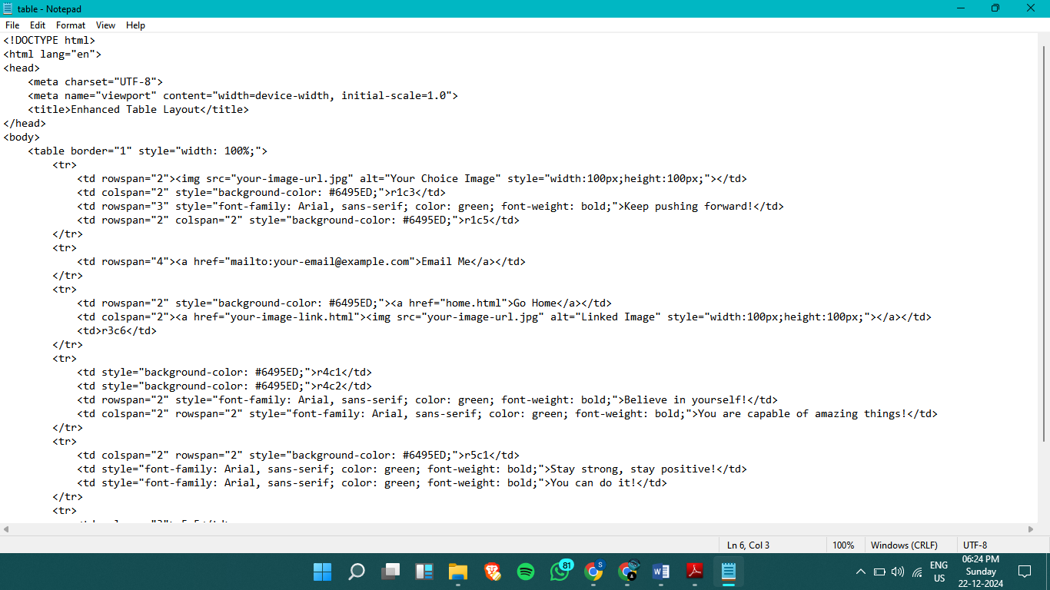

Output

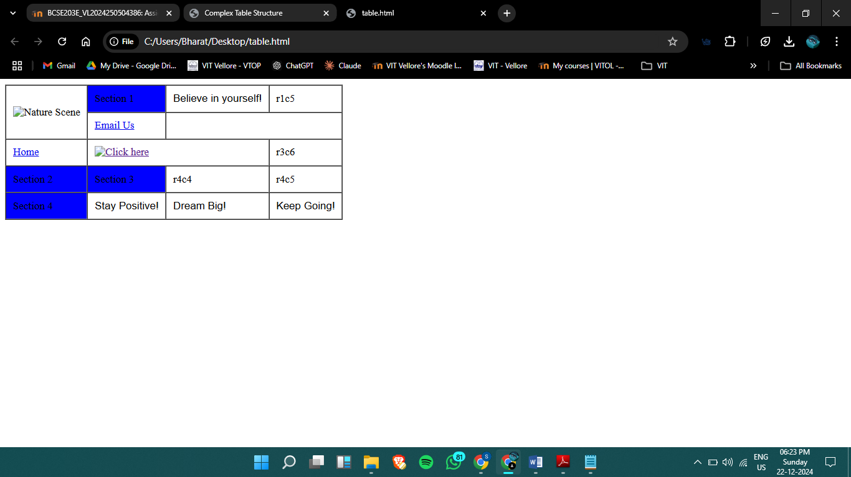

Result:

table