Name:Shayla Tyagi

Registration number:23BCE0822

***Activity-8***

Aim:

**Activity 8: Semantic html**

Design a web page of your choice “*myindex.html*” and include the following information as follows.

* Home Page - Short Descriptions about your theme.
* Navigation page- include all the activity listed in assignment 1A ,1B, and 1C
* Blog Page – Photos/ videos/ hyperlinks
* Contact us – Use your intuitive approach and add the form fields for a contact us page in the footer.

|  |  |
| --- | --- |
| **HTML Tags need to be used:**    **Tags used** | **Attributes** |
|  |  |
| <table> | border, rowspan, colspan, align=center/left/right, cellpadding=, cellspacing= |
| <tr> | |
| <td> | bg-color |
| <th> | |
| <caption> | |
| <font>  <form>  <action>  <section> | color, face, size |

**Procedure:**

1. In notepad or any editor or IDE type the necessary code & save with the file name mentioned with .html extension display your time table.
2. To view your web page, simply double click your html file.

Code(with timestamp)

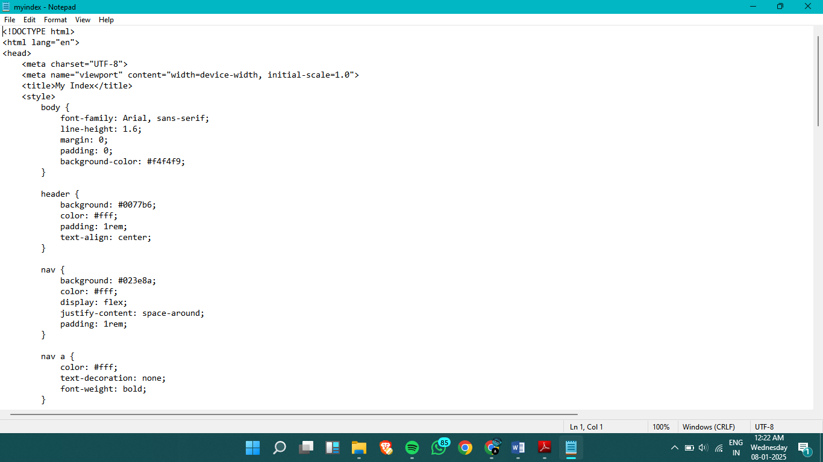

Output(with timestamp)

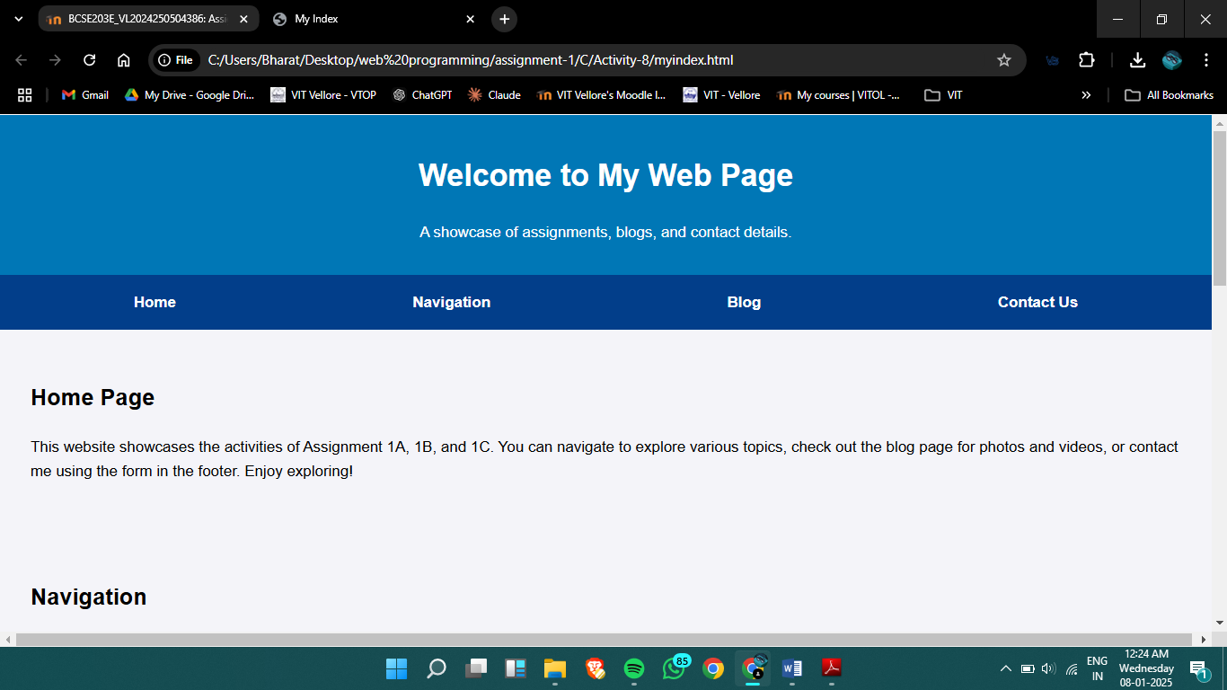

Result:

Web page