Activity-12

Aim:

**Activity 12:**

For activity #12, you must re -create a new version of the Web site you created for Assignment 1C (activity #8), only this time you must use only CSS to achieve the same design

**CSS constraints**

* Use respective selector for designing layout temple as per your choice.
* Design customized banner image for home page
* Apply CSS for navigation page and hyperlinks can be styled with any CSS property (e.g. color, font-family, background, etc.).
* Apply styles for signup and login pages.
* Apply box model and position properties which is applicable for your design

**Note: Choose the layout design of your choice and use external CSS file**

HTML and CSS Tags need to be used:

|  |  |  |  |
| --- | --- | --- | --- |
| HTML Tags used  Html | HTML Attributes | CSS style selector | CSS style Properties |
| Head | P | Font-family | Margin |
| Title | H1 | font-size | Padding |
| Style |  | color | Border |
| Div |  | text-align | display |

Procedure:

1. In notepad or any editor or IDE type the necessary code & save with the file name mentioned with .html extension display your time table.

2. To view your web page, simply double click your html file

- As screenshot with timestamp (date and time) –

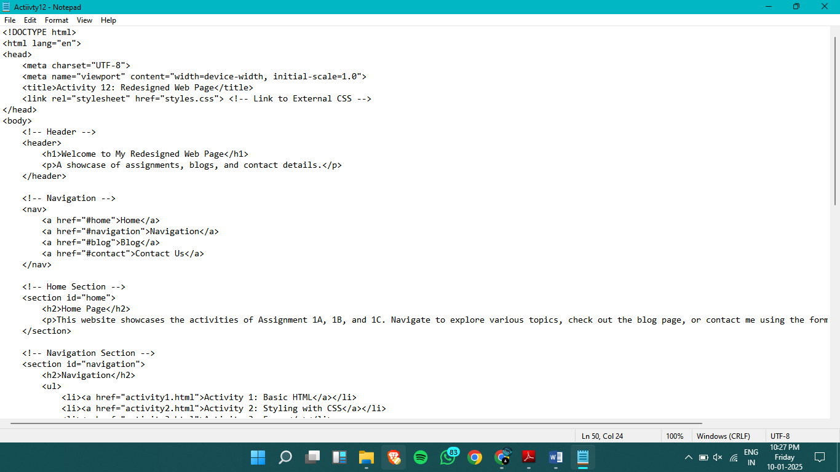

Output

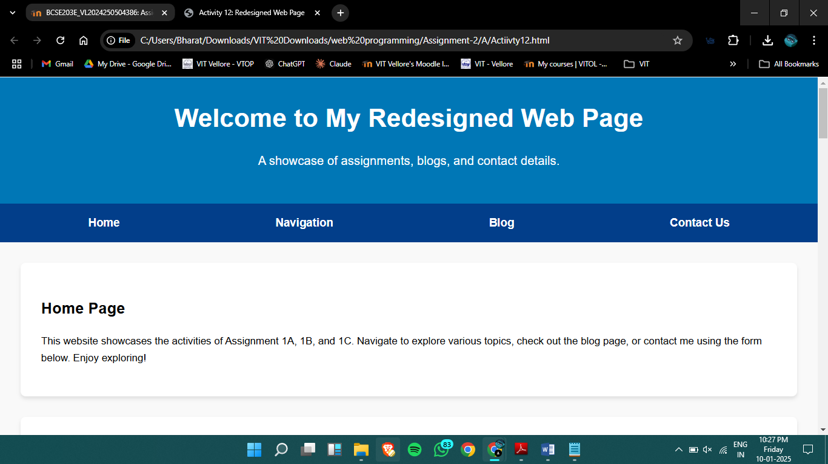

Result:

Thus, a web page design to replicate the above table and the output was verified.