Activity-9

Aim:

Activity 9: For activity #9, you must re -create a new version of the Web site you created for Assignment 1A (activity #1), only this time you must use only CSS to achieve the same design.

• Include heading h1 should be of size 16 and highlights with color of your choice

• Sub heading for each paragraph using h2 and all sub headings should be of size 14 and color “green”

• Use different font family for all three paragraphs and should be font-size 12.

• All the paragraph contents should be aligned with justify.

• Use div element to differentiate each paragraph. (Hint: use background-color)

• Apply vertical text of your choice.

• Display the overflowed content when hovering over the element.

• Display your image as rounded images and create drop-shadow effect to an image.

• Use the border property to create thumbnail images.

Note: Include your CSS style as a container

HTML and CSS Tags need to be used:

|  |  |  |  |
| --- | --- | --- | --- |
| HTML Tags used  Html | HTML Attributes | CSS style selector | CSS style Properties |
| Head | P | Font-family | Margin |
| Title | H1 | font-size | Padding |
| Style |  | color | Border |
| Div |  | text-align | display |

Procedure:

1. In notepad or any editor or IDE type the necessary code & save with the file name mentioned with .html extension display your time table.

2. To view your web page, simply double click your html file

- As screenshot with timestamp (date and time) –

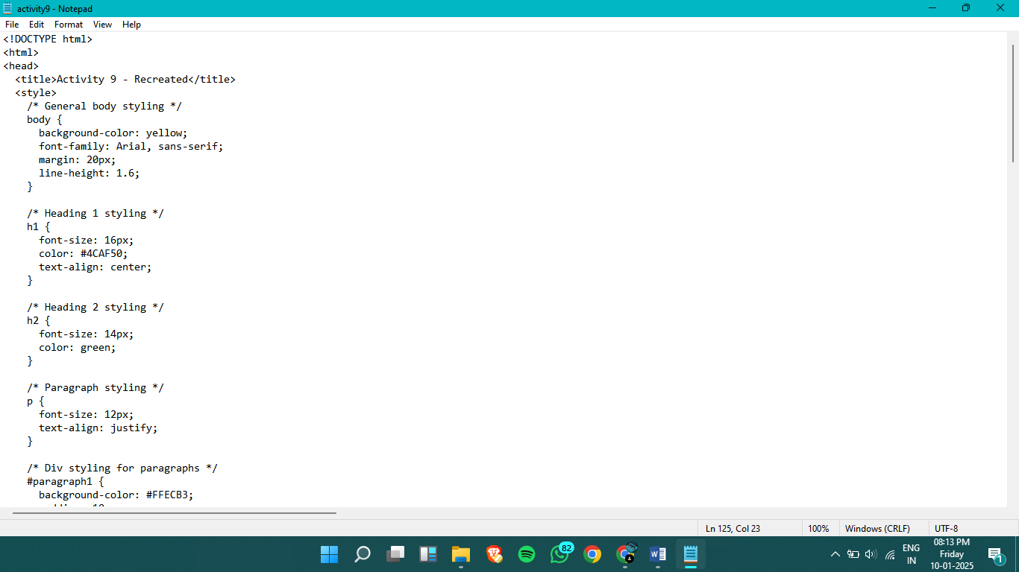

screenshot with timestamp

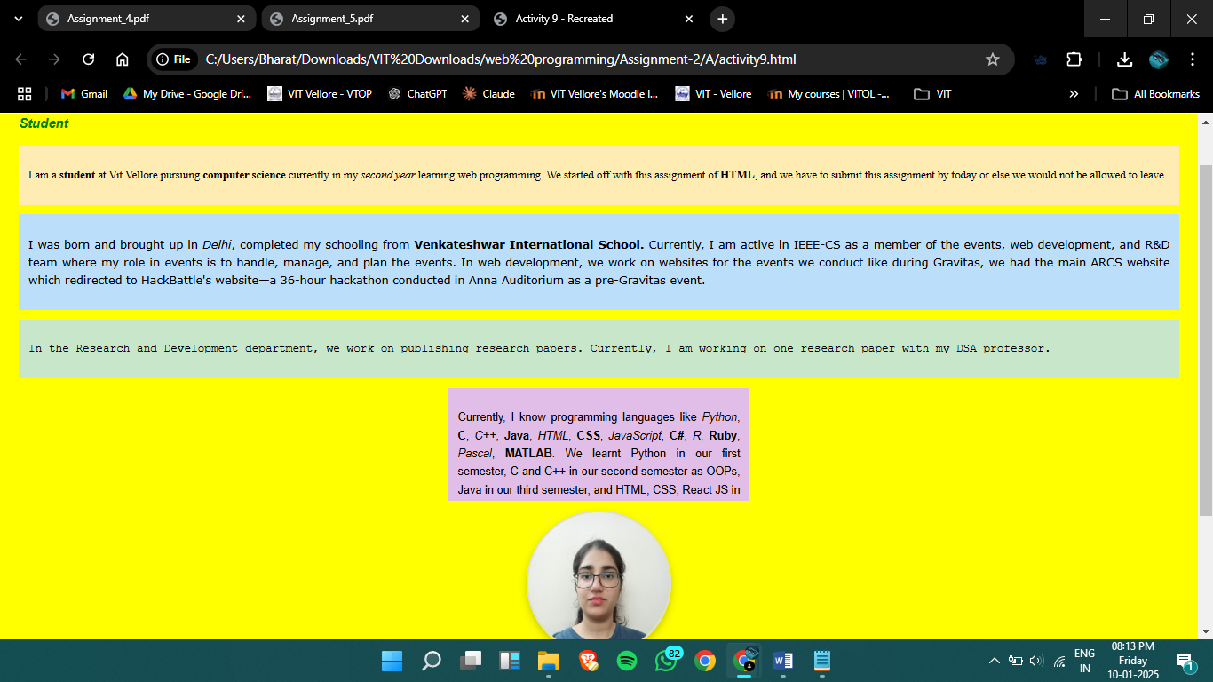

Result:

Thus, a web page design to replicate the above table and the output was verified.