Name:Shayla Tyagi

Registration number:23BCE0822

Activity 1

Aim:

Design a web page “home.html” that describes about you and it include all of the following information
- Your name as Heading (use h1) to the webpage and add tagline about you (use h2 and italics).

Note: Choose font family and color as per your choice
- A description of yourself in minimum 3 paragraphs and justify the text content
- Highlight the most important word(s) and infer the differences of bold, strong, emphasize.
- Use background colours and text colours appropriately for a good design.
- Add your image in left corner of the first paragraph

HTML Tags need to be used:  Tags used | Attributes
<table> | border, rowspan, colspan, align=center/left/right, cellpadding=, cellspacing=
<tr>
<td> | bg-color
<th>
<caption>
<font> | color, face, size

Procedure:

- In notepad or any editor or IDE type the necessary code & save with the file name mentioned with .html extension display your time table.
- To view your web page, simply double click your html file.

Code(with timestamp)

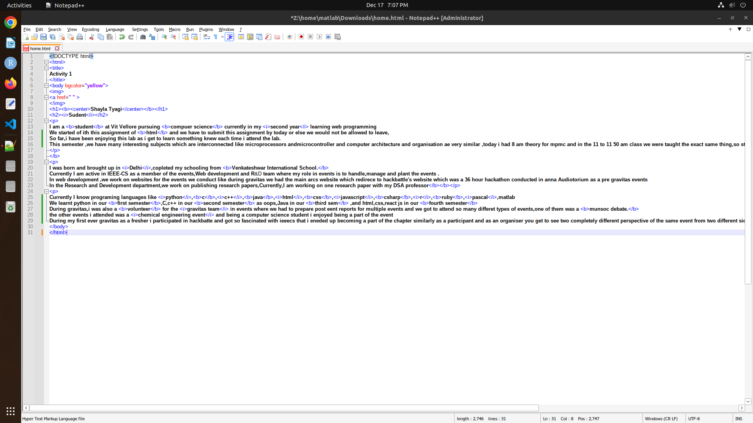

Output(with timestamp)

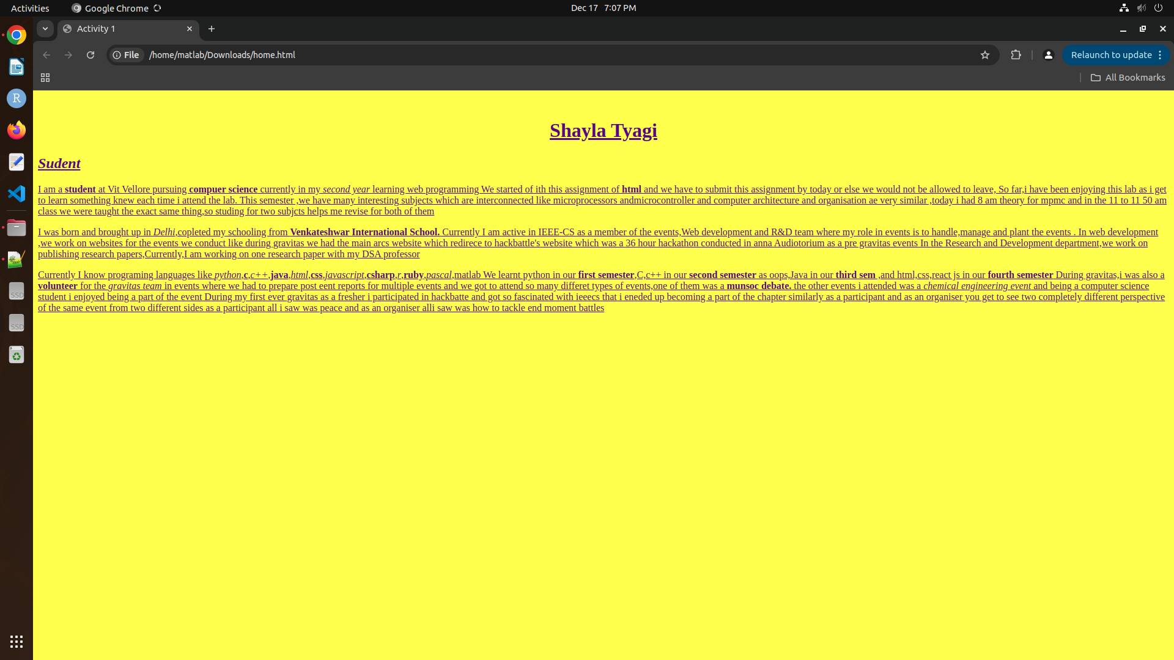
Result:
Home page done

