Name: shayma Al-Akhrass.

Major: BIT.

App Name: Foods.

Framework: Angular.

Components: \*create component.

\*read component.

\*model.

\*reducer.

\*sign.

\*actions.

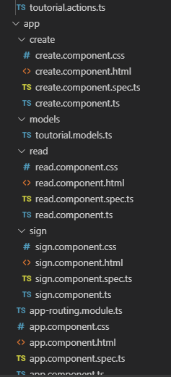

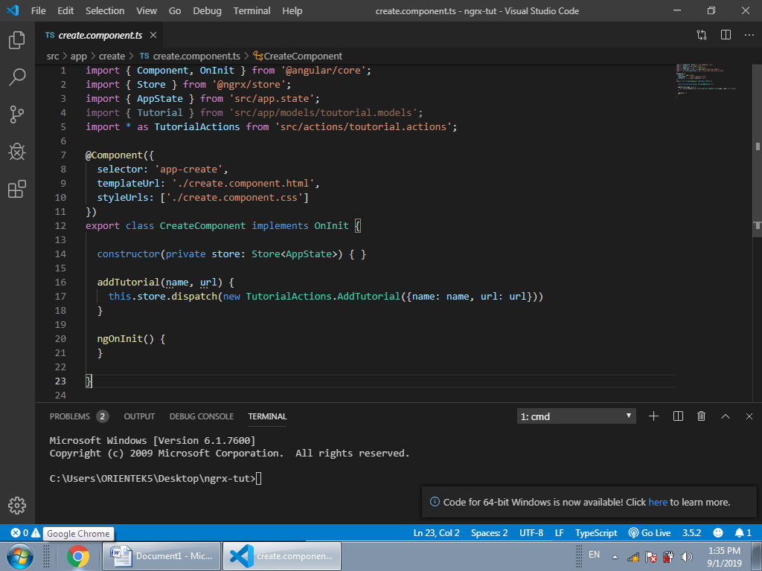

The use of the Ngrx….