1) Define System Vision

NexusOS is a multi-tenant SaaS administration platform that enables organizations to manage users, products, and orders securely through a centralized dashboard.

2) Define Core Modules
- Authentication
- Authorization
- Dashboard
- Tenant Management
- Users Management
- Products Management
- Orders Management

3) User Roles
- Super Admin
- Tenant Admin
- User

4) Plans
- Enterprise
- Pro
- Basic

4) User Stories
- As a Super Admin, I want to oversee entire system infrastructure and manage tenants.
- As a Tenant Admin, I want to create users so that my organization can manage access.
- As a Tenant User, I want to create and manage products and orders depend on given permission.

5) Use Cases
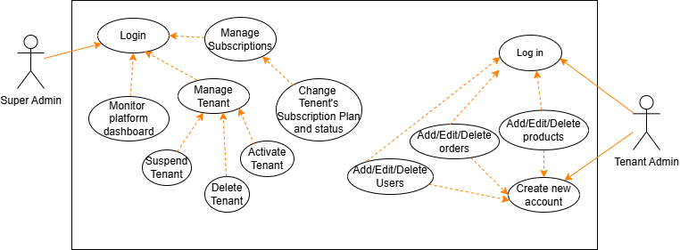

6) Entity Relationship Diagram (ERD)
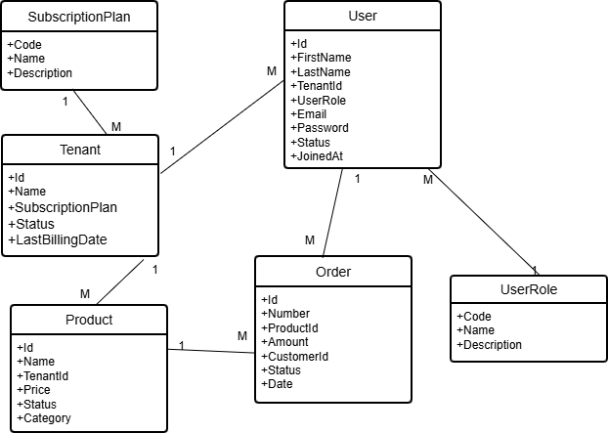

7) C4 Diagrams

System context diagram
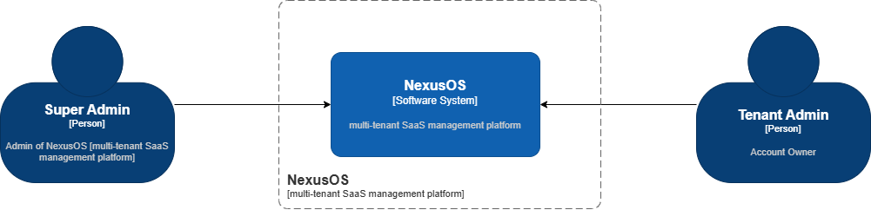

Container diagram
