Shay Snyder

CSCI-1250-088

Raptor Flow Chart

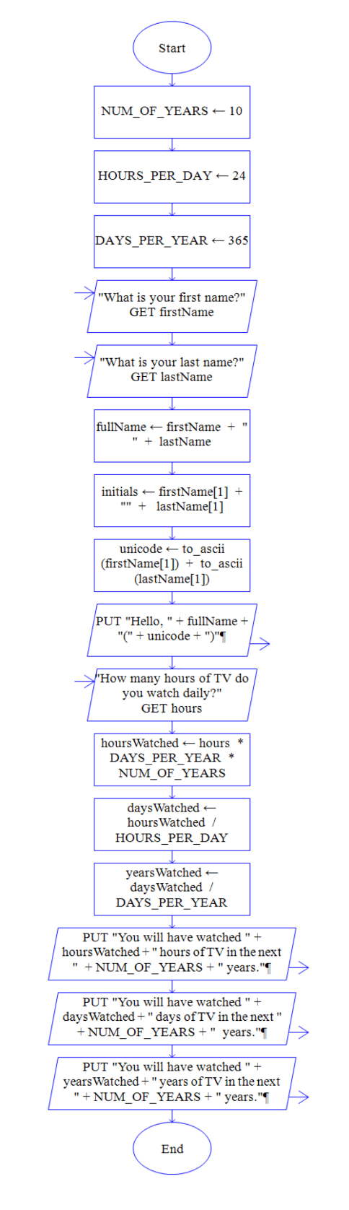

Screenshot 1

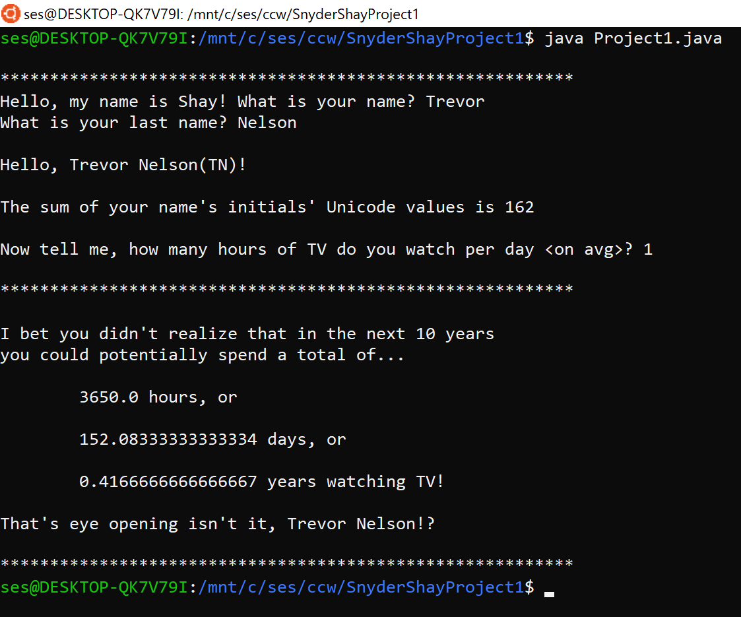

Screenshot 2

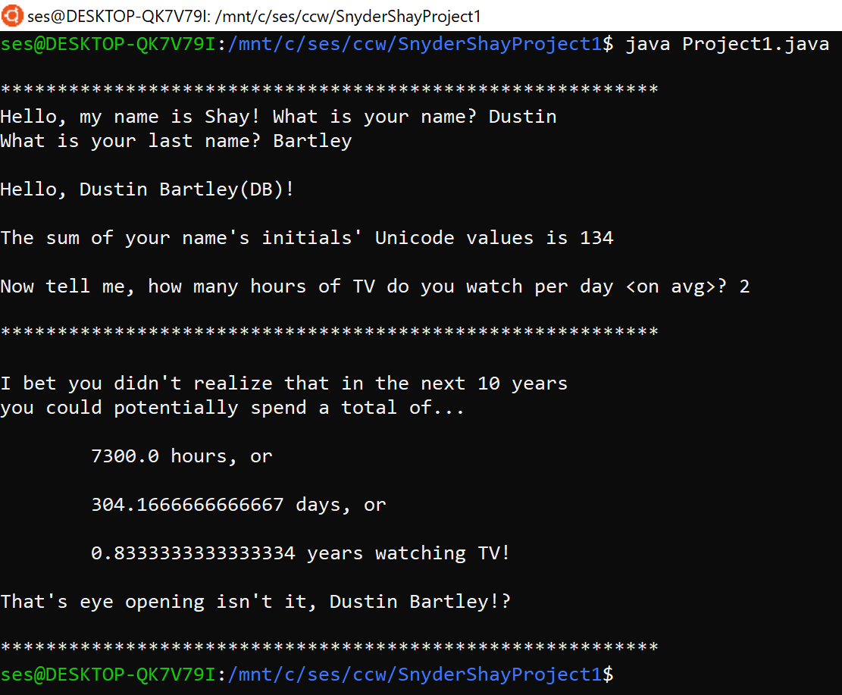

Screenshot 3

