[Documentation] FINAL ASG - Connect Friend

================================================================

Nama : Fulgencia Shaynalie Rue NIM : 2602187885

================================================================

Application flow:

1. The application will display a home page containing photos from other users who have registered,

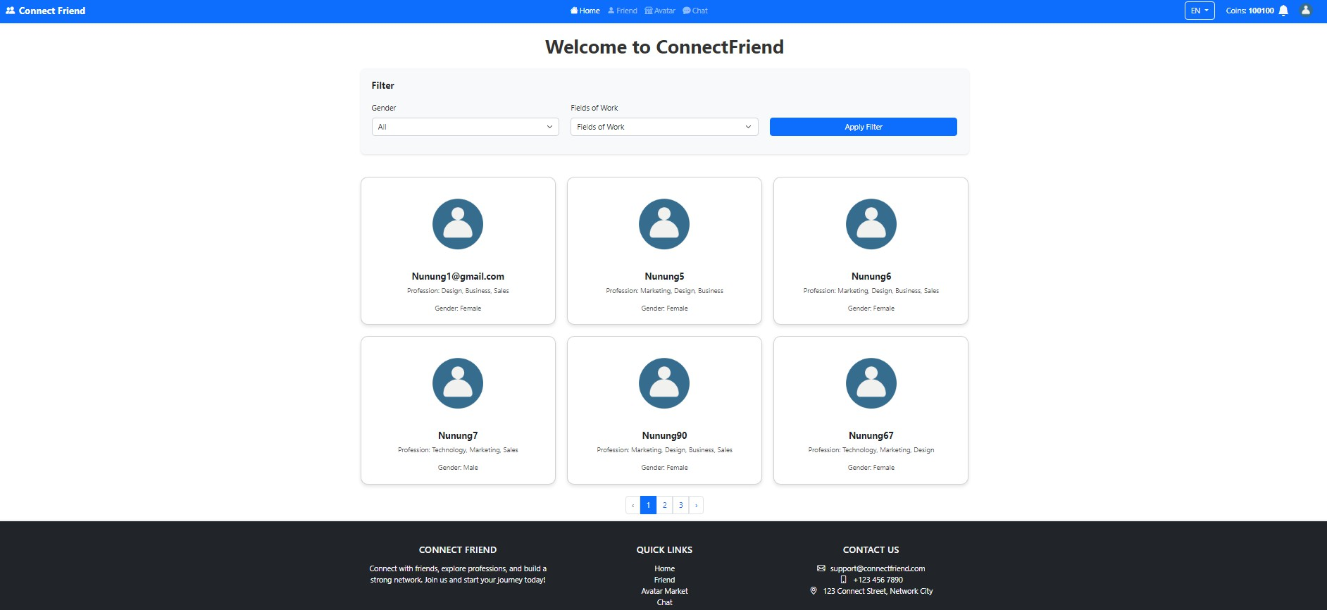

1. If the user selects one of the users in the image, direct the user to login if not already logged in. If the user has not registered, then create a register button that can be seen clearly on the login page.

User that already logged in, can see selected user profile], if not, will be directed to login

/ register page

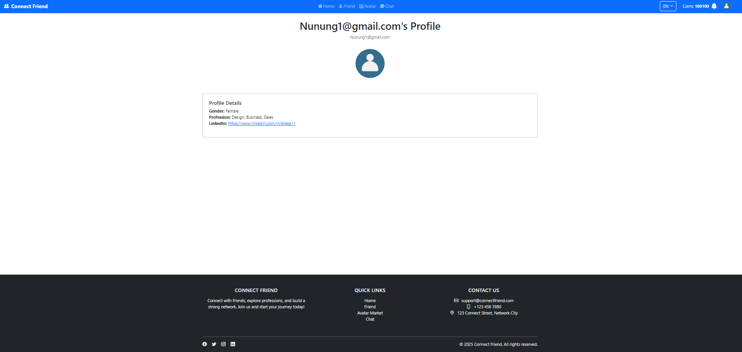

1. Users can press the Thumb button to enter the desired user into the Wishlist.

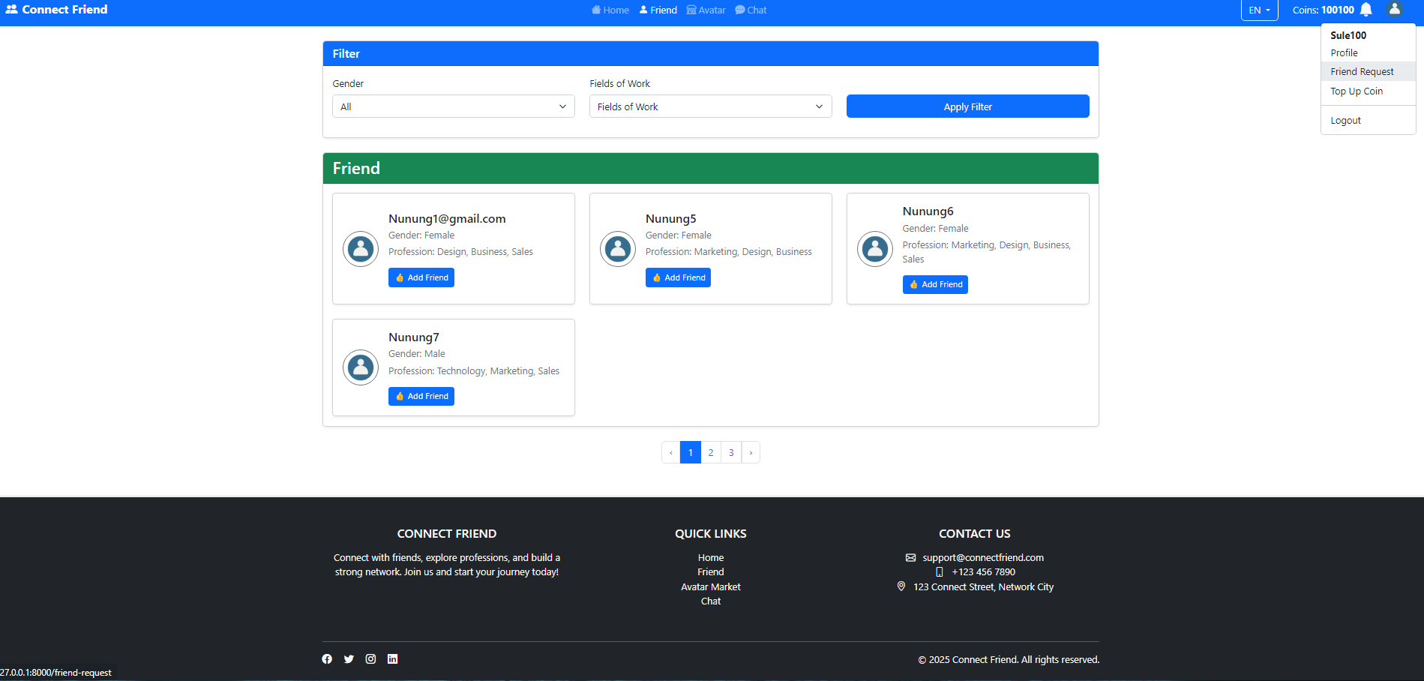

1. If other users respond by pressing the Thumb button too then users can communicate with each

other through the application (chat).

For this example, User (Sule100) Add Friend (Nunung 90)

On Nunung90ʼs Friend Request Page]

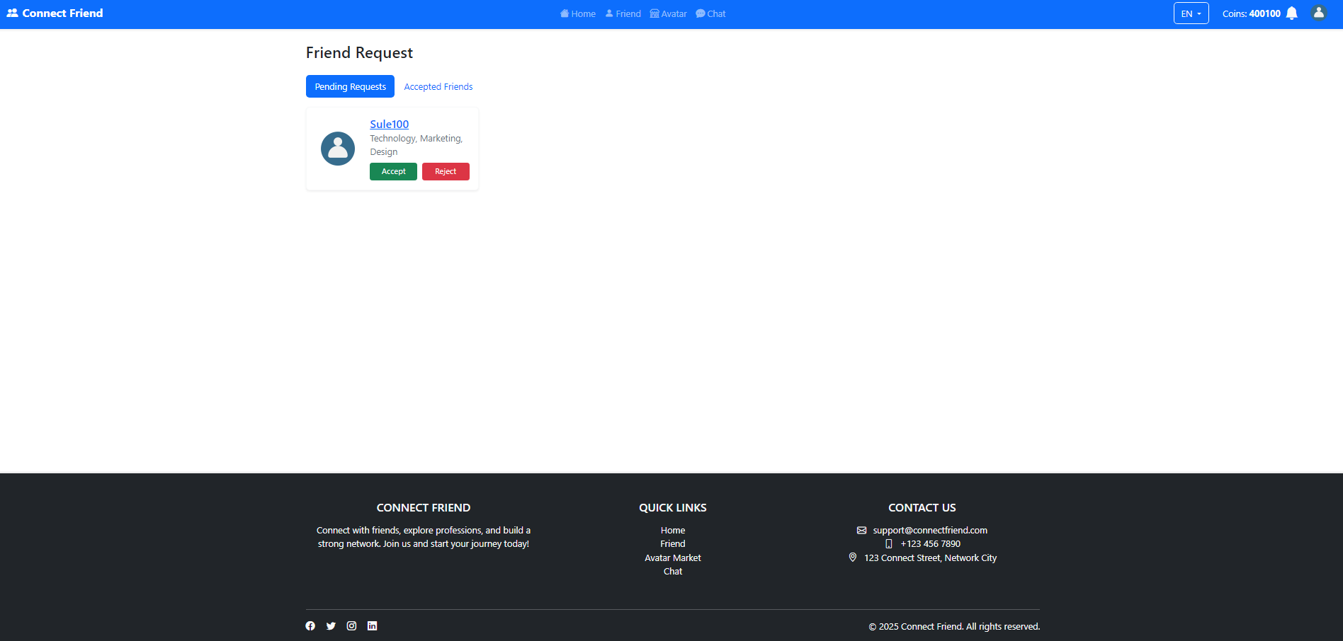

After Friend Request Accepted]

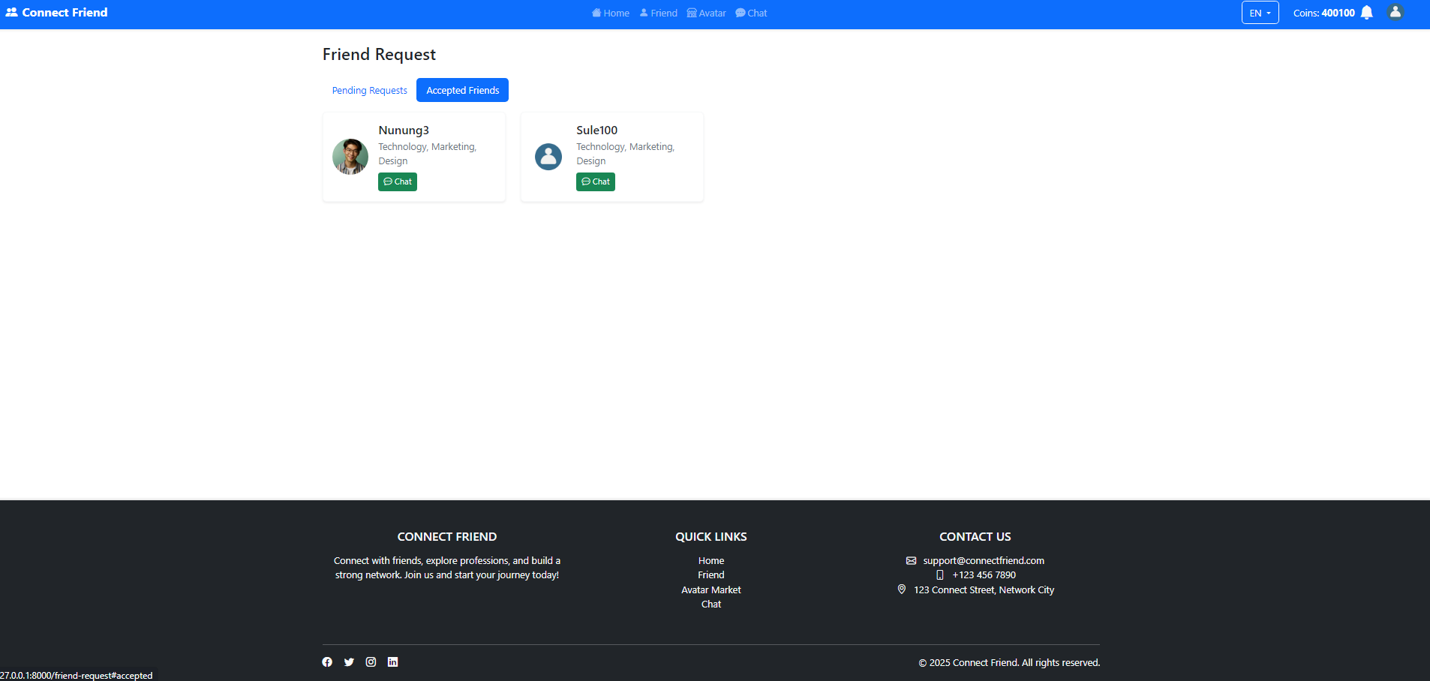

1. Users can filter users by gender. Create a container (page/section) for the gender filter.
2. Users can search by field of work. Create a container (page/section) to filter fields of work.

E & F, Users can filter users by gender and field of work on Home Page and Friend Page]



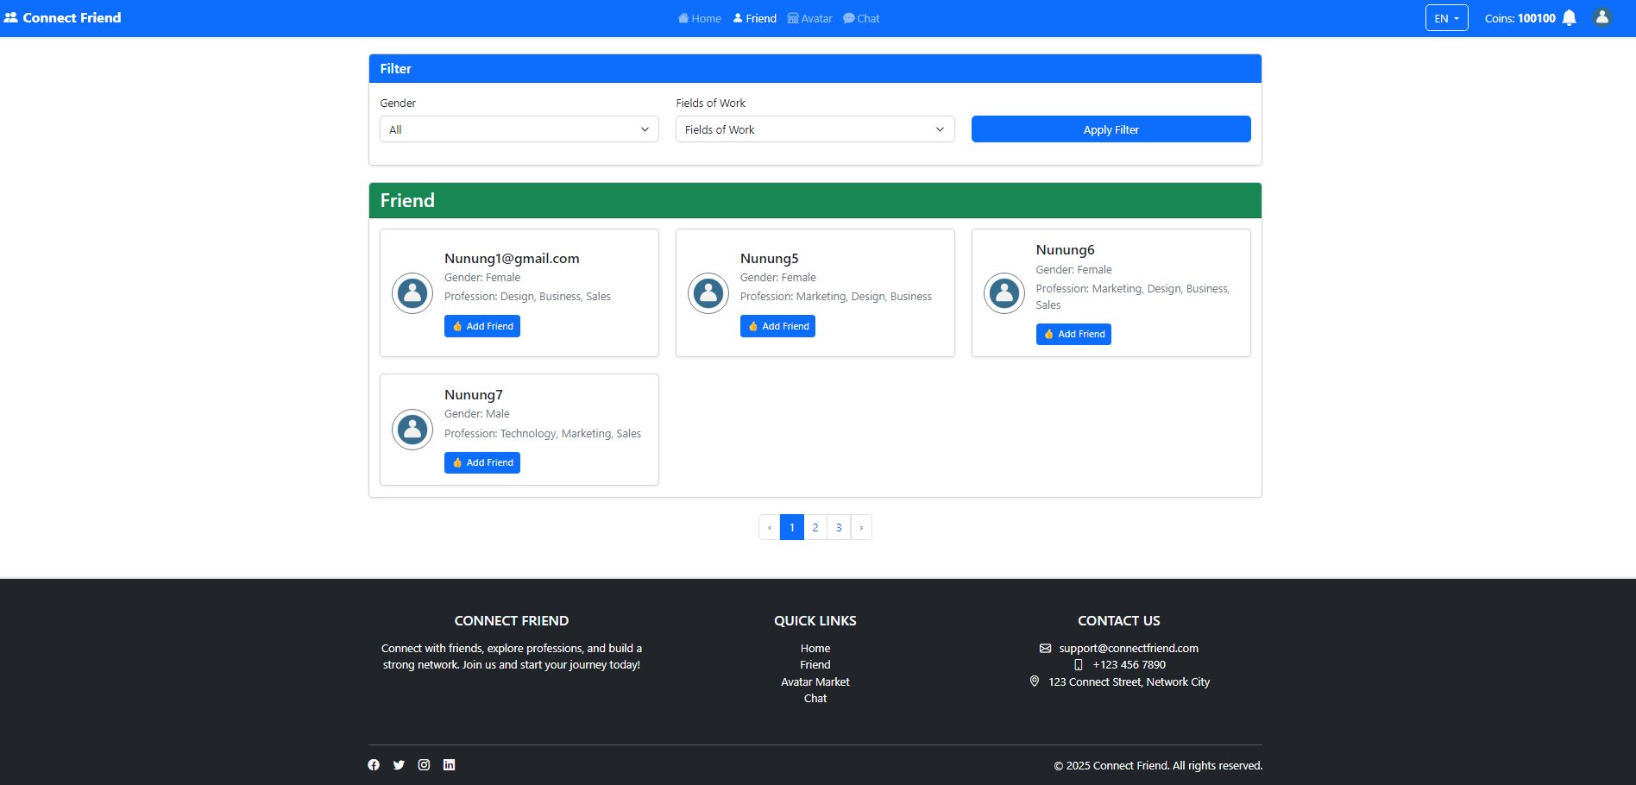

# Main Features:

LO1,LO2,LO3 & LO4, 20 points] User Authentication

* + Implement the user authentication feature with login and registration
  + Perform validation according to the above conditions

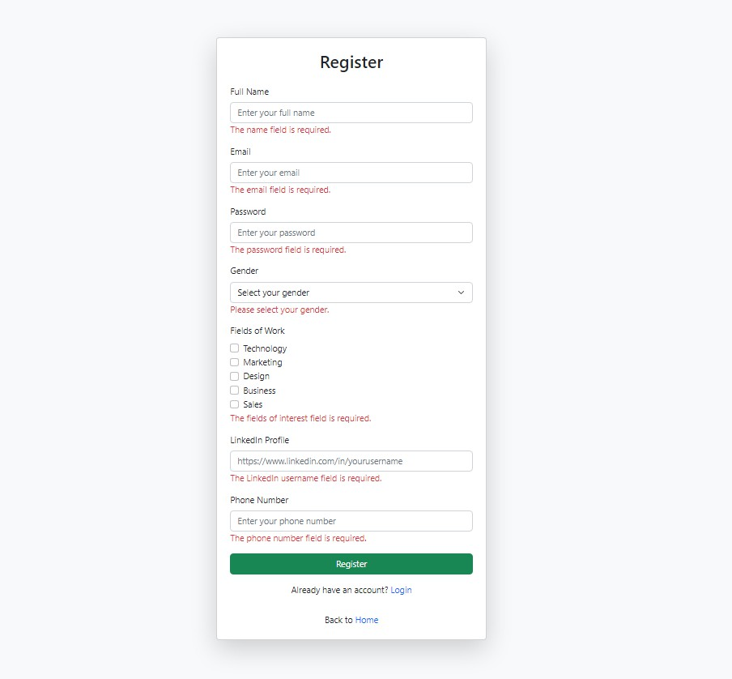

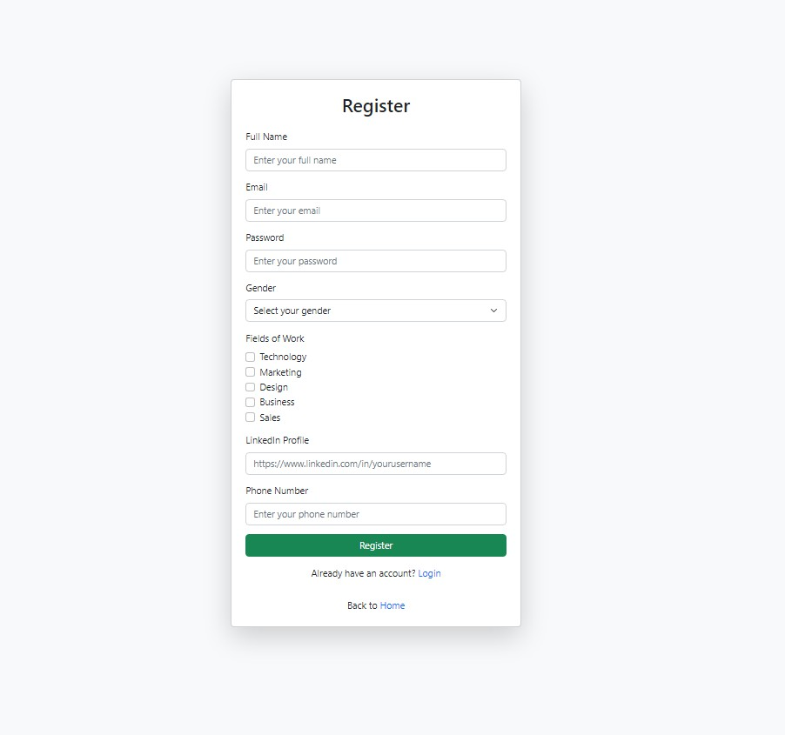

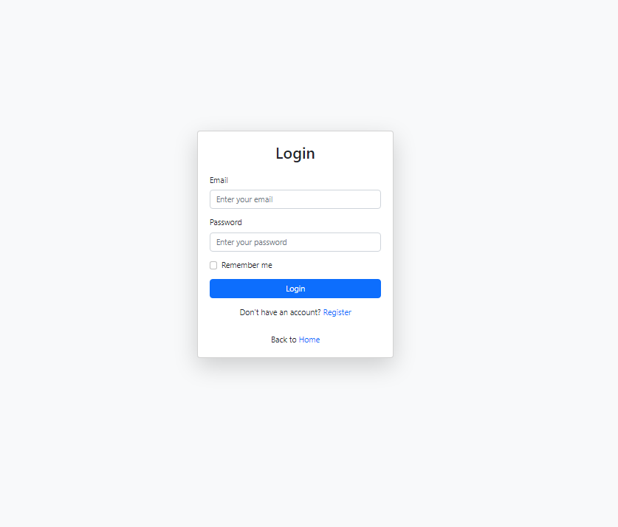

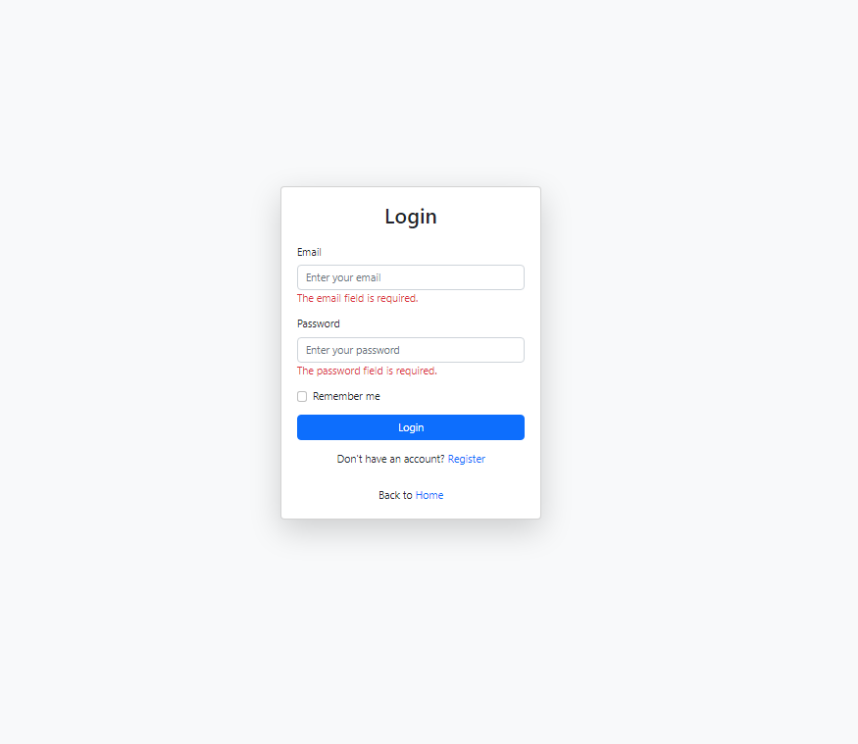

LO1,LO2,LO3 & LO4, 10 points] Payment

* + Every user who registers is required to make a payment.
  + Payment using the Coin system
  + Conduct validation in accordance with the provisions above

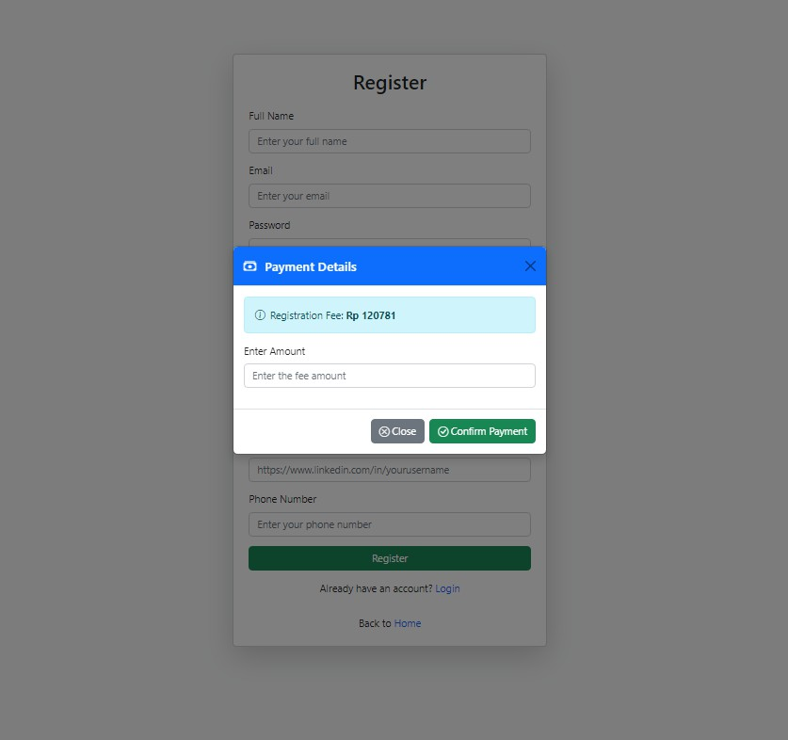

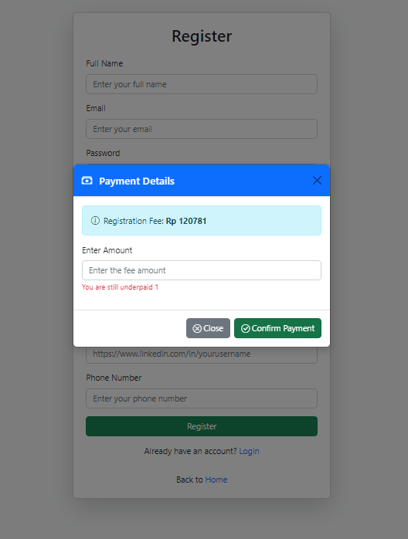

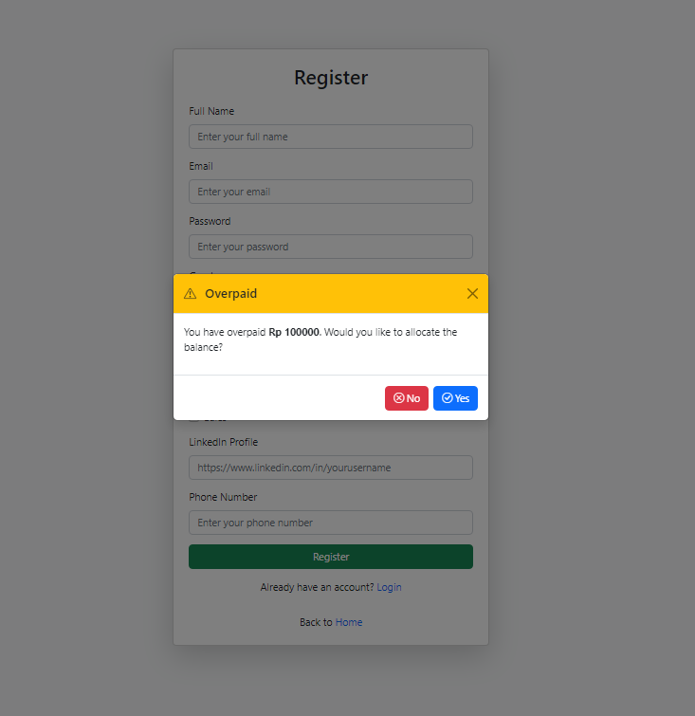

LO1,LO2,LO3 & LO4, 30 points] Friends

* + Implement the friends feature, allowing users to add and remove friends by giving likes according to the specified topic.
  + Display the user's friend list on the profile

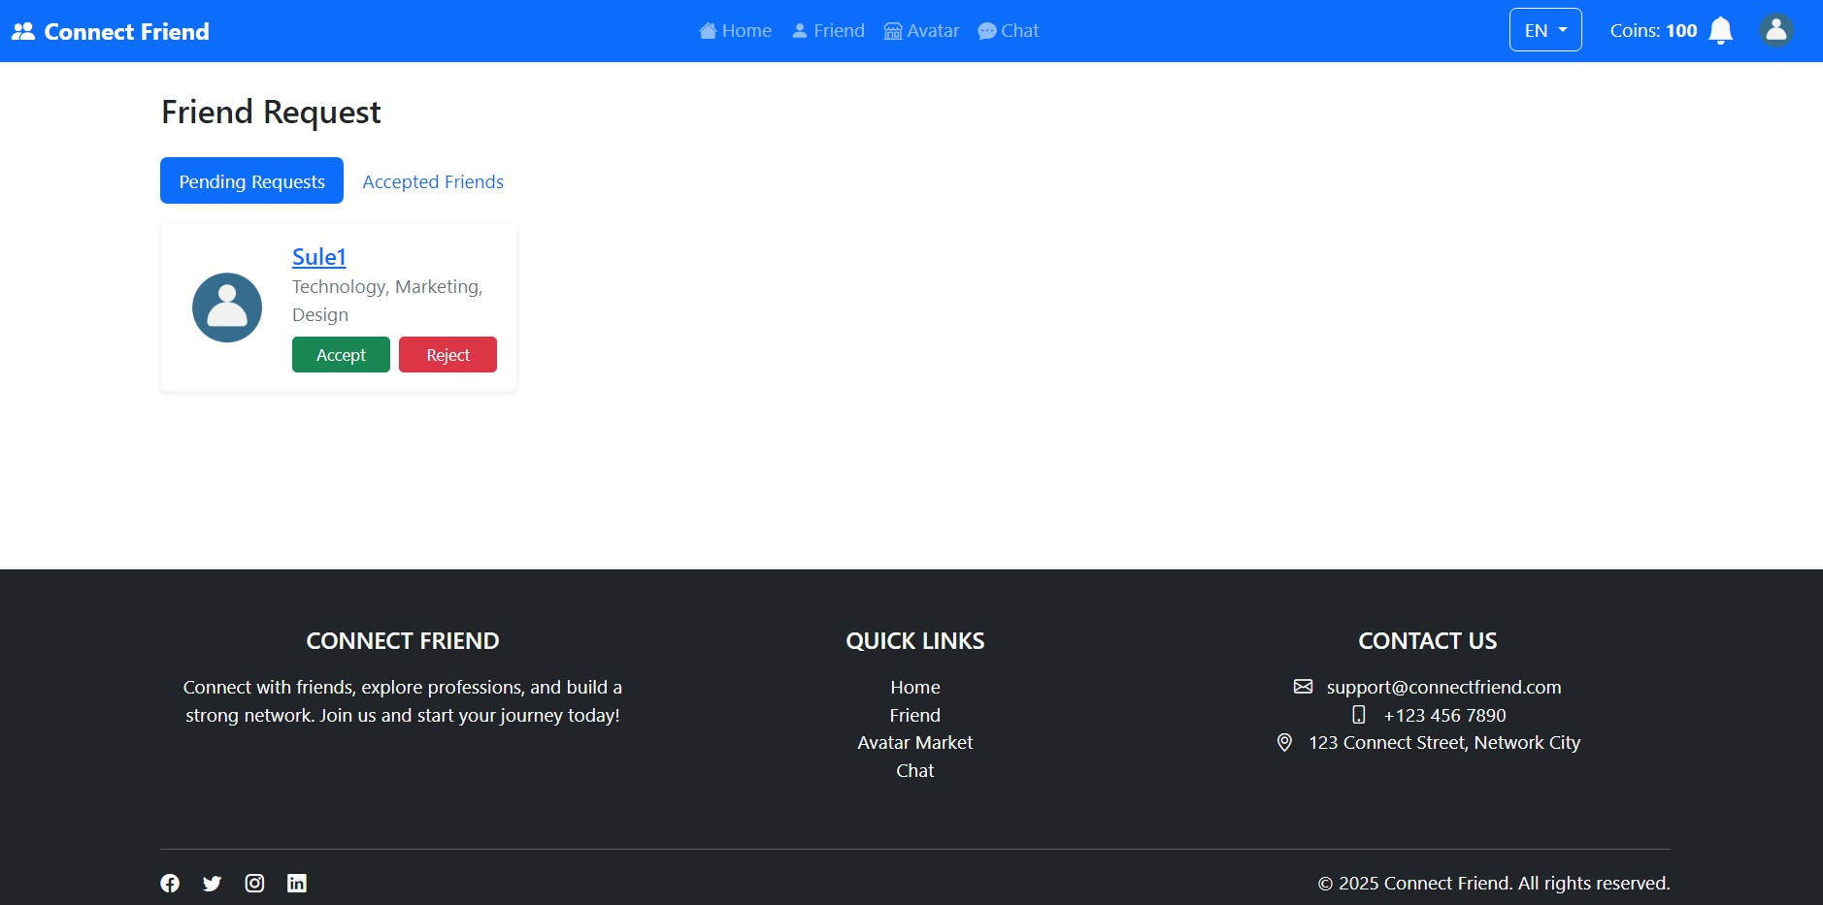

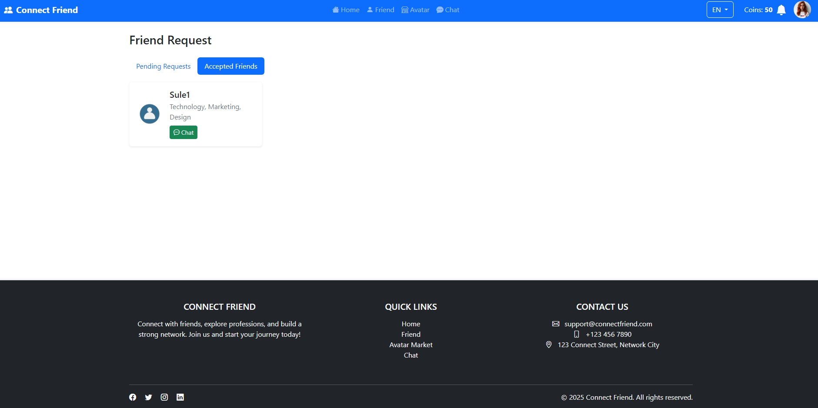

LO1,LO2,LO3 & LO4, 20 points] Messaging

* + Each user who has made friends, can communicate with each other through messages

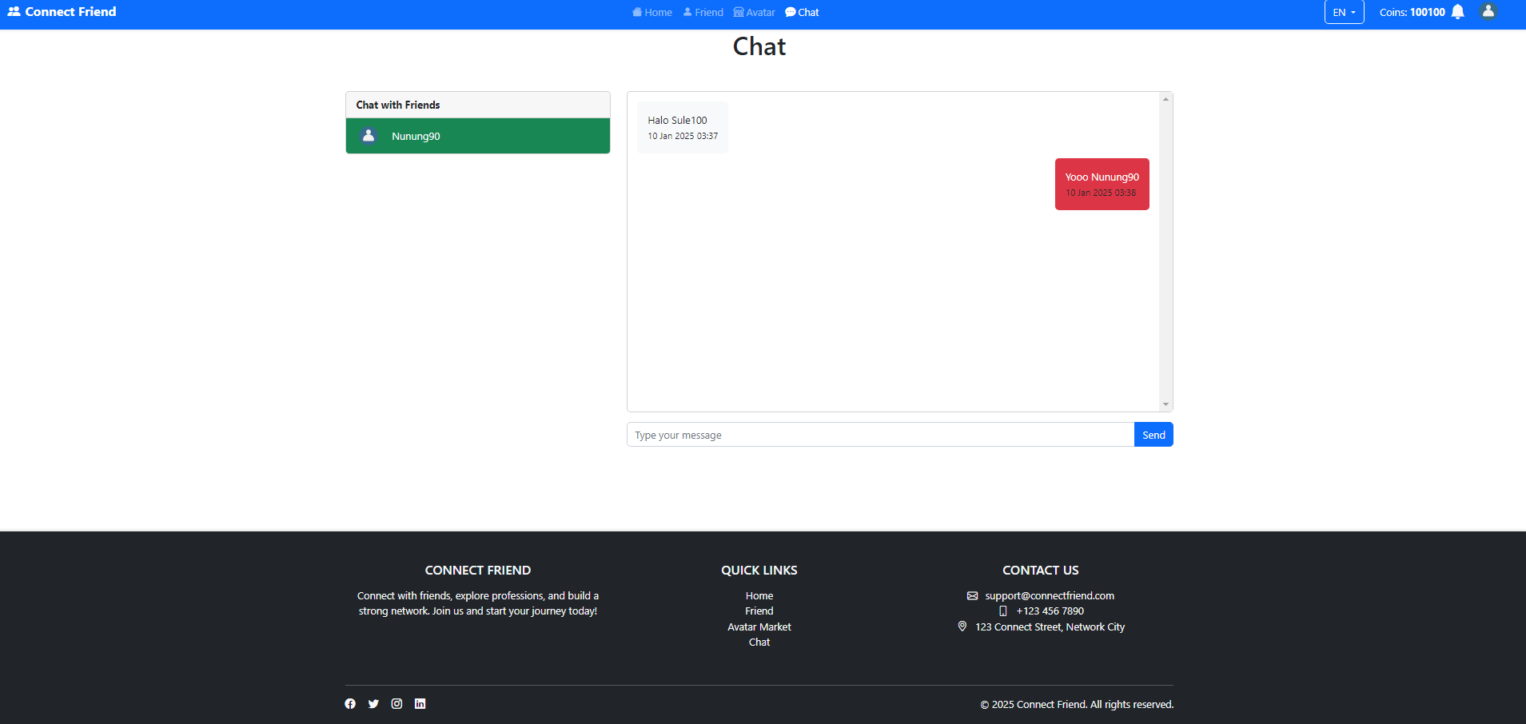

LO1,LO2,LO3 & LO4,10 points] Notification

* + Notify users of friend requests and incoming messages.

Incoming Message]

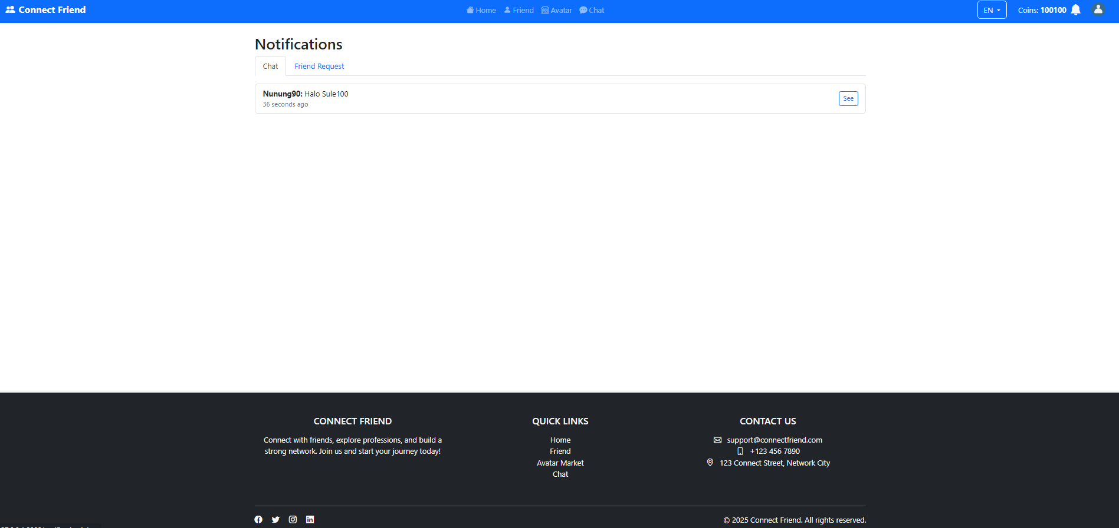

# Additional features:

LO1,LO2,LO3 & LO4, 30 points] Buy Avatar

* + - Users can buy an avatar and use the avatar as a profile picture.
    - The system must be able to deduct the total coins for each avatar purchase.

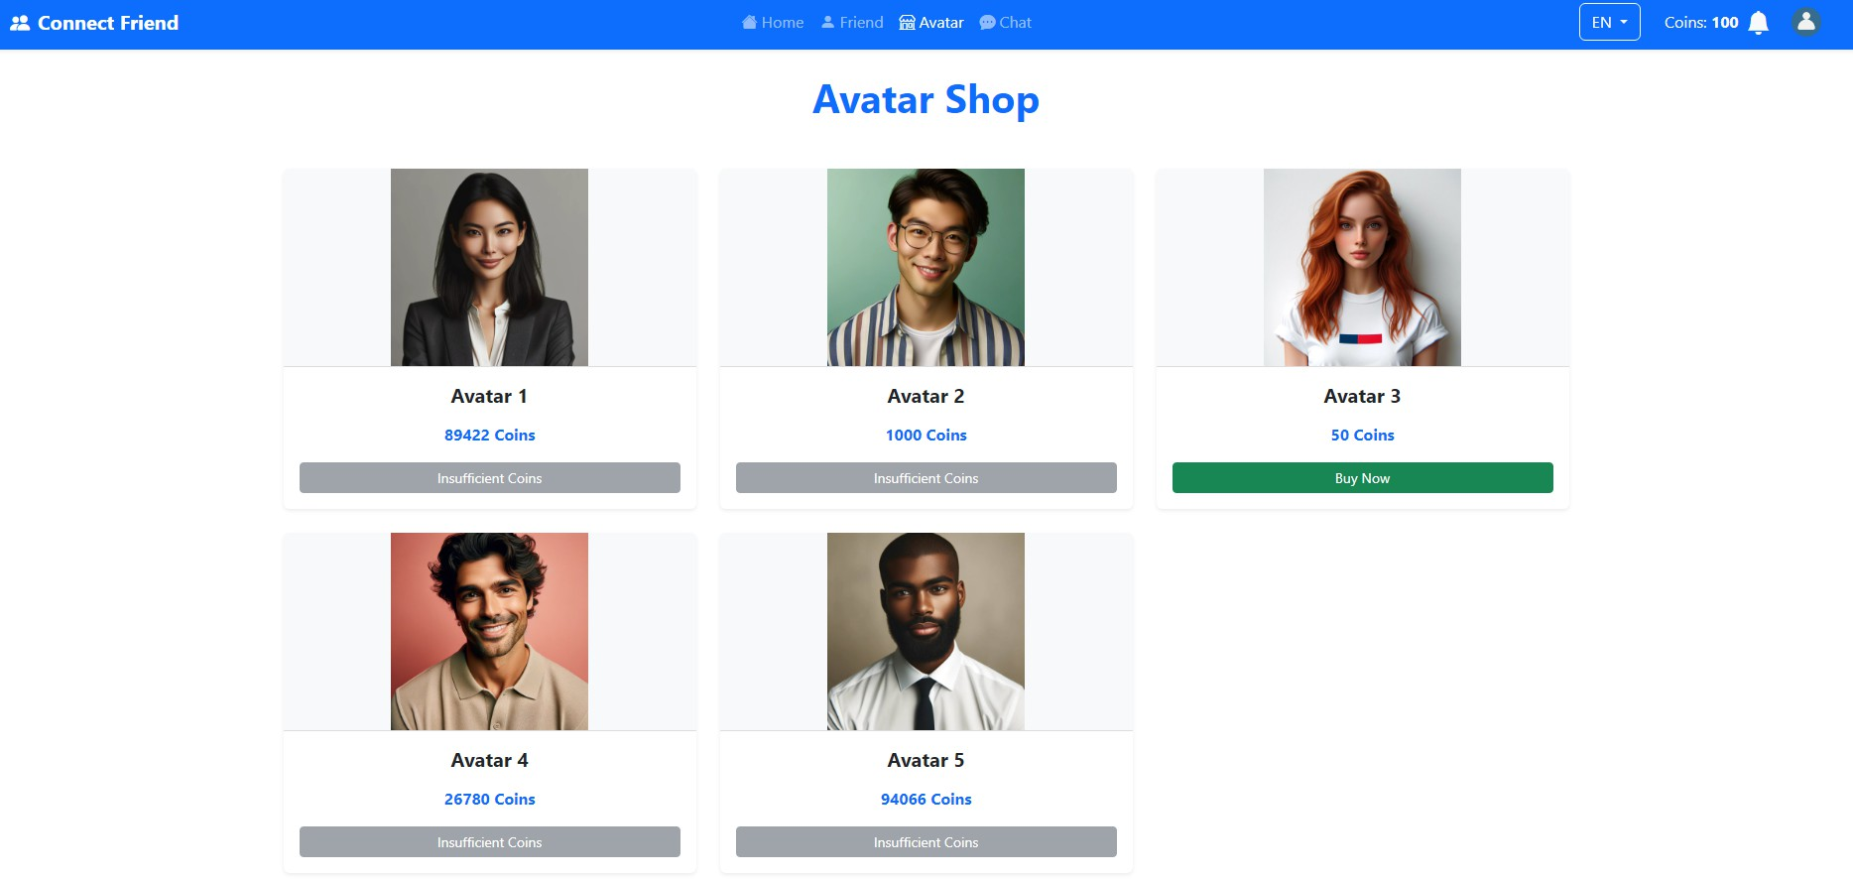

LO1,LO2,LO3 & LO4, 15 points] Topup Coins

* + - User can add 100 coins from each press of 1 button.

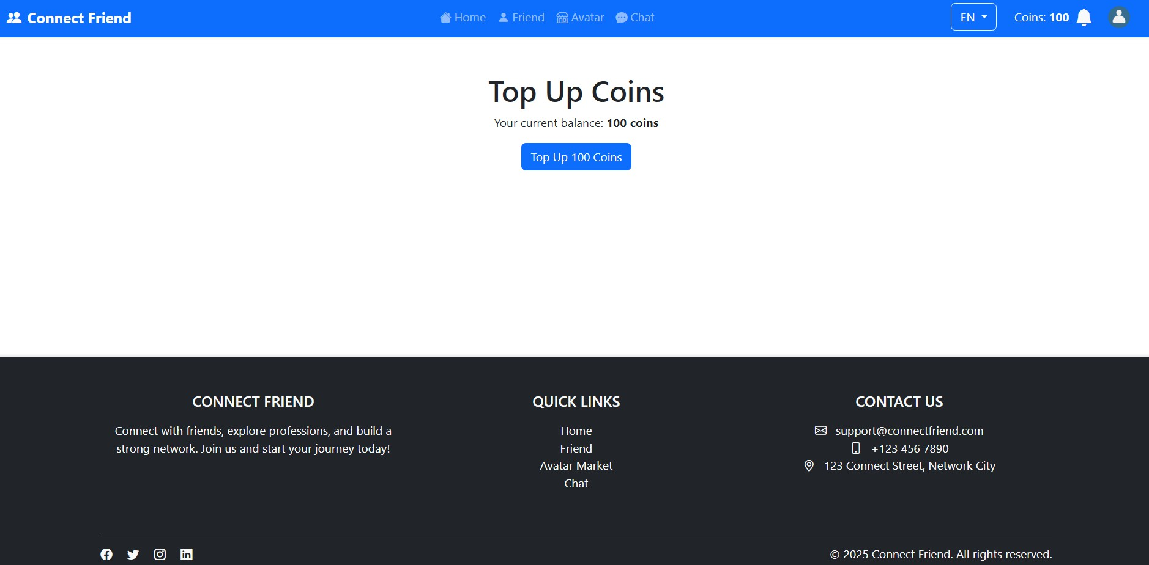

LO1,LO2,LO3 & LO4, 30 points] Visible Profile

* + - User can set profile visibility in the menu, so that it cannot be seen and cannot be searched by other users.
    - The system must be able to cut coins if using this feature.
    - The system must be able to change the profile photo to a bear image if using the invisible

feature.

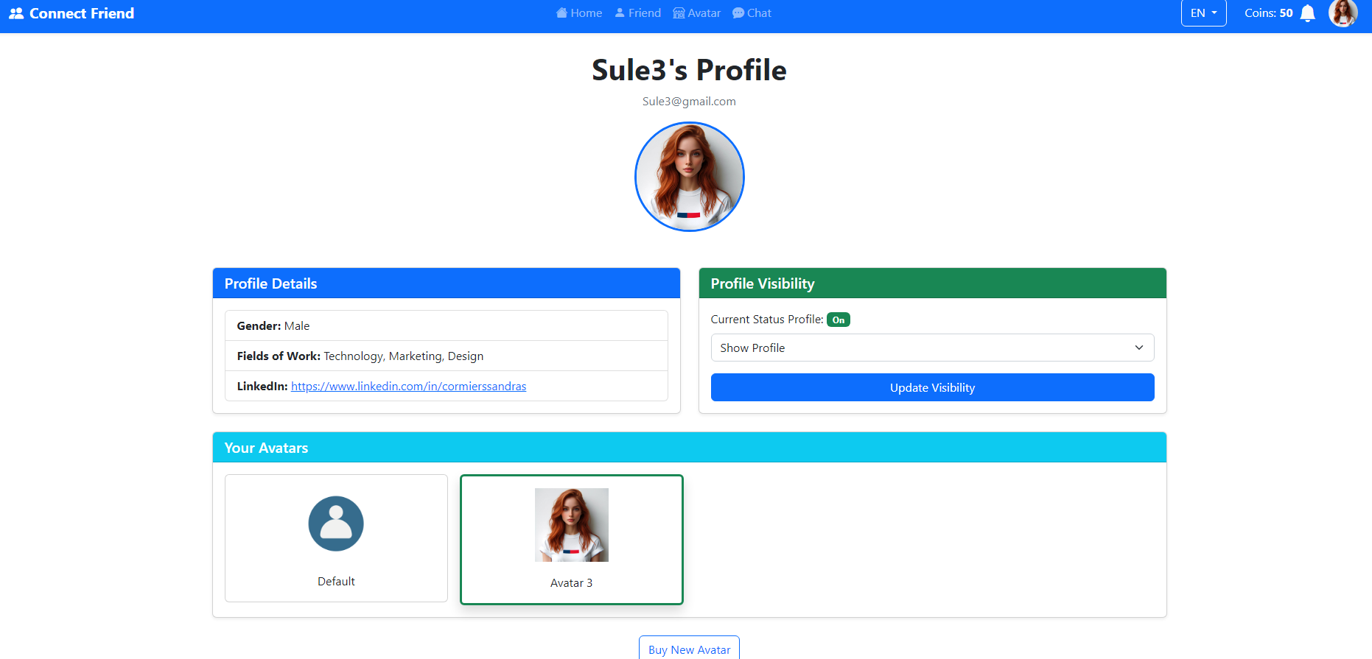

# LOCALIZATION

EN

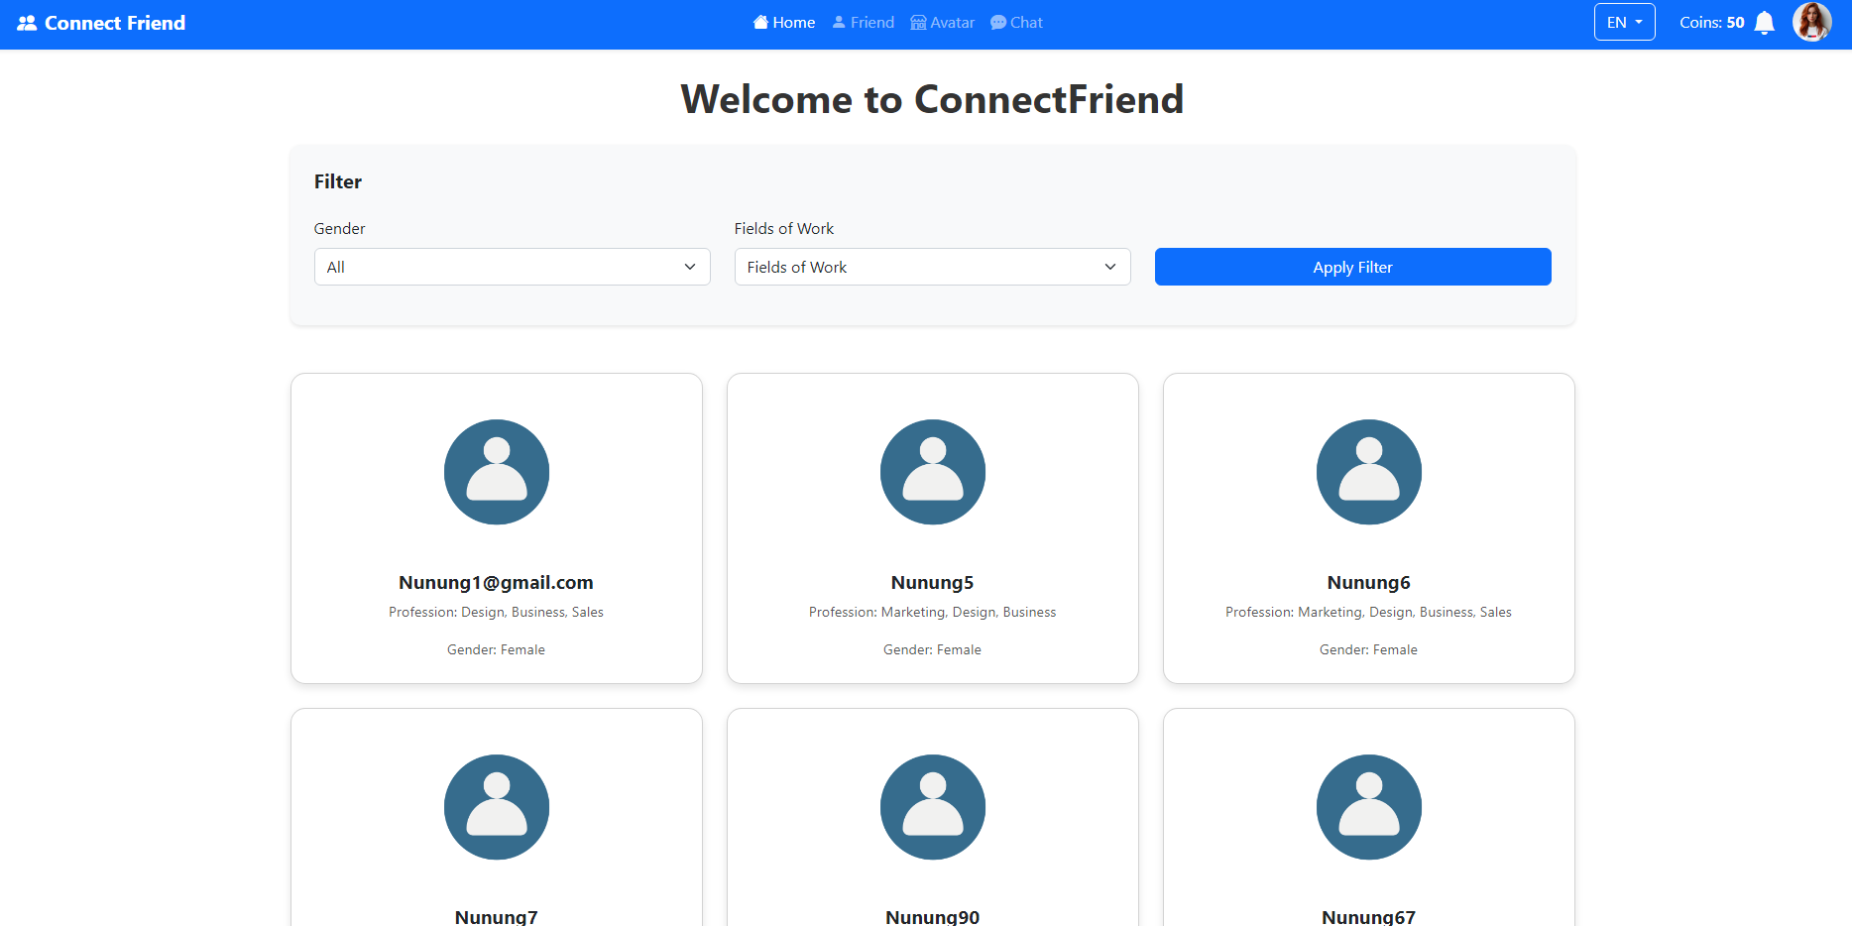

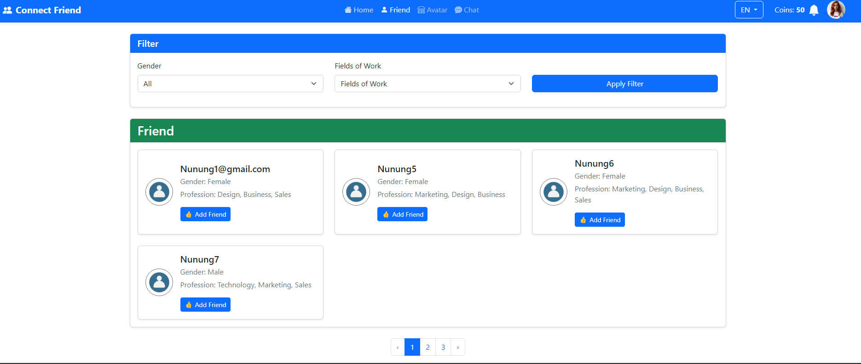

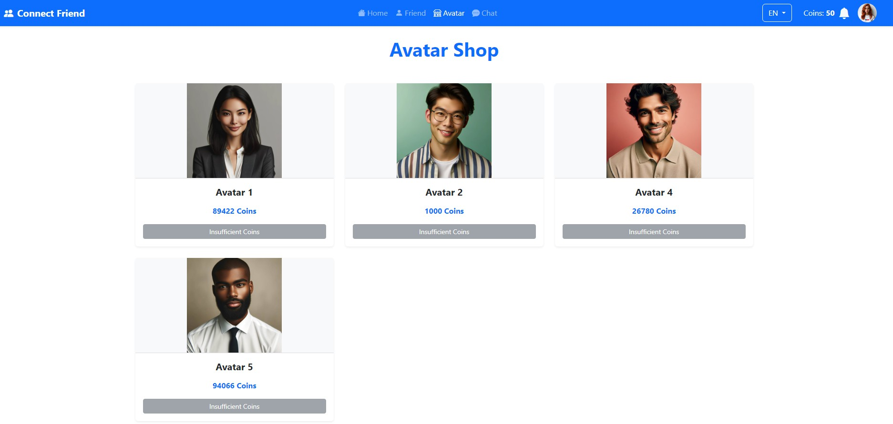

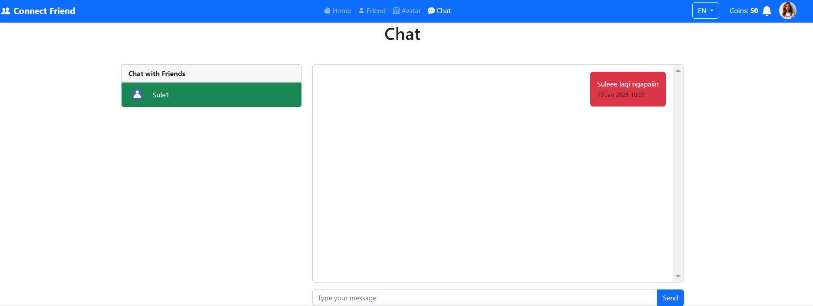

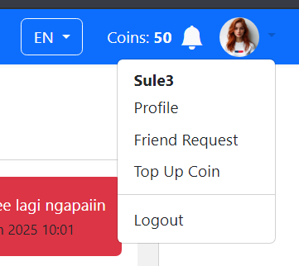

ID

