

AI Enabled IoT Smart Energy Meter with Predictive Energy Analysis
A Student Research Paper and Prototype Report
Submitted by | Shayna Singh  Rupali Patel  Bhavya Sharma
Under the guidance of | Dr. Rupesh Kumari  Supervisor Coordinator
Institution | VIT Bhopal University
Academic work | Prototype development in progress

September 2026

Abstract
This paper presents the current development of a low-cost IoT smart energy meter using an ESP32 controller. The purpose of the project is to observe household electrical quantities, display them on an online dashboard, and create a base for simple future energy prediction. The prototype is being assembled with a switch board, breadboard, LED light as a small load, ESP32, ZMPT101B voltage sensor, and a current-sensing module. The ESP32 reads the sensor outputs and is planned to send voltage, current, power, and energy information to a Blynk dashboard. The work is intentionally focused on a practical student prototype rather than a commercial billing meter. At the present stage, the dashboard layout has been created and the hardware connections are being developed. Future work will include calibration, safe enclosed wiring, collection of time-stamped readings, and a small prediction model based on recent usage patterns.

Keywords: ESP32, IoT, energy meter, voltage sensor, current sensor, Blynk, energy prediction

1 Introduction
Electricity use is normally known only after a monthly bill is generated. For a student project, it is useful to see the basic values while an appliance is running. A connected energy meter can help a user observe voltage, current, estimated power and accumulated energy from a phone or computer. This project studies a simple approach using an ESP32 because it provides Wi-Fi connectivity and analog input pins in a small, affordable board.
The project does not claim laboratory-grade billing accuracy. Its main contribution is a working learning platform: it connects basic sensing hardware with an IoT dashboard and leaves a clear path for later energy prediction. The LED load and switch board are used only to demonstrate the idea at a small scale.

2 Objectives
- To build a simple ESP32-based prototype for monitoring voltage and current.
- To calculate estimated instantaneous power from measured voltage and current values.
- To display voltage, current, power and energy values on a Blynk IoT dashboard.
- To store readings over time so that basic energy-use prediction can be explored later.
- To learn safe interfacing practices while working around AC supply connections.

3 Hardware and Software Used
Component | Role in prototype | Current status
ESP32 | Reads sensor signals and connects to Wi-Fi | Selected controller
ZMPT101B | Provides an isolated voltage-sensing output | Included in wiring plan
Current sensor module | Provides current-related signal to ESP32 | Included in wiring plan
Switch board and LED | Small demonstration load and control | Used in hardware setup
Breadboard and jumper wires | Temporary low-voltage connections | Used in prototype
Blynk Cloud dashboard | Shows values through gauges | Dashboard created

4 Proposed System Design
The proposed system has three layers. In the sensing layer, voltage and current-related signals are obtained from the sensor modules. In the processing layer, the ESP32 samples the analog signals and performs simple calculations. In the IoT layer, the ESP32 publishes values to Blynk using Wi-Fi. The dashboard then acts as the user interface for the project.
Stage | What happens | Output
Sense | Voltage and current modules generate low-voltage signals | Raw readings
Process | ESP32 samples, filters and calibrates the readings | V, I and estimated P
Publish | ESP32 sends values to Blynk through Wi-Fi | Live dashboard gauges
Analyze later | Saved readings are grouped by time and day | Simple usage forecast

5 Connection Plan
The connection tables below are based on the supplied wiring notes. The sensor outputs are connected to ADC-capable ESP32 pins GPIO35 and GPIO34. An optional I2C LCD can use GPIO21 and GPIO22. The 3.3 V and ground lines must be common on the low-voltage side. These connections should be checked against the exact board labels before power is applied.
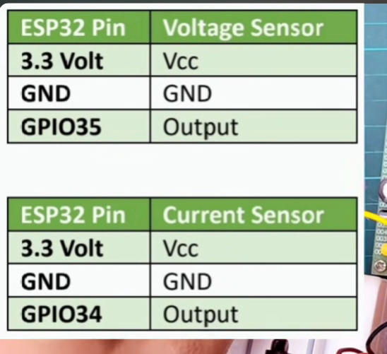
Figure 1. Supplied ESP32 wiring reference for voltage and current sensor outputs.
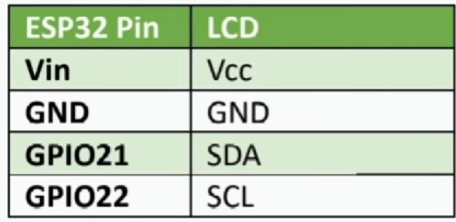
Figure 2. Supplied ESP32 to LCD I2C connection reference.
ESP32 pin | Connected module pin | Purpose
3.3 V | Voltage sensor VCC | Low-voltage supply
GND | Voltage sensor GND | Common reference
GPIO35 | Voltage sensor output | Analog voltage signal
3.3 V | Current sensor VCC | Low-voltage supply
GND | Current sensor GND | Common reference
GPIO34 | Current sensor output | Analog current signal
GPIO21 | LCD SDA | I2C data, if LCD is used
GPIO22 | LCD SCL | I2C clock, if LCD is used

Safety Note
The switch board and AC-side wiring require special care. Breadboards, jumper wires and exposed terminals must not be used as a permanent mains connection. All measurements should be supervised, insulated and enclosed before testing with household AC. The ESP32 must only receive the low-voltage sensor output, never direct mains voltage.

6 Prototype Wiring and Dashboard
The supplied wiring image shows the switch board, current sensor and ZMPT101B voltage sensor connected around the load path. This figure is treated as the project connection concept. During final assembly, the group should use proper terminals, fuses where required, insulation and a protective enclosure. The diagrams alone should not be treated as a complete safety-approved mains design.
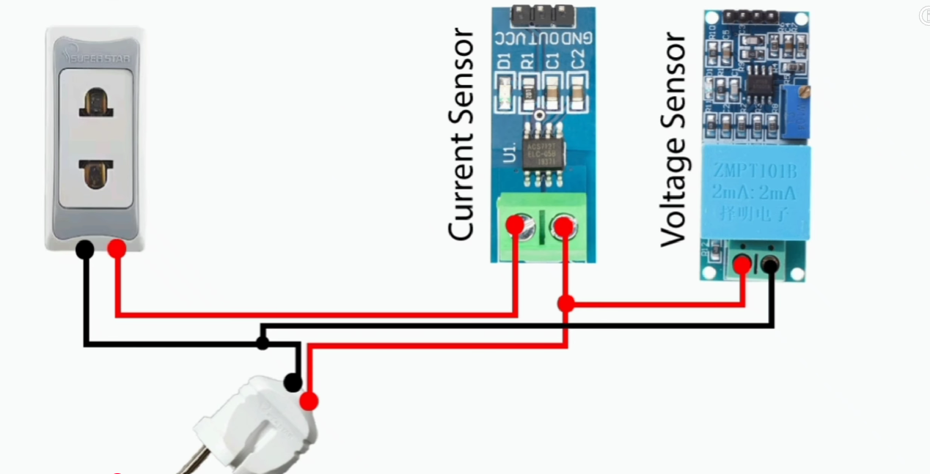
Figure 3. Supplied wiring concept for the switch board, current sensor and voltage sensor.
A Blynk dashboard has been configured with four gauges: Voltage, Current, Power and Unit. The dashboard structure is useful because it gives a clear view of the values that the ESP32 will publish. In the supplied screenshot, the device is shown offline and the readings are zero; this is consistent with a dashboard setup stage before the completed hardware is connected and calibrated.
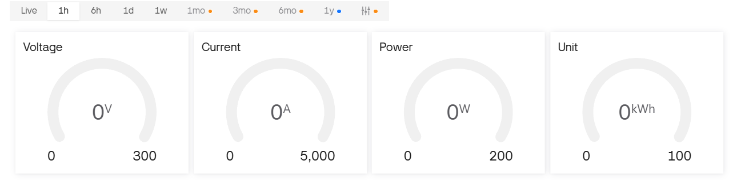
Figure 4. Project Blynk dashboard showing voltage, current, power and energy gauges.

7 Measurement Logic
The ESP32 receives varying analog values from the two sensor modules. These raw values cannot be treated immediately as physical voltage and current. They first require offset correction and calibration against a known reference meter. After calibration, an estimated power value can be calculated using P = V x I x PF, where P is power in watts, V is RMS voltage, I is RMS current and PF is power factor. For a first student prototype, PF may be assumed as 1 only for a simple resistive demonstration load; this assumption should be clearly stated in any result table.
Energy can be estimated by adding power over time. For readings collected every small time interval, the approximate energy in kWh is the sum of P multiplied by the interval in hours, divided by 1000. The final result will be more meaningful after the sensor calibration is complete and repeated readings are taken.

8 Current Progress and Planned Testing
Project activity | Current position | Next step
Hardware selection | ESP32, sensors, LED load, switch board and breadboard identified | Move to insulated, checked assembly
Sensor connections | Pin mapping prepared | Connect low-voltage outputs and test ADC values
IoT interface | Blynk gauges configured | Send calibrated values from ESP32
Power and energy calculation | Formula planned | Compare with a reference meter
Prediction feature | Concept selected | Collect enough daily readings for a small forecast
No final accuracy result is reported in this paper because the current prototype is still in the build and connection stage. Reporting only verified observations is important for an honest student project. After calibration, the group can record test readings for a known LED load and compare the displayed values with a multimeter or standard energy meter, where safely available.

9 Predictive Energy Analysis Approach
The word AI in this project refers to a small, practical prediction feature that can be added after data collection. The first version does not need a complex model. The dashboard values can be saved with date and time, then grouped by hour or by day. A simple moving average can predict the next period from recent energy use. For example, the expected energy for a particular hour can be estimated from the average of that hour during the previous several days.
This approach is suitable for a student prototype because it is easy to explain and evaluate. Once more data is available, the group may compare it with a simple linear regression model using inputs such as time of day, day of week and recent energy use. Prediction quality can be reported using the average difference between predicted and actual energy. The result should be described as an estimate, not a guarantee.

10 Expected Benefits and Limitations
- The user can see basic electrical values remotely instead of waiting for a monthly bill.
- The project combines hardware, embedded programming, cloud dashboard design and basic data analysis.
- The ESP32 and sensor modules keep the prototype affordable for learning purposes.
- Results depend strongly on sensor calibration, wiring quality, load type and sampling method.
- The prototype is not a certified revenue meter and should not be used for billing decisions.
- Prediction accuracy will be limited until enough reliable time-series data has been collected.

11 Conclusion
This paper describes the current design of an AI-enabled IoT smart energy meter being developed at VIT Bhopal University. The project uses an ESP32, a ZMPT101B voltage sensor, a current sensor module, a small LED load and a Blynk dashboard. The present work has established the components, pin mapping and user-interface plan. The next important work is safe hardware completion, calibration and data logging. After obtaining dependable readings, the project can add simple energy prediction based on previous usage. The work is a realistic student-level starting point for learning how IoT can support energy awareness.

Acknowledgement
We sincerely thank Dr. Rupesh Kumari for guidance and coordination during this project. We also acknowledge VIT Bhopal University for providing the academic environment to develop this prototype.

References
- Espressif Systems. ESP32 Series Datasheet. Available from: https://www.espressif.com/
- Blynk. Blynk IoT Platform Documentation. Available from: https://docs.blynk.io/
- ZMPT101B voltage transformer module product documentation and module markings used for the prototype.
- Project team. Prototype wiring notes, supplied pin-mapping images and Blynk dashboard screenshot, September 2026.

