Lab02

Shayne Lewis

100506658

**Part1**

Local Repository

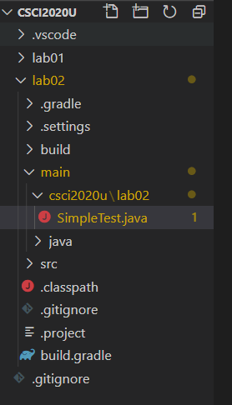

Remote Repository (GitHub)

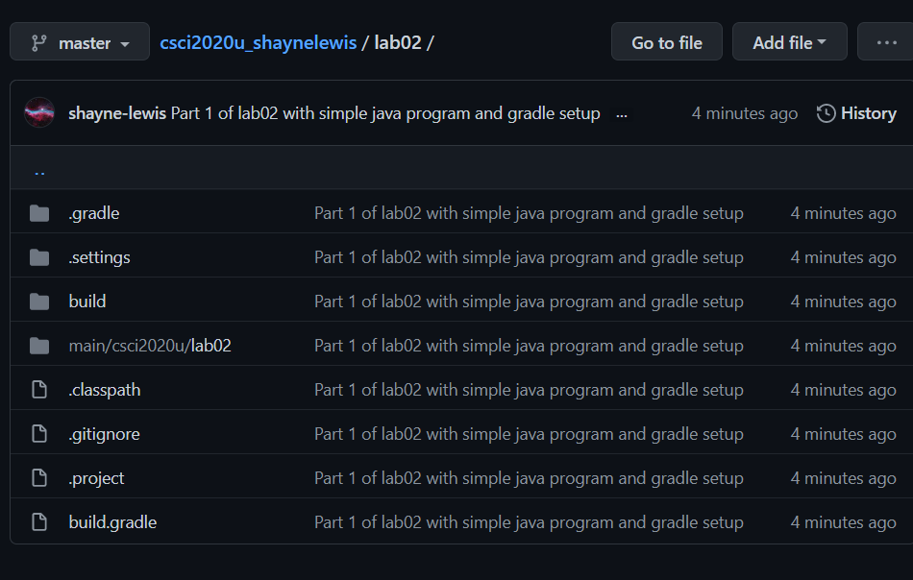

Simple Test Program

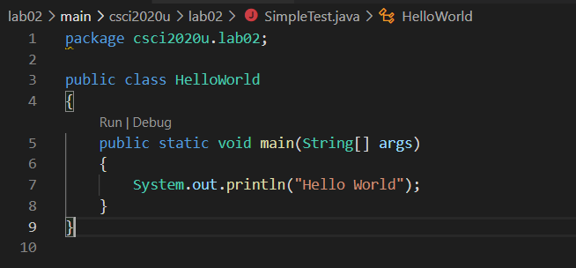

Build.gradle File

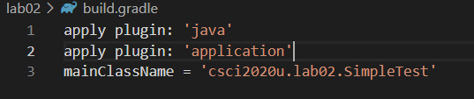

Successful Build

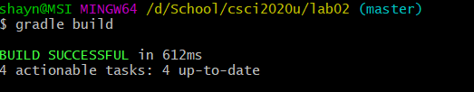

Program Output

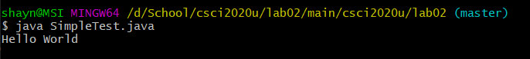

**Part2**