Lab03

Shayne Lewis

100506658

**Part1**

New directory for Lab03 with all of Lab02’s data.

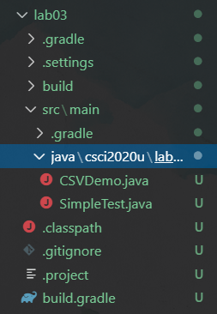

Added data.csv file.

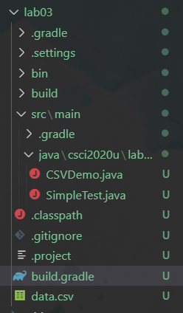

Changed main file in build.gradle so CSVDemo runs using data.csv.

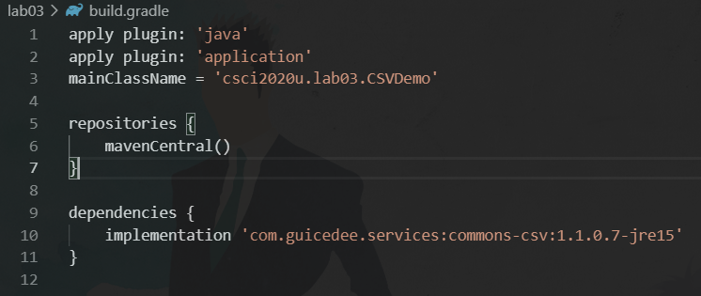

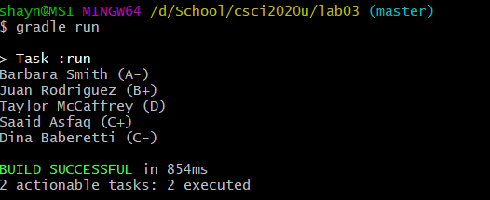

**Part2**

New jar file in lab03.

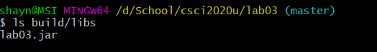

**Part3**

ProGuard added and extracted inside csci2020u folder, creating a new proguard6.2.2 folder.

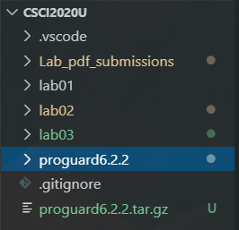

Build.gradle changed to use proguard.

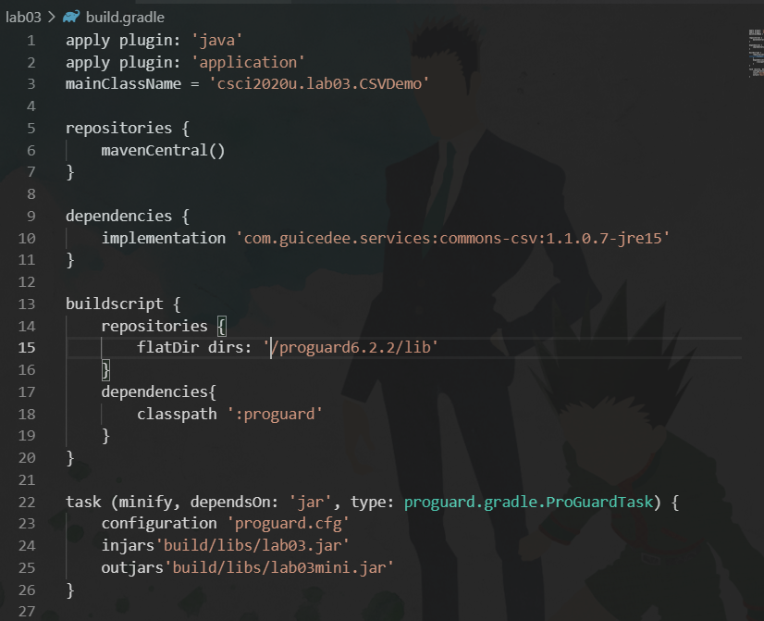

Proguard.cfg created

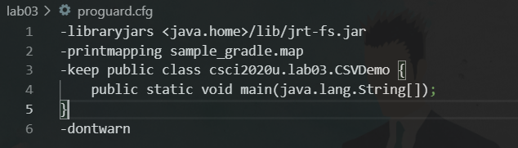

Task ran to minify the code.

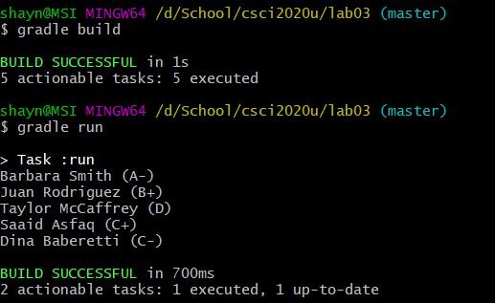

Gradle minify.

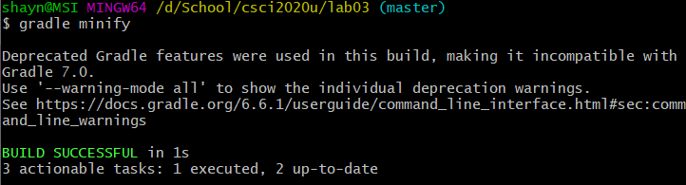

New jar file in build/lib

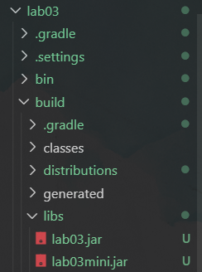

Local repository

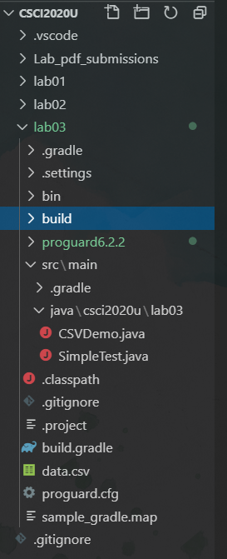

Github repository

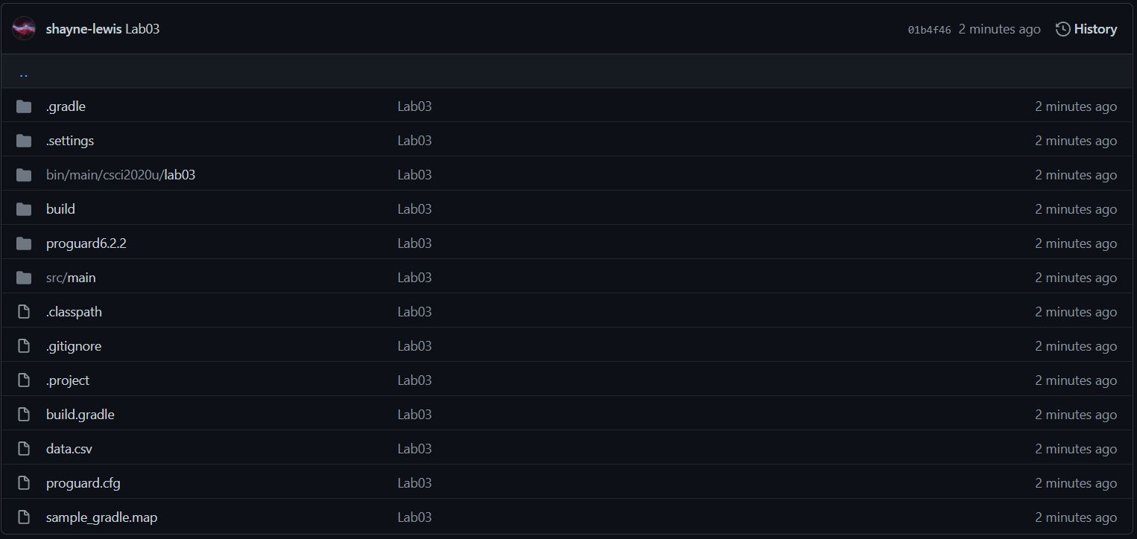

Github link: https://github.com/shayne-lewis/csci2020u_shaynelewis