Lab04

Shayne Lewis

100506658

Fxml file

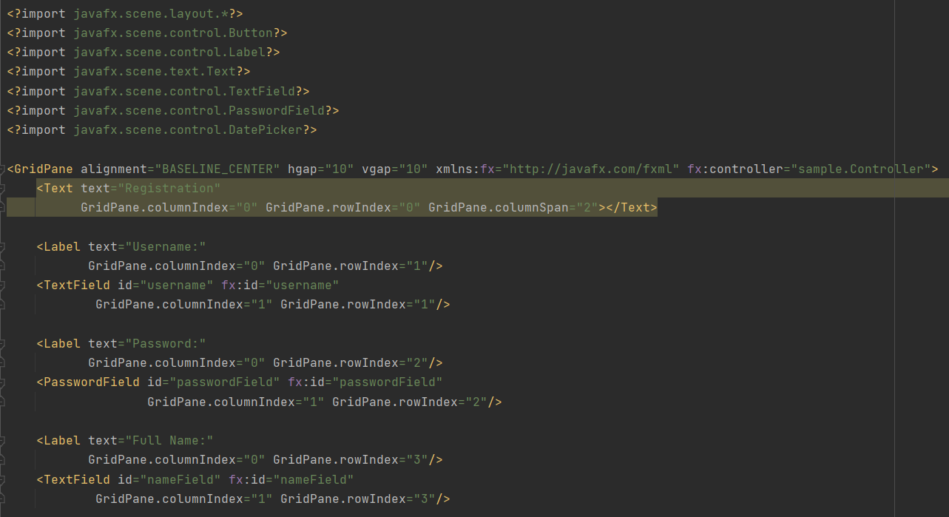

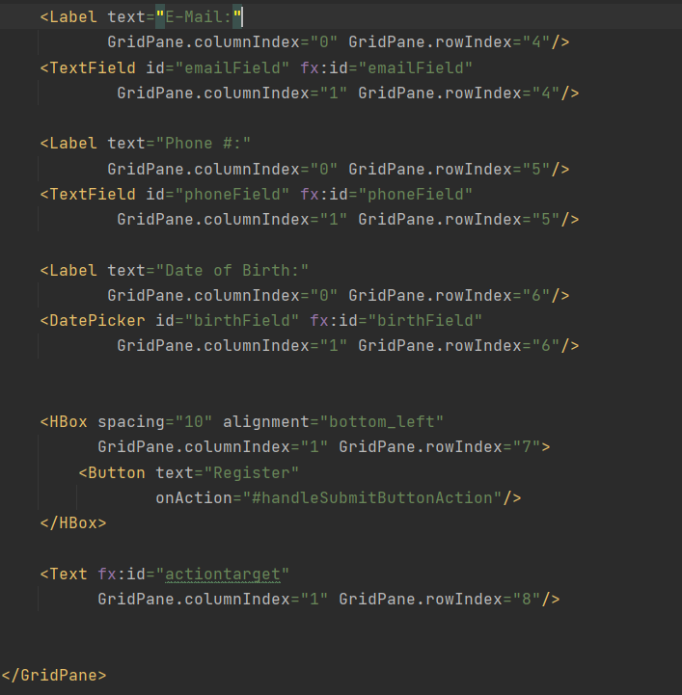

Controller.java

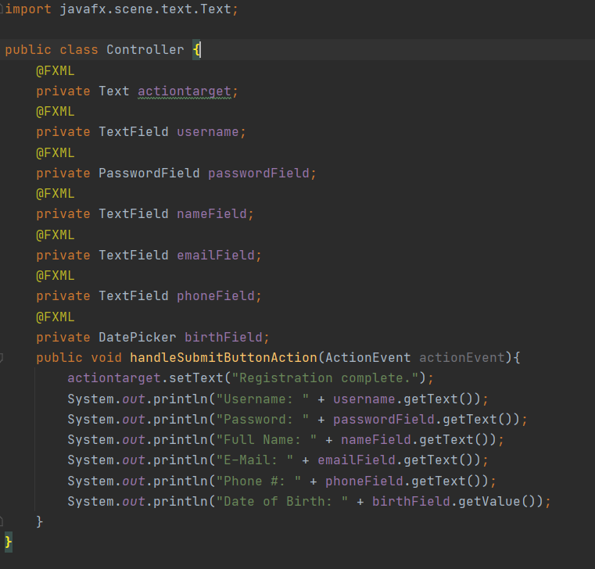

GUI Window with my inputs.

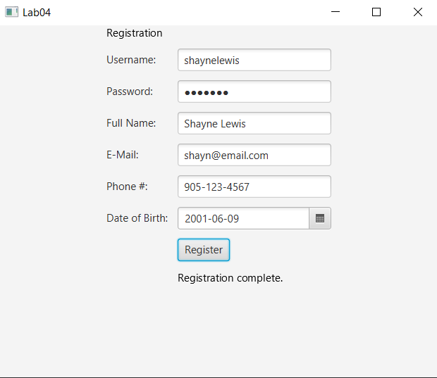

Console output from inputs entered in GUI.

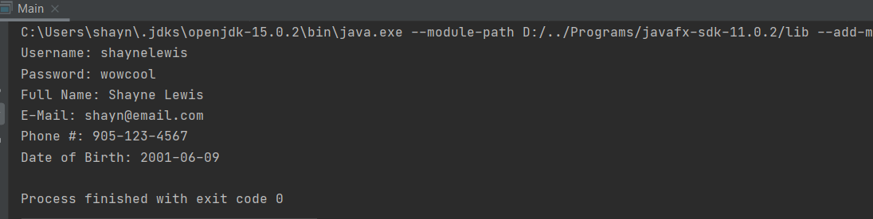

Local repository

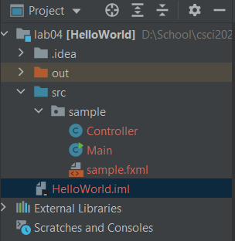

Github repository

<https://github.com/shayne-lewis/csci2020u_shaynelewis>