Lab07

Shayne Lewis

100506658

Local Repository

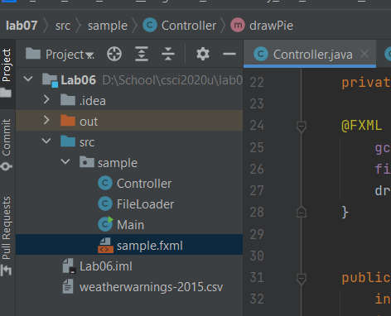

Github Repository

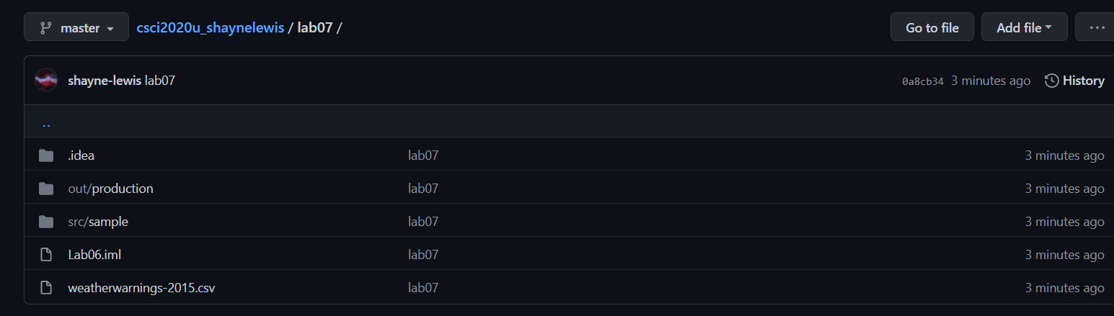

<https://github.com/shayne-lewis/csci2020u_shaynelewis/tree/master/lab07>

FileLoader.java

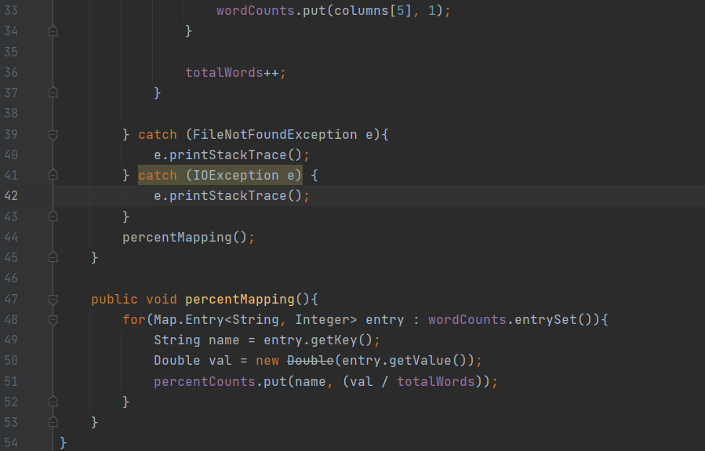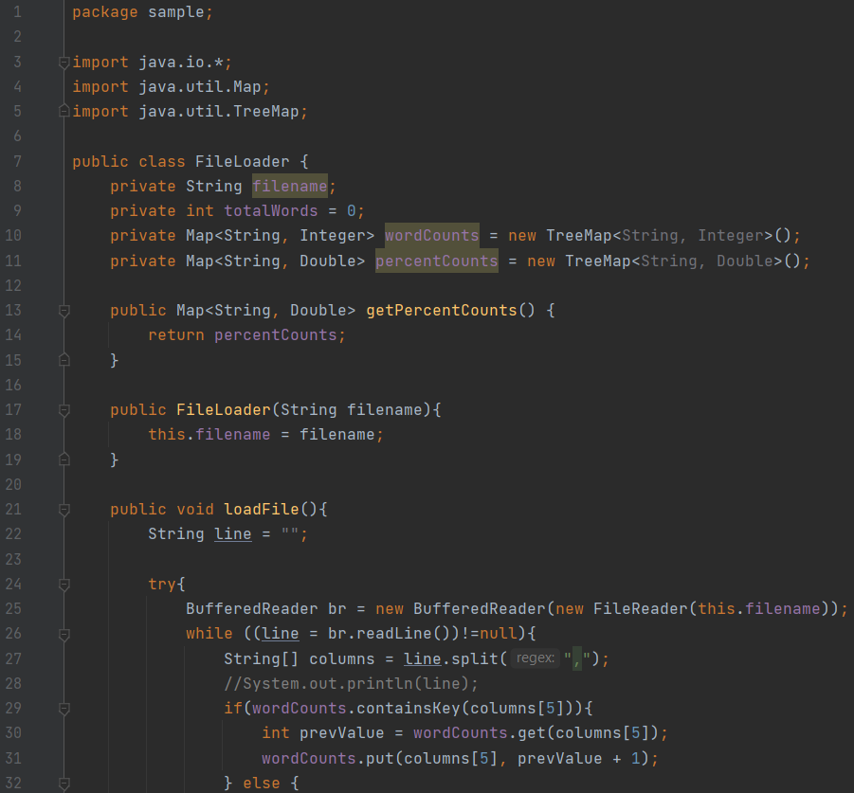

Controller.java

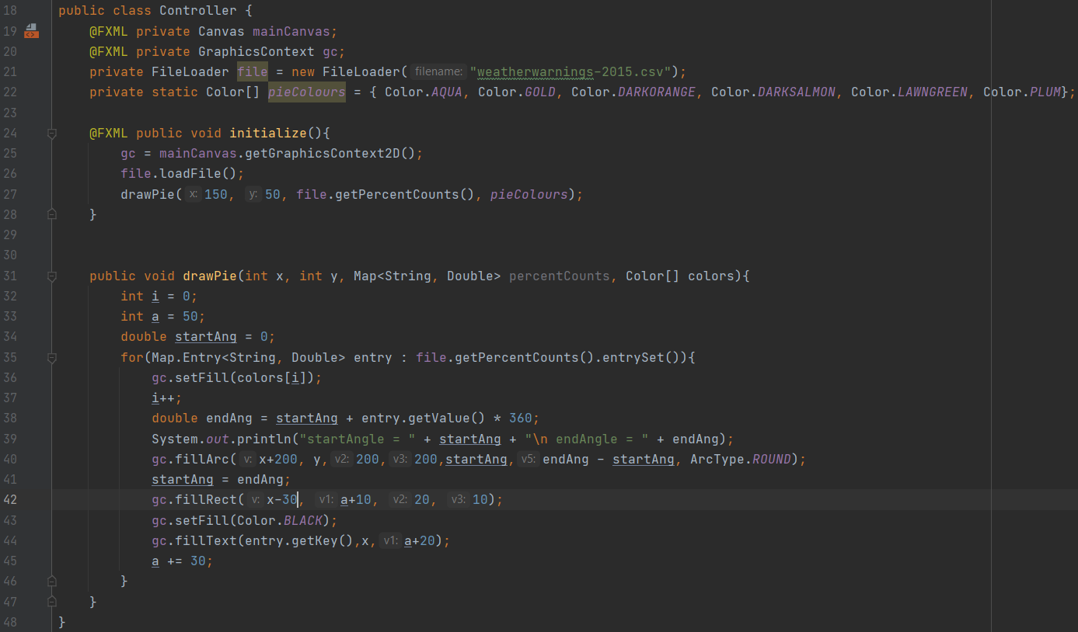

Main.java and sample.fxml were unchanged from lab06. They just created and instantiated the canvas.

Output Window

