Administration Instructions for The Beacon Website

This document will detail the administration of the website <https://thebeacon.film/>, including creating, editing, and channel entries and managing primary channel pages.

# Logging In:

To log into the admin panel visit <https://thebeacon.film/admin.php>, where you will see this login screen.

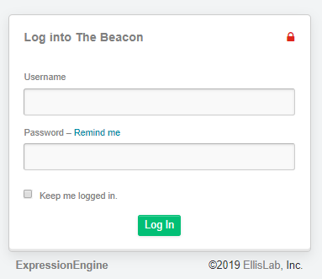

You should all have login credentials.

It is possible that browser caching can occur which may result in repeated requests to login as you administer to the site. Clearing your browser cache if this happens.

# Dashboard:

When you log in you will see this screen.

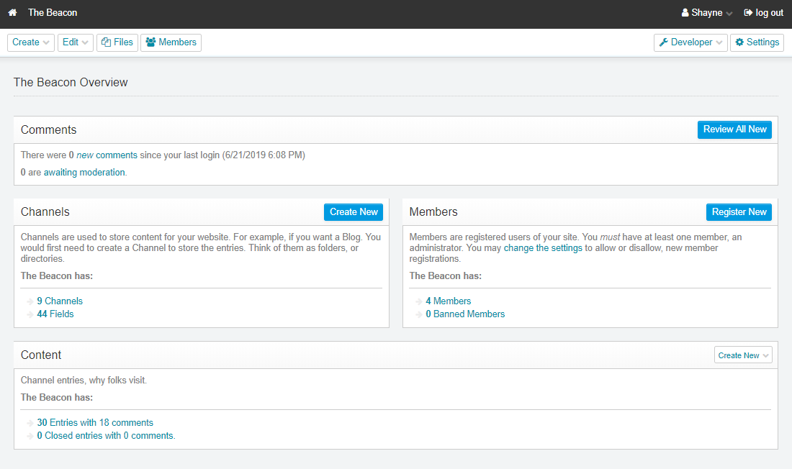

Focus your attention on the top left. The **Create** and **Edit** buttons are where you will be primarily concerned.

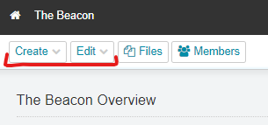

I am going to go over the process of creating a movie with showtimes because in going through that it will become apparent how to edit and manage your Series, Programs, Movies, Showtimes, and other pages.

# Setting Up a Movie with Showtimes

Expression Engine allows you to create and edit channels from within another channel entry page, which means that setting up showtimes, movies, and programs/series can be done quite seamlessly once the process is well understood.

1. Create a Showtime

Click the **Create** dropdown and select **Showtimes**

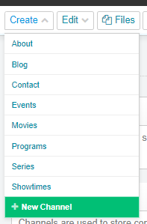

You will see this page:

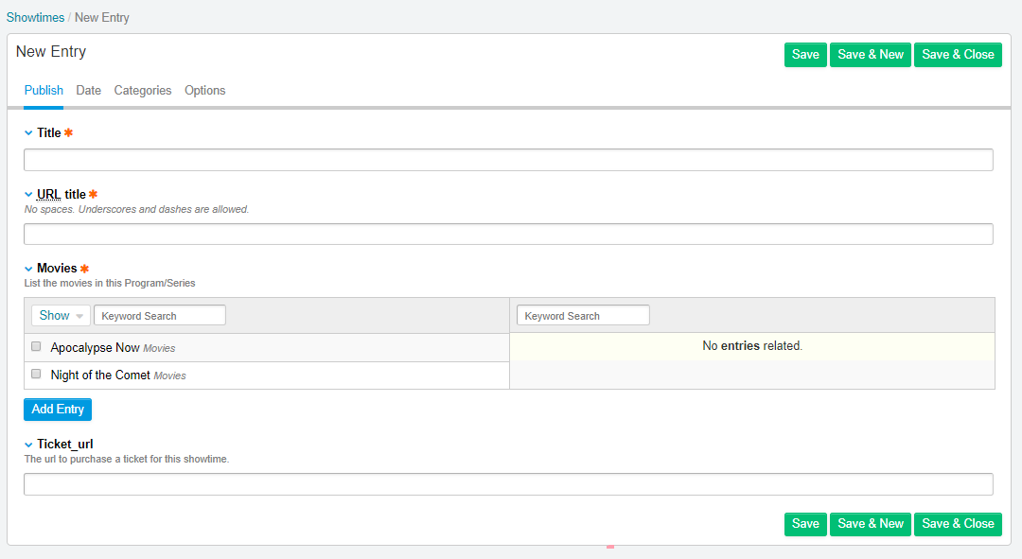

Click on the **Date** tab

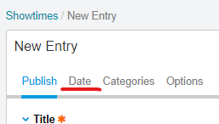

This will show some **Date** fields for this entry. The only thing you need to do is set the date for this showtime in the **Entry date** field.

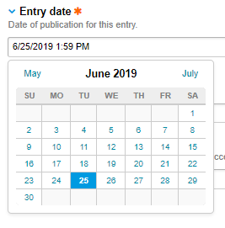

Select the ACTUAL DATE for this specific showtime. For instance, if this showtime is on “June 27, 2019th at 5:30PM”, click on the “27” cell in the date picker under the “June 2019” month. The date picker will automatically set the time to whatever your current time is now, so go ahead and change the time manually. Once you’ve done this go ahead and select everything within that field and copy it (ctrl + c).

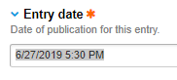

Click **Publish** to go continue creating the rest of the entry

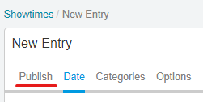

Under **Title** write the title of the movie for this showtime (even if you haven’t created the movie yet) and paste the date-time you just copied to the end of the title. This is important because each entry must have a unique **Title** and **URL title** (the URL title is generated automatically as you type the title, it uses accepted url standards). You should end up with something like this:

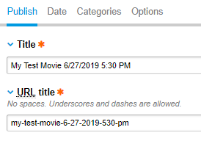

Now go ahead and past the url to your brownpapertickets.com page into the **Ticket_url** field: (your actual link will not by “/[my_test_movie]”. It’ll be whatever url Brown Paper Tickets gives you for the showtimes you set up there.

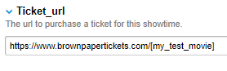

1. Set your Showtime to a Movie

As mentioned before, ExpressionEngine allows you to create entries within other channel entries if a relationship has been set up across multiple channels (which they have in this case between **Showtimes** and **Movies**).

So while you’re in this Showtime entry, go ahead and add a new **Movie** and apply this **Showtime** to it.

Click the Add Entry button at the bottom of the **Movies** section.

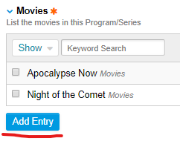

This will bring up a modal **New Entry** page for the **Movies** channel. Pretty cool! You should see something like this:

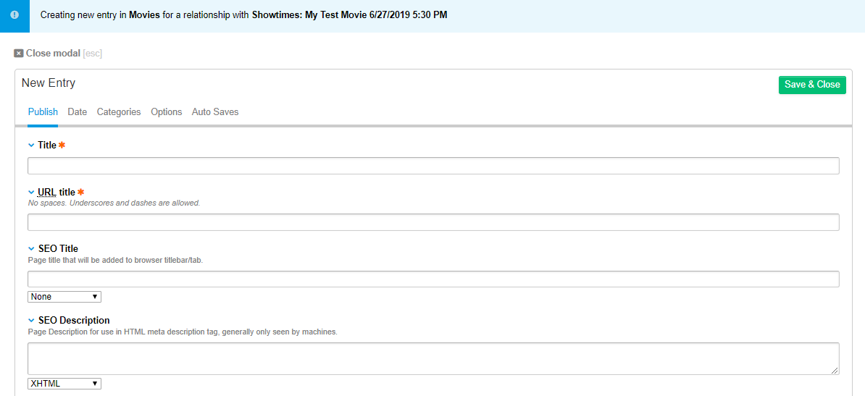

Let’s make a new **Movie** to apply to our **Showtime.**

Set all the required fields for your new movie (let’s not worry about much in here besides the title – we can change the rest in the next step) and press **Save & Close.**

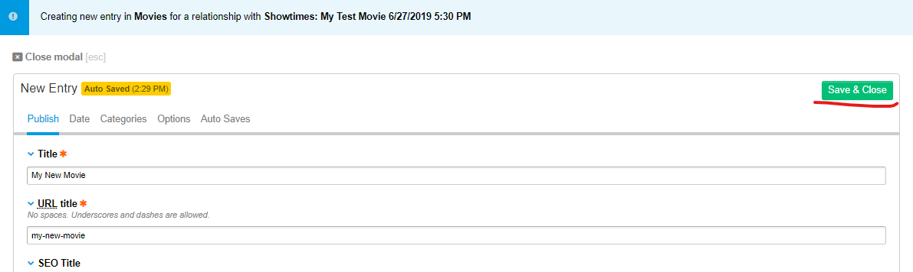

Now you will see under **Movies** that your new movie is there and already set to your showtime!

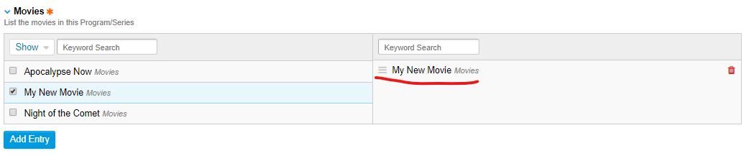

You must have a movie in the right-hand section in **Movies**, so if it’s not there make sure to check the movie for this showtime (in the left-hand section).

Click **Save.**

1. Edit your movie

Now that we have a **Showtime** with a **Movie** set to it, let’s edit our new **Movie** so it has everything we want.

Click the **Edit** button in the top-left and select **Movies** from the dropdown.

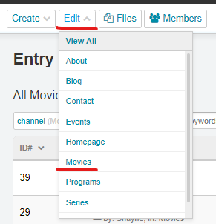

Here we see the list of **Movies** including the one we just made.

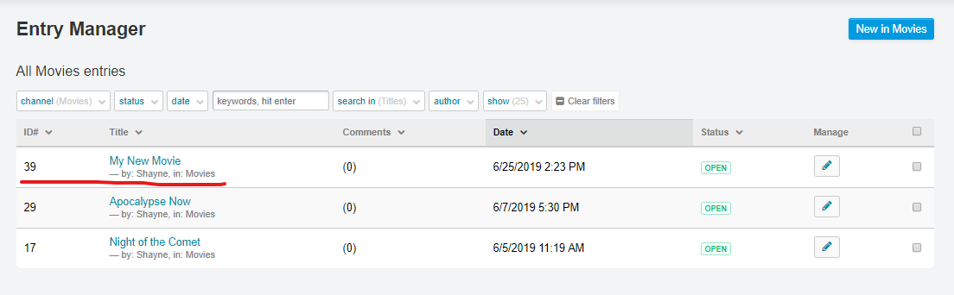

Click its title or the pencil button under **Manage** to go into the edit entry page, where we will see this:

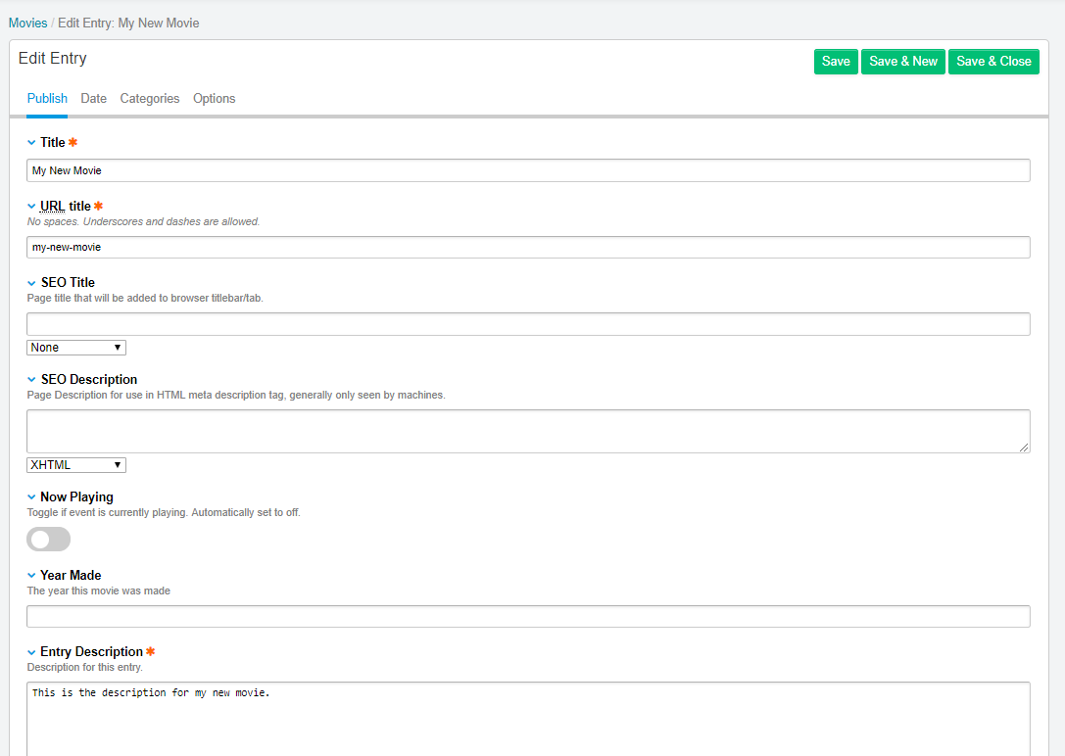

We will already have our required fields (Title, URL title, Entry Description, and Image) from creating the **Movie** in the **Showtimes** entry. Let’s go down the list through each field and explain them in detail.

# SEO Title and SEO Description

After Title and URL title come your SEO options: **SEO Title** and **SEO Description**. SEO stands for Search Engine Optimization, and these are the things that will appear in the results list (along with some other pre-set meta data that I’ve set up) on search engines like Google and DuckDuckGo. It’s good to have a good title and description for SEO so your page’s results look good and clickable on search engines.

**SEO Title** has a dropdown which is automatically set to None and **SEO Description** has one automatically set to XHTML. You don’t need to mess with these unless you plan on doing some SEO customization (your choice).

# Now Playing

This is a toggle that sets your movie to **Now Playing** or not. This will effect where the movie is listed. Generally, if you want a movie NOT to show, set this toggle in the off position

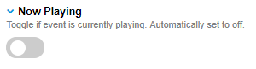

If you want the movie to show, sett it to on.

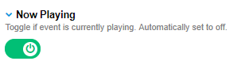

# Year Made, Description, and Runtime

These are the fields that will appear where your movie is listed on the frontend. Not all of them are required, but if they’re not there the fields will be empty on the frontend.

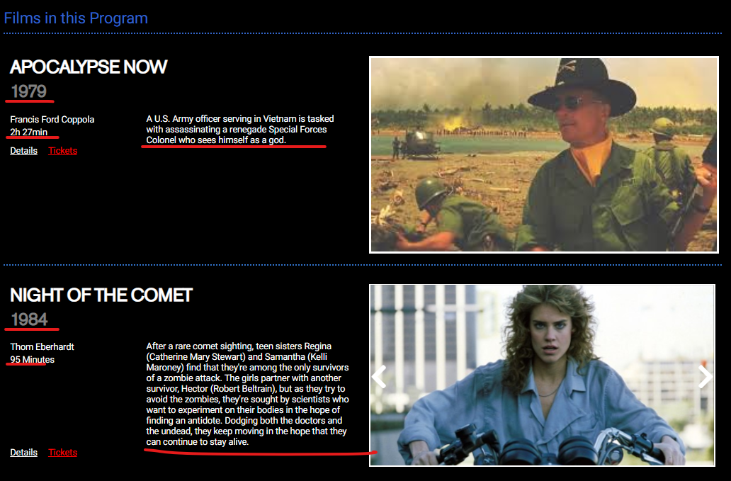

# Director, Staring, and Content Warning

Director and Staring are lists where you can add names of directors and actors starting in the picture.

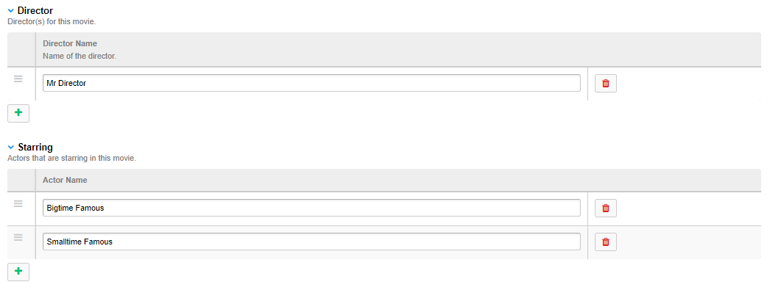

Click the + button to add a new name to the list. Click the red trash can to the right of their name to remove them from the list. The hamburger bars to the left of the name allow you to sort the order of the names in the list.

Content Warning will display whatever you put in the textfield in a dropdown section on the frontend of the entry page.

These appear along with other movie data on the frontend of movie entry pages.

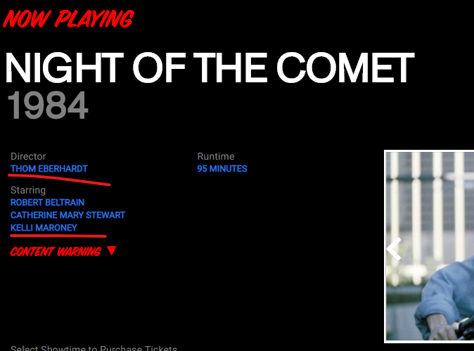

# Image, Video ID, and Video Type

An Image is required and will show wherever movie details are listed. If you’d like to add a video ID to the movie you MUST also set it’s video type, as the frontend templates will be expecting both if a video ID exists.

The Image section allows you to upload new images or use existing ones. The interface should be familiar and easy to use and thus doesn’t require explaining in detail.

To get the video ID, visit the video page for the video you want from either YouTube of Vimeo and copy the ID from the url.

YouTube after the “v=”:



Vimeo after the slash:



Once you have this ID put it into the **Video ID** field and then choose the type of video in the **Video Type** dropdown.

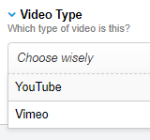

If you leave the **Video ID** empty, you don’t need to worry about the **Video Type**.

# Showtimes

In the **Showtimes** section we can set the showtimes for the movie! This part is very important because although we set the movie to the showtime we just created, we also must RELATE THE MOVIE BACK TO THE SHOWTIME HERE.

We simply do this by checking the showtime In the showtime list.

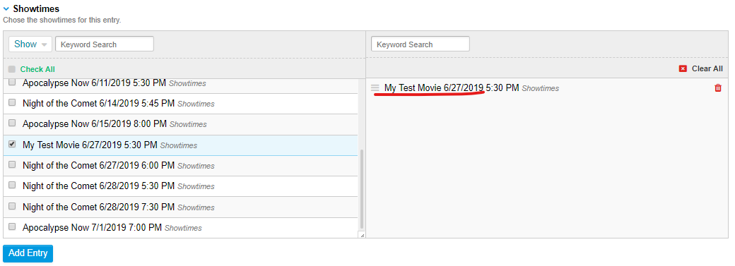

This list has a few useful options in the **Show** dropdown. So, for instance, if we want to only show showtimes that are already related to this movie, click **Related only** in the dropdown.

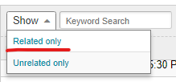

This will list only showtimes that are already related to THIS MOVIE. Which, as it just so happens, would be the showtime we created earlier.

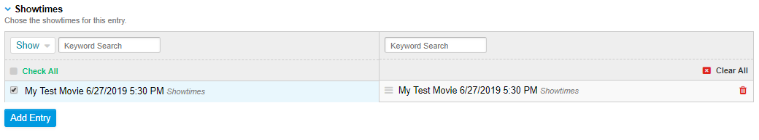

Add more showtimes now

If you want to add more showtimes to this movie, now is the perfect time to do it. Click Add Entry and start creating more showtimes as we did above (remember to relate them to this movie as you create them). Each one you create will be automatically related to this entry.

# Programs and Series

You can add your movie to Programs and Series at this time as well, which I would recommend.

If the right Series or Program doesn’t exist yet, you can also create it here from the Programs and Series sections.

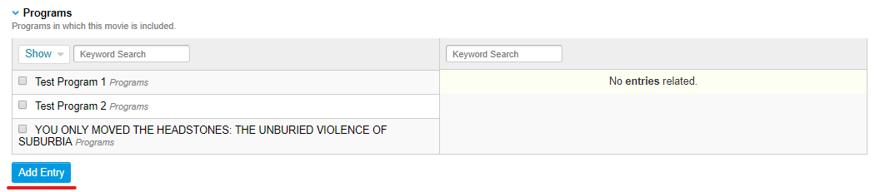

That will bring you to the modal for either the Programs or Series channel where you can create your new Program or Series.

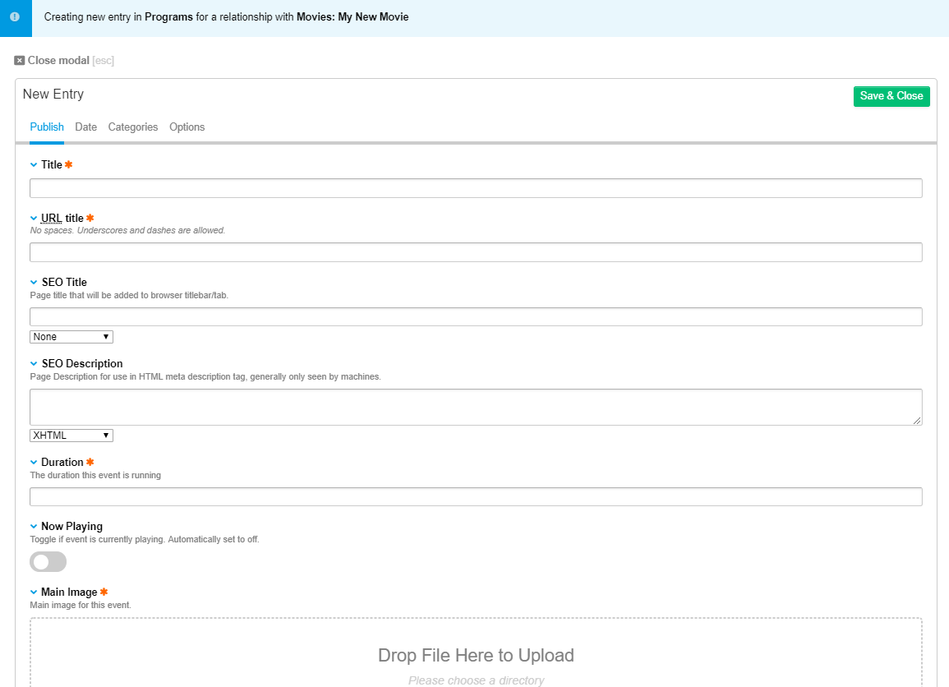

Remember if you are creating a new Program or Series here to relate the entry back to the movie you’re creating in the **Movies** section.

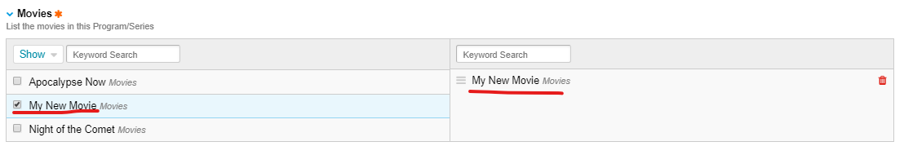

When you’re finished click **Save & Close**.

If you’re finished with your movie entry, click **Save**.

1. Edit your Programs/Series

Now that you have **Movies** with **Showtimes**, you’ll want to have **Programs** and **Series** for those movies.

If you’ve already created **Programs/Series** for your **Movie** when you created it, then you’ll already know what to do here. If you ever need to edit, delete, or create any of the entries for these channels outside of the movie entry creation process you can easily do that using the **Create** and **Edit** buttons in the top left

The structure of Programs and Series are the same, so if you know how to do one you know how to do the other as well, and they’re really not much different than movie entries (in fact a good deal simpler).

Just like the Movie entries, these channel entries have a:

Title

URL title

SEO Title

SEO Description

Now Playing toggle

Main Image

Description

Video ID

Video Type

Which all work in exactly the same way they do with the Movie entries. The only new things are a Duration field which works the same as the Year Made and Runtime fields in Movie entries, and a **Movies** selector, which relates your Program/Series to a movie (this is required and works in the same way that the other relationship selectors we’ve used work).

And that’s it for the vast majority of what you’ll be doing with your website!

Updating Movies, Showtimes, Programs, and Series.

# Homepage

The homepage is also something you might touch here and there, mostly to update the Featured Movie, but there are many other things you can do with this entry.

Come to the homepage entry by clicking the **Edit** button at the top and selecting it from the dropdown. There is only one Homepage entry allowed so you won’t be able to **Create** one.

Some of these fields will affect the header/footer of every page and some of them will only change portions of the homepage.

In here you can change the **Header Icon** and the **Header Image**, which go in the header and footer of every page.



You can change the **Address**, **Hours of Operation** / **Hours Image,** and **Entry Description**, which also go in the header and footer.



It’s important to note that you can enter html into the text fields here, and in the case of the **Address** and **Entry Description**, there is an HTML break element to break the text into two lines. It looks like this:

4405 Rainier Ave S<br>Seattle, WA 98118

And

A New Movie Theater <br>in Columbia City

If you ever need to change these text fields and want to put a break in them, just add “<br>” wherever in the string you want the break to be.

The **Hours of Operation** will be replaced by the **Hours Image** if it exists.

The **Homepage Image** goes right here:

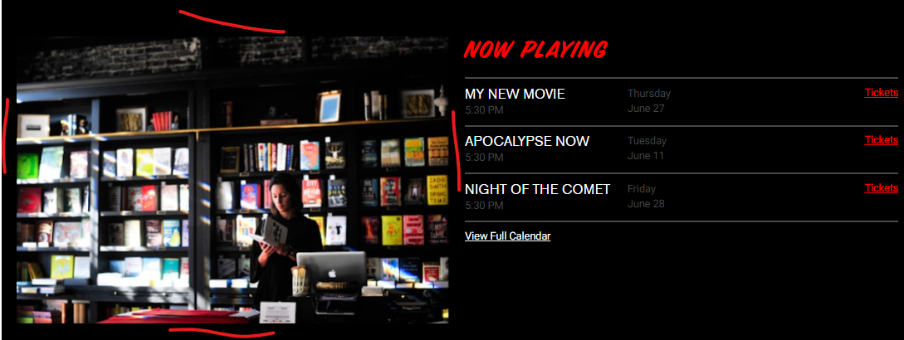

The **Top Homepage Image** was a prototype that we tested but decided not to go with. It is still here and functional if you ever change your mind. If you ever set an image in this field it will be a full-width banner and it will go on the homepage above the Homepage Image and below the header.

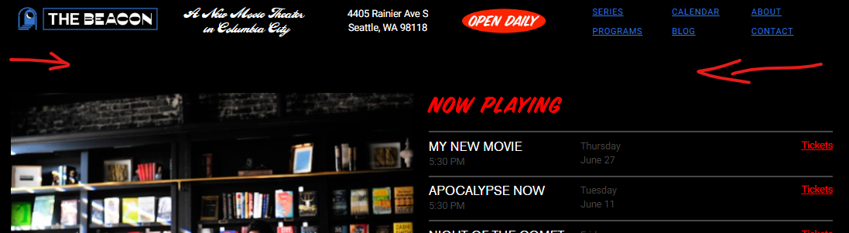

The **Featured Movie** section is where you set a movie you’d like to feature on the homepage (obviously). It is a list of all the movies.

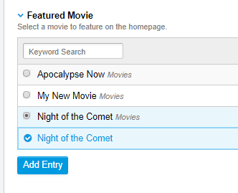

If you set something here it will show on the homepage just above the **Programs** section. If nothing is set here the section will not show on the homepage.

# Blog

Here you can create and manage blog entries. The format here is self explanatory. If you put anything into the audio, image, or video fields it will appear above the main content on the entry. Set the SEO options for your blog posts to have better search discovery. There are two content sections here: **Content** and **Rich Blog.** I recommend using Rich Blog as it is a rich text editor that allows you to create a blog post like you would a word document. The Content section is only text.

# About

There is a single about page. This works just like a blog page and the primary can be edited with the rich text editor.

# Contact

Contact, like About, has some basic input fields for Title, Content, and SEO. There are a few other fields here that should be self explanatory. The most important thing here is to set the **Contact Email** to the primary point of contact for the website.

# Events

As of the first iteration of the site, the Events do not exist, but they have a channel and base templates in case of future development.