So after installing Debian on my hard Drive these are the next steps I’ve done:

On my terminal I inputted su to log in my root and enterede my password

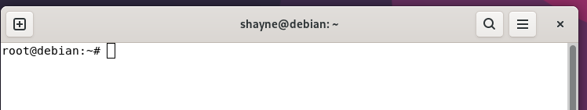

Modified wallpaper Appearance:


