1. **React HandsOn-1**

* Define SPA and its benefits
* Define React and identify its working
* Identify the differences between SPA and MPA
* Explain Pros & Cons of Single-Page Application
* Explain about React
* Define virtual DOM
* Explain Features of React

**Define SPA and its benefits**

**SPA (Single Page Application)** is a web application that loads a single HTML page and dynamically updates the content as the user interacts with the app, without reloading the entire page from the server.

#### ****Benefits of SPA:****

**Faster user experience**: Only necessary data is loaded, not full pages.

**Reduced server load**: Fewer HTTP requests to the server.

**Smooth navigation**: No full-page refreshes, transitions feel like a native app.

**Better caching**: Data can be cached efficiently, improving performance.

**Seamless user experience**: Faster interactions and real-time updates.

**Define React and indentify its working**

**React** is a JavaScript library developed by Facebook for building fast, interactive user interfaces for web and mobile applications using reusable UI components.

#### ****How React Works:****

React uses a **component-based architecture**.

It utilizes a **Virtual DOM** to optimize updates.

When data changes, React calculates the difference (**diffing**) and efficiently updates only the necessary parts of the DOM (**reconciliation**).

Components can have **state** and **props**, which control how they render and behave.

**Difference between SPA and MPA**

· **Page Reload:**

**SPA:** Loads a single HTML page; no full-page reload on navigation.

**MPA:** Reloads the entire page from the server on each user action.

· **Speed:**

**SPA:** Faster after initial load due to dynamic content loading.

**MPA:** Slower navigation as each action reloads a new page.

· **User Experience:**

**SPA:** Smooth and app-like experience.

**MPA:** Feels more traditional and less fluid.

· **SEO (Search Engine Optimization):**

**SPA:** SEO is harder; needs server-side rendering or pre-rendering.

**MPA:** Better SEO since each page has a unique URL and metadata.

· **Routing:**

**SPA:** Handled on the client-side using JavaScript (e.g., React Router).

**MPA:** Handled by the server (each page has a route).

· **Initial Load Time:**

**SPA:** Higher (downloads JS bundle and app logic upfront).

**MPA:** Faster (loads only what's required for the current page).

· **Development Complexity:**

**SPA:** More complex (requires client-side routing, state management).

**MPA:** Simpler and more straightforward for small to medium projects.

· **Server Load:**

**SPA:** Lower server load after initial load; fewer HTTP requests.

**MPA:** Higher server load due to frequent page reloads.

· **Technology Stack:**

**SPA:** Built using frameworks like React, Angular, Vue.

**MPA:** Built using server-side technologies like PHP, ASP.NET, JSP.

**Pros and Cons of SPA**

#### ****Pros:****

Fast, seamless user experience.

Reduced server load.

Easy to build progressive web apps (PWA).

Better front-end control with frameworks like React or Vue.

#### ****Cons:****

Poor SEO by default (requires SSR).

Slower initial loading.

Requires JavaScript to be enabled.

More complex client-side routing and state management.

**Explain about React**

React is a **front-end JavaScript library** mainly used to build **user interfaces** for web applications.

#### ****Key Aspects:****

Developed by **Facebook**.

Uses a **Virtual DOM** for efficient rendering.

Emphasizes **reusable components**.

Supports **hooks** for functional component state and side-effects.

Enables **one-way data binding**.

Can be used with libraries like Redux for state management.

**Define Virtual DOM**

**Virtual DOM (VDOM)** is a lightweight JavaScript representation of the actual DOM.

#### ****How it works:****

React creates a VDOM tree of components.

On state change, a new VDOM is created.

The new and old VDOM are compared (diffing).

Only changed parts are updated in the real DOM (reconciliation).

This results in **faster updates** and better performance than directly manipulating the DOM.

**Features of React**

· **JSX** – A syntax extension that lets you write HTML in JavaScript.

· **Component-Based Architecture** – Build encapsulated components that manage their own state.

· **Virtual DOM** – Efficient UI rendering.

· **One-Way Data Binding** – Data flows from parent to child components only.

· **Hooks** – Add state and lifecycle methods to functional components.

· **High Performance** – Faster DOM updates using Virtual DOM and diffing.

· **Declarative UI** – Design views for each state, and React handles rendering.

· **Large Ecosystem** – Rich ecosystem with tools like Redux, React Router, Next.js.

**App.js**

import React from 'react'

import './App.css'

function App(){

  return (

    <h1>Welcome to the first session of React</h1>

  )

}

export default App

**App.css:**

h1{

  text-align: center;}

**Output:**

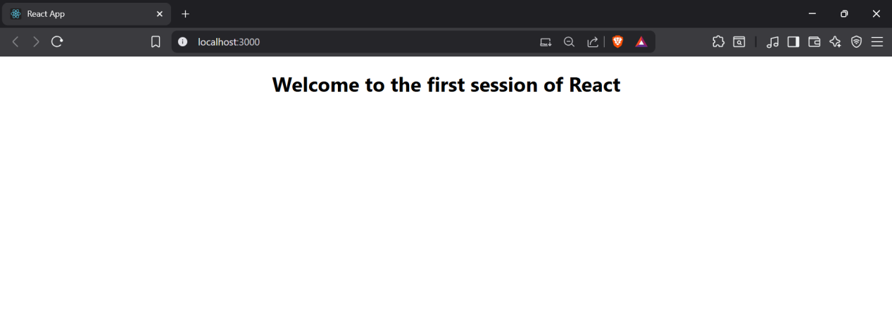

1. **React HandsOn-2**

* Explain React components
* Identify the differences between components and JavaScript functions
* Identify the types of components
* Explain class component
* Explain function component
* Define component constructor
* Define render() function

**Explain React components**

**React Components** are the building blocks of any React application. Each component represents a reusable piece of the UI (User Interface) and can manage its own state and logic.

#### Features:

Components let you split the UI into independent, reusable pieces.

They can be either **class-based** or **function-based**.

Each component can accept inputs called **props**.

Components can be **nested** inside one another.

**Difference between React Components and Javascript functions**

· **Purpose:**

**React Component:** Designed to render UI in React applications.

**JavaScript Function:** Used for general-purpose logic and operations.

· **Return Type:**

**React Component:** Returns **JSX** (which represents UI elements).

**JavaScript Function:** Returns any **data type** like numbers, strings, objects, etc.

· **Lifecycle Methods:**

**React Component:** **Class components** have lifecycle methods (e.g., componentDidMount, componentDidUpdate).

**JavaScript Function:** Does **not** have any lifecycle behavior.

· **React Integration:**

**React Component:** Automatically part of the **React rendering system**.

**JavaScript Function:** Not integrated with React by default.

· **Props:**

**React Component:** Accepts props to render dynamic data.

**JavaScript Function:** Accepts **parameters** (not React-aware).

· **State Management:**

**React Component:** Can manage state using **hooks (in function components)** or this.state (in class components).

**JavaScript Function:** Does **not manage state** internally.

**Identify the types of components:**

There are **two main types** of React components:

**Class Components**

**Function Components**

**Explain Class component:**

A **class component** is a React component defined using a JavaScript class that extends React.Component.

#### Features:

Has access to **lifecycle methods** (e.g., componentDidMount)

Can manage **state** directly via this.state

Uses this.props to access properties

**Explain Function Component:**

A **function component** is a simpler way to write components using JavaScript functions.

#### Features:

Stateless by default, but can use **React Hooks** (e.g., useState, useEffect) to manage state and lifecycle.

Easier to write and understand.

Preferred in modern React development.

**Define Component Constructor**

The **constructor** is a special method used in **class components** to initialize state and bind methods.

#### Usage:

Called before the component is mounted.

Initializes this.state and binds this context for methods.

**Define render() function:**

The render() method is used **in class components** to describe what the UI should look like.

#### Features:

It returns **JSX**.

Called every time the component's **state or props** change.

Must return a **single root element**.

**Home.js**

import React ,{Component} from 'react';

class Home extends Component {

  render() {

    return(

    <div>

    <h3>Welcome to the Home Page of Student Management Portal</h3>

    </div>

    );

  }

}

export default Home;

**About.js**

import React ,{Component} from 'react';

class About extends Component {

  render() {

    return(

    <div>

    <h3>Welcome to the About Page of Student Management Portal</h3>

    </div>

    );

  }

}

export default About;

**Contact.js**

import React ,{Component} from 'react';

class Contact extends Component {

  render() {

    return(

    <div>

    <h3>Welcome to the Contact Page of Student Management Portal</h3>

    </div>

    );

  }

}

export default Contact;

**App.js**

import React from 'react'

import Home from './Components/Home'

import './App.css'

import About from './Components/About';

import Contact from './Components/Contact';

function App (){

  return(

    <div className='container'>

      <Home/>

      <About/>

      <Contact/>

    </div>

  );

}

export default App

**App.css**

.container {

  display: flex;

  flex-direction: column;

  align-items: center;

  height: 100vh;

}

**Output:**

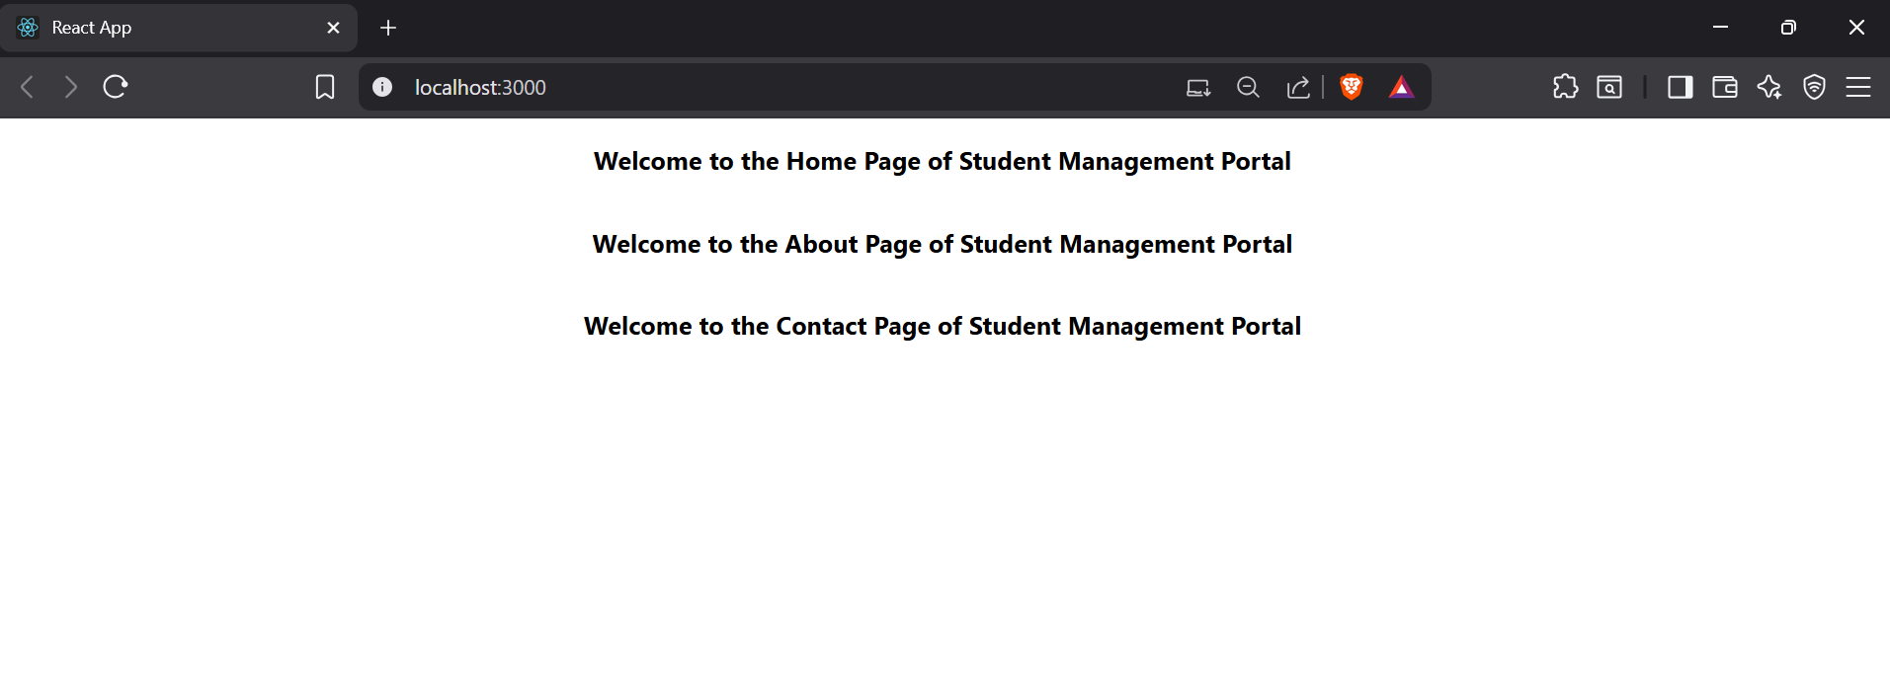

1. **React HandsOn-3**

**CalculateScore.js**

import React from 'react'

import "../mystyle.css";

const percentToDecimal=(decimal)=>{

    return(decimal.toFixed(2)+'%');

}

const calcScore=(total,goal)=>{

    return percentToDecimal(total/goal)

}

export const CalculateScore = ({Name,School,total,goal}) => {

  return (

    <div className='formatstyle'>

        <h1>

            <font color="Brown">

                Student Details:

            </font>

        </h1>

        <div className='Name'> <b><span>Name:</span></b><span>{Name}</span></div>

        <div className='School'><b><span>School:</span></b><span>{School}</span></div>

        <div className='Total'><b><span>Total:</span></b><span>{total}</span><span>Marks</span></div>

        <div className='Score'><b>Score:</b>

        <span>

            {calcScore(total,goal)}

        </span>

        </div>

    </div>

  )

}

export default CalculateScore

**mystyle.css**

.Name{

    font-weight: 300;

    color:blue;

}

.School{

    color:crimson;

}

.Total{

    color:darkmagenta;

}

.formatstyle{

    text-align: center;

    font-size:large;

}

.Score{

    color:forestgreen;

}

**App.js**

import CalculateScore from "./components/CalculateScore";

function App(){

  return(

    <div>

      <CalculateScore Name={'Steeve'} School={'DNV Public School'} total={284}goal={3}/>

    </div>

  )

}

export default App

**Output:**

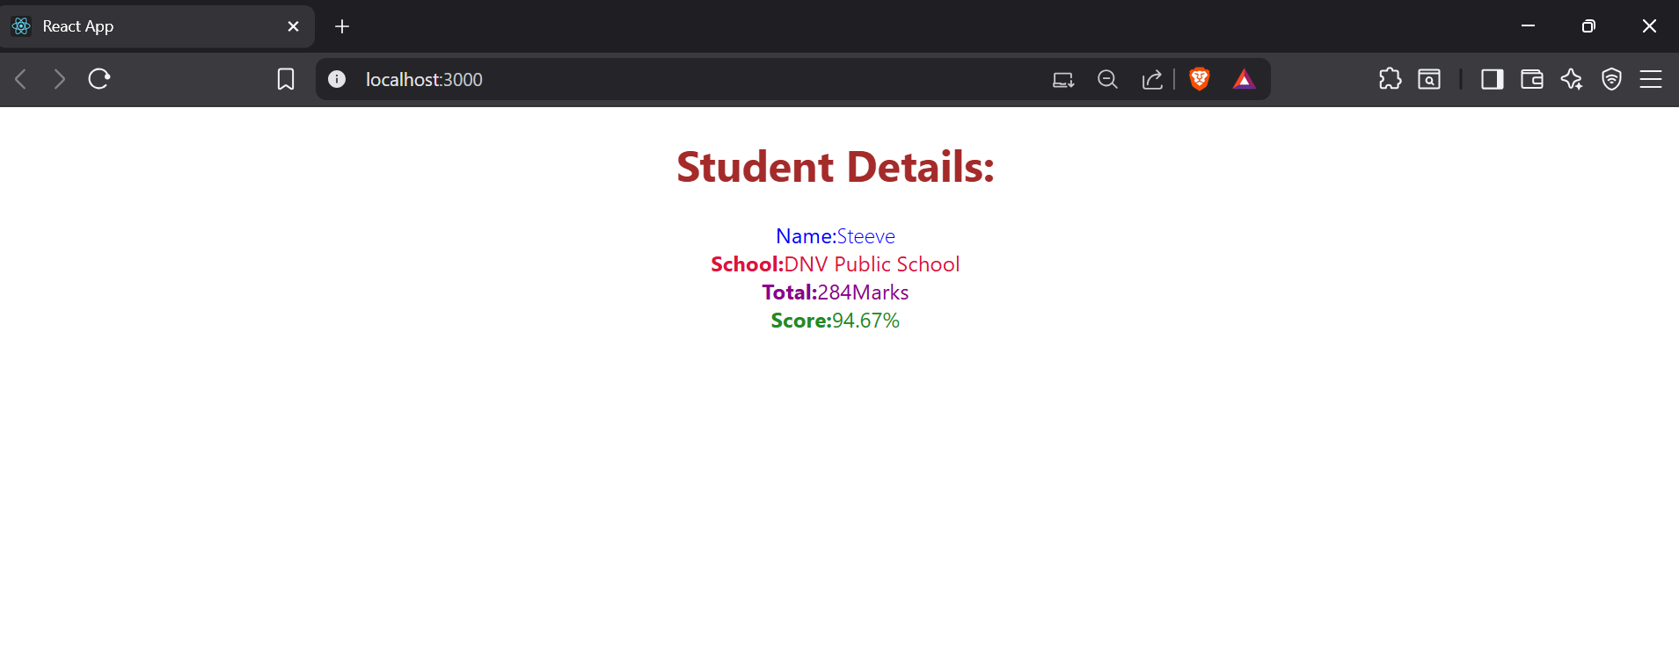

1. **React HandsOn-4**

**Post.js**

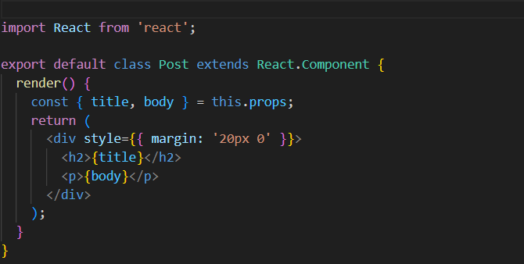

**Posts.js**

**App.js**

Output

1. **React HandsOn-5**

**CohortDetails.module.css**

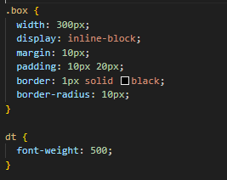

CohortDetails.js

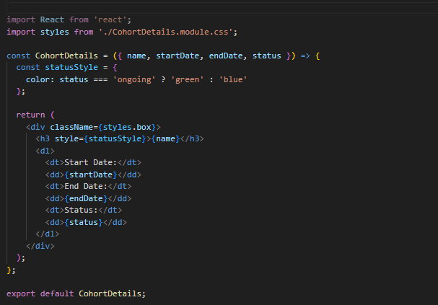

App.js

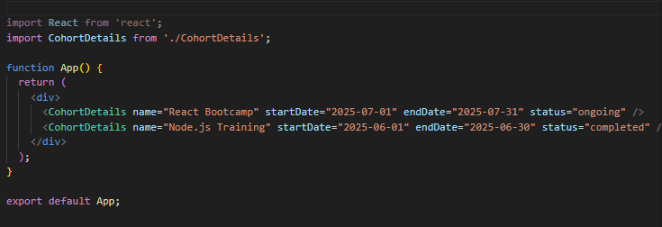

Output

1. **React HandsOn-6**

**Trainer.js**

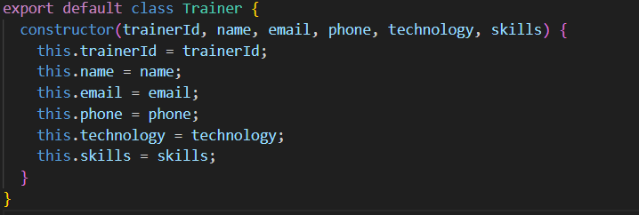

**TrainersMock.js**

**Home.js**

**TrainerList.js**

**TrainerDetails.js**

**App.js**

**Output**

