1. **React HandsOn-9**

**Features of ES6:**

· **let and const** – Block-scoped variable declarations.

· **Arrow Functions** – Shorter syntax for writing functions.

· **Classes** – Syntactic sugar over JavaScript’s prototype-based inheritance.

· **Template Literals** – Multi-line strings and embedded expressions.

· **Destructuring Assignment** – Unpacking values from arrays or properties from objects.

· **Default Parameters** – Set default values for function parameters.

· **Spread and Rest Operators** – ... for expanding or collecting elements.

· **Modules (import/export)** – Support for modular code.

· **Promises** – Handle asynchronous operations more cleanly.

· **Map and Set** – New data structures for storing key-value pairs and unique values.

· **for...of Loop** – Iterates over iterable objects like arrays.

**Explain Javascript let:**

· Introduced in ES6.

· Used to declare **block-scoped** variables.

· Cannot be re-declared in the same scope.

· Can be **updated**, but **not hoisted** like var (or hoisted in a TDZ - temporal dead zone).

**Difference between var and let:**

| **Feature** | **var** | **let** |
| --- | --- | --- |
| Scope | Function-scoped | Block-scoped |
| Hoisting | Yes (initialized as undefined) | Yes (but in TDZ) |
| Redeclaration | Allowed in same scope | Not allowed in same scope |
| Global Object | Attaches to window object | Doesn’t attach to window |

**JavaScript const**

* Also block-scoped like let.
* Used for **constants** (values that shouldn’t change).
* Must be **initialized at declaration**.
* Does **not make objects/arrays immutable**, only the binding is constant.

**Explain ES6 CLass Fundamentals:**

· **Class Declaration**:

class MyClass { }

· **Constructor Method**: Automatically called when a new object is created.

· **Method Definitions**: Define functions directly inside the class.

· **No function keyword**: Methods are defined without function.

·**Prototype-Based**: Still uses prototype behind the scenes, but syntax is cleaner.

**ES6 Class Inheritance:**

· extends **Keyword**: Used to create a class that inherits from another.

· super() **in Constructor**: Calls the parent class constructor.

· **Method Overriding**: Subclass can define its own version of methods.

**Define ES6 Arrow Functions:**

· **Short Syntax**:

const sum = (a, b) => a + b;

· **No** this **Binding**: Uses this from the surrounding lexical context.

· **No** arguments **Object**: Cannot access arguments like normal functions.

· **Cannot be used as constructors**: new keyword doesn't work with arrow functions.

· **Best For**: Callbacks, functional programming.

**Set in Javascript**

· **Collection of Unique Values**: No duplicates allowed.

· **Maintains Insertion Order**.

· **Methods**:

add(value): Adds a value.

has(value): Checks existence.

delete(value): Deletes value.

clear(): Removes all elements.

size: Returns count.

**Map in JavaScript**

· **Key-Value Pairs**: Like objects but allows any type as key.

· **Maintains Insertion Order**.

· **Methods**:

set(key, value): Adds/updates entry.

get(key): Retrieves value.

has(key): Checks existence.

delete(key): Removes entry.

clear(): Removes all entries.

size: Returns count.

**App.js**

import React from 'react';

import ListofPlayers from "./components/ListofPlayers";

import IndianPlayers from "./components/IndianPlayers";

function App() {

  const flag = true;

  return (

    <div className="App">

      <h1>Cricket App</h1>

      {flag ? <ListofPlayers /> : <IndianPlayers />}

    </div>

  );

}

export default App;

**ListofPlayers.js**

import React from 'react';

function ListofPlayers() {

  const players = [

    { name: "Rohit", score: 90 },

    { name: "Virat", score: 85 },

    { name: "Dhoni", score: 95 },

    { name: "Hardik", score: 60 },

    { name: "Jadeja", score: 75 },

    { name: "Bumrah", score: 45 },

    { name: "Gill", score: 88 },

    { name: "Surya", score: 70 },

    { name: "Shreyas", score: 55 },

    { name: "KL Rahul", score: 78 },

    { name: "Ishan", score: 65 }

  ];

*// Filter using arrow function*

  const lowScorers = players.filter(player => player.score < 70);

  return (

    <div>

      <h2>All Players</h2>

      <ul>

        {players.map((player, index) => (

          <li key={index}>{player.name}: {player.score}</li>

        ))}

      </ul>

      <h3>Players with score below 70</h3>

      <ul>

        {lowScorers.map((player, index) => (

          <li key={index}>{player.name}: {player.score}</li>

        ))}

      </ul>

    </div>

  );

}

export default ListofPlayers;

**IndianPlayers.js**

import React from 'react';

function IndianPlayers() {

  const allPlayers = [

    "Rohit", "Virat", "Dhoni", "Hardik", "Jadeja",

    "Bumrah", "Gill", "Surya", "Shreyas", "KL Rahul", "Ishan"

  ];

  const oddTeam = allPlayers.filter((_, index) => index % 2 !== 0);

  const evenTeam = allPlayers.filter((_, index) => index % 2 === 0);

  const T20players = ["Rohit", "Surya", "Bumrah"];

  const RanjiTrophyPlayers = ["Pujara", "Karun", "Saha"];

  const mergedPlayers = [...T20players, ...RanjiTrophyPlayers];

  return (

    <div>

      <h2>Odd Team Players</h2>

      <ul>

        {oddTeam.map((player, index) => <li key={index}>{player}</li>)}

      </ul>

      <h2>Even Team Players</h2>

      <ul>

        {evenTeam.map((player, index) => <li key={index}>{player}</li>)}

      </ul>

      <h2>Merged Players (T20 + Ranji Trophy)</h2>

      <ul>

        {mergedPlayers.map((player, index) => <li key={index}>{player}</li>)}

      </ul>

    </div>

  );

}

export default IndianPlayers;

**Output:**

**Flag==true**

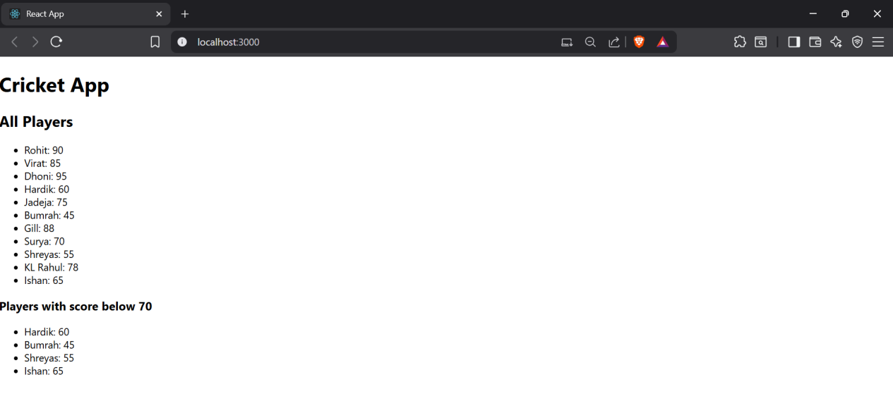

**Flag==false:**

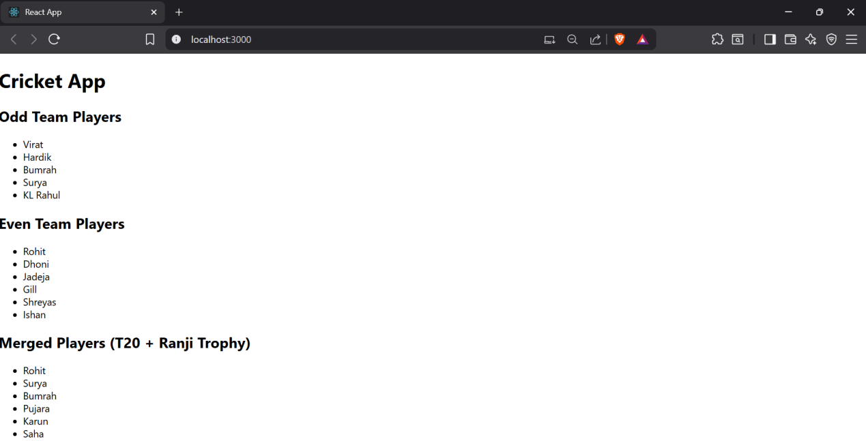

1. **React HandsOn-10**

**App.js**

import React from 'react';

import './App.css';

function App() {

  const offices = [

    {

      name: "DBS",

      rent: 55000,

      address: "Bangalore, Karnataka",

      image: "https://via.placeholder.com/300x200?text=SkyView"

    },

  ];

  return (

    <div className="App">

      <h1>Office Space ,at Affordable Range</h1>

      {offices.map((office, index) => (

        <div className="info" key={index} style={{ border: '1px solid #ccc', margin: '10px', padding: '10px',height:"500px",width:"450px" }}>

          <img

        src="https://t4.ftcdn.net/jpg/03/84/55/29/360_F_384552930_zPoe9zgmCF7qgt8fqSedcyJ6C6Ye3dFs.jpg"

        width="100%"

        alt="Office Space"

      />

          <h2>Name:{office.name}</h2>

          <p>Address:{office.address}</p>

          <p style={{ color: office.rent < 60000 ? 'red' : 'green' }}>

            Rent: ₹{office.rent}

          </p>

        </div>

      ))}

    </div>

  );

}

export default App;

**Output:**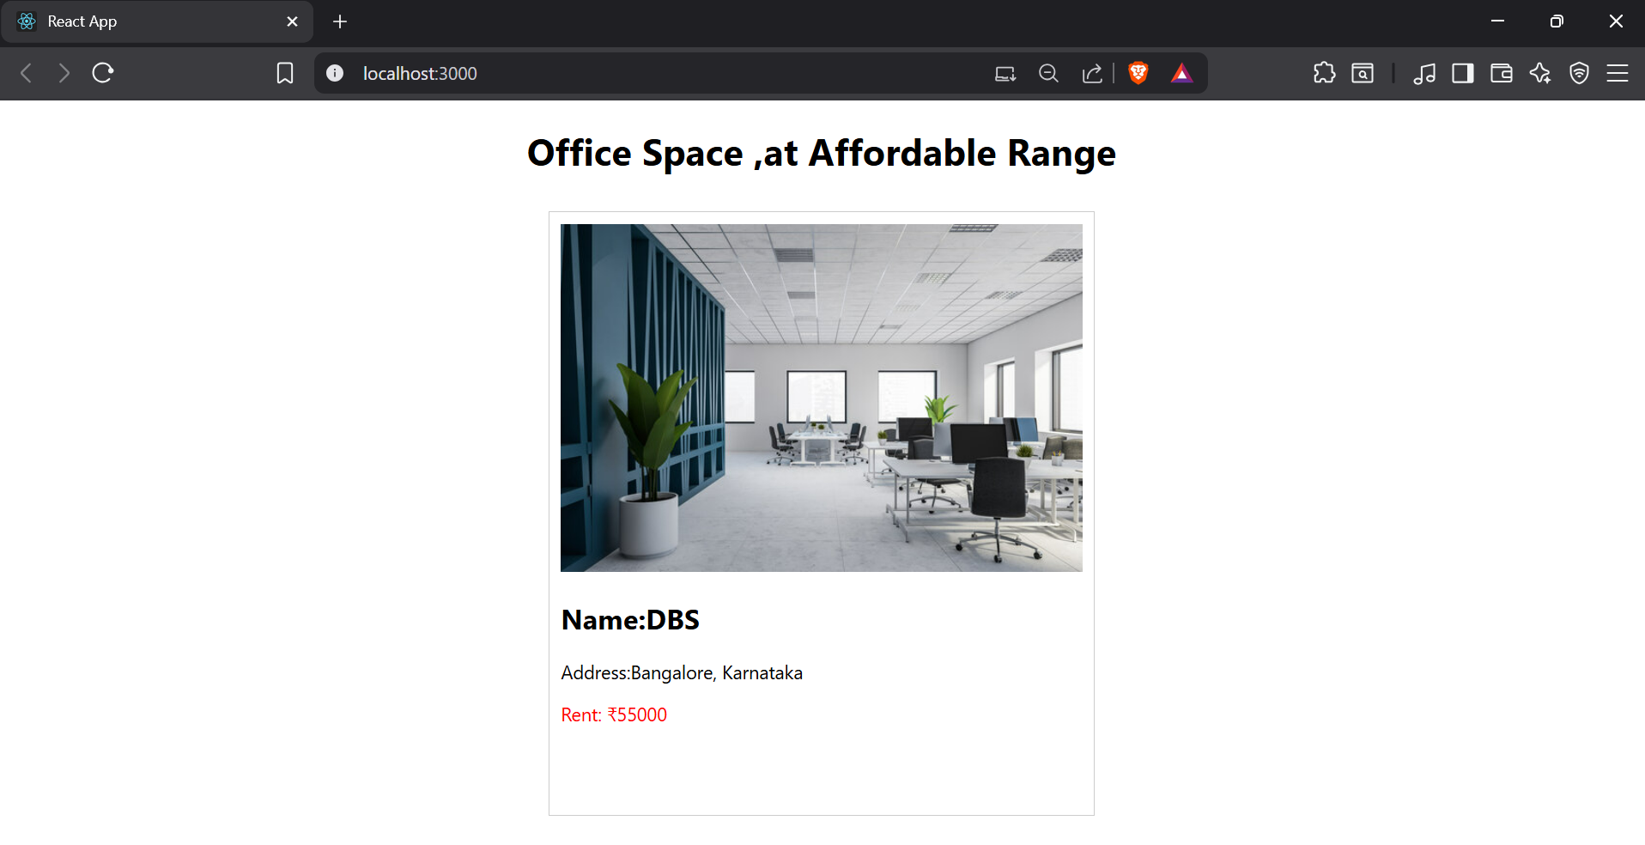

1. **React HandsOn-11**

**App.js**

import React, { useState } from 'react';

import './App.css';

import CurrencyConvertor from './CurrencyConvertor';

function App() {

  const [counter, setCounter] = useState(0);

  const increment = () => {

    sayHello();

    setCounter(prev => prev + 1);

  };

  const sayHello = () => {

    console.log("Hello! This is a static message.");

  };

  const decrement = () => {

    setCounter(prev => prev - 1);

  };

  const sayWelcome = (message) => {

    alert(message);

  };

  const handlePress = (event) => {

    alert("I was clicked");

    console.log("Synthetic Event Type:", event.type);

  };

  return (

    <div className="App">

      <h1>Event Handling in React</h1>

      <p>Counter: {counter}</p>

      <button onClick={increment}>Increment</button>

      <button onClick={decrement}>Decrement</button>

      <br /><br />

      <button onClick={() => sayWelcome("Welcome!")}>Say Welcome</button>

      <br /><br />

      <button onClick={handlePress}>Synthetic OnPress</button>

      <br /><br />

      <CurrencyConvertor />

    </div>

  );

}

export default App;

**CurrencyConvertor.js**

import React, { useState } from 'react';

const CurrencyConvertor = () => {

  const [rupees, setRupees] = useState('');

  const [convertedAmount, setConvertedAmount] = useState(null);

  const [currency, setCurrency] = useState('EUR');

  const conversionRates = {

    EUR: 0.011,

    USD: 0.012,

    GBP: 0.0095,

  };

  const handleSubmit = (e) => {

    e.preventDefault();

    const rate = conversionRates[currency];

    const result = parseFloat(rupees) * rate;

    setConvertedAmount(result.toFixed(2));

  };

  return (

    <div>

      <h2>Currency Convertor</h2>

      <form onSubmit={handleSubmit}>

        <div>

          <label>

            INR:

            <input

              type="number"

              value={rupees}

              onChange={(e) => setRupees(e.target.value)}

              required

              style={{ marginLeft: '5px' }}

            />

          </label>

        </div>

        <div style={{ marginTop: '10px' }}>

          <label>

            Convert To:

            <select

              value={currency}

              onChange={(e) => setCurrency(e.target.value)}

              style={{ marginLeft: '5px' }}

            >

              <option value="EUR">Euro (EUR)</option>

              <option value="USD">US Dollar (USD)</option>

              <option value="GBP">British Pound (GBP)</option>

            </select>

          </label>

        </div>

        <button type="submit" style={{ marginTop: '10px' }}>Convert</button>

      </form>

      {convertedAmount !== null && (

        <p>

          {currency}: {currency === 'EUR' ? '€' : currency === 'USD' ? '$' : '£'}{convertedAmount}

        </p>

      )}

    </div>

  );

};

export default CurrencyConvertor;

**OUTPUT:**

1. **React HandsOn-12**

**App.js**

import React, { useState } from 'react';

import './App.css';

import GuestPage from './GuestPage';

import UserPage from './UserPage';

function App() {

  const [isLoggedIn, setIsLoggedIn] = useState(false);

  const handleLogin = () => {

    setIsLoggedIn(true);

  };

  const handleLogout = () => {

    setIsLoggedIn(false);

  };

  let page;

  if (isLoggedIn) {

    page = <UserPage />;

  } else {

    page = <GuestPage />;

  }

  return (

    <div className="App">

      <h1>✈️ Flight Ticket Booking App</h1>

      {isLoggedIn ? (

        <button onClick={handleLogout}>Logout</button>

      ) : (

        <button onClick={handleLogin}>Login</button>

      )}

      <hr />

      {page}

    </div>

  );

}

export default App;

**GuestPage.js**

import React from 'react';

const GuestPage = () => {

  return (

    <div>

      <h2>Welcome, Guest!</h2>

      <p>You can view available flights but need to log in to book tickets.</p>

      <ul>

        <li>✈️ Flight A: Delhi → Mumbai - ₹5000</li>

        <li>✈️ Flight B: Bangalore → Kolkata - ₹4500</li>

        <li>✈️ Flight C: Chennai → Hyderabad - ₹3000</li>

      </ul>

    </div>

  );

};

export default GuestPage;

**UserPage.js**

import React from 'react';

const UserPage = () => {

  return (

    <div>

      <h2>Welcome, User!</h2>

      <p>You can now book tickets:</p>

      <ul>

        <li>

          ✈️ Flight A: Delhi → Mumbai

          <button style={{ marginLeft: '10px' }}>Book</button>

        </li>

        <li>

          ✈️ Flight B: Bangalore → Kolkata

          <button style={{ marginLeft: '10px' }}>Book</button>

        </li>

        <li>

          ✈️ Flight C: Chennai → Hyderabad

          <button style={{ marginLeft: '10px' }}>Book</button>

        </li>

      </ul>

    </div>

  );

};

export default UserPage;

**OUTPUT:**

1. **React HandsOn-13**

**App.js**

import React, { useState } from 'react';

import './App.css';

import BookDetails from './BookDetails';

import BlogDetails from './BlogDetails';

import CourseDetails from './CourseDetails';

function App() {

  const [activeTab, setActiveTab] = useState('book');

  let componentToRender;

  if (activeTab === 'book') {

    componentToRender = <BookDetails />;

  } else if (activeTab === 'blog') {

    componentToRender = <BlogDetails />;

  } else if (activeTab === 'course') {

    componentToRender = <CourseDetails />;

  }

  return (

    <div className="App">

      <h1>📚 Blogger App</h1>

      <div style={{ marginBottom: '20px' }}>

        <button onClick={() => setActiveTab('book')}>Book Details</button>

        <button onClick={() => setActiveTab('blog')} style={{ marginLeft: '10px' }}>Blog Details</button>

        <button onClick={() => setActiveTab('course')} style={{ marginLeft: '10px' }}>Course Details</button>

      </div>

      {componentToRender}

    </div>

  );

}

export default App;

**BookDetails.js**

import React from 'react';

const BookDetails = () => {

  return (

    <div>

      <h2>📘 Book Details</h2>

      <ul>

        <li>Title: Learn React</li>

        <li>Author: John Doe</li>

        <li>Price: ₹499</li>

      </ul>

    </div>

  );

};

export default BookDetails;

**BlogDetails.js**

import React from 'react';

const BlogDetails = () => {

  return (

    <div>

      <h2>📝 Blog Details</h2>

      <ul>

        <li>Title: React vs Angular</li>

        <li>Author: Jane Smith</li>

        <li>Date: 03-Aug-2025</li>

      </ul>

    </div>

  );

};

export default BlogDetails;

**CourseDetails.js**

import React from 'react';

const CourseDetails = () => {

  return (

    <div>

      <h2>🎓 Course Details</h2>

      <ul>

        <li>Course: React for Beginners</li>

        <li>Instructor: Alex Johnson</li>

        <li>Duration: 4 weeks</li>

      </ul>

    </div>

  );

};

export default CourseDetails;

**OUTPUT:**

