Homework 2

Ekaterina Marbot, Elizabeth Chung, Shay Culpepper, Flaka Bajraktari

9/25/2018

## Benford’s Law

## Education and Income

## Income inequality, averages, by neighborhood and borough

This isn’t one of your questions, but this boxplot is a nice representation of the inequality by borough. 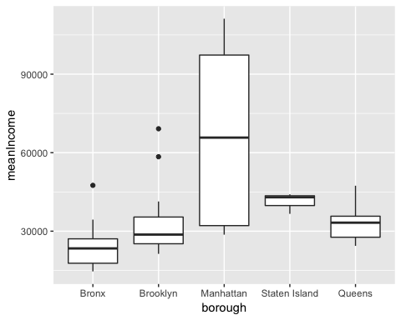

### Richest and poorest neighborhoods by borough

#### Highest Mean Income

## # A tibble: 5 x 3  
## # Groups: borough [5]  
## borough PUMA meanIncome  
## <fct> <fct> <dbl>  
## 1 Bronx Riverdale, Fieldston & Kingsbridge 47512.  
## 2 Brooklyn Park Slope, Carroll Gardens & Red Hook 69142.  
## 3 Manhattan Upper East Side 111189.  
## 4 Staten Island Tottenville, Great Kills & Annadale 44094.  
## 5 Queens Forest Hills & Rego Park 47377.

#### Lowest Mean Income

## # A tibble: 5 x 3  
## # Groups: borough [5]  
## borough PUMA meanIncome  
## <fct> <fct> <dbl>  
## 1 Bronx Hunts Point, Longwood & Melrose 14632.  
## 2 Brooklyn East New York & Starrett City 21341.  
## 3 Manhattan Washington Heights, Inwood & Marble Hill 28669.  
## 4 Staten Island Port Richmond, Stapleton & Mariner's Harbor 36632.  
## 5 Queens Elmhurst & South Corona 24382.

### Inequality by neighborhood

#### Measured by 75 quartile minus 25 quartile.

## # A tibble: 5 x 3  
## # Groups: borough [5]  
## borough PUMA q75.less.q25  
## <fct> <fct> <dbl>  
## 1 Bronx Riverdale, Fieldston & Kingsbridge 52900  
## 2 Brooklyn Brooklyn Heights & Fort Greene 67900  
## 3 Manhattan Upper East Side 108000  
## 4 Staten Island Tottenville, Great Kills & Annadale 54100  
## 5 Queens Forest Hills & Rego Park 58775

#### Measured by standard deviation

## # A tibble: 5 x 3  
## # Groups: borough [5]  
## borough PUMA sd  
## <fct> <fct> <dbl>  
## 1 Bronx Riverdale, Fieldston & Kingsbridge 87546.  
## 2 Brooklyn Park Slope, Carroll Gardens & Red Hook 85972.  
## 3 Manhattan Upper East Side 159799.  
## 4 Staten Island New Springville & South Beach 55362.  
## 5 Queens Forest Hills & Rego Park 58536.

#### Compare differences between approaches

## # A tibble: 6 x 3  
## # Groups: borough [1]  
## borough PUMA q75.less.q25  
## <fct> <fct> <dbl>  
## 1 Manhattan Upper East Side 108000  
## 2 Manhattan Battery Park City, Greenwich Village & Soho 105000  
## 3 Manhattan Chelsea, Clinton & Midtown Business District 102700  
## 4 Manhattan Upper West Side & West Side 92650  
## 5 Manhattan Murray Hill, Gramercy & Stuyvesant Town 92375  
## 6 Manhattan Chinatown & Lower East Side 45300

## # A tibble: 6 x 3  
## # Groups: borough [1]  
## borough PUMA sd  
## <fct> <fct> <dbl>  
## 1 Manhattan Upper East Side 159799.  
## 2 Manhattan Chelsea, Clinton & Midtown Business District 136658.  
## 3 Manhattan Battery Park City, Greenwich Village & Soho 133604.  
## 4 Manhattan Upper West Side & West Side 129747.  
## 5 Manhattan Murray Hill, Gramercy & Stuyvesant Town 129031.  
## 6 Manhattan Chinatown & Lower East Side 72333.