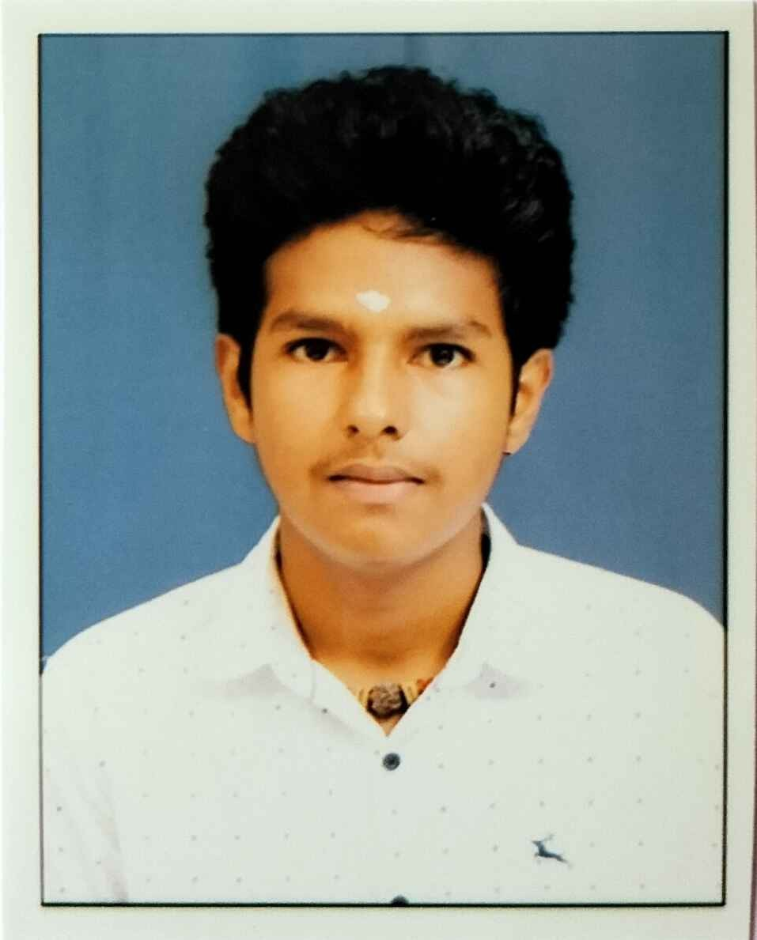
SUDALAI MUTHU S  +91-8778341996
Software Development Engineer ssudalaimuthu2005@gmail.com
B.Tech smuthu2005.business@gmail.com
Information Technology  GitHub Profile
Panimalar Engineering College, Chennai LinkedIn Profile

EDucation
- Panimalar Engineering College, Chennai 2027
B.Tech., Information Technology CGPA/Percentage: 8.88
- IIPE Laxmi Raman Matric Higher Secondary School 2023
State Board of Secondary Education, Tamil Nadu CGPA/Percentage: 82.33

Experience
- Elewayte June-July 2023
Artificial Intelligence Programmer Bengaluru
- Performing data analysis for various AI applications.
- Experience with data analysis and a foundational knowledge of statistics, probability, and linear algebra is often beneficial.
- Alfido Tech June-July 2025
Java Developer Hyderabad
- Write, test, and debug code for Java-based applications and features.
- Assist in identifying and resolving bugs and performance issues.

Projects
- Toxic Comment Detection (IEEE - Paper Presentation) August 2025 Toxic Comment Detection In Web Chat
- Tools and Technologies used : Node JS, React JS, MongoDB, ML-NLP
- This project is a web-based chat system that uses Natural Language Processing and machine learning to auto- matically detect, classify, and control toxic comments in real time, helping maintain a safe and respectful online environment.
- Language Agnostic Bot (SMART INDIA HACKATHON’25 - FINALIST) December 2025 A language-agnostic chat bot is an AI system that can understand and respond to users in multiple languages.
- Tools and Technologies used : React JS, Python FastAPI, Pinecone, HuggingFace LLaMA-3, n8n, MongoDB
- Our Language Agnostic Chatbot provides instant, accurate, and multilingual responses to common student queries like admissions, fees, scholarships, exam schedules, timetable details, department info, and general college services.

Technical Skills
Languages: C, Java, Python, HTML, CSS, JavaScript Developer Tools: GitHub, VS Code Cloud/Databases: ORACLE SQL, Mongo DB
Soft Skills: Teamwork, Adaptability, Leadership
Coursework: Contributed to a team project to develop a web application for SMART INDIA HACKATHON 2025
Areas of Interest: Software Developer, Data Analyst, Network Administrator

Positions of responsibility
- Senior Member - in National Service Service >3 Years
- Associate Member - in Japanese Club <1 Year

Achievements
- 7th International Conference - Top 10 Bluetooth-Controlled Car with HC-05 Module March 23, 2024
- 8th International Conference - Top 15 NFC Based Smart Attendance System JApril 21, 2025
- Google Hackathon - Top 3 Full Stack Project with Google Tech Stack January 07, 2026
- Code-A-Thon - Top 10 Toxic Comment Detection Through Cross-Platform January 30, 2026

