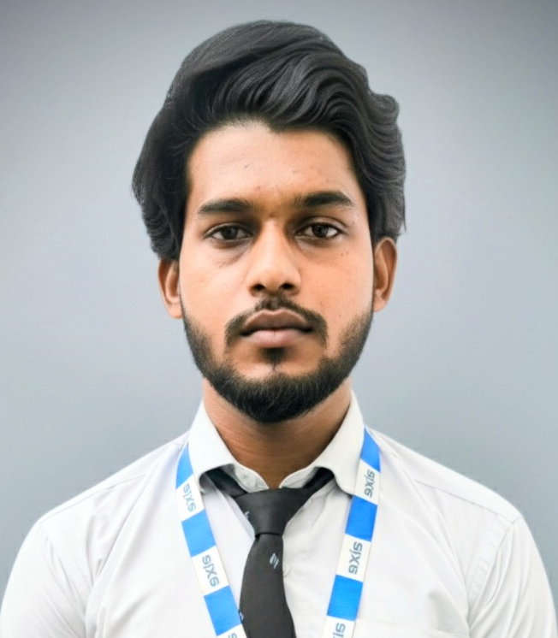
Shazeb Ahmad
Bachelor of Computer Application (BCA)
A self-driven and dedicated individual aiming to build a career in Data Analytics




(+91) – 8953508662
Kanpur
https://www.linkedin.com/in/shazeb-ahmad-13739625b?utm_source=share&utm_campaign=share_via&utm_content=profile&utm_medium=android_app
ranuraineee@gmail.com

EDUCATION
Bachelor of computer Application |61%
Axis institute of higher education, Kanpur
CSJMU, Kanpur
2023-2026

Higher Secondary | 60%
Manoj Inter College Kanpur
UP Board
2020

Senior Secondary | 53%
Manoj Inter College Kanpur
UP Board
2022

INTERNSHIP
TCS ION CAREER-EDGE
Young professional course that covers communication skills,
interview skills, IT fundamental skills, overview of artificial intelligence

SEMINARS/ WORKSHOPS/CERTIFICATIONS

TCS ION – Career Edge (2025)
Young professional course that covers communication skills, interview skills, IT fundamental skills, overview of artificial intelligence

GenAi Powered data analytics –TATA (2025)
Leverage the power of Generative AI to revolutionize data analytics with cutting-edge tools and techniques.

Data analytics-DELOITTE (2025)
Learn to harness data for strategic decision-making with Deloitte’s industry-leading analytics frameworks.

Afaq Foundation Seminar (2025)
Free Career Counselling Seminar

Crack-Ed PDP Workshop (2024)
Personality development workshop to p

IBM-(2025)
Data Science Tools A course on cognitiveclass.ai Powered by IBM Developer Skills Network.

TECH SKILLS
SQL Power BI
Python MS-Excel
Java Beginner Html
CSS MS-Word

ACADEMIC PROJECTS
FOOD ORDERING SYSTEM (AUG-NOV-2025)
-Web based application that allows customers to browse restaurant, menus, place and receive food at their preferred location.
-To provide easy to use platforms for customers
-Using technology-html css JavaScript java SQL python and java

SOFT SKILLS
Communication
Leadership
Negotiation skills
TM

