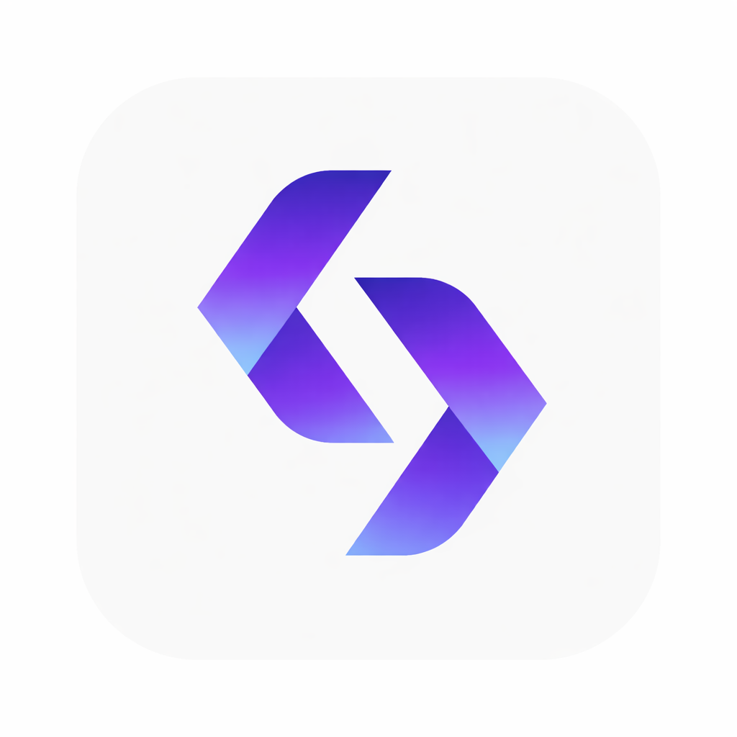
PickPic / SellSell
Technology Guide

Technologies Used in PickPic / SellSell System
This document explains all major technologies used in the PickPic / SellSell AI Marketplace platform.

1. Next.js

What is it?
Next.js is the main framework used to build the website and application.
It helps us create:
- Web pages
- APIs
- Dashboard
- Seller system
- Chat system
- Admin panel

Why are we using it?
Because it is:
- Fast
- Modern
- SEO friendly
- Good for large scalable applications

In our project
Next.js handles:
- Frontend UI
- Backend APIs
- Authentication
- Server-side rendering

2. React

What is it?
React is the UI library inside Next.js.
React builds the visual components users interact with.
Example:
- Buttons
- Cards
- Product listings
- Search bars
- Chat interface

Why are we using it?
Because React allows reusable components and faster UI development.

3. TypeScript

What is it?
TypeScript is a safer version of JavaScript.
It helps developers:
- Avoid bugs
- Catch errors early
- Build large projects safely

Why are we using it?
Because our project is large and AI-based.
TypeScript improves maintainability.

4. Node.js

What is it?
Node.js allows JavaScript to run on the server/backend.

What does it do in our system?
It runs:
- APIs
- Server logic
- AI integrations
- Database operations
- Authentication

5. Docker

What is it?
Docker creates isolated containers for applications.
Think of Docker like:
“Small mini computers inside your computer.”

Why are we using Docker?
Because Docker makes setup easy and consistent.
Everyone gets:
- Same environment
- Same dependencies
- Same versions

In our project Docker runs:
- PostgreSQL
- Qdrant
- App services
- AI-related services

6. Docker Compose

What is it?
Docker Compose manages multiple Docker containers together.
Instead of starting services one by one:
- database
- vector database
- app
We use one command:
docker compose up -d

7. PostgreSQL

What is it?
PostgreSQL is our main database.

What does it store?
It stores:
- Users
- Products
- Sellers
- Chats
- Categories
- Listings
- Messages
- Admin data

Why PostgreSQL?
Because it is:
- Reliable
- Fast
- Enterprise-level
- Scalable

8. Prisma

What is it?
Prisma is a database ORM.
ORM means:
A tool that helps developers talk to databases using code instead of raw SQL.

Why are we using Prisma?
Because it makes database development:
- Easier
- Cleaner
- Safer

In our project Prisma handles:
- Database queries
- Migrations
- Schema management

9. Qdrant

What is it?
Qdrant is a vector database.

What is a vector database?
A vector database stores AI embeddings.
Embeddings are AI-generated numerical representations of:
- Text
- Images
- Products
- Search meaning

Why do we need Qdrant?
Because our marketplace uses:
- Semantic search
- AI search
- Similarity matching
Example:
User searches:
“cheap gaming laptop under 200 KD”
Even if the seller didn’t write those exact words,
Qdrant helps AI understand meaning.

10. AI Embeddings

What are embeddings?
Embeddings are AI-generated vectors/numbers representing meaning.
Example:
- “car”
- “vehicle”
- “automobile”
AI understands they are related.

Why are embeddings important?
They power:
- Smart search
- AI recommendations
- Similar products
- AI chat understanding

11. Ollama

What is it?
Ollama runs AI language models locally or on GPU servers.

In our project
We use Ollama to run:
- Qwen models
- AI chat
- Product analysis
- Description generation
- AI moderation

12. Qwen AI Models

What are they?
Qwen models are Large Language Models (LLMs).
They are similar to:
- ChatGPT
- Claude
- Gemini

In our project Qwen helps with:
- AI conversations
- Product descriptions
- Smart search
- Arabic understanding
- Seller assistance

13. RunPod

What is it?
RunPod provides GPU cloud servers.
AI models require powerful GPUs.

Why are we using RunPod?
Because local PCs are not powerful enough for large AI models.
RunPod runs:
- Ollama
- AI inference
- Whisper transcription

14. SSH Tunnel

What is it?
SSH tunnel securely connects local apps to remote servers.

In our project
The local app connects securely to:
- RunPod Ollama
- AI services
Example:
ssh -L 11435:localhost:11434 server

15. Faster Whisper

What is it?
An AI speech-to-text model.

What does it do?
Converts voice into text.

In our project
It powers:
- Voice search
- Voice chat
- Audio transcription

16. Redis

What is Redis?
Redis is a fast in-memory database.

Why use Redis?
For:
- Caching
- Session storage
- Fast temporary data
- Performance optimization

17. REST API

What is it?
REST APIs allow frontend and backend communication.
Example:
Frontend asks:
“Give me all products”
Backend responds with product data.

18. Authentication System

What is it?
Authentication verifies users.

In our system
It handles:
- Login
- Signup
- Sessions
- User roles

19. Semantic Search

What is semantic search?
Search based on meaning instead of exact words.
Example:
Searching:
“phone for photography”
Can return:
- iPhone
- Samsung Ultra
- DSLR listings
Even if wording differs.

20. AI Moderation

What is it?
AI checks listings automatically.

It can:
- Detect spam
- Detect wrong category
- Detect fake content
- Analyze images
- Approve/reject listings

21. Image Analysis

What is it?
AI analyzes uploaded product images.

Example
AI can detect:
- Car
- Phone
- Furniture
- Electronics
And compare against:
- Title
- Category
- Description

22. Hybrid Search

What is hybrid search?
Combination of:
- Traditional search
- AI semantic search
This improves accuracy.

23. Antigravity

What is Antigravity?
AI-powered development assistant.

Why are we using it?
To help:
- Setup projects
- Run commands
- Debug errors
- Automate development tasks
Especially useful for beginners.

24. Git

What is Git?
Git tracks code changes.

Why use Git?
Because multiple developers work together safely.

25. GitHub

What is GitHub?
Cloud platform for storing code repositories.

Why are we using it?
For:
- Collaboration
- Backup
- Version control
- Branch management

26. Branches

What are branches?
Separate workspaces inside Git.
Example:
git checkout -b feature/login-fix
This allows safe development without breaking the main project.

27. CI/CD (Future)

What is CI/CD?
Automation system for:
- Testing
- Building
- Deploying code

Future goal
Automatic deployments after testing.

28. Kubernetes (Future Scaling)

What is Kubernetes?
Container orchestration platform.

Why may we use it later?
For:
- Auto scaling
- Load balancing
- High availability
- Production scaling

29. Load Balancer

What is it?
Distributes traffic across multiple servers.

Why important?
Prevents server overload.

30. Monitoring & Logging

What is monitoring?
Tracking system health.

What is logging?
Recording application events/errors.

Why important?
Helps detect:
- Bugs
- Crashes
- Security issues
- Performance problems

Final Architecture Summary
Our system combines:
- Modern web development
- AI language models
- Semantic search
- Voice AI
- Image AI
- Cloud GPU infrastructure
- Scalable backend architecture
To create:
An AI-powered marketplace platform with intelligent search and seller assistance.

