**Document Title: "Day 3 - API Integration Report - [DESIGN-O-PEDIA E-COMMERCE]"**

A report:

API integration process

Adjustments made to schemas

Migration steps and tools used

Screenshots of:

API calls

Data successfully displayed in the fronted

Populated Sanity CMS fields

Code snippets for API integration and migration scripts.

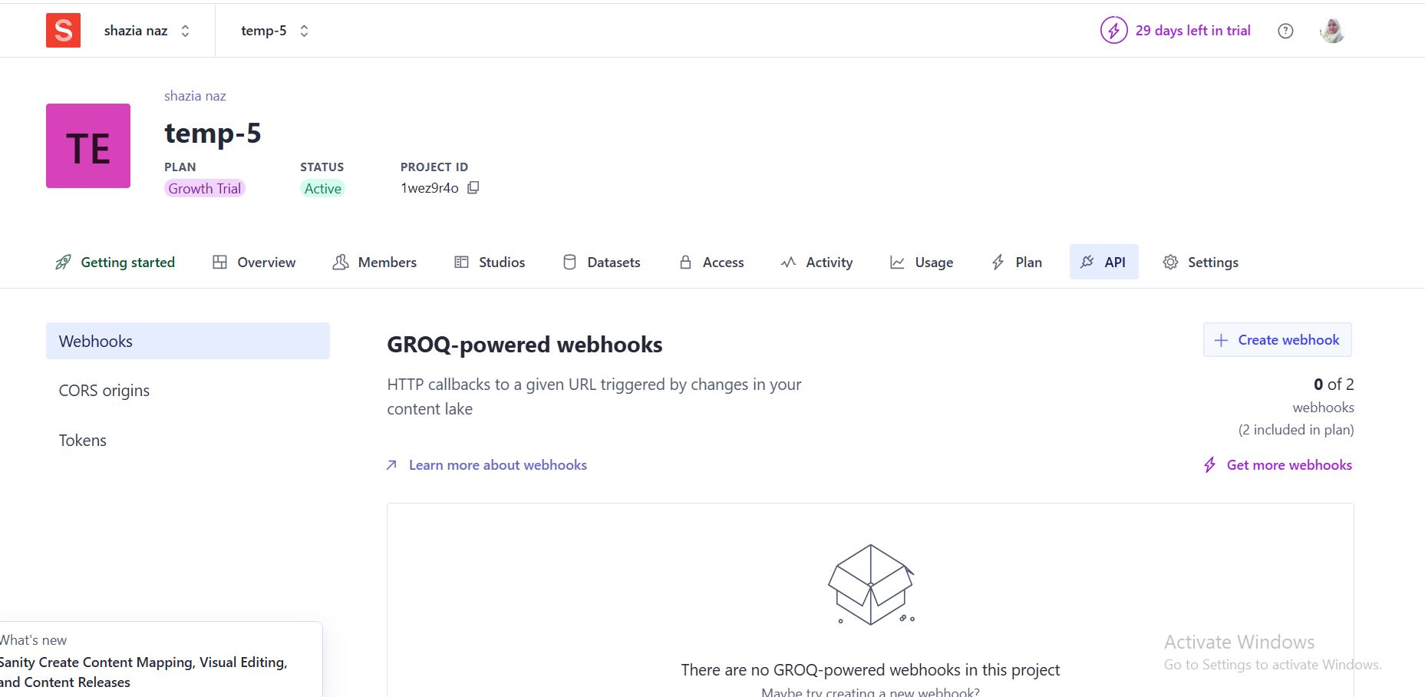

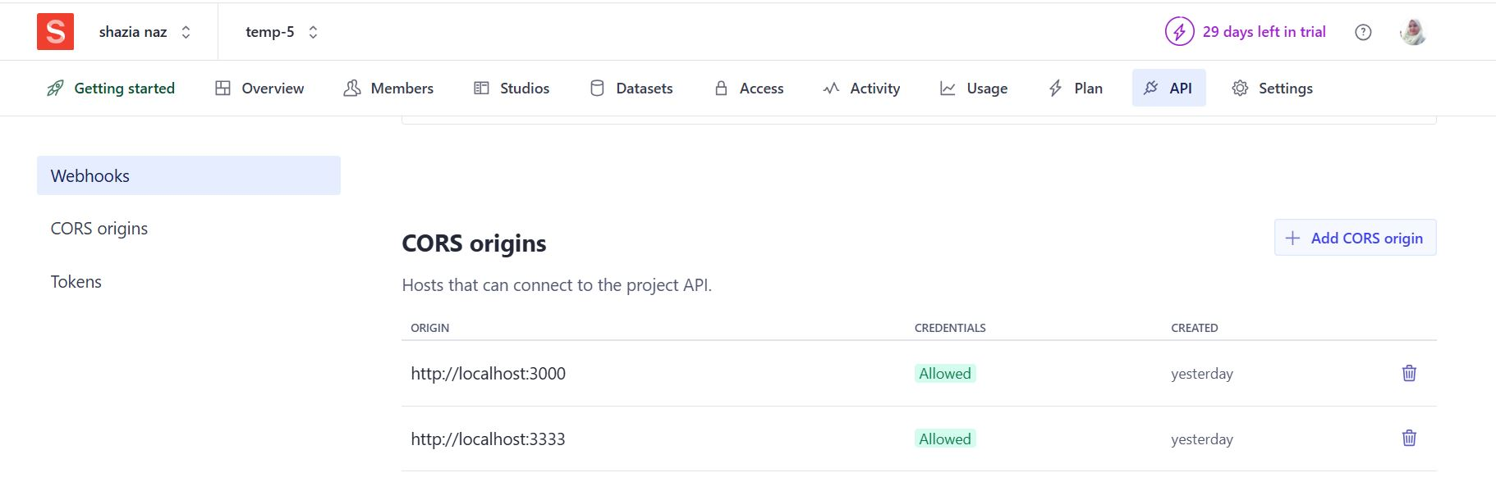

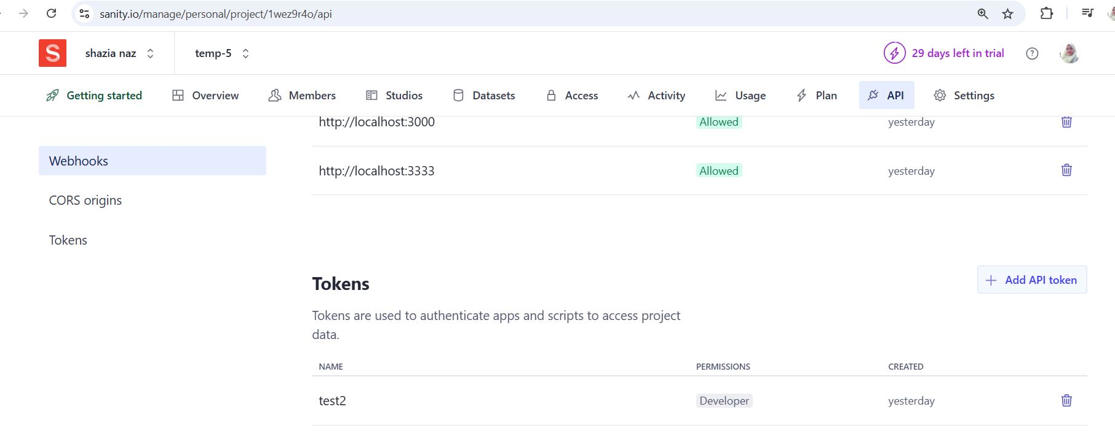

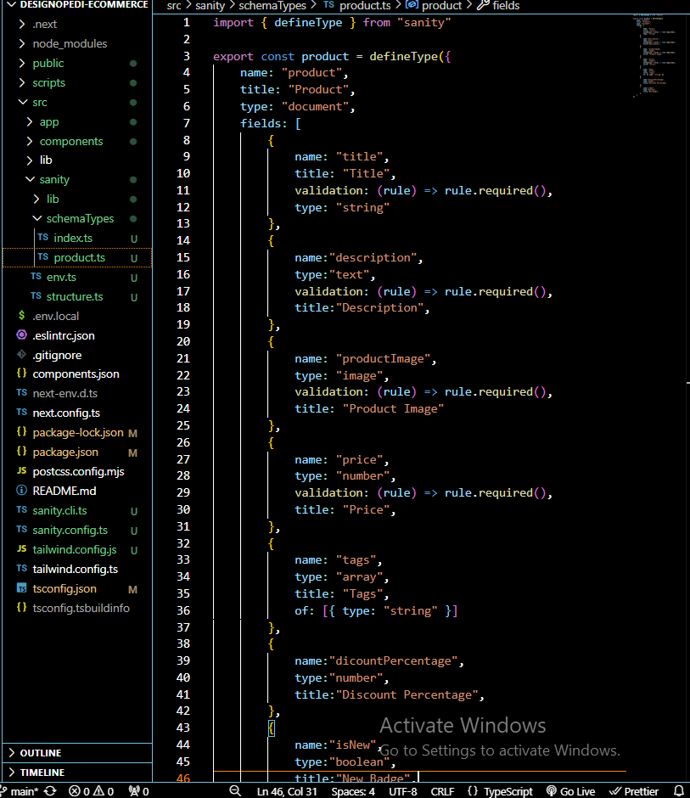

1. npm install @sanity/client axios dotenv
2. npm run import-data
3. node script/importData.js on package.mjs

