Subnetting Worksheet - VLSM Starting Address: _10.240.0.0/12__
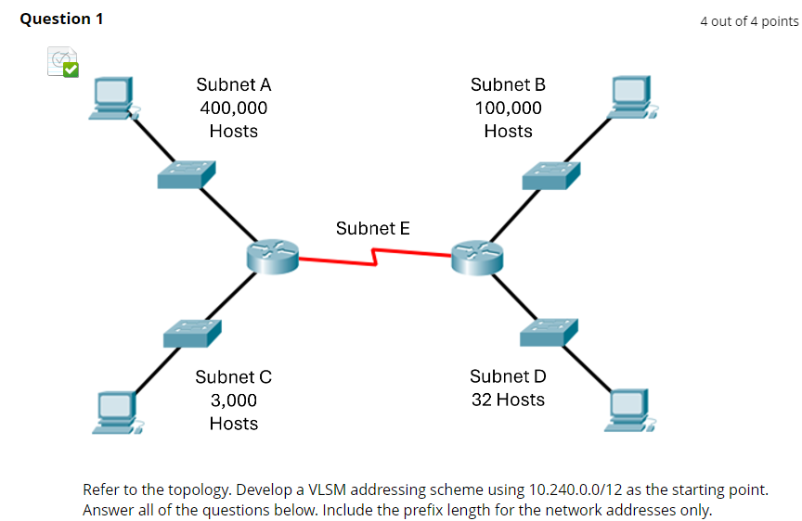
Subnet  Name | Hosts  Required | Host  Bits  ( h ) | Usable  Addresses  ( 2^{h} - 2 ) | Pseudo Address Map, CSM,  Wildcard Mask, & Prefix | Interval  / Octet | Network Address / Prefix Len
A | 400K | 19 | 524286 | PAM: N.ssssshhh.H.H  CSM: 255.248.0.0  WCM: 0.7.255.255  Prefix: /13 | 8, 2nd | NTWK: 10.240.0.0/13  FRST: 10.240.0.1  LAST: 10.247.255.254  BCST: 10.247.255.255
B | 100K | 17 | 131070 | PAM: N.sssssssh.H.H  CSM: 255.254.0.0  WCM: 0.1.255.255  Prefix: /15 | 2, 2nd | NTWK: 10.248.0.0/15  FRST: 10.248.0.1  LAST: 10.249.255.254  BCST: 10.249.255.255
C | 3K | 12 | 4094 | PAM: N.ssssssss.sssshhhh.H  CSM: 255.255.240.0  WCM: 0.0.15.255  Prefix: /20 | 16, 3rd | NTWK: 10.250.0.0/20  FRST: 10.250.0.1  LAST: 10.250.15.254  BCST: 10.250.15.255
D | 32 | 6 | 62 | PAM: N.ssssssss.ssssssss.sshhhhhh  CSM: 255.255.255.192  WCM: 0.0.0.63  Prefix: /26 | 64, 4th | NTWK: 10.250.16.0/26  FRST: 10.250.16.1  LAST: 10.250.16.62  BCST: 10.250.16.63
E | 2 | 2 | 2 | PAM: N.ssssssss.ssssssss.sssssshh  CSM: 255.255.255.252  WCM: 0.0.0.3  Prefix: /30 | 4, 4th | NTWK: 10.250.16.64/30  FRST: 10.250.16.65  LAST: 10.250.16.66  BCST: 10.250.16.67
 |  |  |  | PAM:  CSM:  WCM:  Prefix: |  | NTWK: 10.250.16.68  FRST:  LAST:  BCST:
 |  |  |  | PAM:  CSM:  WCM:  Prefix: |  | NTWK:  FRST:  LAST:  BCST:
 |  |  |  | PAM:  CSM:  WCM:  Prefix: |  | NTWK:  FRST:  LAST:  BCST:

