Subnetting Worksheet - VLSM Starting Address: 172.16.0.0/16
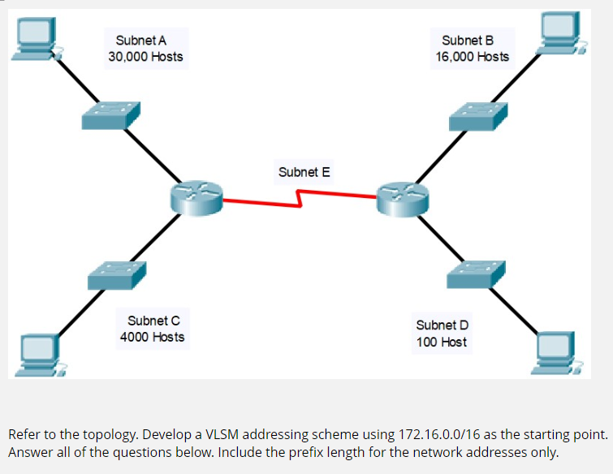
Subnet  Name | Hosts  Required | Host  Bits  ( h ) | Usable  Addresses  ( 2^{h} - 2 ) | Pseudo Address Map, CSM,  Wildcard Mask, & Prefix | Interval  / Octet | Network Address / Prefix Len
A | 30k | 15 | 32766 | PAM: N.N.shhhhhhh.H  CSM: 255.255.128.0  WCM: 0.0.127.255  Prefix: /17 | 128, 3rd | NTWK: 172.16.0.0/17  FRST: 172.16.0.1  LAST: 172.16.127.254  BCST: 172.16.127.255
B | 16k | 14 | 16382 | PAM: N.N.xshhhhhh.H  CSM: 255.255.192.0  WCM: 0.0.63.255  Prefix: /18 | 64, 3rd | NTWK: 172.16.128.0/18  FRST: 172.16.128.1  LAST: 172.16.191.254  BCST: 172.16.191.255
C | 4k | 12 | 4094 | PAM: N.N.xxxshhhh.H  CSM: 255.255.240.0  WCM: 0.0.15.255  Prefix: /20 | 16, 3rd | NTWK: 172.16.192.0/20  FRST: 172.16.192.1  LAST: 172.16.207.254  BCST: 172.16.207.255
D | 100 | 7 | 126 | PAM: N.N.X.shhhhhhh  CSM: 255.255.255.128  WCM: 0.0.0.127  Prefix: /25 | 128, 4th | NTWK: 172.16.208.0/25  FRST: 172.16.208.1  LAST: 172.16.208.126  BCST: 172.16.208.127
E | 2 | 2 | 2 | PAM: N.N.X.xxxxxshh  CSM: 255.255.255.252  WCM: 0.0.0.3  Prefix: /30 | 4, 4th | NTWK: 172.16.208.128/30  FRST: 172.16.208.129  LAST: 172.16.208.130  BCST: 172.16.208.131
 |  |  |  | PAM:  CSM:  WCM:  Prefix: |  | NTWK: 172.16.208.132  FRST:  LAST:  BCST:
 |  |  |  | PAM:  CSM:  WCM:  Prefix: |  | NTWK:  FRST:  LAST:  BCST:
 |  |  |  | PAM:  CSM:  WCM:  Prefix: |  | NTWK:  FRST:  LAST:  BCST:

