Subnetting Worksheet - VLSM Starting Address: ___10.128.0.0/9_____
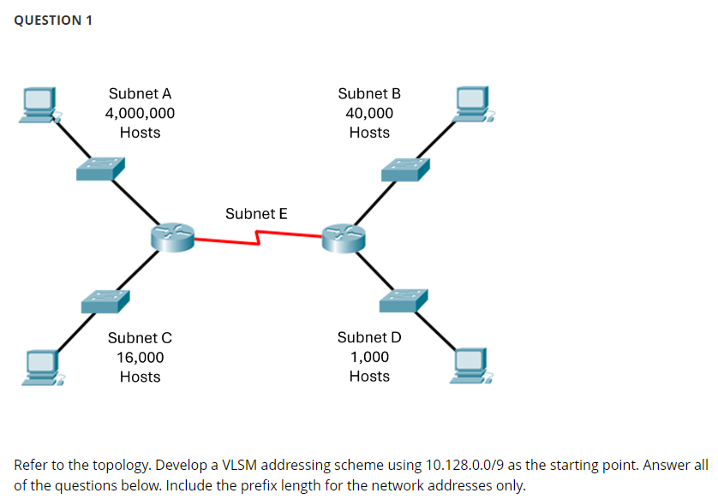
Subnet  Name | Hosts  Required | Host  Bits  ( h ) | Usable  Addresses  ( 2^{h} - 2 ) | Pseudo Address Map, CSM,  Wildcard Mask, & Prefix | Interval  / Octet | Network Address / Prefix Len
A | 4million | 22 | 4,194,302 | PAM: N.sshhhhhh.H.H  CSM: 255.192.0.0  WCM: 0.63.255.255  Prefix: /10 | 64, 2nd | NTWK: 10.128.0.0/10  FRST: 10.128.0.1  LAST: 10.191.255.254  BCST: 10.191.255.255
B | 40k | 16 | 65,534 | PAM: N.ssssssss.H.H  CSM: 255.255.0.0  WCM: 0.0.255.255  Prefix: /16 | 1, 2nd | NTWK: 10.192.0.0/16  FRST: 10.192.0.1  LAST: 10.192.255.254  BCST: 10.192.255.255
C | 16k | 14 | 16,382 | PAM: N.N.sshhhhhh.H  CSM: 255.255.192.0  WCM: 0.0.63.255  Prefix: /18 | 64, 3rd | NTWK: 10.193.0.0/18  FRST: 10.193.0.1  LAST: 10.193.63.254  BCST: 10.193.63.255
D | 1k | 10 | 1,022 | PAM: N.N.sssssshh.H  CSM: 255.255.252.0  WCM: 0.0.3.255  Prefix: /22 | 4, 3rd | NTWK: 10.193.64.0/22  FRST: 10.193.64.1  LAST: 10.193.67.254  BCST: 10.193.67.255
E | 2 | 2 | 2 | PAM: N.N.N.sssssshh  CSM: 255.255.255.252  WCM: 0.0.0.3  Prefix: /30 | 4, 4th | NTWK: 10.193.68.0/30  FRST: 10.193.68.1  LAST: 10.193.68.2  BCST: 10.193.68.3
 |  |  |  | PAM:  CSM:  WCM:  Prefix: |  | NTWK: 10.193.68.4  FRST:  LAST:  BCST:
 |  |  |  | PAM:  CSM:  WCM:  Prefix: |  | NTWK:  FRST:  LAST:  BCST:
 |  |  |  | PAM:  CSM:  WCM:  Prefix: |  | NTWK:  FRST:  LAST:  BCST:

