Subnetting Worksheet - VLSM Starting Address: __172.16.192.0/18_
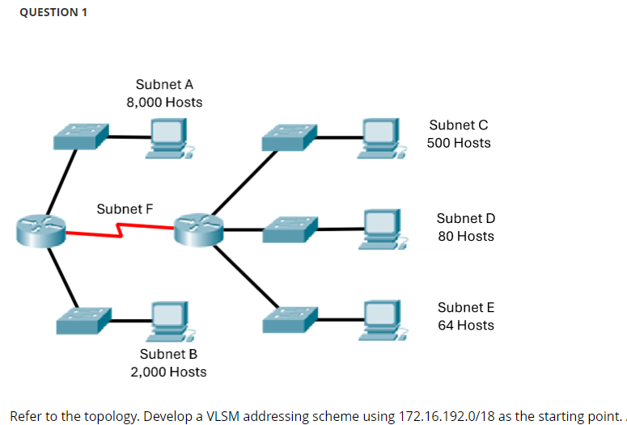
Subnet  Name | Hosts  Required | Host  Bits  ( h ) | Usable  Addresses  ( 2^{h} - 2 ) | Pseudo Address Map, CSM,  Wildcard Mask, & Prefix | Interval  / Octet | Network Address / Prefix Len
A | 8k | 13 | 8,190 | PAM: N.N.ssshhhhh.H  CSM: 255.255.224.0  WCM: 0.0.31.255  Prefix: /19 | 32, 3rd | NTWK: 172.16.192.0/19  FRST: 172.16.192.1  LAST: 172.16.223.254  BCST: 172.16.223.255
B | 2k | 11 | 2,046 | PAM: N.N.ssssshhh.H  CSM: 255.255.248.0  WCM: 0.0.7.255  Prefix: /21 | 8, 3rd | NTWK: 172.16.224.0/21  FRST: 172.16.224.1  LAST: 172.16.231.254  BCST: 172.16.231.255
C | 500 | 9 | 510 | PAM: N.N.sssssssh.H  CSM: 255.255.254.0  WCM: 0.0.1.255  Prefix: /23 | 2, 3rd | NTWK: 172.16.232.0/23  FRST: 172.16.232.1  LAST: 172.16.233.254  BCST: 172.16.233.255
D | 80 | 7 | 126 | PAM: N.N.N.shhhhhhh  CSM: 255.255.255.127  WCM: 0.0.0.128  Prefix: /25 | 128, 4th | NTWK: 172.16.234.0/25  FRST: 172.16.234.1  LAST: 172.16.234.126  BCST: 172.16.234.127
E | 64 | 7 | 126 | PAM: N.N.N.shhhhhhh  CSM: 255.255.255.127  WCM: 0.0.0.128  Prefix: /25 | 128, 4th | NTWK: 172.16.234.128/25  FRST: 172.16.234.129  LAST: 172.16.234.254  BCST: 172.16.234.255
F | 2 | 2 | 2 | PAM: N.N.N.sssssshh  CSM: 255.255.255.252  WCM: 0.0.0.3  Prefix: /30 | 4, 4th | NTWK: 172.16.235.0/30  FRST: 172.16.235.1  LAST: 172.16.235.2  BCST: 172.16.235.3
 |  |  |  | PAM:  CSM:  WCM:  Prefix: |  | NTWK: 172.16.235.4  FRST:  LAST:  BCST:
 |  |  |  | PAM:  CSM:  WCM:  Prefix: |  | NTWK:  FRST:  LAST:  BCST:

