**Task Steps Followed**

1. **Install Jenkins on a Docker container. Jenkins should be run on Port 8081.**

1) Created Ansible-playbook to Install Prerequisites, Install Docker and Install Jenkins in Docker running on port 8081

**(Playbook Attached in GitHub Depository *Docker1.yml*)**

2) Successfully test Jenkins on Host

3) Logged in to docker to obtain Jenkins Admin password using

*docker exec -it myjenkins2 bash*

and obtained password from

*/var/jenkins_home/secrets/initialAdminPassword* within Docker

4) Logged on to Jenkins

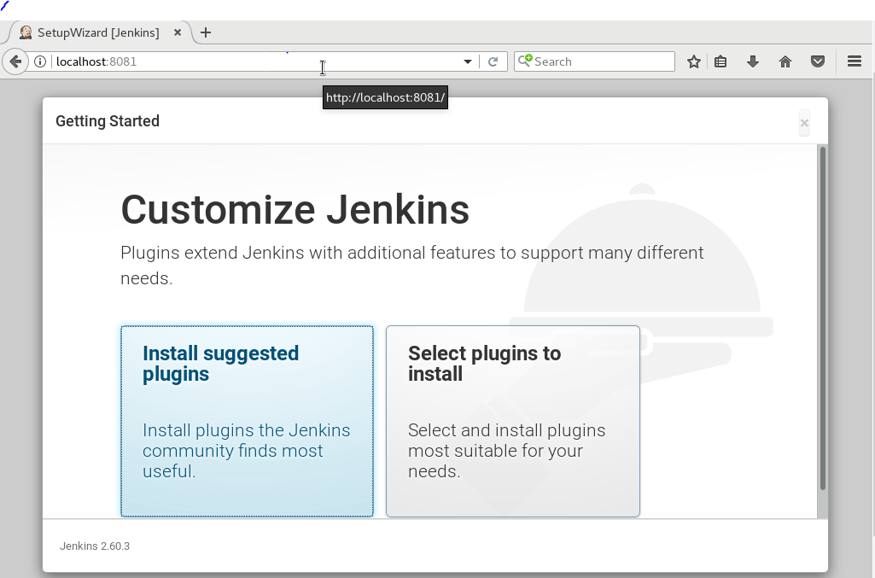

Initial Setup

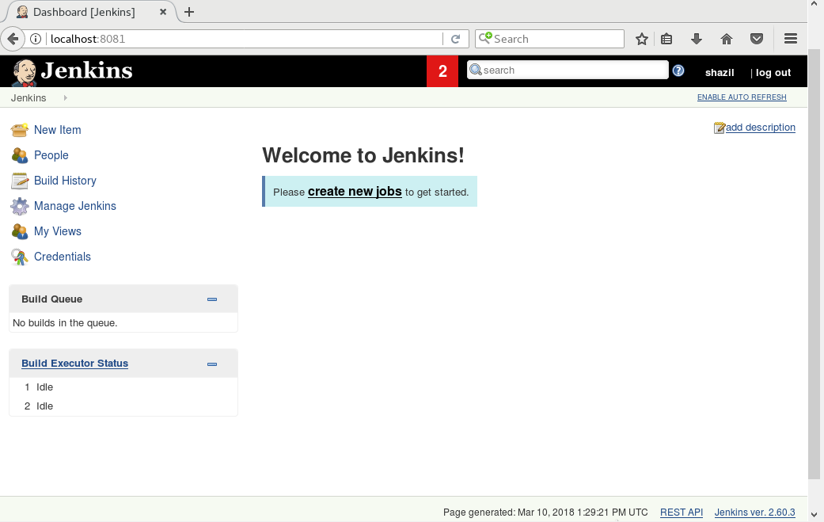

1. **Create a sample project in Jenkins to just checkout code from git.**

Created Project to Checkout Code

