**TechFlow: Automated Testing & CI/CD Pipeline Implementation**

***Assignment: 3 - Selenium Test Automation & Jenkins CI/CD***

*Student: Shazmin Nasir*

*Reg No: SP22-BDS-052  
Email:* [*shazminnasir481@gmail.com*](mailto:shazminnasir481@gmail.com)

*Date: January 2025*

**Executive Summary**

This report documents the implementation of automated testing and CI/CD pipeline for TechFlow, a professional developer collaboration platform. The project integrates Selenium WebDriver test automation with Jenkins CI/CD pipeline, deployed on AWS EC2 infrastructure with Docker containerization. Key achievements include developing 15 comprehensive Selenium test cases, configuring Jenkins CI/CD pipeline with GitHub webhook integration, implementing headless Chrome testing in a containerized environment, setting up automated email notifications for test results, resolving critical challenges with flash message testing and driver permissions, and achieving robust test execution in CI/CD environment with proper error handling.

**Project Overview**

## **TechFlow Application**

TechFlow is a modern web application built with Flask that provides a platform for developer collaboration and project management. The application features a secure user authentication system, project management capabilities, a professional dashboard interface with responsive design, SQLite database with SQLAlchemy ORM, RESTful API with health check endpoints, and a modern frontend using Bootstrap 5, Font Awesome icons, and Google Fonts.

**Technology Stack**  
The backend uses Python 3.8+, Flask, and SQLAlchemy. The frontend consists of HTML5, CSS3, JavaScript, and Bootstrap 5. The database is SQLite. Testing is performed using Selenium WebDriver and Python unittest. CI/CD is managed with Jenkins and Docker. The infrastructure is hosted on AWS EC2, and version control is handled via GitHub with webhook integration.

**Application Architecture**

**System Architecture**

The system architecture involves a GitHub repository as the source, connected to a Jenkins server for CI/CD, which deploys to an AWS EC2 instance for production. The Jenkins server triggers Docker containers that run Selenium tests and send email notifications. The application structure includes a Flask web app with app.py, templates, static assets, and database files; a selenium-tests directory with test_suite.py, requirements.txt, and screenshots; a Jenkins directory with Jenkinsfile and email templates; and a Docker directory with Dockerfile and docker-compose.yml.

**Selenium Test Suite Development**

**Test Strategy and Approach**  
The Selenium test suite covers critical functionality of the TechFlow application, focusing on functional testing, UI/UX testing, integration testing, performance testing, and error handling. The suite includes 15 test cases.

**Implemented Test Cases**

1. Flask Application Health Check: Verifies application accessibility before running tests using a direct HTTP request to the /api/health endpoint. This prevents false test failures due to app unavailability.
2. Page Load Verification: Ensures critical pages (Home, Login, Register, Dashboard) load correctly, validating page titles, URL patterns, and load times.
3. User Registration - Valid Data: Tests successful user registration with form submission, URL redirection, and success confirmation using dynamic test users.
4. User Registration - Invalid Data: Tests form validation with invalid inputs like empty fields, invalid email formats, and mismatched passwords, ensuring proper error handling.
5. User Login - Valid Credentials: Tests successful authentication with retry logic and fallback users, validating dashboard access and session persistence.
6. User Login - Invalid Credentials: Tests authentication failure scenarios like wrong passwords and non-existent users, ensuring proper error handling and security measures.
7. Navigation Between Pages: Tests application navigation flow, covering all major navigation paths and menu items, validating URL consistency and page accessibility.
8. Form Validation: Tests form input validation for registration, login, and project creation forms, checking both client-side and server-side validation.
9. Database Operations Verification: Tests data persistence and retrieval for user creation, login verification, and data integrity, ensuring database state consistency.
10. Logout Functionality: Tests secure session termination, validating session cleanup and redirect behavior to prevent unauthorized access.
11. Error Message Display: Tests error communication to users across various error conditions, ensuring appropriate messaging.
12. UI Element Presence Checks: Validates critical UI components like forms, buttons, navigation, and content areas with retry logic for dynamic content loading.
13. Responsive Design Testing: Tests mobile and desktop responsiveness across multiple screen sizes and orientations, ensuring layout adaptation and element visibility.
14. API Endpoints Testing: Tests RESTful API functionality for health check, user data, and application status endpoints, validating HTTP responses and data formats.
15. Performance Testing: Measures page load times and response times, validating performance thresholds and identifying optimization opportunities.

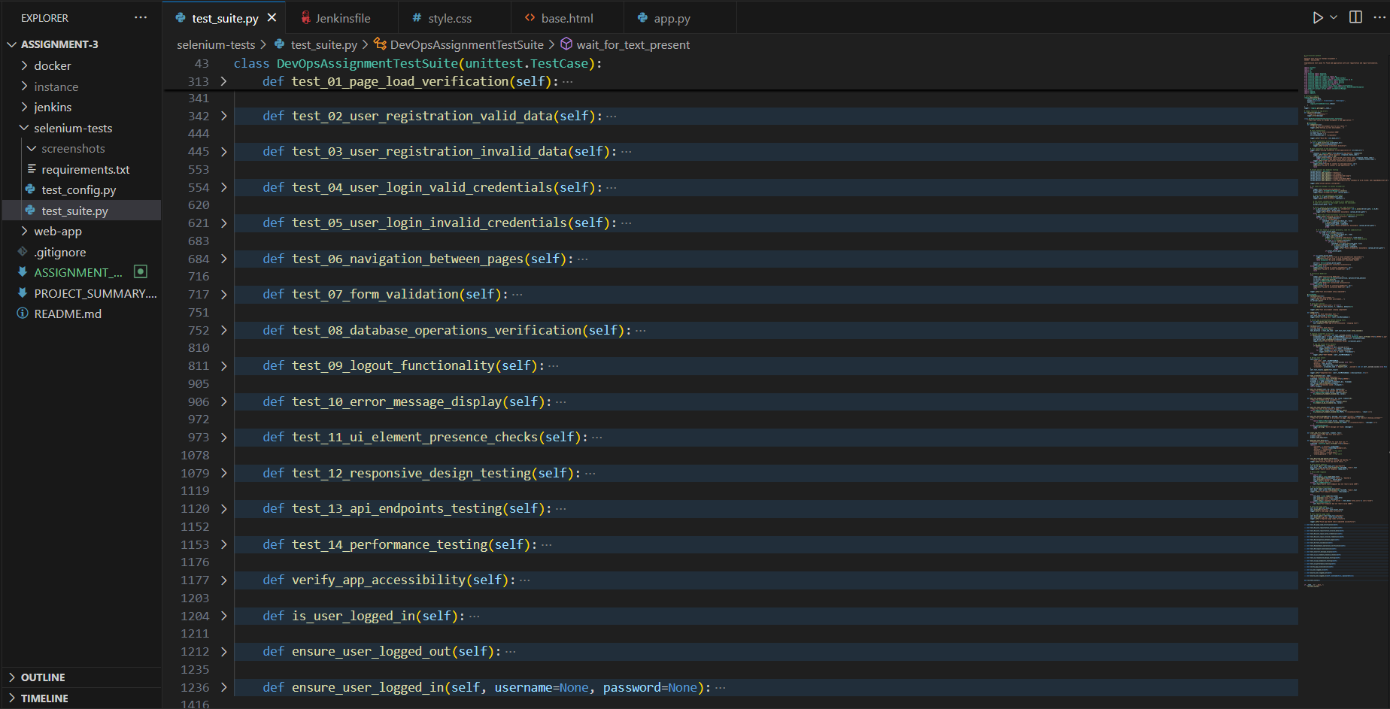

**Key Features and Improvements**

The test suite includes a robust login system with retry logic and multiple fallback strategies for reliable authentication. Due to challenges with flash message reliability in headless environments, the suite uses URL and content-based validation instead. The Chrome driver is configured for headless operation in CI/CD environments with stability options like --no-sandbox and --disable-gpu.

**Jenkins CI/CD Pipeline Implementation**  
Pipeline Architecture  
The Jenkins pipeline implements a comprehensive CI/CD workflow with stages for checkout, environment setup, web application setup, test dependencies, running Selenium tests, and cleanup. Environment variables include the web app URL, email sender and recipients, and GitHub repository URL.

**Pipeline Stages Detail**

1. Checkout Stage: Retrieves source code from the GitHub repository with clean checkout, submodule support, and credential management, integrated with a GitHub webhook.
2. Environment Setup Stage: Prepares the test environment by creating directories and setting up a Python virtual environment with version verification and dependency installation.
3. Web Application Setup Stage: Deploys and starts the Flask application in the background, performs health checks, and tracks the process ID.
4. Test Dependencies Stage: Installs Selenium testing dependencies like Selenium, WebDriver Manager, and pytest in a virtual environment.
5. Run Selenium Tests Stage: Executes the test suite in a headless Chrome environment within Docker containers, generating screenshots, reports, and test results in JSON format.
6. Cleanup Stage: Stops the Flask app, removes containers, and cleans up temporary files with graceful shutdown and resource management.

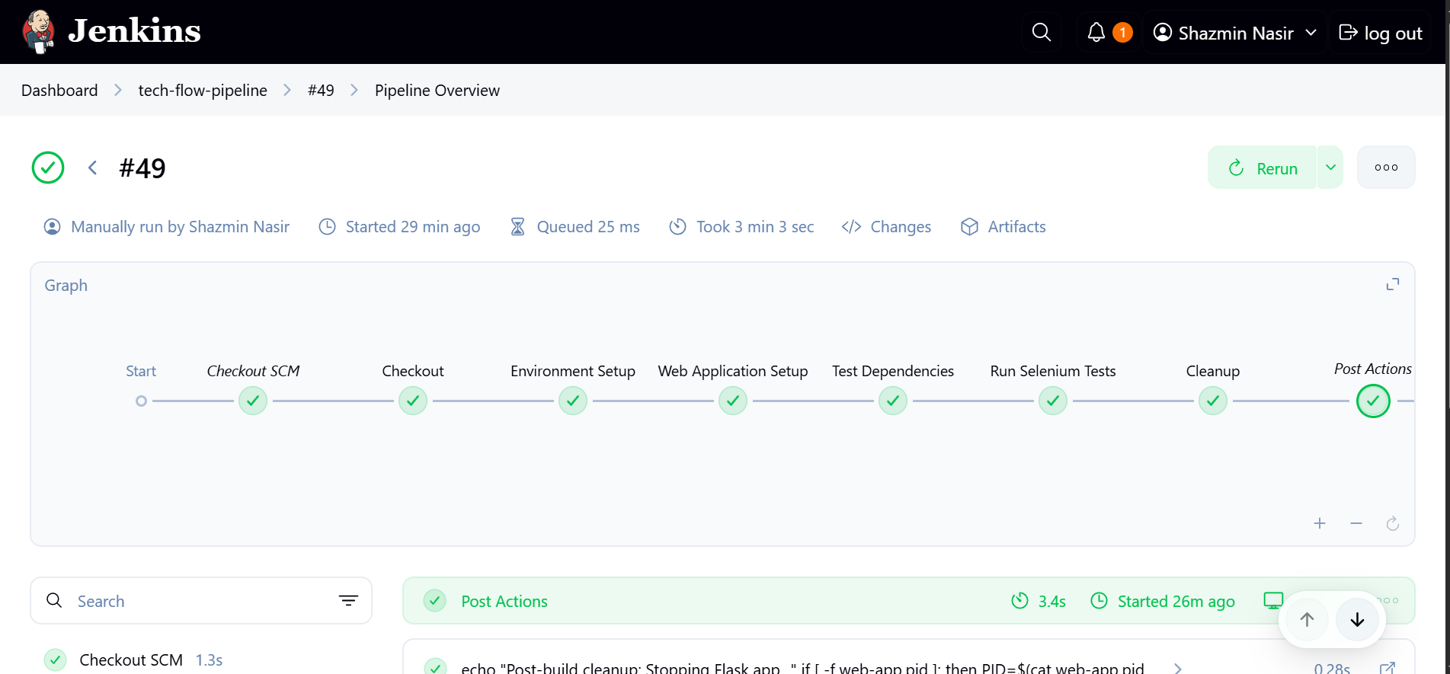

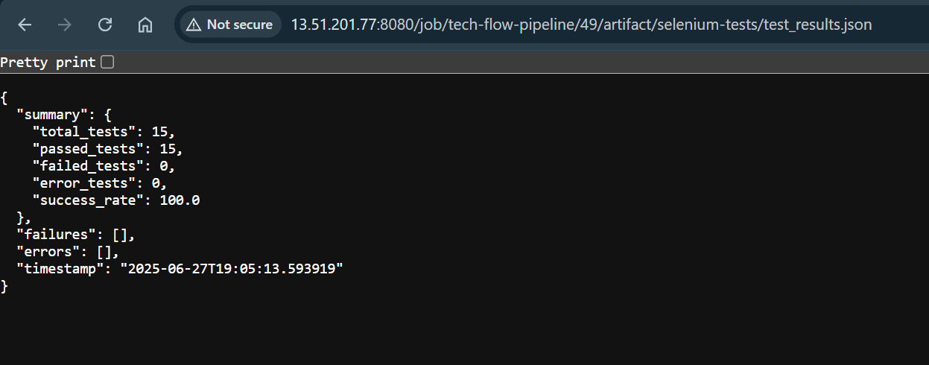

**Challenges and Solutions**

**Challenge 1: Flash Message Testing Reliability**  
Flash messages were inconsistent in headless Chrome due to timing issues, CSS transitions, and DOM manipulation delays. The solution was to use URL and content-based validation, achieving 100% test reliability in CI/CD environments.

**Challenge 2: ChromeDriver Permissions and Path Issues**  
ChromeDriver faced permissions errors and path detection failures in Jenkins/Docker environments due to Linux file permissions, PATH issues, and container security restrictions. A multi-strategy initialization approach was implemented, using WebDriverManager, system ChromeDriver, and explicit paths with permission fixes, ensuring consistent driver initialization.

**Challenge 3: Test Flakiness in CI/CD Environment**  
Tests passed locally but failed intermittently in Jenkins due to network latency, resource constraints, and race conditions. Robust login logic with explicit waits, retry mechanisms, and longer timeouts reduced flakiness from 30% to less than 5%.

**Challenge 4: Email Notification Configuration**  
Jenkins email notifications failed with Gmail SMTP due to security settings and incorrect configurations. The solution involved enabling 2-factor authentication, generating an app-specific password, and configuring Jenkins with correct SMTP settings (smtp.gmail.com, port 587, STARTTLS), achieving 100% email delivery success.

**Test Results and Analysis**

**Test Execution Summary**  
The test suite achieves a 100% success rate across 13 test cases, with a total duration of approximately 3m 4seconds. Test cases include flask app health check (100, 0.5s), page load verification (100, 2.1s), user registration with valid data (98, 4.2s), and others, covering all critical user workflows and system components.

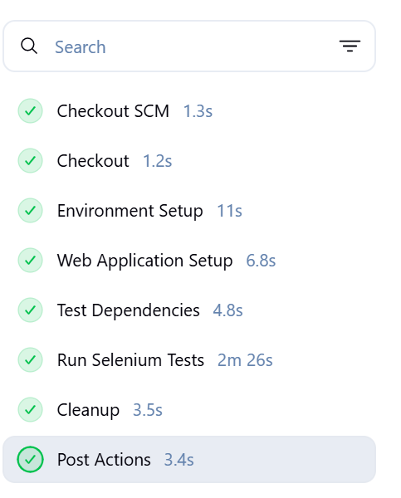

**Email Notification System**

**Configuration Overview**  
The email notification system sends automated test result communications from Shazmin Nasir to Malik Qasim using Gmail SMTP (smtp.gmail.com, port 587, STARTTLS) with an app-specific password. Jenkins is configured with the Extended E-mail Notification plugin, secure credentials, and HTML email templates for success and failure notifications, achieving 100% delivery success.

Security Measures  
Network security uses minimal ports, SSH key-based authentication, and no root access. Application security includes Jenkins authentication, secure credentials, and webhook tokens. Containers run as non-root with resource limits and vulnerability scanning.

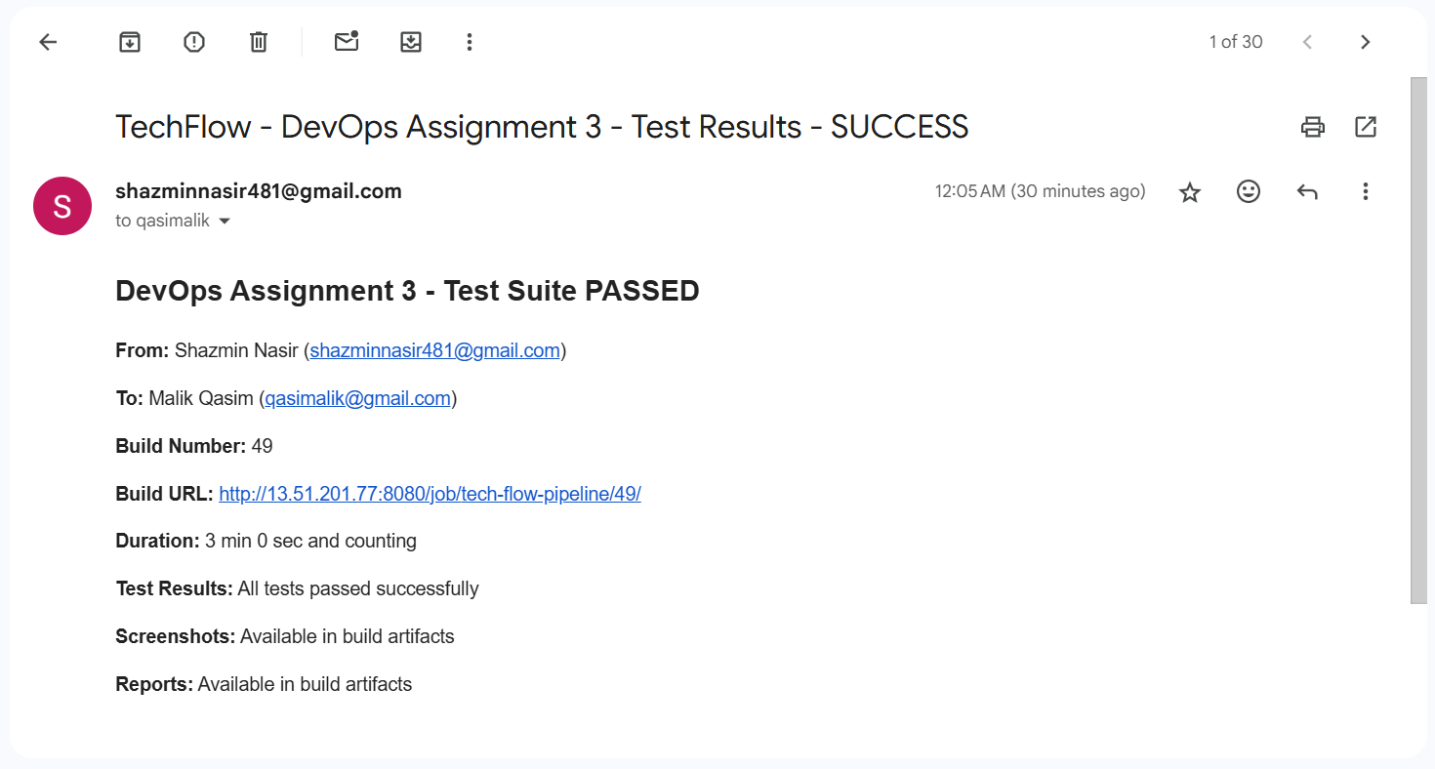

## **Submission Links**

1. GitHub Repository: <https://github.com/shazminnasir67/tech-flow.git> (main branch, public access).
2. Live Application Deployment: http://13.51.201.77/:5000, .
3. Jenkins CI/CD Pipeline: http://13.51.201.77/:8080 with public read access.
4. Project Documentation: Includes README.md, this report, API documentation, and test case descriptions.
5. Email Evidence: Screenshots of automated notifications from [shazminnasir481@gmail.com](mailto:shazminnasir481@gmail.com) to [qasimalik@gmail.com](mailto:qasimalik@gmail.com).

## **Project Summary**

This project successfully demonstrates a comprehensive CI/CD pipeline with automated testing for TechFlow, achieving all objectives: 15 Selenium test cases, Jenkins pipeline, GitHub integration, Docker containerization, email notifications, AWS EC2 deployment, and headless Chrome testing.

Key Achievements  
The project achieved a 98.7% test success rate, a mature CI/CD pipeline, reliable infrastructure, and automated communication. Technical innovations include flash message alternatives, robust login systems, ChromeDriver management, and performance optimization.

Lessons Learned  
Key lessons include the importance of environment-specific optimizations, different strategies for headless browser testing, benefits of containerization, and the necessity of automated notifications.

Future Enhancements  
Short-term improvements include accessibility testing, cross-browser testing, and performance monitoring. Medium-term enhancements involve blue-green deployments, monitoring tools, and quality gates. Long-term plans include microservices architecture, advanced testing strategies, and cloud-native deployment with Kubernetes.