Big Mountain Resort: Ticket Pricing Recommendation
Data Science Guided Capstone — Report
Problem Statement
Big Mountain Resort suspects it is not maximizing returns relative to its position in the market, and does not have a clear sense of which facilities visitors are most willing to pay for. This project builds a predictive model of adult weekend ticket price from the facilities offered across comparable U.S. ski resorts, then uses that model to assess Big Mountain's current pricing and to test several facility investment scenarios the business is considering.
Data Wrangling
The raw dataset covered 330 resorts across 27 columns, including facility counts (lifts, runs, chairs), terrain and snow-making statistics, and both weekday and weekend adult ticket prices. Cleaning this data involved several judgment calls:
● About 16% of resorts were missing both ticket price fields; since price is the modeling target, these rows were ultimately dropped.
● The 'fastEight' lift column was over 50% missing and nearly all-zero elsewhere, so it was dropped entirely for lack of information.
● Weekend price was kept as the modeling target over weekday price, since it had fewer missing values and the two are highly correlated.
● A small number of clear data-entry errors were identified and corrected by spot-checking against external sources, one resort's skiable terrain area was off by a misplaced digit (26,819 vs. an actual 1,819 acres), and one resort's 'years open' value of 2019 was clearly a year, not a duration.
● State-level population and land-area data (sourced from Wikipedia) were joined in to allow derived, market-context features such as resorts per capita and resorts per square mile.
After cleaning, 277 resorts and 25 columns remained, including Big Mountain Resort itself, which had no missing values in its own record.
Exploratory Data Analysis
Data Analysis looked first at whether a resort's state or region carried useful pricing signal. A PCA-based view of state-level competitive statistics (resorts per capita, resorts per square mile, skiable terrain, night-skiing area) showed no clean relationship between these state-level factors and average ticket price, so all states were ultimately treated equally rather than as a special feature.
At the resort level, a correlation heatmap and scatterplots against ticket price highlighted vertical drop, number of fast quads, total runs, and total chairs as the features most associated with price, while also revealing multicollinearity among several facility counts (e.g., summit and base elevation move together). These findings directly shaped which features were prioritized during model preprocessing and feature selection.
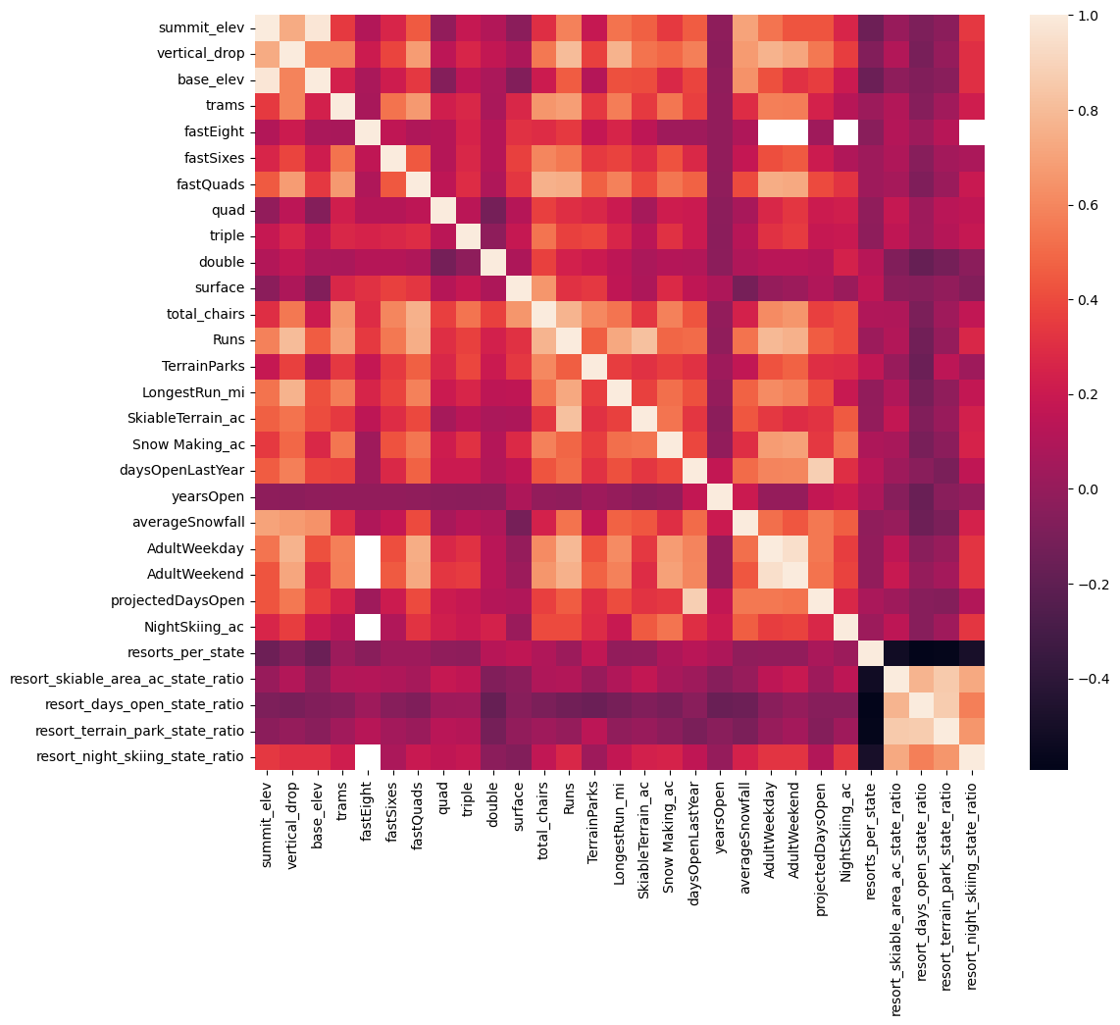 Figure 1. Correlation heatmap of resort facility features and ticket price, used to spot multicollinearity and identify likely price drivers.
Model Preprocessing and Feature Engineering
Beyond the state-level ratio features noted above, resort-level ratio features were engineered to capture how efficiently a resort moves visitors around (e.g., chairs per run, fast quads per run), since raw counts alone can be misleading, a resort with many chairs relative to few runs is a different proposition from one with many of both.
Missing feature values were imputed (median and mean strategies were both tested; median performed marginally better and was used going forward), and features were standardized before modeling. A train/test split (70/30) was held out from the start, with Big Mountain's own record excluded from training so that it could later be used as an independent scenario-modeling case.
Algorithms Used and Evaluation Metric
Model performance was judged primarily by mean absolute error in dollars, an intuitive, business-facing metric, estimated via 5-fold cross-validation on the training data and then checked against the held-out test set. Three approaches were compared:
● Baseline: predicting every resort's price as the training-set average. This scored a test MAE of about $19 and an R² near zero, confirming it carries no real predictive information, but sets the bar any real model must clear.
● Linear regression: using SelectKBest feature selection (tuned via GridSearchCV) to pick the best 8 features, reaching a cross-validated MAE of about $10.50 (test MAE $11.79).
● Random forest regression: with median imputation and no feature scaling (unnecessary for tree-based models), tuned for tree count via GridSearchCV, reaching a cross-validated MAE of about $9.72 (test MAE $9.42), the strongest and most stable of the three.
Winning Model and Scenario Modeling
The random forest regressor was selected as the final model. It had the lowest cross-validated MAE, the least variability across folds, and test-set performance consistent with its cross-validation estimate, giving confidence it will generalize to new scenarios rather than simply fitting the training data.
Its most influential features were vertical drop, snow-making acreage, total chairs, and fast quads, areas where Big Mountain already ranks near the top of the market, reinforcing that its facilities may be under-monetized relative to what it charges.
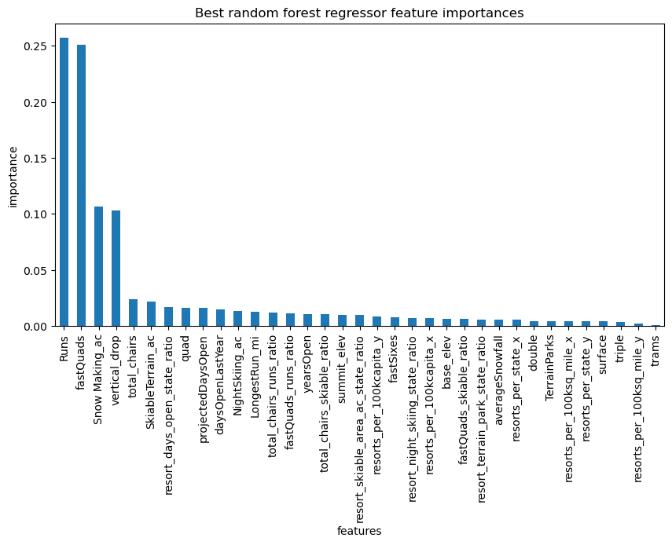 Figure 2. Feature importance from the final random forest model.
Where Big Mountain Stands Today
Big Mountain currently charges $81.00 for an adult weekend ticket. Feeding Big Mountain's own facilities into the model suggests the market would support a price around $98, even allowing for the model's typical error of about $10, this points to real, currently unrealized pricing room.
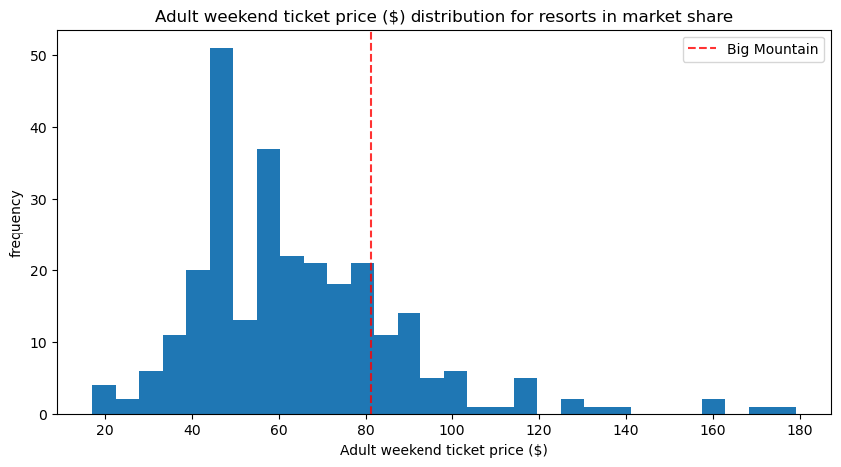 Figure 3. Big Mountain's current ticket price sits well below where its facilities place it among comparable resorts.
Scenario Modeling Results
Four facility-investment scenarios proposed by the business were run through the model:
● Scenario 1 - Close up to 10 of the least-used runs: closing 1 run has no effect on supported price; closing 2-3 causes a small drop, and 6+ causes a much larger one. Because run-level operating costs weren't available, the potential cost savings of this option can't yet be weighed against the price impact.
● Scenario 2 - Add a run, increase vertical drop by 150 ft, and install an additional chair lift: supports a $2.22 increase in ticket price, worth about $3.89M in additional season revenue.
● Scenario 3 - Scenario 2 plus 2 additional acres of snow making: identical result to Scenario 2, the extra snow making adds cost for no additional pricing power.
● Scenario 4 - Extend the longest run by 0.2 mile and add 4 acres of snow making: no change in supported price at all.
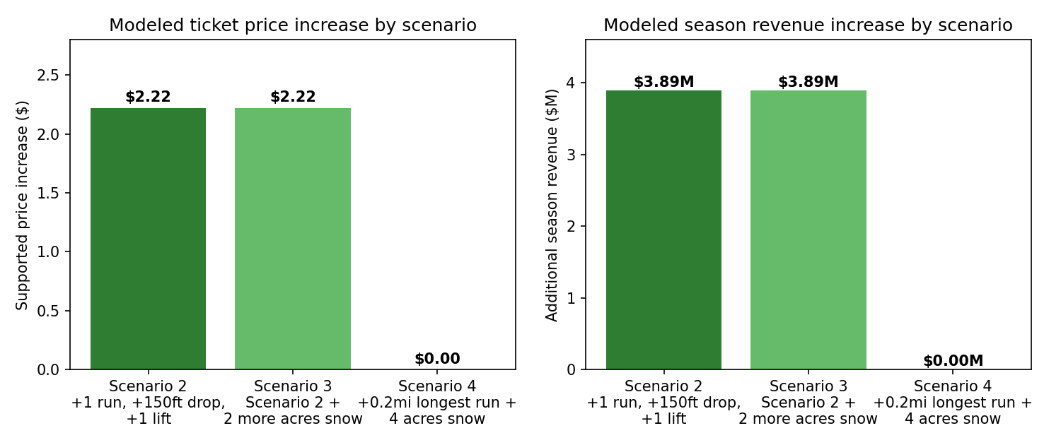 Figure 4. Modeled ticket price and season revenue impact for Scenarios 2–4.

Pricing Recommendation
We recommend Big Mountain move forward with Scenario 2, adding a run, extending vertical drop by 150 ft, and installing the new chair lift, without the extra snow making in Scenario 3, which adds cost with no return.
The new lift adds $1,540,000 in operating cost this season. Spread across an expected 350,000 visitors buying 5 tickets each (1.75M tickets), that's roughly $0.88 per ticket, well under the $2.22 in added price support the scenario provides, leaving about $1.34 per ticket ($2.35M for the season) net benefit after covering the lift's cost.
More broadly, Big Mountain's current $81 price sits meaningfully below the $98 the market would likely support given its existing facilities. We recommend leadership treat this as a directional signal to raise price independent of any new investment, and validate it against the resort's historical pricing strategy and local competitive position before finalizing a number.
Conclusion
The random forest pricing model, validated through cross-validation and consistent test-set performance, indicates Big Mountain is underpriced relative to its facilities. Of the four scenarios tested, only the lift and vertical-drop expansion (Scenario 2) delivers a meaningful, well-supported revenue increase, and it comfortably covers its own added operating cost.
Future Scope of Work
● Gather facility-level operating cost data (beyond the chair lift) so run closures and other cost-saving scenarios can be evaluated on a net-profit basis, not just price impact.
● Investigate why Big Mountain's modeled price so far exceeds its current price, confirm with leadership whether this reflects a deliberate pricing strategy or an unrealized opportunity.
● Package the model into a simple internal tool (e.g., a lightweight dashboard) so business analysts can test new facility scenarios directly, without needing a data scientist for every query.

