
Lab Report 05

Course Id: CSM 3226
Course Name: Microprocessor & Embedded System

Submission Date: 26/01/2026

Submitted By  Shazzadul Islam Chowdhury  Student Id: 2209008  Reg. No.: 55332  Session: 2021-22  B. Sc. in Bioinformatics  Engineering | Submitted To  Mr. Md. Sakhawat Hossain  Lecturer  Dept. of Computer Science & Mathematics  Bangladesh Agricultural University,  Mymensingh

Problem No. 1
Problem Statement:
Write an 8086 assembly language program to take a binary number from the user and display the same number after removing all leading zeros.
Sample Input:
Enter binary number: 00010111 Sample Output:
Binary output: 10111

Overview:
This program accepts an 8-bit binary number from the user as input and then displays the same number after eliminating all leading zeros. The input is taken one bit at a time using DOS interrupt services, and each bit is processed and stored in a register through rotate and shift operations. During the output phase, the program ignores any leading zeros and begins displaying digits only after the first 1 appears. It utilizes bitwise operations, loops, and conditional jumps to manage binary input and produce correctly formatted output in 8086 assembly language.
Code:
.MODEL SMALL
.STACK 100H

.DATA
msg1 DB 'Enter binary number: $' msg2 DB 0DH,0AH,'Binary output: $' buf DB 20 DUP(?)

.CODE

MAIN PROC

MOV AX,@DATA
MOV DS,AX

; print the prompt first
MOV AH,09H
LEA DX,msg1
INT 21H

; read chars one by one, stop at enter
LEA SI,buf
MOV CX,0

getchar: MOV AH,01H
INT 21H
CMP AL,0DH
JE done_input
MOV [SI],AL
INC SI
INC CX
JMP getchar

done_input:

; now print the label
MOV AH,09H
LEA DX,msg2
INT 21H

; point back to start of buffer
LEA SI,buf

; if CX is 0 somehow, just bail
CMP CX,0
JE bye

strip:
CMP CX,1 ; dont strip the last digit even if its 0
JE print
MOV AL,[SI]
CMP AL,'0'
JNE print ; hit a 1, stop stripping
INC SI
DEC CX
JMP strip

print: CMP CX,0
JE bye
MOV DL,[SI]
MOV AH,02H
INT 21H
INC SI
DEC CX
JMP print

bye:
MOV AH,4CH
INT 21H

MAIN ENDP
END MAIN

Output:

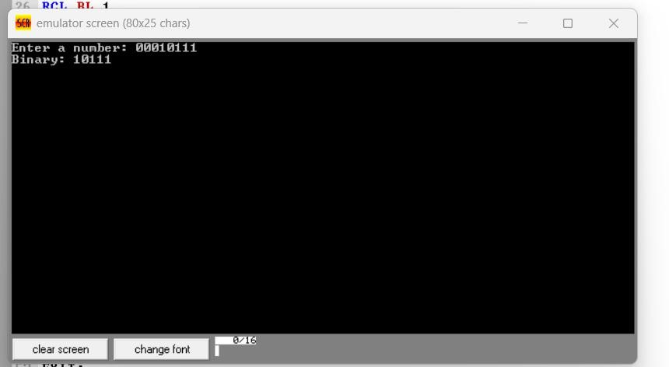

Discussion:
Discussion:
The program reads a fixed number of binary digits (8 bits) from the user, so its time complexity is constant, O(1). It utilizes rotate (RCL) and shift (SHL) instructions to manipulate bits efficiently while constructing and displaying the binary value. A flag mechanism (using register BH) is implemented to suppress leading zeros during output, ensuring a clean binary representation. The use of CPU registers such as BL, BH, and CL minimizes memory usage and improves execution efficiency. The program demonstrates key concepts of 8086 assembly language, including keyboard input handling via interrupts, bitwise operations, looping with counters, and conditional branching. However, a limitation of the program is that it assumes exactly 8-bit input and lacks flexibility for handling variable-length binary numbers. Additionally, some instructions in the input phase do not correctly manage the carry flag, which may affect accuracy.

Problem No. 2
Problem Statement:
Write an 8086 assembly language program to take an 8-bit number and count how many 1s are in its binary form using shift instructions.
Sample Input:
Enter a number: 29 Sample Output:
Total set bits: 4

Overview:
This program is written in 8086 assembly language and is designed to read a binary number from the user, then calculate and display the total number of set bits (1s) in that number. It uses DOS interrupt 21H for input and output operations. The user enters a sequence of binary digits, which are processed and stored in register BL. After the input is completed (terminated by the Enter key), the program counts the number of bits set to 1 using bitwise shift operations. Finally, it prints the result with an appropriate message.
Code:
.MODEL SMALL
.STACK 100H
.DATA
msg1 DB 'Enter a number (0-255): $'
msg2 DB 0DH,0AH,'Total set bits: $'

.CODE
MAIN PROC
MOV AX, @DATA
MOV DS, AX

LEA DX, msg1
MOV AH, 09H
INT 21H

MOV CX, 0
MOV BX, 0

READ:
MOV AH, 01H
INT 21H
CMP AL, 0DH
JE DONE

SUB AL, '0'
MOV AH, 0
MOV DX, BX
MOV BX, 10
MUL BX
ADD AX, DX
MOV BX, AX
JMP READ

DONE:
MOV BL, BL
MOV CL, 08
MOV BH, 00

L1:
SHR BL, 1
JNC L2
INC BH

L2:
DEC CL
JNZ L1

LEA DX, msg2
MOV AH, 09H
INT 21H

MOV DL, BH
ADD DL, '0'
MOV AH, 02H
INT 21H

MOV AH, 4CH
INT 21H

MAIN ENDP
END MAIN

Output:

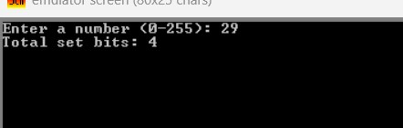

Discussion:
The program processes input sequentially until the Enter key is pressed, making its time complexity dependent on input length, though it effectively handles up to 8 bits due to register size limitations. Bit manipulation is performed using shift (SHL) instructions to both construct the binary number and later examine each bit for counting. A loop-based mechanism is used to count set bits by shifting the contents of BL and checking the carry flag, incrementing a counter (CH) whenever a 1 is detected. Registers are used efficiently to minimize memory usage and ensure faster execution. The program demonstrates important assembly concepts such as looping, conditional branching, bitwise operations, and interruptdriven I/O. However, it assumes valid binary input and does not include error handling for invalid characters. Additionally, the counting logic is limited to 8 bits, and the conversion logic used while building the number is somewhat inefficient and could be optimized.

Problem No. 3 Problem Statement: only XOR instruction.
Sample Input
Enter A: 7
Write an 8086 assembly language program to swap two numbers without using any extra variable, Enter B: 3
Sample Output
After swapping
- = 3
- = 7

Overview:
This program swaps two numbers without using any temporary variable by applying the XOR swapping technique. The user inputs two single-digit numbers, which are stored in registers. The XOR instruction is used three times to exchange the values efficiently. After swapping, the program displays the updated values of both numbers. DOS interrupt services handle user input, output formatting, and program termination.

Code:
.MODEL SMALL
.STACK 100H
.DATA
msg1 DB 'Enter A: $' msg2 DB 0DH,0AH,'Enter B: $' msg3 DB 0DH,0AH,'After swapping',0DH,0AH,'A = $' msg4 DB 0DH,0AH,'B = $'

.CODE
MAIN PROC
MOV AX, @DATA
MOV DS, AX

LEA DX, msg1
MOV AH, 09H
INT 21H

MOV AH, 01H
INT 21H
SUB AL, '0'
MOV BL, AL

LEA DX, msg2
MOV AH, 09H
INT 21H

MOV AH, 01H
INT 21H
SUB AL, '0'
MOV CL, AL

XOR BL, CL
XOR CL, BL
XOR BL, CL

LEA DX, msg3
MOV AH, 09H
INT 21H

MOV DL, BL
ADD DL, '0'
MOV AH, 02H
INT 21H

LEA DX, msg4
MOV AH, 09H
INT 21H

MOV DL, CL
ADD DL, '0'
MOV AH, 02H
INT 21H

MOV AH, 4CH
INT 21H

MAIN ENDP END MAIN Output:
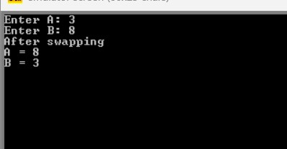

Discussion:
The XOR-based swapping technique eliminates the need for extra memory, making the program space-efficient. Since the program executes a fixed number of instructions, the time complexity is O(1). Registers are used optimally, and the logic remains simple and effective. ASCII conversion ensures correct display of numeric values. The main limitation is that the program supports only single-digit inputs due to direct ASCII handling. Overall, the program demonstrates logical operations, register manipulation, and efficient data exchange in 8086 assembly language.

Problem No. 4
Problem Statement:
Write an 8086 assembly language program to take a binary number and check whether it is a palindrome or not.
Sample Input:
Enter binary number: 10011001 Sample Output:
Binary is a palindrome.

Overview:
This program checks whether an 8-bit binary number entered by the user is a palindrome or not. The binary input is read bit by bit and stored in a register. The program then reverses the bit order using rotate instructions and compares the reversed value with the original one. If both values are equal, the binary number is declared a palindrome; otherwise, it is not. DOS interrupt services are used for input, output, and program termination.

Code:
.MODEL SMALL
.STACK 100H
.DATA
MSG DB "Enter a binary number: $"
MSG2 DB "Binary is not a palindrom $"
MSG3 DB "Binary is palindrom $"
.CODE
MAIN PROC
MOV AX,@DATA
MOV DS,AX
MOV AH,9
LEA DX,MSG
INT 21H

MOV CX,8
XOR BL,BL
MOV AH,1

FOR:
INT 21H
SUB AL,'0'
MOV DH,0
SHR DH,1
CMP AL,0
JE END
MOV DH,1 SHR DH,1 END:
RCL BL,1
LOOP FOR

MOV AH,2
MOV DL,0AH
INT 21H
MOV DL,0DH
INT 21H
XOR AL,AL
MOV CX,8

FOR2:
ROR BL,1
RCL AL,1
LOOP FOR2
CMP AL,BL
JE PAL
MOV AH,9
LEA DX,MSG2 INT 21H
JMP EXIT
PAL:
MOV AH,9
LEA DX,MSG3
INT 21H

EXIT:
MOV AH,4CH
INT 21H
MAIN ENDP

END MAIN

Output:

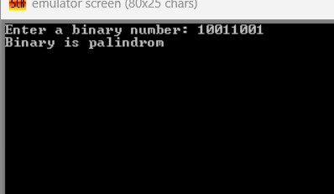

Discussion:
The program operates on a fixed 8-bit input, resulting in a time complexity of O(1). Rotate instructions (ROR, RCL) are used to efficiently reverse the binary number without additional memory. Register comparison ensures accurate palindrome detection. Conditional jumps control program flow and output selection. A limitation of the program is that it assumes a fixed binary length of 8 bits. Nevertheless, the program effectively demonstrates bit manipulation, comparison logic, and efficient use of registers in 8086 assembly language.

