
Islamic University of Technology
Name : Shazzad Ahmed
Student ID : 220021108
Section : A-(02)
Department :EEE
Course No : EEE-4404
Course Title : Communication Engineering I Lab
Experiment No : 3 and 4
Experiment Name : Amplitude Shift-Keying (ASK) Modulation and
Demodulation and Frequency Shift-Keying
(FSK) Modulation and Demodulation
Date of Performance : 14/07/2025
Date of Submission : 16/08/2025

Introduction: -
Amplitude Shift Keying (ASK) –
Amplitude Shift Keying (ASK) is a type of amplitude modulation where digital data is sent by turning a carrier wave on or off. In this method, a binary 1 is transmitted as a carrier wave at full amplitude, while a binary 0 is sent by either switching the carrier off completely or reducing its amplitude significantly.This technique is also called on-off keying (OOK) or interrupted continuous wave. ASK is easy to design and can be decoded using a simple envelope detector.However, its main drawback is high sensitivity to noise—any unwanted changes in amplitude caused by interference can make the receiver misinterpret the signal, confusing ones and zeros.
Frequency Shift Keying (FSK) –
Frequency Shift Keying (FSK) is a digital modulation method where binary data is transmitted by changing the carrier wave’s frequency between two set values.
Mark frequency (higher frequency) represents binary 1
Space frequency (lower frequency) represents binary 0
You can think of it as the digital counterpart of frequency modulation (FM), which gives it better resistance to noise. Since most noise affects amplitude rather than frequency, FSK signals can be cleaned using limiters without degrading the information.
For decoding (demodulation), common approaches include FM-based methods like zero-crossing detection and phase-locked loops, or techniques using filters followed by envelope detection.

Oscilloscope Graphs: -
ASK Modulation –
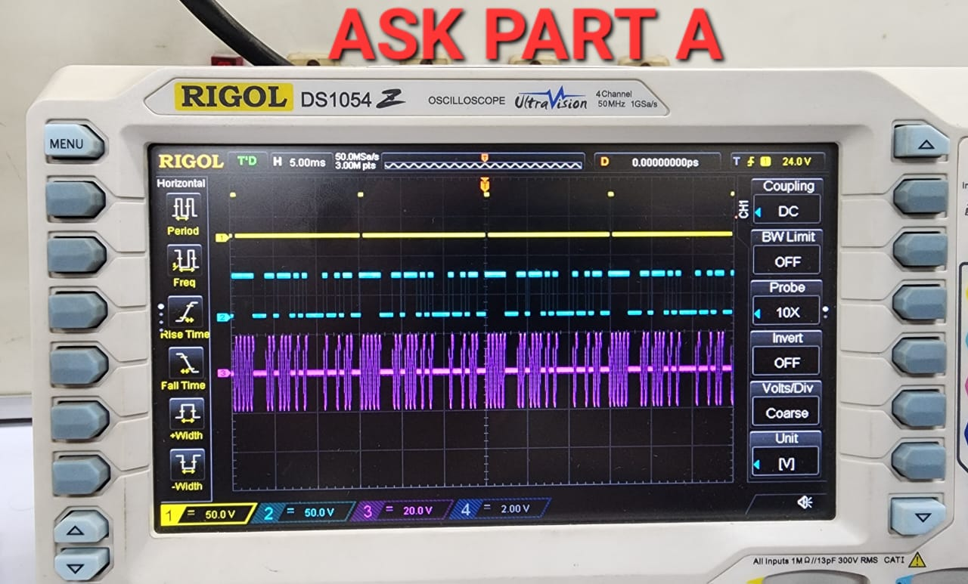
ASK Demodulation –
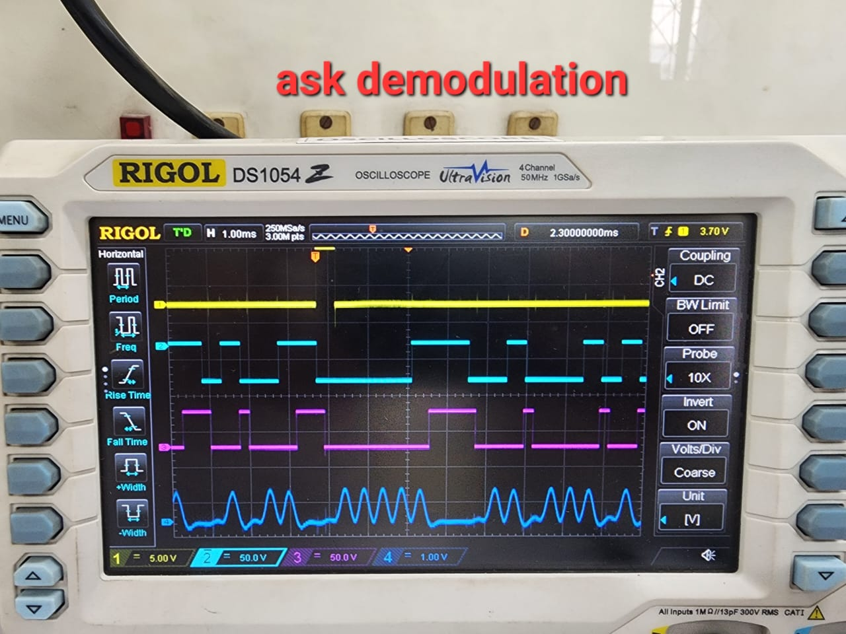
FSK Modulation –
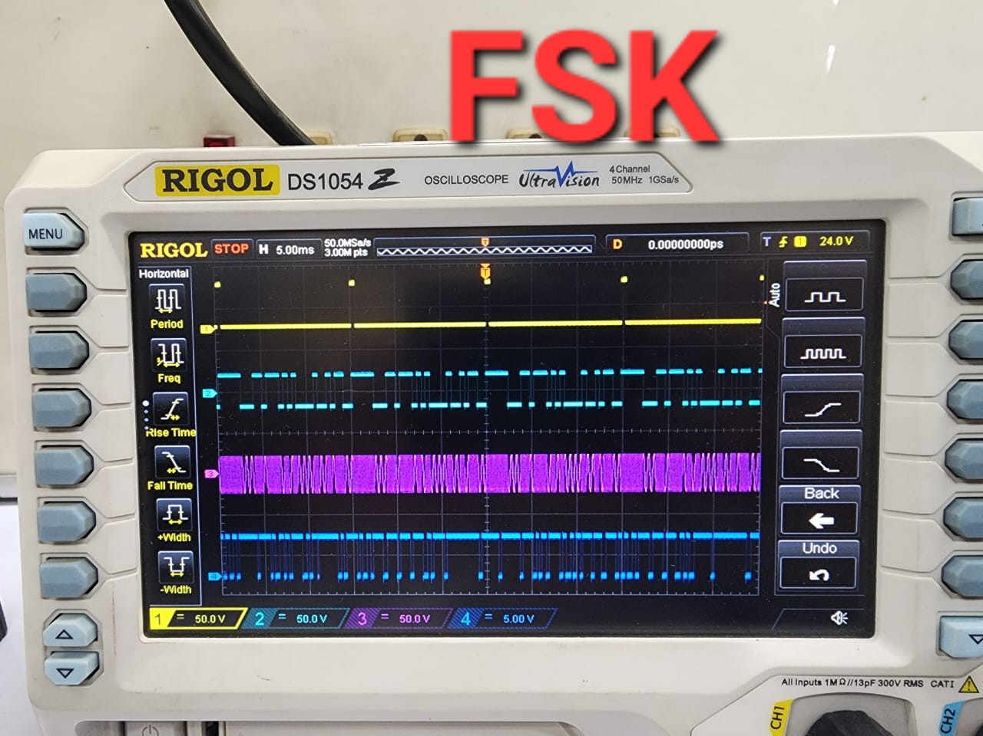
FSK Demodulation –
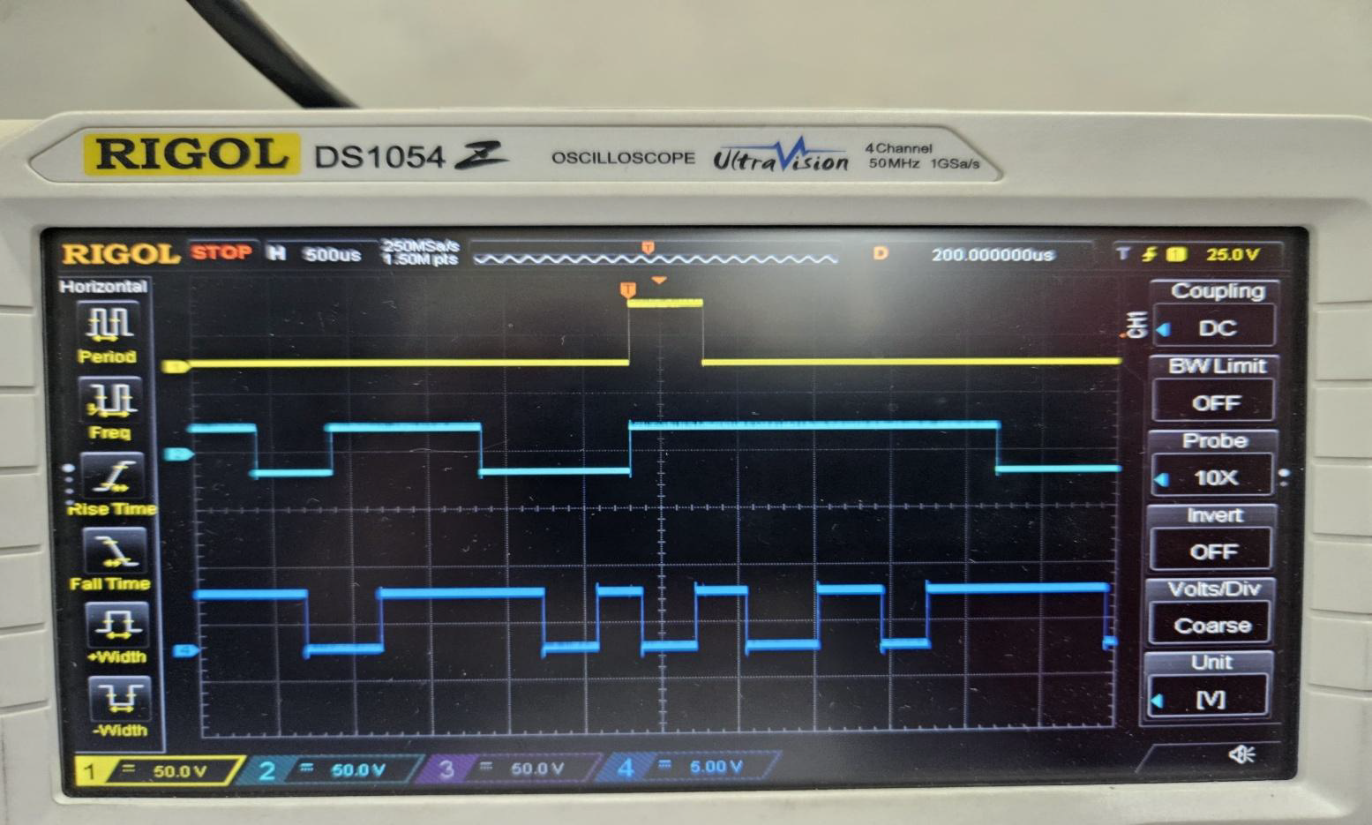
ASK block diagram: -
ASK Modulation –
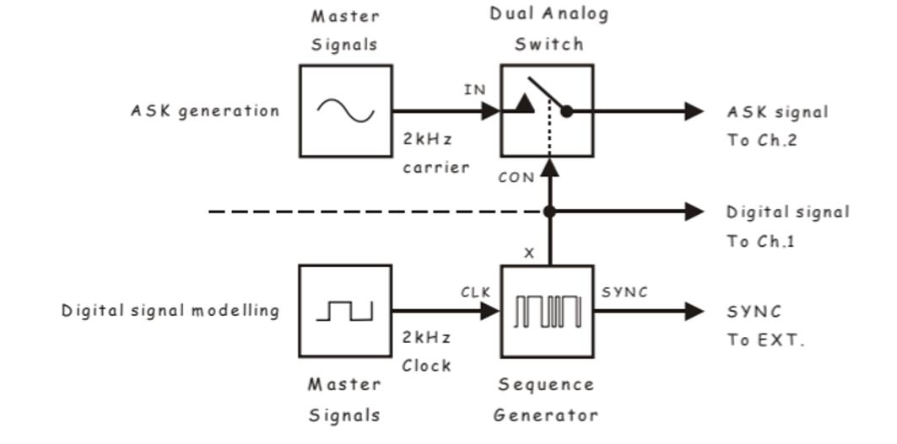
Demodulation –

FSK block diagram:
Modulation –
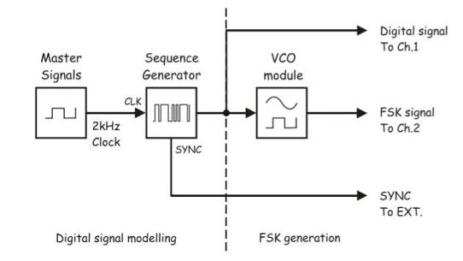
Demodulation –
