
Islamic University of Technology
Name : Shazzad Ahmed
Student ID : 220021108
Section : A-(02)
Department :EEE
Course No : EEE-4416
Course Title : Matlab Simulation Lab
Experiment : MATLAB GUI Project
Date of Submission : 30/09/2025

Digital Logic & Digital Modulation Simulator (MATLAB App)

Introduction
This project is a MATLAB App Designer-based application that integrates Digital Logic Design and Digital Modulation concepts into a single interactive platform. The app provides a user-friendly graphical interface for simulating logic gates, constructing truth tables, and visualizing digital modulation schemes.

Features
- **Digital Logic Design Tab**: Includes buttons for logic gates (AND, OR, NOT, NAND, NOR, XOR, XNOR).
- Generates truth tables based on selected logic gates.
- Displays corresponding waveforms for input and output signals.
- **Digital Modulation Tab**: Allows selection of modulation schemes (ASK, PSK, FSK, etc.).(Not completed yet. It’s a prototype)
- User inputs binary streams for modulation.
- Displays output waveform, constellation diagram, and eye diagram.
- Includes fields for amplitude, phase, BER, and modulation parameters.

Objective
The main objective of this project is to provide an educational and simulation tool that helps students and researchers understand the fundamentals of digital logic , digital modulation and Kmap of logic design. By combining truth table generation, logic gate simulation, Kmap, and modulation visualization, the app serves as an interactive laboratory environment.

APP’s Design View

Prototype
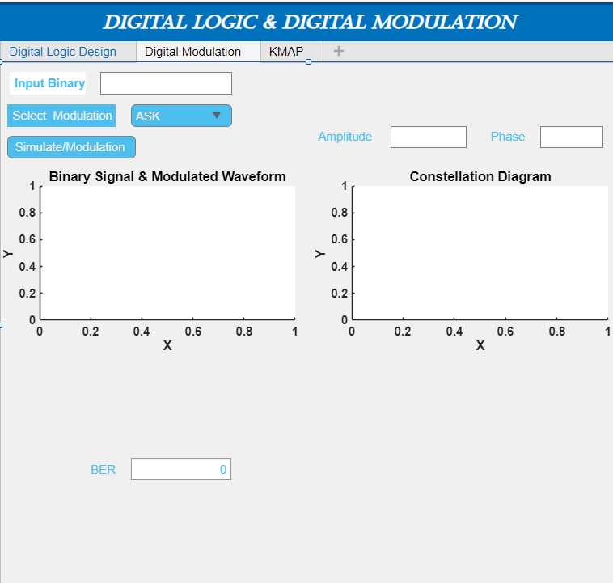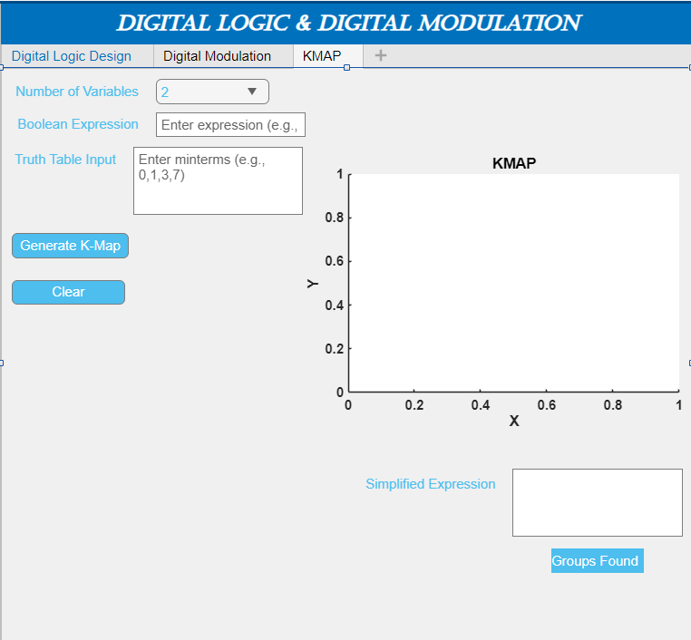
Working
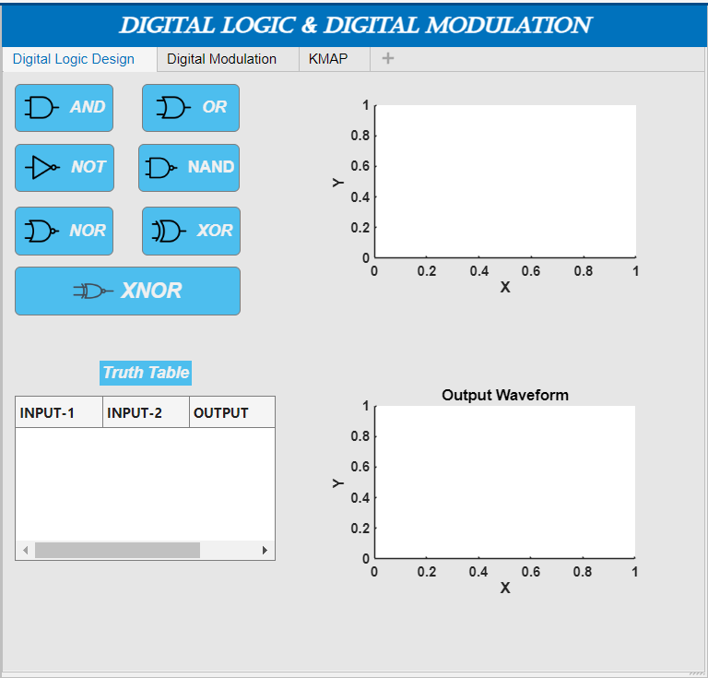

Different Segments and Outputs
And Gate:
Design view Output Code view
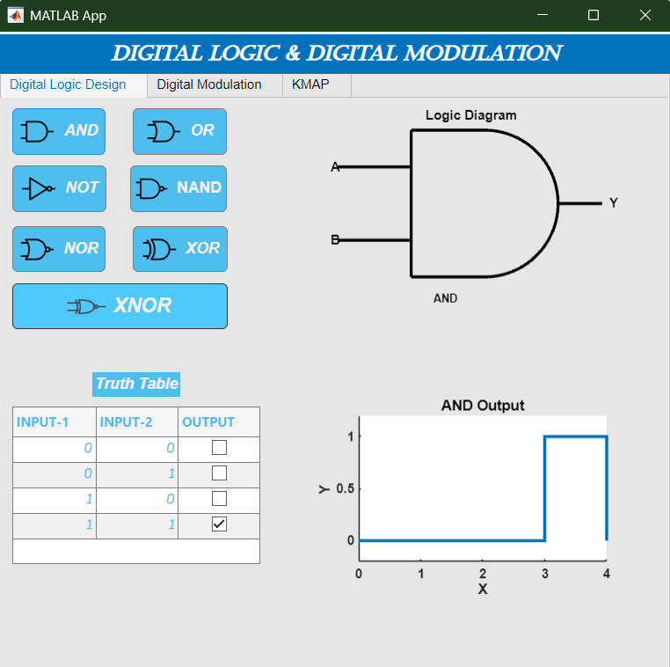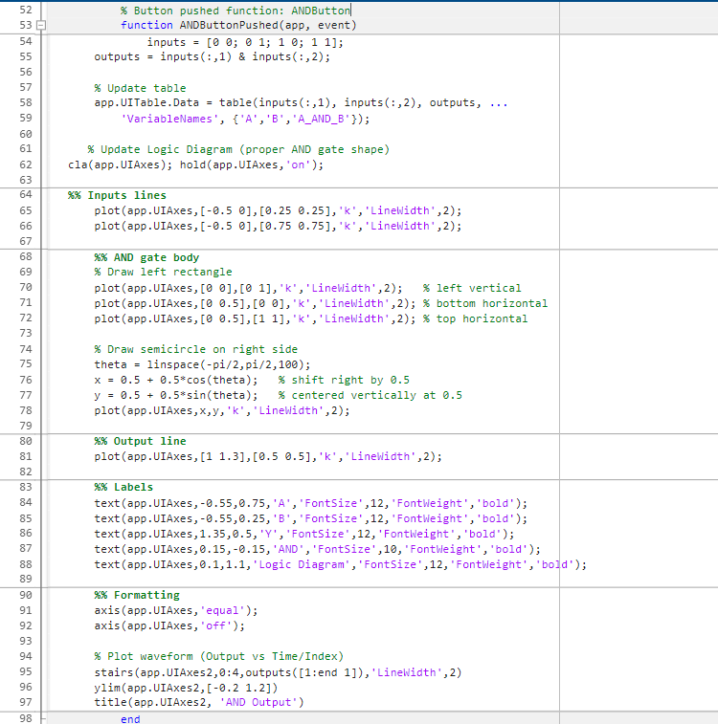
OR Gate:
Design view Output Code view
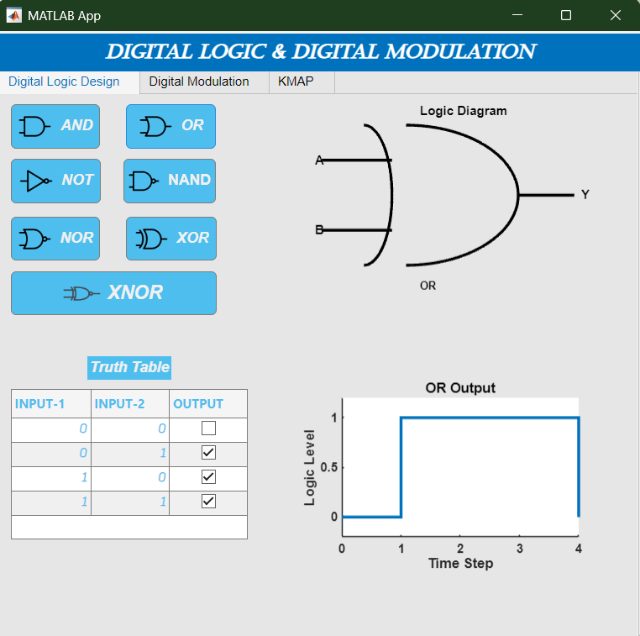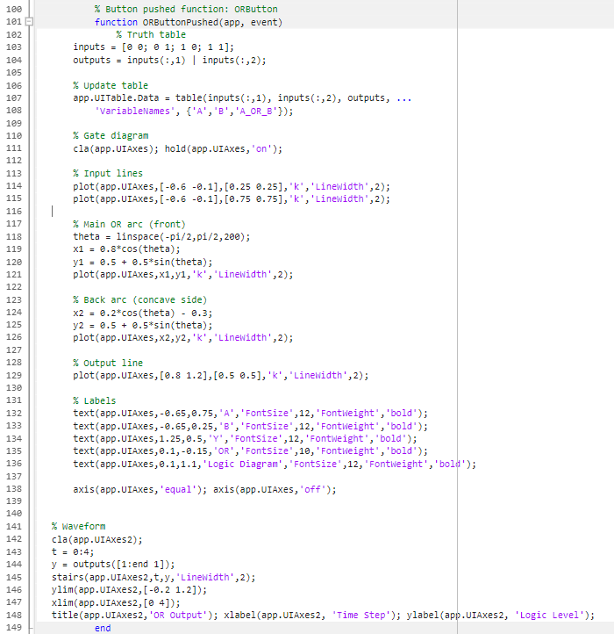

NOT Gate:
Design view Output Code view
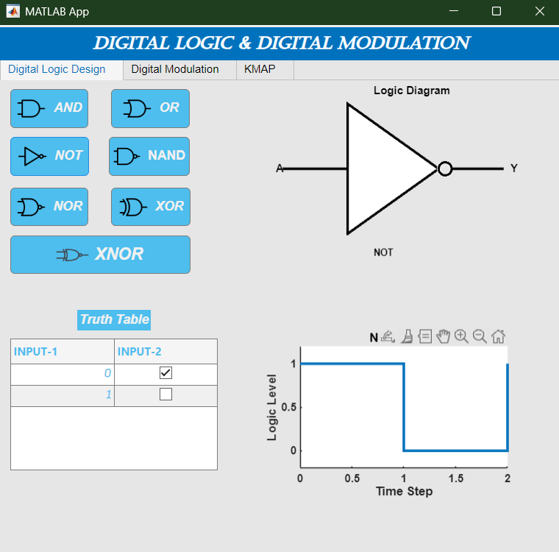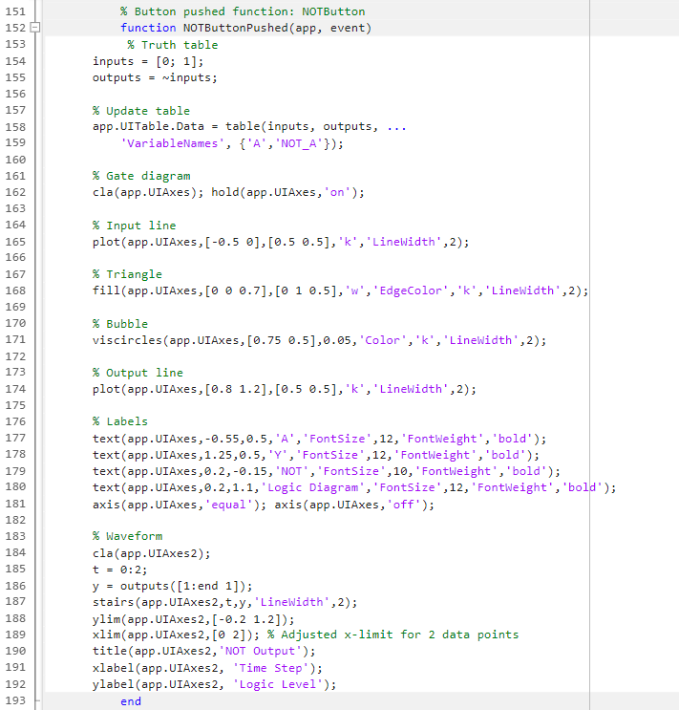
NAND Gate:
Design view Output Code view
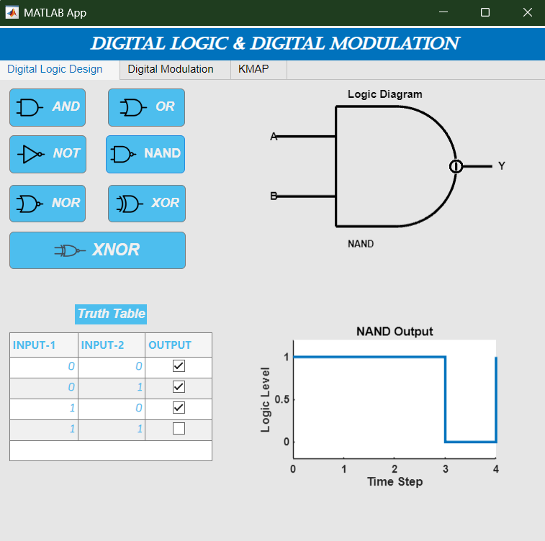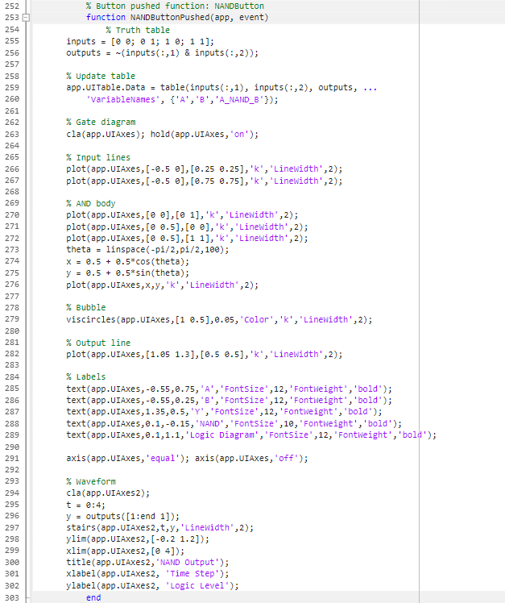
NOR Gate:
Design view Output Code view
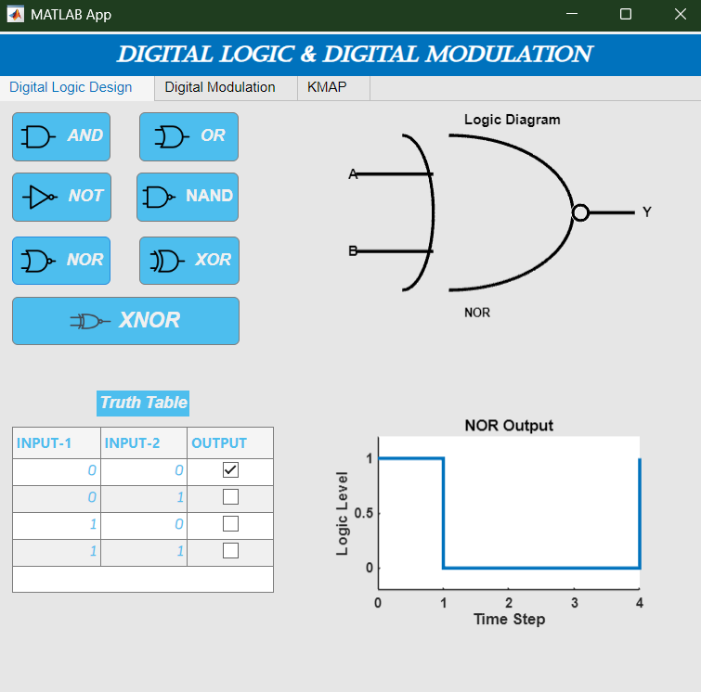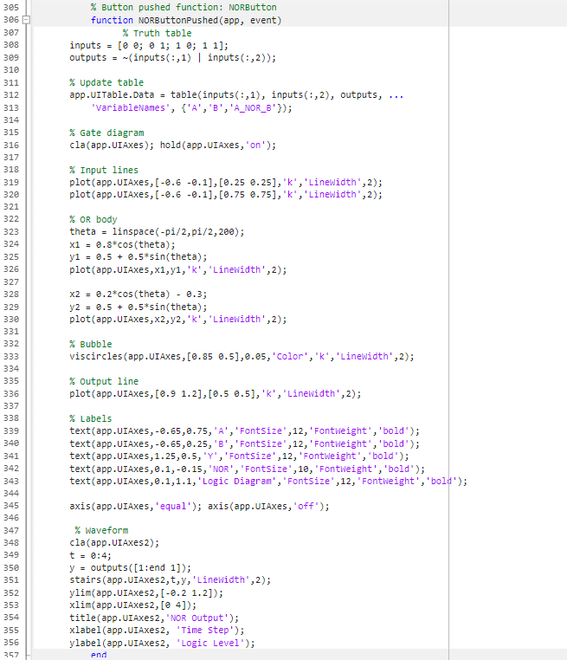
XOR Gate:
Design view Output Code view
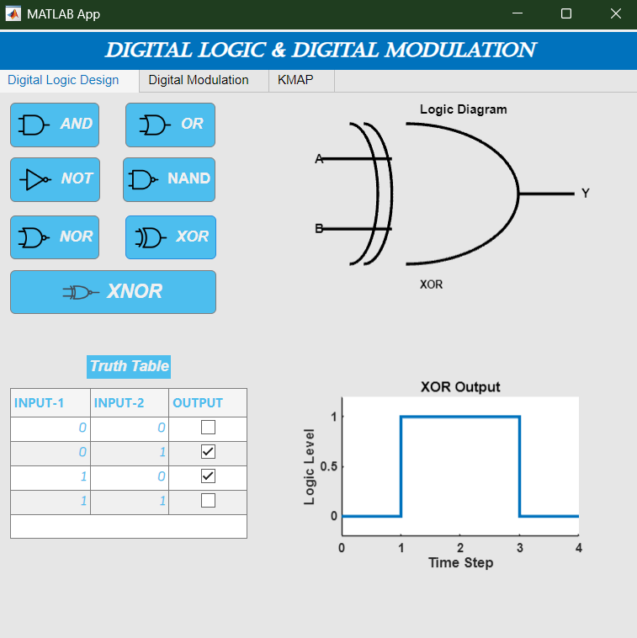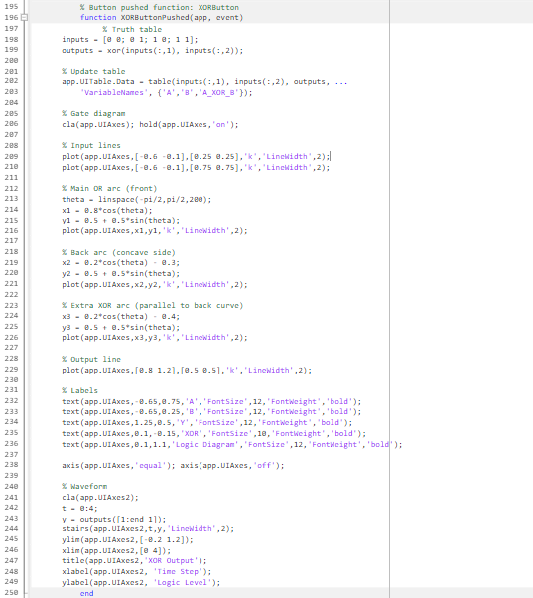

XNOR Gate:
Design view Output Code view
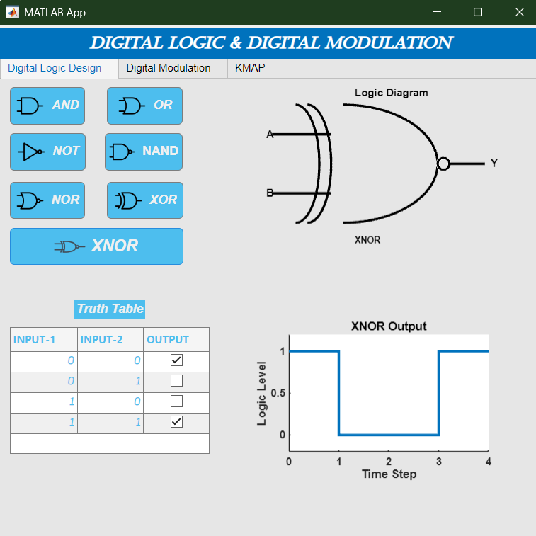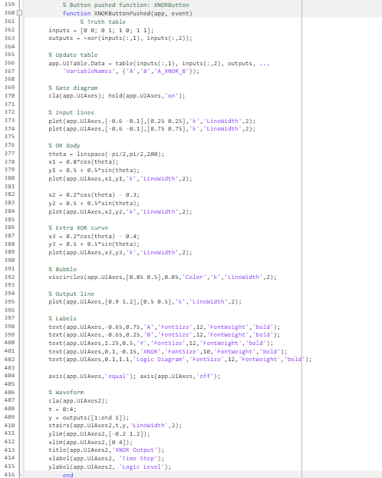

Conclusion
The Digital Logic & Digital Modulation Simulator is a versatile learning and teaching tool. It enhances practical understanding of core concepts in Digital Electronics and Communication Systems through interactive simulations.

