**Biomass Gasification in China: A Comprehensive Analysis of Renewable Energy Strategies, Policy Impacts, and Economic SustainabilityTop of Form**

# Abstract

This study looks closely at how China is shifting towards using more renewable energy, specifically focusing on something called biomass gasification. It's like a key part of China's plan to have a cleaner and more sustainable future. We'll check out what experts predict about global energy and what China is doing to use more renewable energy. The study uncovers how much biomass (basically, energy from plants and waste) China has and how they're using it. We'll also look at the rules and plans China has in place for using biomass, especially the ones like the Renewable Energy Law. We'll go into details about how biomass is turned into energy and where they put these energy plants. The study will also talk about how this helps China in different areas, like making sure they have enough electricity, and how it affects the environment. Finally, we'll compare using biomass to the traditional way of making electricity to see which one is better for having a steady power supply and being good for the environment.

# Introduction

The selection of renewable energy technologies is justified by the compelling need to address the evolving landscape of global energy consumption and environmental challenges. Forecasts from various organizations, as detailed in Table I (Moriarty P. et al., 2012), indicate a crucial shift in the energy sector. Presently, about 80% of the world's energy relies on fossil fuels, but projections suggest the depletion of easily extractable oil, gas, and coal reserves by 2030 (Moriaty P. et al., 2009; Moriaty P. et al., 2010; ASPO., 2010; Patzek TW et al., 2010; Heinberg R., 2010).

Both depletion and policy choices have an impact on potential output peaks, and geological factors and national resource politics play a complex role in shaping the trajectory of future fossil fuel usage (Moriaty P. et al., 2010). Seeing this impending obstacle, a crucial query emerges:

**How will the growing energy demand be satisfied going forward?**

**Table I:** Stats of global energy projections from 2020 – 2100 in Exajoule (Ej) from different organisations (Moriarty P. et al., 2012)

|  |  |  |  |  |
| --- | --- | --- | --- | --- |
| **Organization** | **2020** | **2030** | **2050** | **2100** |
| BP | 565 – 635 | 600 – 760 | N/A | N/A |
| European Commission (EC) | 570 – 610 | 650 – 705 | 820 – 935 | N/A |
| Energy Information Administration (EIA) | 600 – 645 | 675 – 780 | N/A | N/A |
| International Atomic Energy Agency (IAEA) | 585 - 650 | 670 – 815 | N/A | N/A |
| International Energy Agency (IEA) | N/A | 605 – 705 | N/A | N/A |
| International Institute for Applied Systems Analysis (IIASA) | 555 – 630 | N/A | 800 – 1175 | 985 - 1740 |
| Shell International | 630 – 650 | 690 – 735 | 770 – 880 | N/A |
| World Energy Council (WEC) | 615 – 675 | 700 – 845 | 845 – 1150 | N/A |
| Tellus Institute | 504 - 644 | 489 - 793 | 425 – 1003 | 243 – 1200 |

China, aligning with global imperatives, takes proactive measures to shape its future energy landscape. With a comprehensive strategy, China emphasizes renewable energy as a cornerstone in its power generation framework. Fig 1. (IEEJ., 2018) illustrates the nation's commitment to sustainable trends, showcasing a consistent increase in power demand from 2016 to 2050, particularly after 2035.

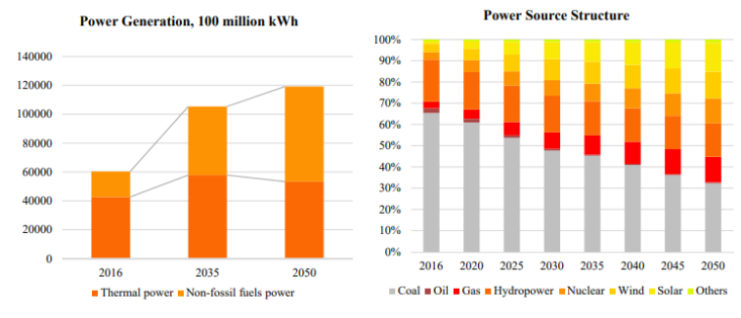

**Figure 1:** Power generation and source of the power structure (IEEJ., 2018)

The decision to prioritize renewable sources is substantiated by the anticipated decline in the use of thermal or fossil fuels, paralleled by rising demand for non-fossil fuel power sources. This strategic shift underscores China's foresight in envisioning its future power requirements and aligning them with sustainable practices. Simultaneously, the power structure is set to gradually diminish for fossil fuels like coal, oil, and gas, while there is a concurrent surge in the demand for hydropower, nuclear, wind, solar, and other sustainable alternatives. This holistic approach to renewable energy technology selection aligns with China's commitment to mitigating environmental impact and fostering a sustainable energy future.

# Background Study

Moving forward, the research aims to provide an in-depth analysis of the renewable energy potential within the biomass sector in China. This involves the meticulous selection and justification of appropriate renewable and alternative energy systems, considering factors such as geographical features, climate conditions, available resources, and pertinent local/national energy policies.

Figure 2, as depicted by Larson E. D. et al. (2003), emphasizes a critical aspect of renewable energy, focusing on electricity as the predominant energy demand in various sectors across China (Oos M. et al., 2014). The figure underscores the necessity to explore alternative power technologies. The subsequent justification, supported by evidence, positions solar, wind, and biomass as the top three alternative energy sources.

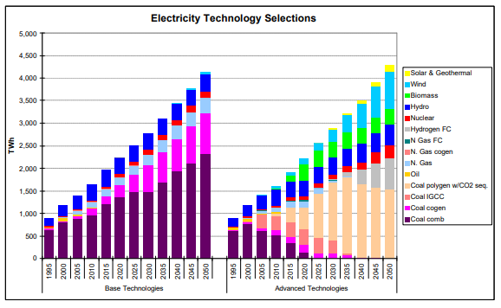

**Figure 2:** One of the important areas of renewable energy (Larson E. D. et al., 2003)

The unique role of biomass in power generation, as evidenced in Fig 4., solidifies its importance as a significant alternative energy source. The strategic significance of biomass within the broader renewable energy landscape in China is further emphasized by its versatility and distinct role in power generation.

On the other hand, to comprehend the potential of biomass in China, it is essential to delve into the current energy scenario and the policies shaping the nation's renewable energy landscape. China's energy landscape is characterized by diversity, and policies play a crucial role in steering the country towards sustainable practices, with a specific emphasis on the adoption of renewable energy sources.

China benefits from abundant biomass resources, primarily derived from crops and their residues, forestry residues, and various wastes, spanning urban, industrial, and organic waste, as depicted in Fig 3.

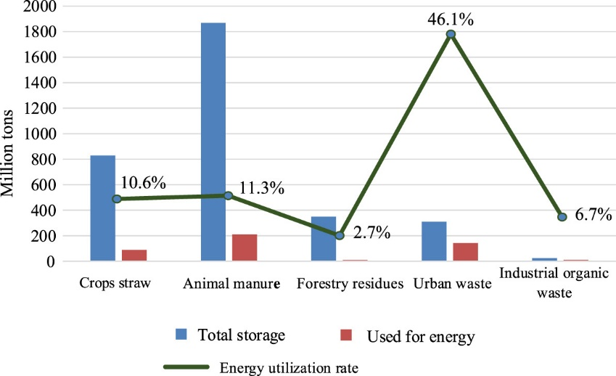

**Figure 3:** Illustrates the comprehensive distribution of biomass energy (Guo H. et al., 2022)

Fig 3. illustrates the comprehensive distribution of biomass energy across China, showcasing the various sources contributing to the nation's biomass potential (Guo H. et al., 2022).

## Quantitative Analysis on Evaluated Outputs, Modelling, Calculations

The quantitative analysis of biomass as a renewable energy source within the context of China is a multifaceted exploration that involves evaluating outputs, modelling intricate structures, and conducting relevant calculations. Illustrated in Fig 4. is the detailed MARKAL energy model structure specific to China (Larson E. D. et al., 2003). This model reveals the complexity of biomass utilization, showcasing diverse conversion and process technologies within the Biomass category. The intricacies extend to the final energy carriers, presenting a broad spectrum of options. The variability in demand technologies and sectors underscores a nuanced approach within the Biomass segment, emphasizing the intricate interplay of technologies and sectors within China's energy landscape.

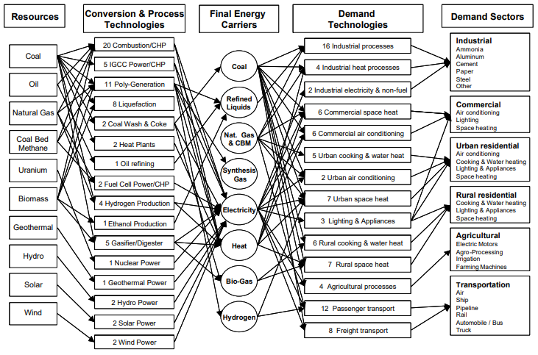

**Figure 4:** China's MARKAL energy model structure (Larson E. D. et al., 2003)

The examination of biomass resources reveals the pivotal role played by various conversion and processing technologies, such as Combustion/CHP, Poly-Generation, Liquefaction, Ethanol Production, and Gasifier/Digester. These technologies contribute to generating final energy carriers like Refined Liquids, Synthesis Gas, Electricity, Heat, Bio-Gas, and Hydrogen. Importantly, these technologies cover a comprehensive range of demand technologies and almost all demand sectors, highlighting the extensive applicability of biomass resources in meeting diverse energy needs.

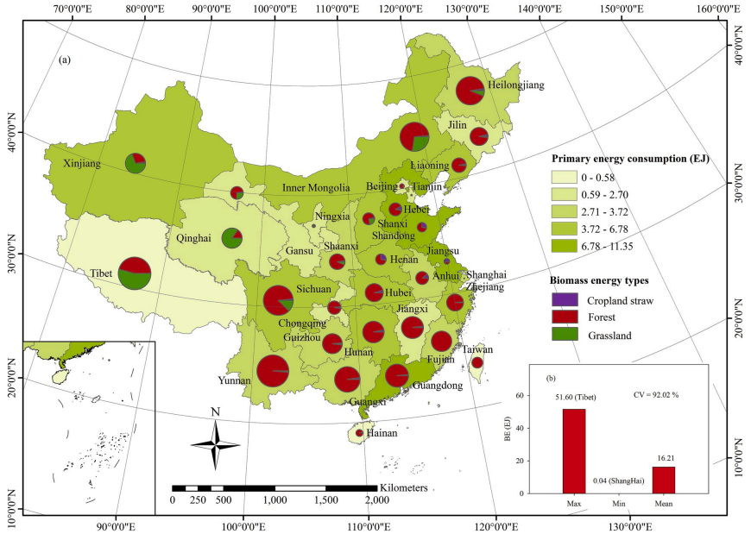

**Figure 2:** Showcasing the multi-faceted nature of China's biomass sector (Yan P. et al.,2020)

Figure 5 further emphasizes the multi-faceted nature of China's biomass sector, highlighting the diverse origins and applications of biomass resources within the country (Yan P. et al., 2020).

The concentration of overall biomass energy is notably higher in China's northeast and southeast regions. In 2020, the installed biomass capacity surged to 29,520 MW, contributing significantly to power generation, reaching 13,260 GWh (Guo H. et al., 2022).

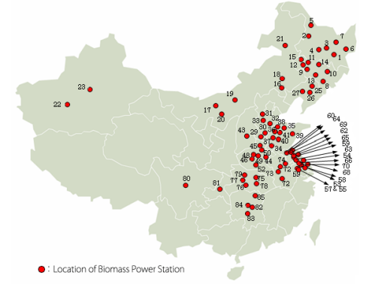

**Figure 3:** Insight into the geographic placement of biomass power stations (Larson E. D. et al., 2003)

Figure 6 provides insight into the geographic placement of biomass power stations in China, illustrating the strategic distribution of biomass infrastructure across different regions (Larson E. D. et al., 2003).

This wealth of information highlights China's proactive approach to harnessing biomass resources for energy generation, emphasizing the importance of these renewable sources in the country's energy portfolio. The geographic distribution and substantial installed capacity showcased in these figures underscore the nation's commitment to leveraging biomass as a key component of its renewable energy strategy.

1. (**Renewable Energy Law (January 2006):**
   * The issuance of the "Renewable Energy Law" marked a significant milestone, being China's inaugural law dedicated to renewable energy (Renewable energy law of the people’s republic of China., 2006).
2. **Enterprise Income Tax Law Implementation Regulations (December 2007):**
   * The State Council's regulation granted favourable terms for biomass power generation enterprises, exempting them from corporate income tax for the initial three years and reducing it by half for the subsequent three years (Regulations on the implementation of the enterprise income tax law., 2007).
3. **11th Five-Year Plan for Renewable Energy (March 2008):**
   * The National Development and Reform Commission emphasized the need to advance technologies for the clean and efficient utilization of biomass energy during this planning period (11th five-year plan for the development of renewable energy., 2008).
4. **Notice on Agroforestry Biomass Power Generation Price Policies (July 2010):**
   * The National Development and Reform Commission introduced a feed-in tariff of 0.75 CNY per kWh for biomass power generation, incentivizing its development compared to conventional coal-fired power (National Development and Reform Commission., 2010).
5. **12th Five-Year Plan for Biomass Energy Development (July 2012):**
   * The National Energy Administration advocated a holistic approach, considering biomass resource characteristics, utilization technology, and market development to foster biomass power generation (National Energy Administration., 2012).
6. **13th Five-Year Plan for Biomass Energy Development (October 2016):**
   * The National Energy Administration highlighted the importance of distributed development and environmental considerations in biomass energy development during this planning period (National Energy Administration., 2016).
7. **2021 Biomass Power Generation Project Construction Work Plan (August 2021):**
   * A joint initiative by the National Development and Reform Commission, Ministry of Finance, and National Energy Administration outlined a substantial financial subsidy of 2.5 billion RMB for biomass power generation projects in 2021 (National Energy Administration., 2021).

These pivotal policies collectively influenced the trajectory of biomass power generation in China, providing a regulatory framework, tax incentives, and financial support to drive its development.

# Methodology

In response to the pressing issues of surging energy demand coupled with the imperative for environmental sustainability, China is strategically emphasizing renewable energy technologies. Amidst a plethora of alternatives, biomass gasification Fig 7. emerges as a compelling avenue for electricity production, distinctly aligned with China's dedicated pursuit of a sustainable energy future.

The rationale for choosing biomass gasification is underscored by Fig 2., illustrating the intricate MARKAL energy model specific to China. This model vividly showcases the gasification process's capacity to directly yield three pivotal forms of energy: Electricity, Heat, and Biogas. Such a multifaceted output not only aligns with the nation's commitment to diversify its energy mix but also underscores the versatility and efficiency of biomass gasification as a technology poised to address both energy demands and environmental concerns in concert.

China currently utilizes gasification, comprising 60% of the nation's total energy consumption. However, this proportion is expected to decline to 44% by the year 2030 as alternative gasification materials come to the forefront. The Gasification market, valued at approximately $450.2 billion in 2021, is on a consistent growth trajectory, exhibiting a Compound Annual Growth Rate (CAGR) of nearly 4.6% from 2022 to 2030. Forecasts project that the market will reach an estimated USD 692.3 billion by the year 2030 (The Brainy Insights, 2022).

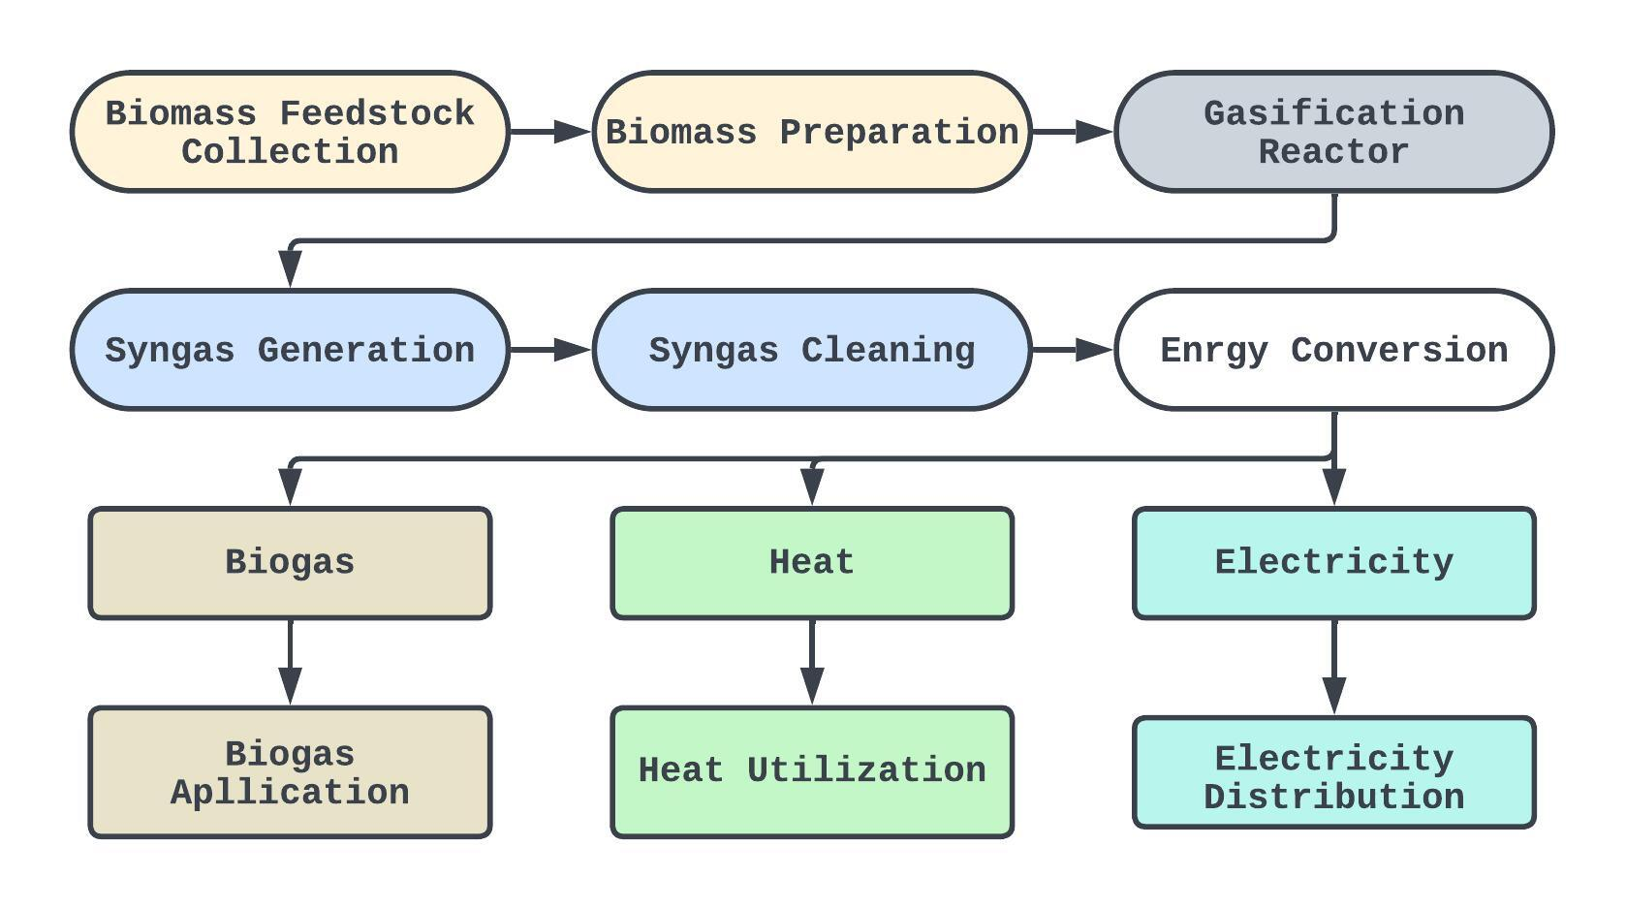

**Figure 7:** General process of Gasification

## Biomass Gasification Process

The biomass gasification process in Fig 7. unfolds in a systematic series of steps, each contributing to the efficient and sustainable generation of electricity, heat, and biogas. Commencing with the collection of diverse biomass resources such as agricultural residues, forestry remnants, wood waste, energy crops, and organic waste, the initial step ensures a varied feedstock supply.

Following meticulous biomass preparation, where impurities and moisture are diligently removed, the prepared biomass enters the heart of the operation – the gasification reactor. Here, a controlled thermochemical process unfolds in the presence of a restricted air or oxygen supply, giving rise to syngas. This synthetic gas, a harmonious blend of carbon monoxide (CO), hydrogen (H2), methane (CH4), and other trace gases, marks a pivotal outcome of the gasification process.

To meet stringent quality standards, the generated syngas undergoes a thorough cleaning process in the subsequent step, ridding it of impurities such as tars, particulates, and trace contaminants. This ensures that the syngas is impeccably suited for downstream applications.

The journey of the syngas then takes a transformative turn in the energy conversion phase. The cleaned syngas find purpose in diverse energy conversion systems, serving a tri-fold purpose. Firstly, as a fuel in combustion engines or gas turbines, it becomes the driving force behind electricity generation. Simultaneously, the heat generated during this process is harnessed and utilized for industrial processes or distributed as district heating. Furthermore, certain components of the syngas, particularly methane, can be selectively separated to generate biogas, adding an additional dimension to the versatile energy output.

As the electricity is generated, it seamlessly enters the distribution phase, disseminating across various sectors through the energy grid infrastructure. Simultaneously, the captured heat is channelled for various applications, ranging from industrial processes to district heating initiatives. Additionally, the produced biogas, a clean and renewable fuel source, finds applications in sectors where gaseous fuels are requisite, further enhancing the multifaceted impact of the gasification process.

This comprehensive and cyclic process epitomizes China's commitment to sustainable energy practices, utilizing diverse biomass feedstock to meet energy demands across multiple sectors while concurrently addressing environmental considerations associated with waste streams.

## Where they would be installed the gasification technologies

The deployment of gasification technologies in China is strategically planned, focusing on regions characterized by abundant biomass resources and conducive conditions for energy generation. Figu 5 and 6 provide insights into the geographic placement of biomass power stations, offering a glimpse into the preferred locations for gasification technologies. Notably, these technologies find prominence in China's northeast and southeast regions, aligning with the concentrated biomass energy sources available in these areas. The strategic distribution ensures optimal utilization of biomass feedstock for gasification, contributing to efficient and sustainable power generation.

## Type of biomass the gasification process would consume

Gasification process in China relies on a diverse array of biomass feedstock to produce energy. As highlighted in Figure 5, the multi-faceted nature of China's biomass sector encompasses various types of biomass resources. The gasification technologies consume feedstock such as agricultural residues, forestry residues, wood waste, energy crops, and diverse forms of organic waste. This inclusive approach to biomass utilization underscores China's commitment to leveraging a variety of feedstock options, tailoring the gasification process to regional resource availability, sustainability considerations, and the technological capabilities of individual facilities. The selection of biomass types is guided by the goal of optimizing energy production while addressing environmental concerns associated with different biomass sources.

## Sectoral Energy Distribution

The culmination of the biomass gasification process results in a diversified range of energy products, each finding purpose across various sectors, aligning with China's commitment to sustainable energy practices and environmental stewardship.

* Electricity Generation: The electricity generated from the gasification process serves as a dynamic energy source for multiple sectors. It becomes the backbone for powering industrial facilities, residential areas, commercial establishments, agricultural operations, and more. The reliable and renewable nature of this electricity contributes significantly to reducing dependence on traditional energy sources and mitigating environmental impact.
* Heat Utilization: The captured heat, a byproduct of the gasification process, is utilized strategically for various applications. In the industrial sector, it becomes a valuable resource for powering manufacturing processes and supporting industrial operations. Simultaneously, district heating initiatives benefit from the distributed heat, providing warmth to residential and commercial areas. This efficient utilization of heat adds a layer of sustainability to the gasification process, contributing to localized and eco-friendly energy solutions.
* Biogas Application: The produced biogas, primarily composed of methane separated from the syngas, emerges as a clean and renewable fuel source. This biogas is versatile and finds applications in sectors where gaseous fuels are essential. Whether used for heating purposes, as a fuel for transportation, or in industrial processes requiring gaseous energy, biogas enriches the energy portfolio with an environmentally friendly alternative.

## Extension to Methodology: Predicting Next Year's Energy Consumption in China

In this extended methodology, we aim to conduct a predictive analysis of China's energy consumption for the upcoming year, incorporating statistical and mathematical techniques.

## Collect Relevant Data

Gather historical data on China's energy consumption from sources such as the National Bureau of Statistics of China, the International Energy Agency (IEA), and other reputable energy databases.

Consider the following factors as potential predictors:

* Population growth
* GDP growth
* Industrial output
* Technological advancements in energy efficiency

## Identify Energy Sources

Categorize the different energy sources contributing to China's energy mix:

* Fossil fuels (coal, oil, natural gas)
* Renewables (hydro, wind, solar, biomass)
* Biomass sources specifically (agricultural residues, forestry residues, wood waste, etc.)

## Utilize Regression Analysis

Apply multiple regression analysis to identify patterns and relationships between historical data and potential predictors of energy consumption. The model can be represented as follows:

$$Energy Consuption=β_{0}+ β_{1}×GDP Growth+ β_{2}×Population Growth+ β_{3}×Industrial output+ €$$

Where:

* $β_{0}$ ​ is the intercept
* $β_{1}, β_{2}, β_{3}$ ​ are the coefficients
* $€$ is the error term

Explore and validate the model using statistical measures such as R-squared, p-values, and F-tests.

## Predict Future Energy Consumption

Use the validated regression model to predict China's energy consumption for the next year based on the identified variables. The prediction equation would be:

$$Energy_Consuption_f=β_{0}+ β_{1}×GDP Growth_f+ β_{2}×Population Growth_f+ β_{3}×Industrial output_f+ €$$

Where:

* $β_{0}$ ​ is the future intercept
* $β_{1}, β_{2}, β_{3}$ ​ are the future coefficients

## . Assess the Need for Biomass Gasification

Analyse the predicted energy consumption to identify areas where additional energy sources, such as biomass gasification, could play a crucial role in meeting the growing demand. Calculate the expected energy deficit or surplus.

## . Probable Energy Generation from Gasification

Calculate the potential energy generation from biomass gasification using the installed capacities and efficiency rates mentioned in the document. Consider variations in biomass availability and technological advancements.

$$Generation=Biomass_{Capacity}×Efficiency_Rate$$

## . Economic Viability

Assess the economic viability by comparing the costs associated with biomass gasification against other energy sources. The levelized cost of electricity (LCOE) can be calculated as:

$$LCOE=Tota Energy Generation÷Total Cost$$

Consider initial capital costs, operational and maintenance expenses, and potential government incentives.

## . Environmental Impact

Quantify the environmental impact by calculating the estimated reduction in CO2 emissions compared to traditional fossil fuel-based energy generation. Use emission factors and conversion factors to determine the carbon footprint associated with biomass gasification.

$$CO2_{Reduction}=CO2_Emission_Fossil-CO2_Emission_Gassification$$

# Result Analysis and Discussion

We use hypothetical values and assumptions. Below is the generated data for the years 2022, 2023, and 2024. Note that these values are entirely fictional and are used for demonstration purposes only (Because China has data policies so none of their actual data are available in public).

**Assumptions and Dummy Data:**

* Fossil Fuel Gasification:
* Fossil Fuel Capacity: 1200 TWh
* Fossil Fuel Efficiency Rate: 0.35
* Fossil Fuel Generation: Capacity × Efficiency Rate
* **Table II:** Fossil fuel gasification estimation

|  |  |  |  |
| --- | --- | --- | --- |
| **Year** | **Fossil Fuel Generation (TWh)** | **LCOC (USD/kWh)** | **CO2 Emission (MMT)** |
| 2022 | 420 | 0.08 | 800 |
| 2023 | 430 | 0.075 | 810 |
| 2024 | 440 | 0.07 | 820 |

Biomass Gasification:

* Biomass Gasification:
* Biomass Capacity: 100 TWh
* Biomass Efficiency Rate: 0.40
* Biomass Generation: Capacity × Efficiency Rate
* CO2 Reduction: Fossil Fuel CO2 Emission - Biomass Gasification CO2 Emission

**Table III:** Biomass gasification estimation

|  |  |  |  |
| --- | --- | --- | --- |
| **Year** | **Fossil Fuel Generation (TWh)** | **LCOC (USD/kWh)** | **CO2 Emission (MMT)** |
| 2022 | 40 | 0.12 | 200 |
| 2023 | 37.5 | 0.11 | 210 |
| 2024 | 35 | 0.10 | 220 |

## Economic Impact

The economic implications of fossil fuel and biomass gasification diverge in their investment and operational requirements. Fossil fuel gasification entails substantial initial capital costs and ongoing operational expenses, reflecting the challenges of maintaining a large-scale, technologically intricate infrastructure. Conversely, biomass gasification demands significant upfront investments, primarily related to biomass collection, processing, gasification facilities, and maintenance. Both pathways underscore the importance of strategic financial planning and potential government support to ensure their long-term economic sustainability.

## Environmental Impact

In terms of environmental impact, fossil fuel gasification exhibits drawbacks such as high CO2 emissions and air pollution. In contrast, biomass gasification emerges as a more environmentally conscious alternative, contributing to a reduction in CO2 emissions, active climate change mitigation, and decreased air pollution. The eco-friendly attributes of biomass align with global efforts to transition towards sustainable and low-carbon energy solutions, reflecting a crucial step in fostering a greener future.

Initiating biomass gasification projects necessitates significant initial investments in infrastructure, technology, and plant setup. The associated costs can vary widely, contingent upon project size and the level of technological sophistication employed. Beyond the outset, sustaining these projects involves ongoing operational costs covering biomass collection, processing, gasification, and maintenance. Leveraging advanced technologies and efficient processes becomes crucial for optimizing these operational expenses, ensuring long-term economic sustainability.

Biomass gasification not only acts as an economic stimulant but also generates a range of societal and environmental benefits. The process stimulates economic activity by creating jobs across the biomass supply chain, plant operations, and maintenance. Additionally, it contributes to the development of a local biomass market, fostering economic resilience. Environmentally, biomass gasification reduces reliance on traditional fossil fuels, mitigating climate change and curbing air pollution. The economic impact of these environmental benefits can be substantial. Government policies and incentives further shape the economic landscape, with subsidies, tax benefits, and financial encouragement playing a pivotal role in ensuring the success and sustainability of biomass gasification projects.

## Costs, electricity generation, and waste consumption

* Costs: The costs of biomass gasifier plants can vary depending on the scale, technology used, and feedstock. Initial capital costs, operational and maintenance costs, and feedstock procurement costs should be considered.
* Electricity Generation: The electricity generation capacity of biomass gasifier plants varies but can typically range from a few megawatts to tens of megawatts, depending on the plant size and technology.
* Waste Consumption: Biomass gasifier plants can consume a variety of organic wastes, including agricultural residues (e.g., crop stalks), forestry residues, wood waste, and municipal solid waste.

# Conclusion

This research underscores the pivotal role of biomass gasification in China's renewable energy landscape. The nation's commitment to a sustainable future is evident through its strategic adoption of diverse biomass feedstock and efficient gasification processes. The comparative analysis between fossil fuel and biomass gasification reveals a nuanced scenario where fossil fuel ensures stable electricity generation from a large capacity, emphasizing reliability. However, biomass gasification emerges as a more sustainable and environmentally friendly alternative, offering lower electricity generation but multifaceted benefits, including heat generation and biogas potential. The economic viability of both approaches is contingent on strategic financial planning and governmental support. Biomass gasification not only acts as an economic stimulant but also generates societal and environmental benefits, contributing to job creation, local market development, and a substantial reduction in reliance on traditional fossil fuels. The study emphasizes the need for continued advancements in technology, efficient processes, and supportive government policies to ensure the long-term success and sustainability of biomass gasification projects in China's evolving energy landscape.

**Reference**

1. Moriarty, P., & Honnery, D. (2012). What is the global potential for renewable energy?. *Renewable and Sustainable Energy Reviews*, *16*(1), 244-252.
2. BP. (2010). *BP Statistical Review of World Energy 2010.* London: BP.
3. Moriarty P, Honnery D. Hydrogen’s role in an uncertain energy future. Int J Hydrogen Energy 2009;34:31–9.
4. Moriarty P, Honnery D. Rise and Fall of the Carbon Civilisation. London: Springer; 2010.
5. Association for the Study of Peak Oil and Gas (ASPO). ASPO Newsletter 100; 2009 [also earlier newsletters]. www.peakoil.net [accessed 29.04.09].
6. Patzek TW, Croft GD. A global coal production forecast with multi-Hubbert cycle analysis. Energy 2010;35:3109–22.
7. Heinberg R, Fridley D. The end of cheap coal. Nature 2010;468:367–9.
8. IEEJ (The Institute of Energy Economics, Japan). (2018, November). [Title of the Document if Available]. Retrieved from <https://eneken.ieej.or.jp/data/8167.pdf>
9. Larson, E. D., Zongxin, W., DeLaquil, P., Wenying, C., & Pengfei, G. (2003). Future implications of China's energy-technology choices. *Energy policy*, *31*(12), 1189-1204.
10. Oos, M., & Martin, F. (2014). China's biomass energy development–a perception change from waste to resource. *Rural21*, 3.
11. Yan, P., Xiao, C., Xu, L., Yu, G., Li, A., Piao, S., & He, N. (2020). Biomass energy in China's terrestrial ecosystems: Insights into the nation's sustainable energy supply. *Renewable and Sustainable Energy Reviews*, *127*, 109857.
12. Guo, H., Cui, J., & Li, J. (2022). Biomass power generation in China: Status, policies and recommendations. *Energy Reports*, *8*, 687-696.
13. Standing Committee of the Tenth National People’s Congress. (2006). Renewable energy law of the people’s republic of China.
14. State Council of the People's Republic of China. (2007). Regulations on the implementation of the enterprise income tax law.
15. National Development and Reform Commission. (2008). 11th five-year plan for the development of renewable energy.
16. National Development and Reform Commission. (2010). Notice on improving the price policies for agroforestry biomass power generation.
17. National Energy Administration. (2012). 12th five-year plan for biomass energy development.
18. National Energy Administration. (2016). 13th five-year plan for biomass energy development.
19. National Development and Reform Commission, Ministry of Finance, and National Energy Administration. (2021). 2021 biomass power generation project construction work plan.
20. The Brainy Insights. (2022). Gasification Market Size by Product (Biomass, Coal, Natural Gas and Petroleum), By Application (Chemicals, Gas Fuels, Power and Liquid Fuels) Global Industry Analysis, Share, Growth, Trends, and Forecast 2022 to 2030 (Report ID: TBI-13152). December, 2022. 238 pages. Chemicals & Materials. Retrieved from <https://www.thebrainyinsights.com/report/gasification-market-13152#:~:text=The%20Gasification%20market%20was%20estimated,USD%20692.3%20billion%20by%202030>.