PROJECT DOCUMENTATION
RISC-V SoC with Virtual Memory Support
Architecture, RTL Design, UVM Verification, and Physical Design (RTL-to-GDS) Report

Field | Detail
Prepared by | Noor-Ul-Aiin, Nabiha Fatima
Training Program | USTP Digital IC Design and varification
Project | Project 01 – RV32I-based SoC with Simplified Virtual Memory
Document Date | 13th September 2026

==

Table of Contents 2
Abstract 3
1. Introduction 3
1.1 Motivation 3
1.2 Objectives 3
1.3 Scope 3
2. System Architecture 3
2.1 Top-Level Data Flow 4
2.2 Key Parameters 4
3. RV32I Core 4
4. Virtual Memory: MMU and TLB 5
4.1 Translation Flow 5
5. Supporting Subsystems 5
5.1 CSR Unit and Exception Handling 5
5.2 Bus, Peripherals, and Memory 6
6. Verification Methodology 7
6.1 Directed Self-Checking Testbench 7
6.2 UVM Environment — What Is Actually Built 7
6.3 Test Sequences 7
7. Physical Design Flow (RTL to GDS-II) 9
7.1 Stage-by-Stage Summary 9
7.2 Sign-off Verification 9
7.3 Layout Views (OpenROAD GUI) 9
8. FPGA Build and Deliverables 12
9. Conclusion 12

Abstract
This document describes a RISC-V (RV32I) System-on-Chip built with a simplified hardware virtual-memory subsystem. It briefly covers the architecture (core, MMU/TLB, CSR, exceptions, bus/peripherals), then focuses on the two areas that make up most of the engineering effort: the UVM verification environment — what it actually contains and how it exercises the design — and the physical design flow that turns the RTL into a manufacturable SKY130 GDS-II layout, illustrated with layout screenshots from OpenROAD.

1. Introduction

1.1 Motivation
Modern processors use virtual addressing: each program sees its own address space, translated to physical memory by a hardware Memory Management Unit (MMU). This project implements a simplified version of that mechanism on an RV32I RISC-V core — an MMU with a page table, a TLB cache, and page-fault reporting — without the full complexity of a multi-level SV32 walker or a complete privileged architecture. The goal is to demonstrate, in synthesizable hardware, the same address-translation and fault-handling principles used by real processors and operating systems such as Linux.

1.2 Objectives
- Design a synthesizable RV32I core and a simplified MMU/TLB virtual-memory subsystem.
- Add CSR-based control (SATP, MSTATUS) and centralized exception/interrupt handling.
- Integrate an AXI4-Lite debug interface and UART/GPIO peripherals.
- Verify the design with a directed testbench and a full UVM environment.
- Carry the design through a complete RTL-to-GDS physical design flow, and a parallel FPGA build.

1.3 Scope
The project targets a simplified virtual-memory model: a single-level page table rather than the two-level SV32 walk, a 4 KB page size, and no full privileged modes (M/S/U), interrupt controller, or operating system. This scope keeps the hardware mechanisms — translation, TLB caching, and fault handling — clear and demonstrable while still being carried all the way to a physical layout.

2. System Architecture
The RV32I core issues virtual addresses for instruction fetch and data access; the MMU (backed by a TLB) resolves these to physical addresses before they reach instruction/data memory. The CSR unit holds translation and status state (SATP, MSTATUS); the exception handler arbitrates faults and interrupts. The top level also exposes an AXI4-Lite port and UART/GPIO pins.
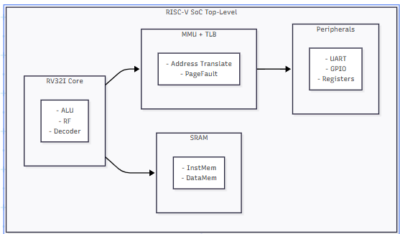

2.1 Top-Level Data Flow
- RV32I Core → (virtual address) → MMU → TLB lookup
- TLB hit → physical address returned in one cycle
- TLB miss → MMU walks the page table → TLB updated → physical address returned
- Physical address → Instruction / Data SRAM
- CSR Unit ↔ Core (SATP, MSTATUS) ↔ MMU (SATP)
- Core / MMU exceptions → Exception Handler → trap vector back to Core

2.2 Key Parameters
Parameter | Value
Register width / count | 32-bit, 32 registers (x0–x31)
Page size | 4 KB
TLB | 16 entries, fully associative
Page table | 1024 entries, single-level
Target frequency | 100 MHz
Target ASIC process | SkyWater SKY130 (130 nm)
Target FPGA | Digilent Arty A7-100T

3. RV32I Core
The core is a multicycle, FSM-based RV32I implementation — FETCH (issue PC to the MMU as a virtual address), EXECUTE (decode and run the ALU operation), MEMORY (issue load/store addresses to the MMU), WRITEBACK (commit the result to the register file) — with a 32-entry register file. Every fetch and every load/store is issued as a virtual address to the MMU rather than to memory directly.
Category | Instructions
Arithmetic (reg/imm) | ADD, SUB, AND, OR, XOR, SLT, SLTU, ADDI, ANDI, ORI, SLLI, SRLI, SRAI
Loads / Stores | LB, LH, LW, LBU, LHU / SB, SH, SW
Control transfer | JAL, JALR, BEQ, BNE, BLT, BGE, BLTU, BGEU
Upper immediate / System | LUI, AUIPC / ECALL, EBREAK, CSRRW, CSRRS, CSRRC
This core-to-MMU handshake (valid/ready plus a page-fault return) is the architectural boundary that makes the rest of the virtual-memory subsystem possible.

4. Virtual Memory: MMU and TLB
A virtual address is split into a Virtual Page Number (VPN) and a page offset. The MMU indexes a single-level, 1024-entry page table with the VPN to find a Physical Page Number (PPN) and permission flags; a 16-entry fully-associative TLB (a CAM that compares all entries in parallel) caches recent translations so most accesses complete in one cycle instead of paying for a full page-table lookup.

PTE Field | Meaning
V / R / W / X | Valid / Read / Write / Execute permission
U / G | User-accessible / global (not flushed on address-space switch)
A / D | Accessed / Dirty
PPN | Physical page number this entry maps to

4.1 Translation Flow
- Core issues a virtual address to the MMU for a fetch or a data access.
- MMU checks the TLB first — on a hit, the physical address returns immediately.
- On a miss, the MMU walks the page table, checks the PTE's valid bit and permissions.
- A valid, permitted access computes the physical address and installs it in the TLB.
- An invalid or permission-violating access raises a page fault instead.
Separate translation state machines handle the instruction and data paths independently, so a fetch and a load/store can be in translation at the same time. The TLB is flushed whenever SATP changes, since a new address space invalidates every previously cached translation.

5. Supporting Subsystems

5.1 CSR Unit and Exception Handling
The CSR unit holds SATP (MMU translation base, flushes the TLB on write), MSTATUS, and a cycle counter, accessed via CSRRW/CSRRS/CSRRC semantics. The exception handler merges core exceptions (illegal instruction, ECALL/EBREAK), MMU page faults, and external interrupts into a single trap decision (cause, interrupt vs. exception, target handler address) using MSTATUS/MIE/MIP and MTVEC.

5.2 Bus, Peripherals, and Memory
An AXI4-Lite subordinate port (plus an AXI4 arbiter for multi-master use) exposes on-chip registers to an external host/debugger. UART and GPIO pins support board-level demonstration. Instruction and data memory are separate 4096-word single-port SRAMs (Harvard-style), accessed only with the physical address the MMU produces.

6. Verification Methodology
Two verification approaches are used together: a lightweight directed testbench for fast bring-up checks, and a complete UVM environment for structured, reusable, scenario-driven verification. UVM is used here because it separates “what stimulus to send” (sequences) from “how to drive it onto pins” (drivers) and “how to check it” (scoreboards) — so new test scenarios can be added by writing a new sequence, without touching the driver/monitor/checking logic.

6.1 Directed Self-Checking Testbench
tb_riscv_soc.sv instantiates the SoC, generates clock/reset, and checks core bring-up: reset behavior, PC advancement, GPIO pass-through, and UART loopback. It is quick to run and used for early sanity checks before the full UVM regression.

6.2 UVM Environment — What Is Actually Built
The environment is built around one top-level env containing four independent agents, each responsible for one interface of the SoC. Every agent follows the same internal structure: a sequencer that arbitrates stimulus, a driver that converts each transaction into pin-level activity, and a monitor that passively observes the interface and reconstructs transactions for checking — the monitor never drives a signal.

Agent | Interface Driven / Monitored | Purpose in This Project
gpio_agent | gpio_in[7:0] / gpio_out[7:0] | Drives GPIO input patterns and checks that they appear correctly on the output side
uart_agent | uart_rx / uart_tx | Serializes bytes onto uart_rx and captures uart_tx to verify the UART path byte-for-bit
axi_agent | AXI4-Lite write/read address, data, response channels | Drives register writes and reads over the AXI4-Lite debug port
interrupt_agent | ext_interrupt | Asserts external interrupt events and checks the SoC's response/handshake

Each agent has its own scoreboard (GPIO, UART, AXI) that compares what the monitor observed against the expected result for that interface; a top-level scoreboard aggregates all three into one pass/fail verdict per test. Functional coverage groups run alongside these agents to record which GPIO bit patterns, UART byte values, AXI address ranges, and interrupt timings have actually been exercised, so coverage holes are visible instead of just a pass/fail count.

6.3 Test Sequences
Seven reusable sequences drive the agents above; each is a self-contained stimulus generator that can be run individually or combined:
Sequence | What It Does | What It Verifies
gpio_passthrough_seq | Drives a set of 8-bit patterns onto gpio_in | gpio_out mirrors gpio_in correctly
uart_echo_seq | Sends bytes on uart_rx | The same bytes are returned on uart_tx (loopback)
axi_write_seq | Issues AXI4-Lite write transactions to on-chip registers | Writes complete with the correct handshake/response
axi_read_seq | Issues AXI4-Lite reads, typically after a write | Read data matches the most recent write
interrupt_seq | Pulses ext_interrupt at varying times | The SoC recognizes and responds to the interrupt
reset_seq | Asserts/de-asserts rst_n mid-test | The design returns to a clean known state
regression_seq | Runs all of the above back-to-back | Full-environment smoke/regression pass

A UVM test (extending uvm_test) builds the environment in build_phase, raises an objection, starts the chosen sequence(s) on the relevant agent's sequencer, waits for completion, and drops the objection to end the run — the same test class is reused for each sequence simply by swapping which sequence it starts, and regression_seq exercises all four agents in one pass.

7. Physical Design Flow (RTL to GDS-II)
The design was carried through the OpenLane/OpenROAD open-source flow targeting the SkyWater SKY130 (130 nm) process (sky130A PDK), converting the RTL into a manufacturable layout in six stages: synthesis, floorplanning, placement, clock tree synthesis, routing, and GDS generation, followed by sign-off verification.

7.1 Stage-by-Stage Summary
Stage | Tool | Key Result
Synthesis | Yosys 0.62 | RTL mapped to 126 SKY130 cells (4 flip-flops, ~114 combinational, 8 buffers); ~450 µm², ~2.5 mW estimate
Floorplanning | OpenROAD | 3600×3600 µm die, 3500×3500 µm core (12.96 mm²) at 75% target utilization; power ring planned
Placement | OpenROAD nPlace | 363 cells placed (fillers/taps/buffers added); HPWL 5,376 µm; avg. displacement 1.0 µm
Clock Tree Synthesis | TritonCTS | 44 flip-flop sinks served via 6 buffers in 2 levels; clock skew 0.18 ns (spec <0.5 ns)
Routing | OpenROAD Router | 4 metal layers (M1–M4); ~500 nets, 79,425 µm total wire, 100% routed, 0 DRC violations
GDS Generation | Magic + KLayout | riscv_soc_top.gds (591 KB) plus KLayout/Magic variants; 363 instances, ~6,880 shapes streamed

7.2 Sign-off Verification
Post-layout checks confirmed the design is ready for fabrication: DRC (Magic and KLayout) came back with zero errors across metal, via, density, and antenna rules; LVS (Netgen) matched 363/363 cells and ~500 nets between the netlist and the extracted layout with no floating nets; and Static Timing Analysis closed with positive slack on every process corner.
Check | Result
DRC (Magic + KLayout) | 0 errors, 0 warnings
LVS (Netgen) | 100% match, no floating nets
STA – Typical / Slow / Fast corners | Setup +0.4 / +0.2 / +0.6 ns; Hold +0.15 / +0.10 / +0.20 ns — all PASS
Power (estimated @ 100 MHz) | ~3.5 mW total, IR drop <45 mV
Manufacturing (antenna/density) | All checks within spec
Overall, 72 of 80 flow stages completed, producing a clean-sign-off, tapeout-ready GDS-II layout.

7.3 Layout Views (OpenROAD GUI)
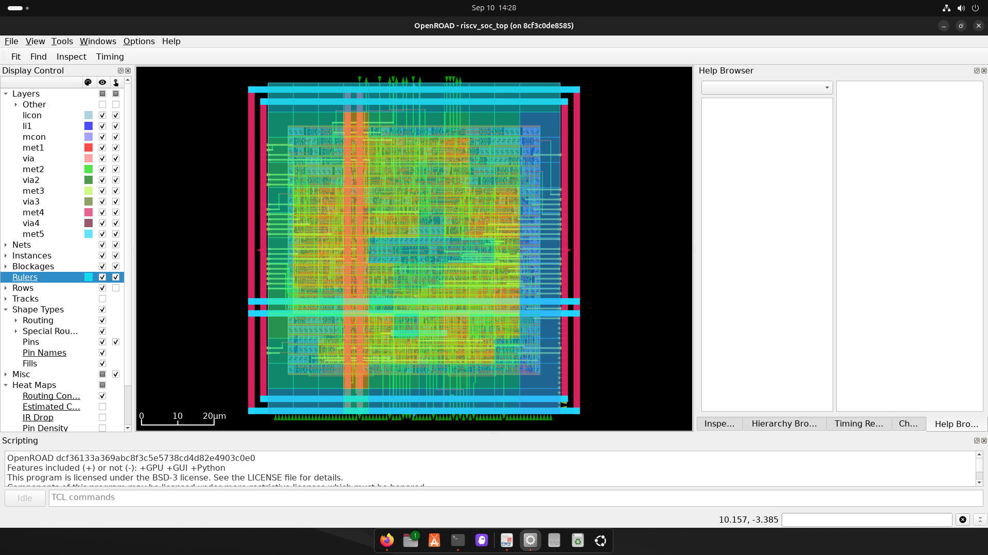
Figure 1: Full-chip layout of riscv_soc_top with a routing-congestion heat map, showing the met1–met5 stack, I/O ring, and power straps.
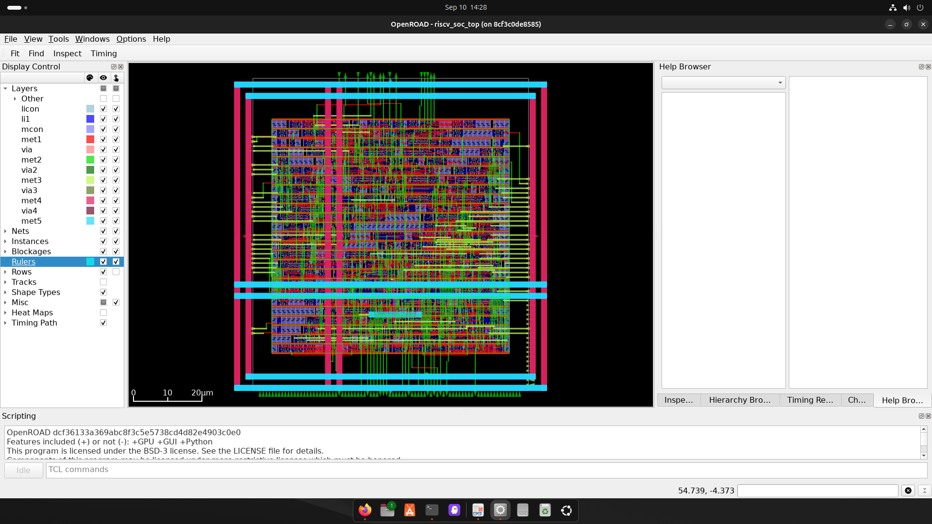
Figure 2: Placed-and-routed standard-cell core with the Timing Path panel active.
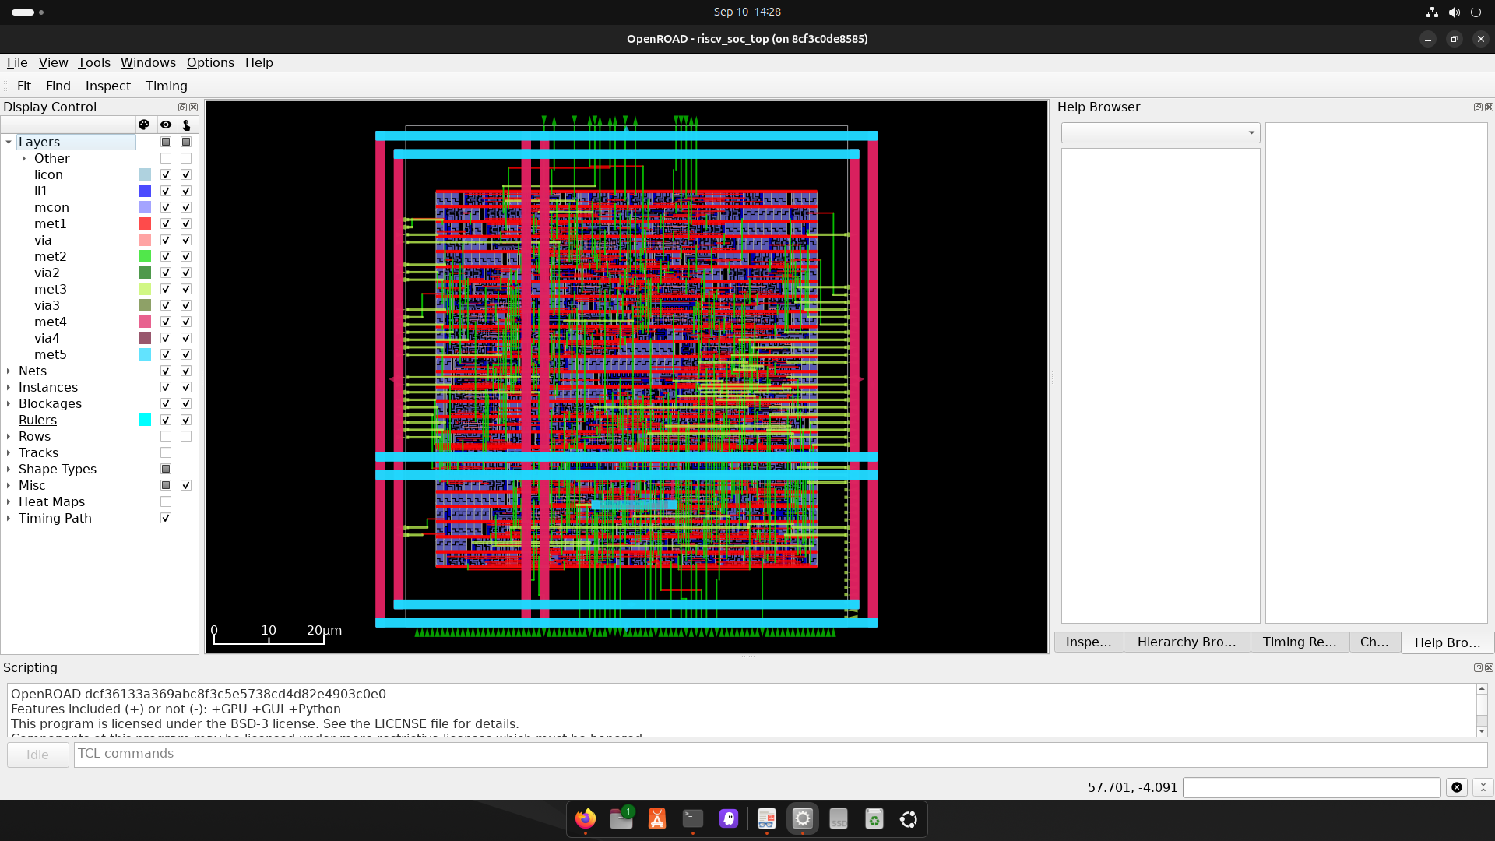
Figure 3: Layer control panel showing the full SKY130 routing stack enabled.
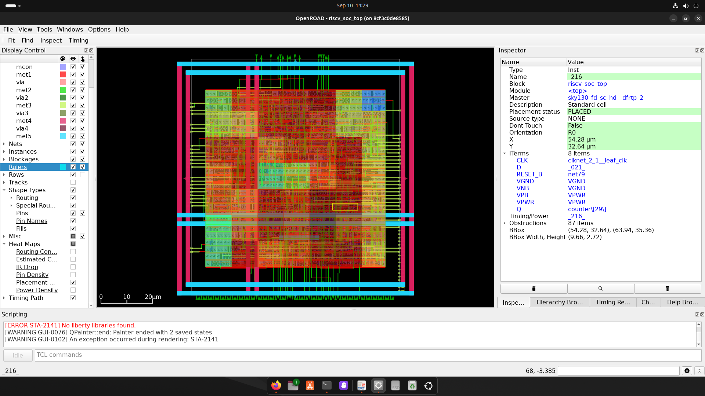
Figure 4: Instance inspector on a placed flip-flop (counter[29]) showing exact placement coordinates and connectivity.

8. FPGA Build and Deliverables
A parallel FPGA path targets the Digilent Arty A7-100T for functional demonstration: pin constraints (arty100t.xdc), an RTL wrapper for board I/O, and a Makefile/flow.json build script, intended to show address-translation behavior via UART and GPIO/LEDs.
Deliverable | Artifact
RTL | rtl/ – core, MMU, TLB, CSR, exception handler, SRAM, AXI arbiter, top-level SoC
Directed testbench | sim/RTL/tb_riscv_soc.sv
UVM environment | uvm/ – 4 agents, 3 scoreboards + aggregator, coverage, 7 sequences
FPGA build | fpga/ – Makefile, flow.json, XDC constraints, RTL wrapper
Physical design / GDS | asic/ – complete OpenLane run, tapeout-ready GDS-II

9. Conclusion
This project implements a virtual-memory-capable RISC-V SoC — RV32I core, MMU/TLB, CSR-based control, and exception handling — verified through a four-agent UVM environment with dedicated scoreboards, coverage, and seven test sequences, and carried through a complete physical design flow to a clean-sign-off, tapeout-ready SKY130 GDS-II layout, alongside a parallel FPGA path. Together these demonstrate the full lifecycle from RTL through verification to physical layout.
Natural next steps: pre-load the MMU's page table so translations can be exercised end-to-end, replace the UART/GPIO pass-through stubs with real controllers, and add a UVM agent targeting the core-MMU-TLB datapath directly (TLB hit/miss, page-table walks, page faults).

