Physical-Design Report
SKY130 / OpenLane-style implementation of SoC_Hardened

Executive Summary
The physical-design flow completed through routed database generation, parasitic extraction, multi-corner STA, KLayout GDS stream-out/DRC, Magic extraction, Netgen LVS, and final view export. DRC, LVS, hold, antenna, max-capacitance, and power-grid connectivity checks are clean. The design is not fully signoff-clean at the 10 ns clock target because setup timing fails in the slow 1.60 V / 100 °C corners. Max-slew violations (26) and one max-fanout violation are also present in the recorded final metrics.
Category | Final result
Die area | 1,482,110 µm²; bbox 0.0 0.0 1212.07 1222.79
Core area | 1,440,140 µm²; bbox 5.52 10.88 1206.12 1210.4
Instance utilization | 41.22%
Macro area | 569,077 µm² across 2 SRAM macros
Standard-cell area | 24,606.1 µm²
Detailed-route wirelength | 31,237 µm
Detailed-route vias | 5,813
KLayout DRC | 0 errors
LVS | 0 errors; circuits match uniquely
Antenna | 0 violating nets / 0 violating pins
Hold timing | WNS 0 ns, TNS 0 ns, 0 violations
Worst setup timing | WNS -0.805 ns; TNS -1.471 ns
Setup violation count | 6 across reported corners
Max slew / fanout / cap | 26 / 0 / 0
Total power | 12.666 mW (reported analysis corner)
Worst power-grid drop | 0.832 mV

Multi-Corner Timing
Corner | Setup WNS (ns) | Setup TNS (ns) | Setup viol. | Hold viol.
max_ff_n40C_1v95 | 0.000 | 0.000 | 0 | 0
nom_ff_n40C_1v95 | 0.000 | 0.000 | 0 | 0
min_ff_n40C_1v95 | 0.000 | 0.000 | 0 | 0
max_tt_025C_1v80 | 0.000 | 0.000 | 0 | 0
nom_tt_025C_1v80 | 0.000 | 0.000 | 0 | 0
min_tt_025C_1v80 | 0.000 | 0.000 | 0 | 0
max_ss_100C_1v60 | 0.000 | 0.000 | 0 | 0
nom_ss_100C_1v60 | 0.000 | 0.000 | 0 | 0
min_ss_100C_1v60 | 0.000 | 0.000 | 0 | 0

Physical Verification and Routing
- KLayout DRC metric: 0 errors.
- Netgen LVS: extracted and schematic circuits each contain 1,061 devices and 1,277 nets; final result states “Circuits match uniquely.”
- Detailed routing converged from 79 DRC errors at iteration 0 to 0 at iteration 3.
- No antenna-violating nets or pins remain; antenna diodes were inserted during repair.
- Power-grid analysis reports connected vccd1/vssd1 shapes and a worst recorded drop below 1 mV; the flow warns that VSRC location files were not supplied, so IR-drop accuracy is limited for manufacturing signoff.

Final Layout Render
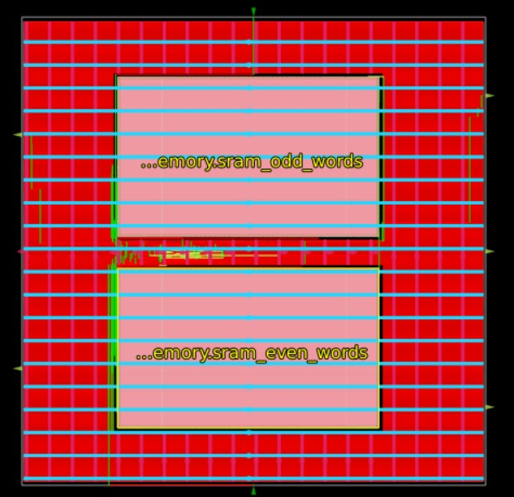
Final layout image emitted by the physical-design run.

Signoff Assessment
Check | Status | Comment
Synthesis/netlist | PASS | Mapped and implementable
Placement/routing | PASS | Routed implementation produced
DRC | PASS | 0 KLayout DRC errors
LVS | PASS | 0 LVS errors
Antenna | PASS | 0 final violations
Hold STA | PASS | 0 hold violations
Max slew | OPEN | 26 violations in final metric set
Max fanout | PASS | 0 violations
Max capacitance | PASS | 0 violations
IR drop | PASS with caveat | Very small reported drop; VSRC_LOC_FILES warning limits signoff fidelity

Source Traceability
Primary evidence used for this report:
- pd/riscv_mmu_pd/runs/RUN_2026-09-13_10-44-24/final/metrics.json
- pd/riscv_mmu_pd/runs/RUN_2026-09-13_10-44-24/57-openroad-stapostpnr/summary.rpt
- pd/riscv_mmu_pd/runs/RUN_2026-09-13_10-44-24/63-klayout-drc/reports/drc.klayout.json
- pd/riscv_mmu_pd/runs/RUN_2026-09-13_10-44-24/67-netgen-lvs/netgen-lvs.log
- pd/riscv_mmu_pd/runs/RUN_2026-09-13_10-44-24/58-openroad-irdropreport/openroad-irdropreport.log
- pd/riscv_mmu_pd/runs/RUN_2026-09-13_10-44-24/flow.log

