Liferay Hires Sven  
project

The Bug Report

Contents

**BUG ID:** LRSV-BUG-001 3

**BUG ID:** LRSV-BUG-002 4

**BUG ID:** LRSV-BUG-003 5

**BUG ID:** LRSV-BUG-004 6

**BUG ID:** LRSV-BUG-005 7

**BUG ID:** LRSV-BUG-006 8

**BUG ID:** LRSV-BUG-007 9

**BUG ID:** LRSV-BUG-008 10

**BUG ID:** LRSV-BUG-009 11

**BUG ID:** LRSV-BUG-010 12

**BUG ID:** LRSV-BUG-011 13

# **BUG ID:** LRSV-BUG-001

**Name of the bug**

Warning message pops up upon calculate without Entry Date;

**Severity: High**

**Steps to reproduce**

1. Go to the URL: http://www.shino.de/parkcalc/index.php
2. On Dropdown option for 'Choose a Parking Lot', select **Valet Parking**
3. On Leaving Date Picker, select Leaving Date: 11/4/2019
4. Click on Calculate button

**Expected result**

1. Warning should not be visible to the user
2. Entry Date & Time should be required

**Actual result**

Warning message shows up on the top navigation

**A screenshot, GIF, or video**

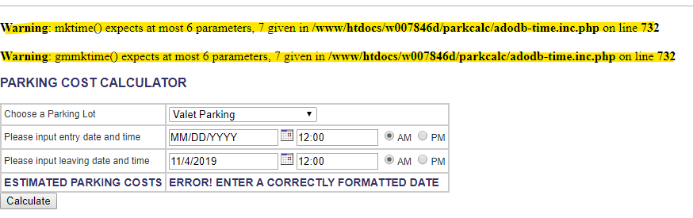

**Helpful logs**

LRSV-BUG-001 is related to TestCase Reference: LRSV-USA-015

# **BUG ID:** LRSV-BUG-002

**Name of the bug**

Warning message will display when entering Alphabet & Special Characters

**Severity: High**

**Steps to reproduce**

1. Go to the URL: http://www.shino.de/parkcalc/index.php
2. On Dropdown option for 'Choose a Parking Lot', select **Economy Parking**
3. On Entry Date Picker, select Entry Date: ASD!@ #$%^^&&*(&
4. On Time Entry, enter Time: ASD!@ #$%^^&&*(&
5. Then select Radio Button: AM
6. On Leaving Date Picker, select Leaving Date: ASD!@ #$%^^&&*(&
7. On Time Leaving, enter Time: ASD!@ #$%^^&&*(&
8. Then select Radio Button: AM
9. Click on Calculate button

**Expected result**

Should be able to capture and return an error message.

**Actual result**

Warning message displayed.

**A screenshot, GIF, or video**

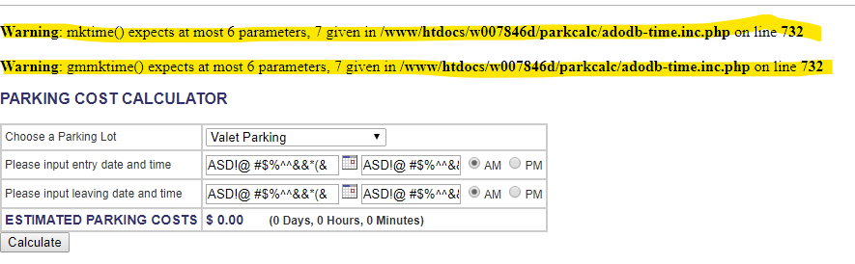

**Helpful logs**

LRSV-BUG-002 is related to TestCase Reference: LRSV-USA-016

# **BUG ID:** LRSV-BUG-003

**Name of the bug**

Warning message pops up upon calculate without Leaving Date

**Steps to reproduce**

1. Go to the URL: http://www.shino.de/parkcalc/index.php
2. On Dropdown option for 'Choose a Parking Lot', select **Valet Parking**
3. On Entry Date Picker, select Entry Date: 11/4/2019
4. Click on Calculate button

**Expected result**

1. Warning should not be visible to the user
2. Leaving Date & Time should be required

**Actual result**

Warning message shows up on the top navigation

**A screenshot, GIF, or video**

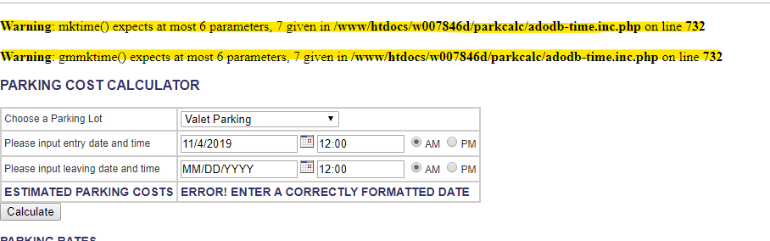

**Helpful logs**

LRSV-BUG-003 is related to TestCase Reference: LRSV-USA-017

# **BUG ID:** LRSV-BUG-004

**Name of the bug**

Selected Dropdown option should be retained after clicking Calculate

**Severity: Medium**

**Steps to reproduce**

1. Go to the URL: http://www.shino.de/parkcalc/index.php
2. On Dropdown option for 'Choose a Parking Lot', select **Economy Parking**
3. On Entry Date Picker, select Entry Date: 11/4/2019
4. On Time Entry, enter Time: 12:00
5. Then select Radio Button: AM
6. On Leaving Date Picker, select Leaving Date: 11/4/2019
7. On Time Leaving, enter Time: 12:01
8. Then select Radio Button: AM
9. Click on Calculate button

**Expected result**

Parking Lot option: Economy Parking should be retained

**Actual result**

Dropdown option would reset to “Valet Parking” as the default option

**A screenshot, GIF, or video**

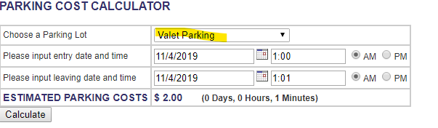

**Helpful logs**

LRSV-BUG-004 is related to TestCase LRSV-USA-018

# **BUG ID:** LRSV-BUG-005

**Name of the bug**

Entry Time Radio Button PM will not retain its value

**Severity: Medium**

**Steps to reproduce**

1. Go to the URL: http://www.shino.de/parkcalc/index.php
2. On Dropdown option for 'Choose a Parking Lot', select **Economy Parking**
3. On Entry Date Picker, select Entry Date: 11/4/2019
4. On Time Entry, enter Time: 12:00
5. Then select Radio Button: PM
6. On Leaving Date Picker, select Leaving Date: 11/4/2019
7. On Time Leaving, enter Time: 12:00
8. Then select Radio Button: PM
9. Click on Calculate button

**Expected result**

Entry Time Radio Button PM should be retained.

**Actual result**

Value for Entry Time Radio Button PM didn’t retain.

**A screenshot, GIF, or video**

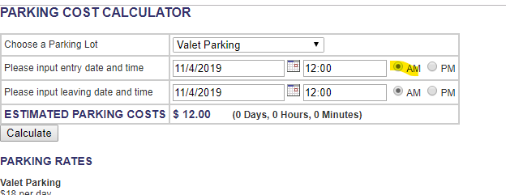

**Helpful logs**

LRSV-BUG-005 is related to TestCase LRSV-USA-019

# **BUG ID:** LRSV-BUG-006

**Name of the bug**

Leaving Time Radio Button PM will not retain its value

**Severity: Medium**

**Steps to reproduce**

1. Go to the URL: http://www.shino.de/parkcalc/index.php
2. On Dropdown option for 'Choose a Parking Lot', select **Economy Parking**
3. On Entry Date Picker, select Entry Date: 11/4/2019
4. On Time Entry, enter Time: 12:00
5. Then select Radio Button: PM
6. On Leaving Date Picker, select Leaving Date: 11/4/2019
7. On Time Leaving, enter Time: 12:00
8. Then select Radio Button: PM
9. Click on Calculate button

**Expected result**

Leaving Time Radio Button PM should be retained.

**Actual result**

Value for Leaving Time Radio Button PM didn’t retain.

**A screenshot, GIF, or video**

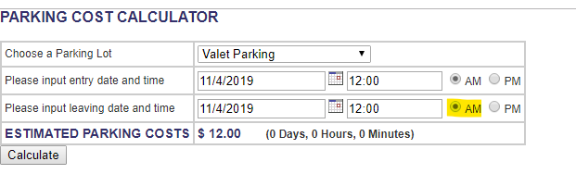

**Helpful logs**

LRSV-BUG-006 is related to TestCase LRSV-USA-019

# **BUG ID:** LRSV-BUG-007

**Name of the bug**

Wrong Estimated Parking Cost when no Entry Time entered.

**Severity: High**

**Steps to reproduce**

1. Go to the URL: http://www.shino.de/parkcalc/index.php
2. On Dropdown option for 'Choose a Parking Lot', select **Economy Parking**
3. On Entry Date Picker, select Entry Date: 11/4/2019
4. On Time Entry, enter blank
5. On Leaving Date Picker, select Leaving Date: 11/4/2019
6. On Time Leaving, enter Time: 1:00
7. Then select Radio Button: PM
8. Click on Calculate button

**Expected result**

Should return an error message that no Entry Time.

**Actual result**

Gave cost of **$ 140,436.00** which is for 18204 days.

**A screenshot, GIF, or video**

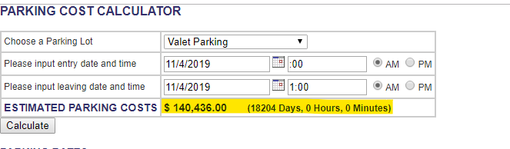

**Helpful logs**

LRSV-BUG-007 is related to TestCase LRSV-USA-020

# **BUG ID:** LRSV-BUG-008

**Name of the bug**

PM Radio Button will increment 12 hours when entered 24-hour format

**Severity: Medium**

**Steps to reproduce**

1. Go to the URL: http://www.shino.de/parkcalc/index.php
2. On Dropdown option for 'Choose a Parking Lot', select **Valet Parking**
3. On Entry Date Picker, select Entry Date: 11/4/2019
4. On Time Entry, enter Time: 20:00
5. Then select Radio Button: PM
6. On Leaving Date Picker, select Leaving Date: 11/5/2019
7. On Time Leaving, enter Time: 24:00
8. Then select Radio Button: PM
9. Click on Calculate button

**Expected result**

24-hour time should retain when clicking PM.

**Actual result**

Time entered will increment by 12 hours.

**A screenshot, GIF, or video**

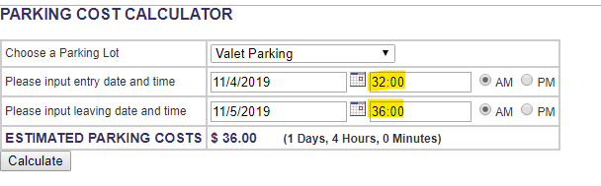

**Helpful logs**

LRSV-BUG-008 is related to TestCase LRSV-VAL-011

# **BUG ID:** LRSV-BUG-009

**Name of the bug**

Value of date will return a Negative value

**Severity: High**

**Steps to reproduce**

1. Go to the URL: http://www.shino.de/parkcalc/index.php
2. On Dropdown option for 'Choose a Parking Lot', select **Economy Parking**
3. On Entry Date Picker, select Entry Date: 11/4/2019
4. On Time Entry, enter Time: 12:00
5. Then select Radio Button: AM
6. On Leaving Date Picker, select Leaving Date: 11/1/2019
7. On Time Leaving, enter Time: 39:00
8. Then select Radio Button: PM
9. Click on Calculate button

**Expected result**

1. Should not return negative value of -1 Days.
2. Should capture error and display error message.

**Actual result**

Value returned -1 Days and no error message displayed.

**A screenshot, GIF, or video**

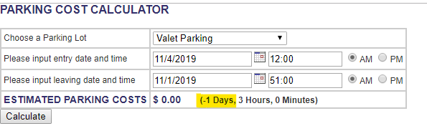

**Helpful logs**

LRSV-BUG-009 is related to TestCase LR-ECO-019

# **BUG ID:** LRSV-BUG-010

**Name of the bug**

Page load is slow when entering large value to compute

**Severity: High**

**Steps to reproduce**

1. Go to the URL: http://www.shino.de/parkcalc/index.php
2. On Dropdown option for 'Choose a Parking Lot', select **Economy Parking**
3. On Entry Date Picker, select Entry Date: 11/4/2019
4. On Time Entry, enter Time: 12:00
5. Then select Radio Button: AM
6. On Leaving Date Picker, select Leaving Date: 11/5/209999999
7. On Time Leaving, enter Time: 25:00
8. Then select Radio Button: PM
9. Click on Calculate button

**Expected result**

Should be able to capture and indicate error message

**Actual result**

1. Warning message displayed
2. Loading time took 16.22seconds

**A screenshot, GIF, or video**

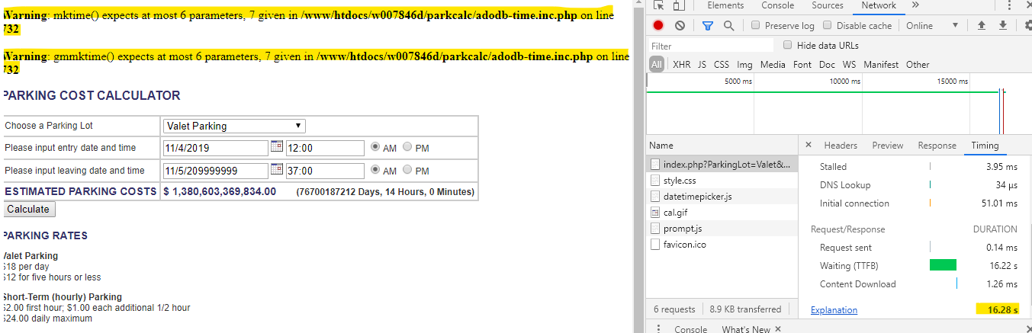

**Helpful logs**

LRSV-BUG-010 is related to TestCase LRSV-USA-021

# **BUG ID:** LRSV-BUG-011

**Name of the bug**

Computation for Hourly rate Economy Parking is incorrect

**Severity: Medium**

**Steps to reproduce**

1. On Dropdown option for 'Choose a Parking Lot', select **Economy Parking**
2. On Date Picker, select Entry Date: 11/4/2019
3. On Time Entry, enter Time: 1:00
4. Then select Radio Button: PM
5. On Date Picker, select Leaving Date: 11/4/2019
6. On Time Leaving, enter Time: 5:01
7. Then select Radio Button: PM
8. Click on Calculate button

**Expected result**

$ 9.00 (0 Days, 4 Hours, 1 Minutes) – Daily maximum of Economy should be $9.00

**Actual result**

$ 10.00 (0 Days, 4 Hours, 1 Minutes)

**A screenshot, GIF, or video**

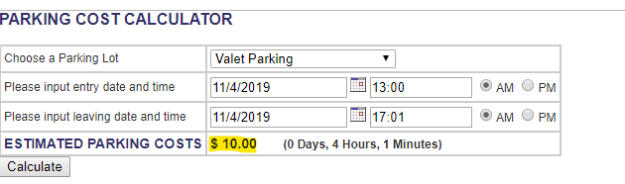

**Helpful logs**

LRSV-BUG-011 is related to TestCase LR-ECO-008